**3GPP TSG-SA5 Meeting #143-eS5-223378**

**e-meeting, 9 - 17 May 2022**

**Source: AsiaInfo**

**Title: pCR 28.824 add procedure of MnS exposure via CAPIF**

**Document for: Approval**

**Agenda Item: 6.5.22.3**

# 1 Decision/action requested

***For approval***

# 2 References

[1] 3GPP TR 28.824 V0.6.0 Study on network slice management capability exposure

# 3 Rationale

This contribution proposes to add procedure MnS exposure via CAPIF

# 4 Detailed proposal

This contribution proposes to make the following changes in [1].

|  |
| --- |
| **1st change** |

## 7.9 Potential solutions for network slice management capability exposure via CAPIF

### 7.9.2 Exposure via CAPIF alternative 2

This clause describes a potential solution where network slice management capability exposure is used in conjunction with a CAPIF core function (see TS 23.222 [14]) to expose management services to MnS consumers.

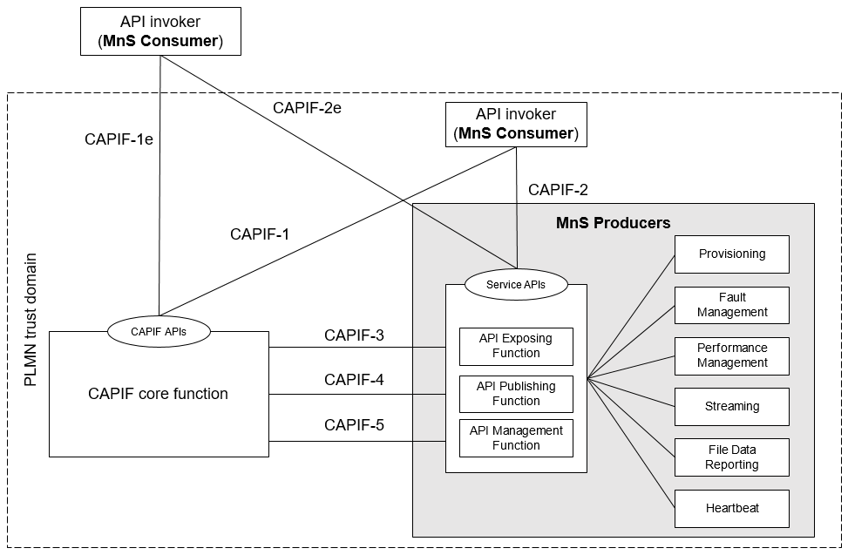

Figure 7.9.2-1: Exposure via CAPIF alternative 2

In this alternative, network slice management capability exposure consumes the interfaces at reference points CAPIF-3, CAPIF-4, and CAPIF-5 as defined in TS 23.222 [14]. It may be necessary to extend CAPIF-3/4/5 as defined in TS 23.222 [14] to support exposure of network slice management services.

Editor’s note: Whether it is necessary to extend CAPIF-3/4/5 is FFS.

In this alternative, network slice management capability exposure provides the interfaces at reference point CAPIF-2/2e. It may be necessary to extend CAPIF-2/2e as defined in TS 23.222 [14] to support network slice management capability exposure and authentication of MnS consumers.

In this alternative, MnS Consumers utilize the interfaces at reference point CAPIF-1/1e. It may be necessary to extend CAPIF-1/1e as defined in TS 23.222 [14] to support network slice management capability exposure and authorization/authentication of MnS consumers.

Editor’s note: Whether network slice management capability exposure is affected by transforming the management service API to another service API is FFS.

The figure 7.9.2-2 describes a procedure where network slice management capability exposure is used in conjunction with a CAPIF core function (see TS 23.222 [14]) to expose management services to MnS consumers.



Figure 7.9.2-2: the procedure of expose management services via CAPIF alternative 2

1. The MnS producers registes its MnS information to CCF. The CCF executes MnS registration for MnS producers via API managenment Function, then the MnS producer publish the exposed MnS information to the CCF via API publishing function and CCF (CAPIF Core Function) stores the exposed MnS information. The exposed MnS information may contain the information for discovering such MnS.

2. The CCF (CAPIF Core Function) executes authentication and authorization for NSC.

3. The NSC sends a request for discovery service for exposed MnS to the CCF, discoveries management capabilities of MnS instances and the address of MnS producer.

4. Upon receiving the discovery MnS information request, the CCF retrieve the MnS information for exposed MnS.

5 the CCF sends a response, including the exposed MnS information, to the NSC for which the NSC has the required authorization, the exposed MnS information including address of the MnS producer.

6. the MnS producer conducts authentication and authorization of the NSC for exposed MnS via API exposing function

7.The NSC identifies the MnS producer and obtain access to the exposed MnS

|  |  |  |  |  |
| --- | --- | --- | --- | --- |
| **Step** | **Description in step** | **Interface** | **Reference** | **Description in reference** |
| 1 | MnS registeration | External(CAPIF4 CAPIF5) | TS23.222[14] | -it may be necessary to extend CAPIF 4 in TS 23.222[14] to supporting MnsInfo  - it may be necessary extend CAPIF 5 in TS 23.222[14] to supporting registeration for MnS producers. |
| 2 | authentication and authorization for MnS consumer | External(CAPIF1/1e) | TS23.222[14] | - It may be necessary to extend CAPIF-1/1e as defined in TS 23.222[14] to support authorization/authentication of MnS consumers. |
| 3 | Discovery service for exposed MnS request | External(CAPIF1/1e) | TS23.222[14] | - It may be necessary to extend CAPIF-1/1e as defined in TS 23.222 [14] to support network slice management capability exposure |
| 4 |  | None | - | - |
| 5 | Discovery service for exposed MnS respones | External(CAPIF1/1e) | TS23.222[14] | - It may be necessary to extend CAPIF-1/1e as defined in TS 23.222 [14] to support network slice management capability exposure |
| 6 | authentication and authorization of NSC for exposed MnS | External(CAPIF2/2e) | TS28.533[11], TS23.222[14] | - Authentication and authorization of MnS consumers is specified in TS 28.533 [11] clause 4.9.  - It may be necessary to extend CAPIF-2/2e as defined in TS 23.222 [14] to support authentication of MnS consumers. |
| 7 | obtain the access to exposed MnS | External (CAPIF2/2e) | TS28.532[15], TS23.222[14] | - the Operations and Notifications defined in clause 11.1.1 of TS 28.532 [15]，such as getMOIAttributes operation  - It may be necessary to extend CAPIF-2/2e as defined in TS 23.222 [14] to support network slice management capability exposure. |

### 7.9.3 Exposure via CAPIF alternative 3

This clause describes a potential solution where network slice management capability exposure implements a Common API Framework for 3GPP Northbound APIs (see TS 23.222 [14]) to expose management services to MnS consumers.

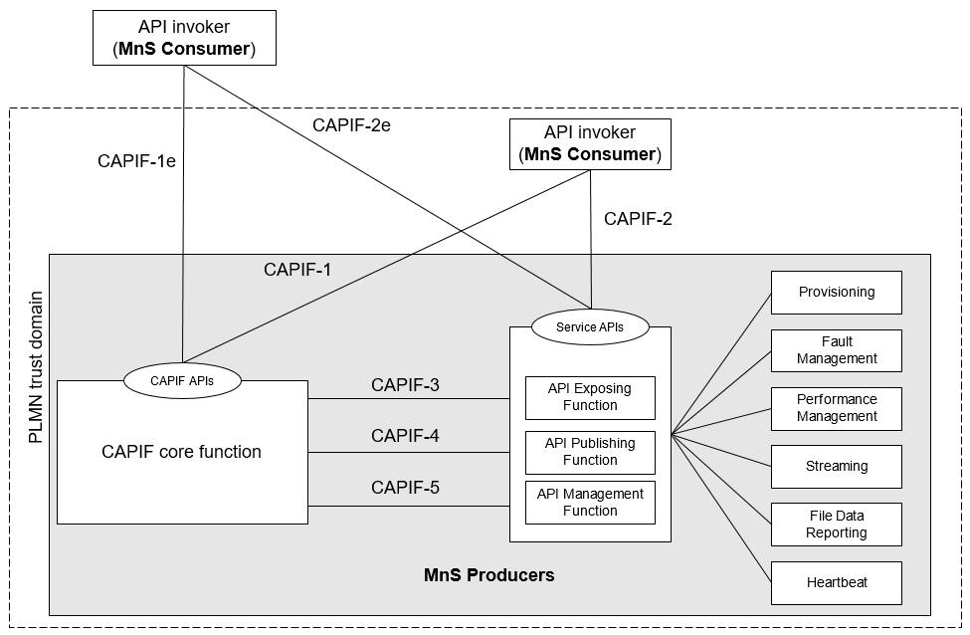

Figure 7.9.3-1: Exposure via CAPIF alternative 3

In this alternative, network slice management capability exposure may internally implement the interfaces at reference points CAPIF-3, CAPIF-4, and CAPIF-5 as defined in TS 23.222 [14] or may use non-standardized interfaces.

In this alternative, network slice management capability exposure provides the interfaces at reference point CAPIF-1/1e. It may be necessary to extend CAPIF-1/1e as defined in TS 23.222 [14] to **support authorization/authentication of MnS consumers and discovery of MnS producers.**

In this alternative, network slice management capability exposure provides the interfaces at reference point CAPIF-2/2e. It may be necessary to extend CAPIF-2/2e as defined in TS 23.222 [14] to support network slice management capability exposure and authentication of MnS consumers.

Editor’s note: Whether network slice management capability exposure is affected by transforming the management service API to another service API is FFS.

The figure 7.9.3-2 describes a procedure where network slice management capability exposure implements a Common API Framework for 3GPP Northbound APIs (see TS 23.222 [14]) to expose management services to MnS consumers.



Figure 7.9.3-1: the procedure of Exposure via CAPIF alternative 3

1. The MnS producers registes its MnS information to CCF. The CCF executes MnS registration for MnS producers via API management Function, then the MnS producers pulish the exposed MnS information to the CCF via API publishing function and CCF (CAPIF Core Function) stores the exposed MnS information. The exposed MnS information may contain the information for discovering such MnS.

2. The CCF executes authentication and authorization for NSC.

3. The NSC sends a request for discovery MnS data for exposed MnS to the CCF, discoveries management capabilities of MnS instances and the address of MnS producer.

4. Upon receiving the request, the CCF retrieve the MnS information for exposed MnS.

5 the CCF sends a response, including the exposed MnS information, to the NSC for which the NSC has the required authorization via, the exposed MnS information including address of the MnS producer.

6. the MnS producer conducts authentication and authorization of the NSC for exposed MnS via API exposing function

7. The NSC identifies the MnS producer and obtain access to the exposed MnS

|  |  |  |  |  |
| --- | --- | --- | --- | --- |
| **Step** | **Description in step** | **Interface** | **Reference** | **Description in reference** |
| 1 | MnS registeration | Internal(CAPIF4 CAPIF5) | TS 28.622[17], TS 28.623[16], | -Registration of MnS by an MnS producer is Specified in TS28.622[17] and TS 28.623[16] |
| 2 | authentication and authorization for MnS consumer | External(CAPIF1/1e) | TS 28.533 [11], TS 28.222 [14] | - Authentication and authorization of MnS consumers is specified in TS 28.533 [11] clause 4.9.  - It may be necessary to extend CAPIF-1/1e as defined in TS 23.222[14] to support authorization/authentication of MnS consumers. |
| 3 | MnS discovery service request | External (CAPIF1/1e) | TS 28.532 [15], TS 28.622[17],TS23.222[14] | - MnS discovery of MnS producers is defined in TS 28.532[15] and TS 28.622[17]  - It may be necessary to extend CAPIF-1/1e as defined in TS 23.222[14] to support discovery of MnS producers.API invoker identity information is defined in TS23.222[14], the service API information may be extended. |
| 4 | - | None | - | - |
| 5 | Discovery MnS information respones | External (CAPIF1/1e) | TS23.222[14] | - MnS discovery of MnS producers is defined in TS 28.532[15] and TS 28.622[17]  - It may be necessary to extend CAPIF-1/1e as defined in TS 23.222[14] to support discovery of MnS producers, Service API information is defined in TS23.222[14], the service API information may be extend. |
| 6 | authentication and authorization of NSC for exposed MnS | External(CAPIF2/2e) | TS28.533[11], TS23.222[14] | - Authentication and authorization of MnS consumers is specified in TS 28.533 [11] clause 4.9.  - It may be necessary to extend CAPIF-2/2e as defined in TS 23.222 [14] to support authentication and authorization of MnS consumers. |
| 7 | Obtainaccess to the exposed MnS | External(CAPIF2/2e) | TS28.532[15], TS 23.222 [14] | - the Operations and Notifications defined in clause 11.1.1 of TS 28.532 [15]，such as getMOIAttributes operation  - It may be necessary to extend CAPIF-2/2e as defined in TS 23.222 [14] to support network slice management capability exposure |

|  |
| --- |
| **End of changes** |