3GPP TSG-SA5 Meeting #143-e S5-223325

e-meeting, 9 - 17 May 2022

Source: Huawei, China Mobile

Title: Add general process of evaluating the autonomous network level

Document for: Approval
Agenda Item: 6.5.2.1

1 Decision/action requested
The group is asked to discuss and approval.

2 References
[1] [1] 3GPP draft TR 28.909: “Management and orchestration; Study on evaluation of autonomous network levels v0.1.0”.

3 Rationale
This contribution proposes to add the general process of evaluating the autonomous network level in Key Issue#2 Generic methodology for autonomous network levels evaluation based on concept for autonomous network level evaluation described in TR 29.909 [1].

4 Detailed proposal
It proposes to make the following changes to TR 28.909 [1].
1st Change

5.2 Key Issue# 2: Generic methodology for autonomous network levels evaluation
Editor's note: this clause will contain the description and potential solutions of generic methodology for quantitatively evaluating the autonomous network levels (evaluation mechanisms for autonomous network levels).

5.2.1 Description

5.2.1.X Potential process of evaluating the autonomous network level
Editor's note: following process of evaluating the autonomous network level may need to be updated based on further discussion/investigation.
The general process of evaluating the autonomous network level is illustrated in Fig. 5.2.2.X-1:
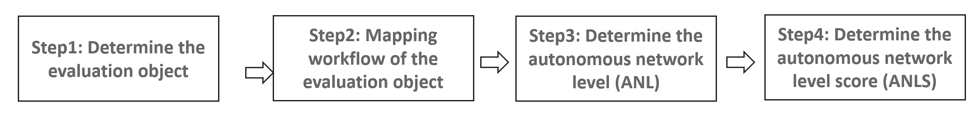
Figure. 5.2.2.X-1 General process of evaluating the autonomous network level
Step 1: Determine the evaluation object
The evaluation object can be an autonomous network workflow for an individual scenario and/or management scope, which means the evaluation object is determined by the dimensions for autonomous network levels evaluation (i.e. scenario, management scope and workflow). For example, the evaluation object can be [NR coverage optimization, RAN MnF, network optimization] or [NR throughput optimization, RAN MnF, network optimization].
Step 2: Mapping workflow of the evaluation object to corresponding standardized tasks of the generic workflow
In this step the workflow of the evaluation needs to be mapped to the standardized tasks of the generic workflow defined in TS 28.100 [2]. For example, the standardized tasks for generic network optimization is defined in clause 7.1.1 in TS 28.100 [2].
Step 3: Determine the autonomous network level (ANL) for the evaluation object
This step is used to derive the autonomous network level (ANL) based on the generic classification of autonomous network level for the workflow of the evaluation object. For each identified task of the workflow of this evaluation object identified evaluation, corresponding autonomy capability needs to be analysed and derived. Then the qualitative autonomous network level for the evaluation object can be derived based on the mapping of the autonomy capability for each task and generic classification of autonomous network level defined in TS 28.100 [2].
Step 4: Determine the autonomous network level score (ANLS) for the evaluation object
This step is used to derive the autonomous network level score (ANLS) based on ANL derived in Step3 and further evaluation with more evaluation factors considered.
Editor's note: the detailed information for this step is FFS.

5.2.2 Potential solutions

End of changes

