3GPP TSG-SA5 Meeting #143-e S5-223322

e-meeting, 9 - 17 May 2022

Source: Huawei, AsiaInfo, China Mobile

Title: Update the key issue of autonomous network level for RAN energy saving scenario

Document for: Approval
Agenda Item: 6.5.1.3

1 Decision/action requested
The group is asked to discuss and approval.

2 References
[1] 3GPP draft TR 28.910: “Management and orchestration; Study on enhancement of autonomous network levels v0.1.0”.

3 Rationale
This contribution proposes to add the workflow and generic classification RAN energy saving in clause 6.1 based on autonomous network level framework defined in TS 28.100.

4 Detailed proposal
It proposes to make the following changes to TR 28.910 [1].

1st Change

2 References
The following documents contain provisions which, through reference in this text, constitute provisions of the present document.
- References are either specific (identified by date of publication, edition number, version number, etc.) or non-specific.
- For a specific reference, subsequent revisions do not apply.
- For a non-specific reference, the latest version applies. In the case of a reference to a 3GPP document (including a GSM document), a non-specific reference implicitly refers to the latest version of that document in the same Release as the present document.
- 3GPP TR 21.905: "Vocabulary for 3GPP Specifications".
[2] 3GPP TS 28.310: "Management and orchestration; Energy efficiency of 5G"
[3] 3GPP TR 28.813: "Management and orchestration; Study on new aspects of Energy Efficiency (EE) for 5G"
[X] 3GPP TS 28.104: "Management and orchestration; Management Data Analytics."

1st Change

6.1 Key Issue# 6-1: Autonomous network level for RAN energy saving use case

6.1.1 Description

6.1.1.1 Use case
The massive deployment of mobile network has brought about a rapid increase in energy consumption. The energy cost and carbon emission also become great challenges for the NOP. Operators are aiming at reducing power consumption in 5G networks to lower their OPEX with energy saving solutions. RAN energy saving represent the energy saving aspects (including capacity booster cell - gNB is fully or partially overlaid by the candidate cell(s) in TS 28.310[2], area based energy saving in TR 28.813[3], and other energy saving aspects) for RAN. So, introducing the autonomous network level for energy saving will benefit for operator to achieve the full autonomy goal step by step and have clear view on which typical issues can be addressed by telecom system in corresponding steps. The requirements for each autonomous level for energy saving are different. So it is important to introduce the autonomous network level definition for energy saving.
The concrete energy saving solutions should not be defined in this document. This key issue only focuses on autonomous network level defined for energy saving.

6.1.1.2 Workflow
Intent handling:
- Task A: RAN energy saving control information generation and determination. The tasks of generating and determining the RAN energy saving related control information (e.g., threshold value of high energy consumption issue analysis) and RAN energy saving actions generation) based on received RAN energy saving intent (e.g. expectation on energy saving targets in the specified areas with considering network or service performance (e.g. RAN UE throughput) assurance, as well as the frequencies and RATs to be considered).
- Task B: RAN energy saving intent fulfilment evaluation. The tasks of evaluating RAN energy saving intent fulfilment information (e.g. energy saving targets (e.g., target RAN energy consumption and RAN UE throughput in the specified area are satisfied or not).
Awareness:
- Task C: RAN energy saving related information collection. The tasks of collecting energy efficiency measurements (e.g., Data Volume measurement, PEE (Power, Energy and Environmental) measurements, performance data (e.g., UE throughput), network configuration data (e.g. energy saving state), environment data (e.g. electronic map, site location), alarm data and service related data (e.g. service type of traffic (e.g., eMBB services, URLLC services))) as TR 28.813 [3] described.
Analysis:
- Task D: RAN energy saving issues identification. The tasks of identifying energy saving issues (including energy efficiency issues (e.g., high energy consumption, low energy efficiency) as TS 28.104 [X] described and performance issue (e.g. low UE throughput) which may be caused by energy saving actions.
- Task E: RAN traffic and performance prediction. The tasks of analysing current and historical RAN traffic load (e.g., PRB utilization rate, RRC connection number, etc.) and performance (including service experience (e.g. RAN UE throughput)) to predict the traffic load trend and performance trend over a period of time which could be used as references for energy saving solutions, analysis evaluation and determination.
- Task F: RAN energy saving issue demarcation. The tasks of analysing the RAN energy saving issues and determine the RAN energy efficiency issue categories (e.g., high energy consumption, low energy efficiency) and corresponding area (which can be identified by geographical area, RAN NEs or cells), as well as determining the performance issue is caused by energy saving actions.
- Task G: RAN energy saving issue root cause analysis. The tasks of analysing the root cause of the RAN energy saving issue, including RAN energy efficiency issues and performance issues caused by energy saving actions).
- Task H: RAN energy saving solutions analysis. The tasks of generating the recommended energy saving solution (e.g. activate or deactivate energy saving state for the energy saving objects, adjust the carrier configuration or transmit power, adjust the energy saving thresholds for different service types.) which can address the identified energy saving issues。
Decision:
- Task I: RAN energy saving solutions evaluation and determination. The tasks of evaluating the energy saving gains, as well as evaluating the RAN performance if such energy saving actions to be executed, and determining the optimal energy saving solutions (i.e. a set of energy saving actions) to be executed.
Execution:
- Task J: RAN energy saving solutions execution. The tasks of adjusting the RAN energy saving actions (e.g., activate or deactivate energy saving state for the energy saving objects, adjust the carrier configuration or transmit power, adjust the energy saving thresholds for different service types.) which can address the identified energy saving issues).

6.1.1.3 Classification of autonomous network level
Level 0:
- All the tasks in the RAN energy saving workflow (Task A, Task B, Task C, Task D, Task E, Task F, Task G, Task H, Task I, Task J) are accomplished by human.
Level 1:
- Telecom system executes the part of RAN energy saving solutions execution tasks (e.g. activate or deactivate energy saving state for the energy saving cell) based on the specified RAN energy saving solutions (Task J). Telecom system also can execute the tasks of collecting part of energy saving related information (including energy efficiency related information (including Data Volume measurement, PEE (Power, Energy and Environmental) measurements etc.), network performance data, network configuration data and alarm data) based on the specified collection control information (Task C). At this level, telecom system can assist human to improve the execution and awareness efficiency for RAN energy saving.
- All the other tasks in the RAN energy saving workflow (Task A, Task B, Task D, Task E, Task F, Task G, Task H, Task I) are accomplished by human.
Level 2:
- Compared to Level 1, telecom system additionally executes the tasks of RAN energy saving issues identification, part of RAN energy saving demarcation and RAN energy saving issue root cause analysis for the energy efficiency issues based on the specified RAN energy saving issue analysis control information (Task D, Task F, Task G). In this level, telecom system also can execute the task of collecting RAN energy saving related information (including energy efficiency data, performance data, network configuration data, environment data, alarm data and service related data) based on the specified collection control information (Task C), The tasks of RAN energy saving solutions execution (Task J) are fully accomplished by telecom system. At this level, telecom system can assist human to achieve the closed loop for RAN energy saving based on human defined control information.
- All the other tasks in the RAN energy saving workflow (Task A, Task B, Task E, Task H, Task I) are accomplished by human.
Level 3:
- Compared to Level 2, telecom system additionally executes the tasks of RAN energy saving solutions analysis (Task H) and RAN energy saving solutions evaluation and determination (Task I) based on the specified RAN energy saving solution analysis and decision control information. In this level, telecom system also can execute the tasks of RAN traffic load and performance prediction (Task E) based on the specified RAN traffic load and performance prediction control information. The tasks of RAN energy saving related information collection (Task C), RAN energy saving issues identification (Task D) and RAN energy saving demarcation (including RAN energy efficiency issues demarcation and RAN performance issues caused by energy saving actions) (Task F) are fully accomplished by telecom system. At this level, the telecom system can achieve the closed loop automation for RAN energy saving based on the human defined control information.
- All the other tasks in the RAN energy saving workflow (Task A, Task B) are accomplished by human.
Level 4:
- Compared to Level 3, the telecom system additionally executes the tasks of RAN energy saving control information generation and determination (Task A), and RAN energy saving intent fulfilment evaluation (Task B) based on received RAN energy saving intent and intent handling control information. The tasks of RAN energy saving issue root cause analysis (including root cause analysis for energy efficiency issues and performance issues caused by energy saving actions) (Task G), RAN energy saving solutions analysis (Task H), RAN energy saving solutions evaluation and determination (Task I), and RAN traffic load and performance prediction (Task E) are fully accomplished by telecom system. At this level, telecom system can achieve the intent driven closed loop automation for RAN energy saving based on human defined intent handling control information.
- The intent handling control information maybe pre-defined and specified by human to assist the telecom system.
Level 5:
- Telecom system can autonomously execute the entire workflow of RAN energy saving for all scenarios, which means the telecom system can achieve the full autonomy for RAN energy saving for full scenarios.
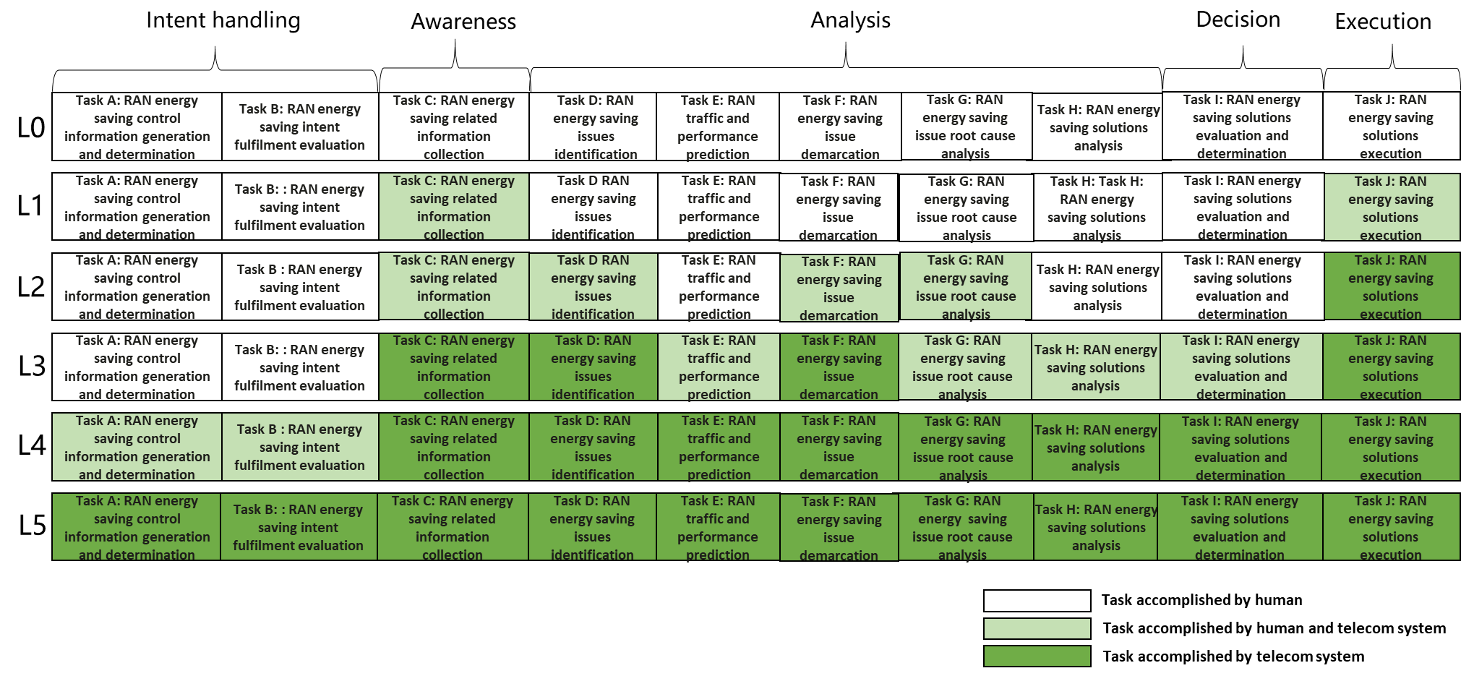
Figure 6.1.2.2-1 Autonomous network level for RAN energy saving scenario
6.1.2 Potential solutions
TBD
End of changes

