**3GPP TSG-SA5 Meeting #143-e *S5-223320***

e-meeting, 9 - 17 May 2022

**Source: China Mobile, Huawei**

**Title: pCR TR 28.909 Add key issues of generic methodology for autonomous network levels evaluation**

**Document for: approval**

**Agenda Item: 6.5.2.1**

# 1 Decision/action requested

***The group is asked to discuss and approval.***

# 2 References

[1] 3GPP draft TR 28.909: “Management and orchestration; Study on evaluation of autonomous network levels v0.1.0”.

# 3 Rationale

This contribution proposes to add key issues for generic methodology for autonomous network levels evaluation based on concept for autonomous network level evaluation in clause 4.1 to reflect which aspects needs to be considered

# 4 Detailed proposal

It proposes to make the following changes to TR 28.909[1].

|  |
| --- |
| **1st Change** |

## 5.2 Key Issue# 2: Generic methodology for autonomous network levels evaluation

*Editor's note: this clause will contain the description and potential solutions of generic methodology for quantitatively evaluating the autonomous network levels (evaluation mechanisms for autonomous network levels).*

### 5.2.1 Description

The purpose of the autonomous network levels evaluation is to provide the guidance to generate the autonomous network level score (ANLS). Based on the dimensions for evaluating autonomous network level specified in TS 28.100[2] , the following aspects need to be considered to support autonomous network level evaluation:

**Consideration-1**: To upgrade the autonomous network levels, autonomy capabilities of the telecom system need to improved to accomplish corresponding tasks completely or partially by itself. It will be easier for the telecom system to accomplish tasks by itself without considering relevant performance assurance than with considering performance assurance if the tasks related actions may cause performance degradation. However, the autonomous network levels upgrading without performance assurance is meaningless and unacceptable for the operators.

Thus, performance assurance is an essential prerequisite for autonomous network level evaluation.

**Consideration-2**: To upgrade the autonomous network to different levels, autonomy capabilities corresponding to different tasks need to be improved. Using the network optimization for example, if operators want to upgrade their telecom system from level 2 to level 3, the corresponding autonomy capability for all the 6 taskstasks (task C to task F, task H and task I) needs to be improved (see figure 5.2.1-1). If the telecom system A improves the autonomy capability for one of the 6 tasks, while telecom system B improves the autonomy capability for one of the other tasks out of the key tasks, the autonomy capability for telecom system A and telecom system B may need to be differentiated according to the improvement on different tasks which may effect or not effect the level upgrading.

Thus, the satisfaction degree for the each key tasks (the task with different autonomy capability between the current autonomous network level (e.g., level 2) and higher autonomous network level (e.g. level 3)) needs to be considered for autonomous network level evaluation.

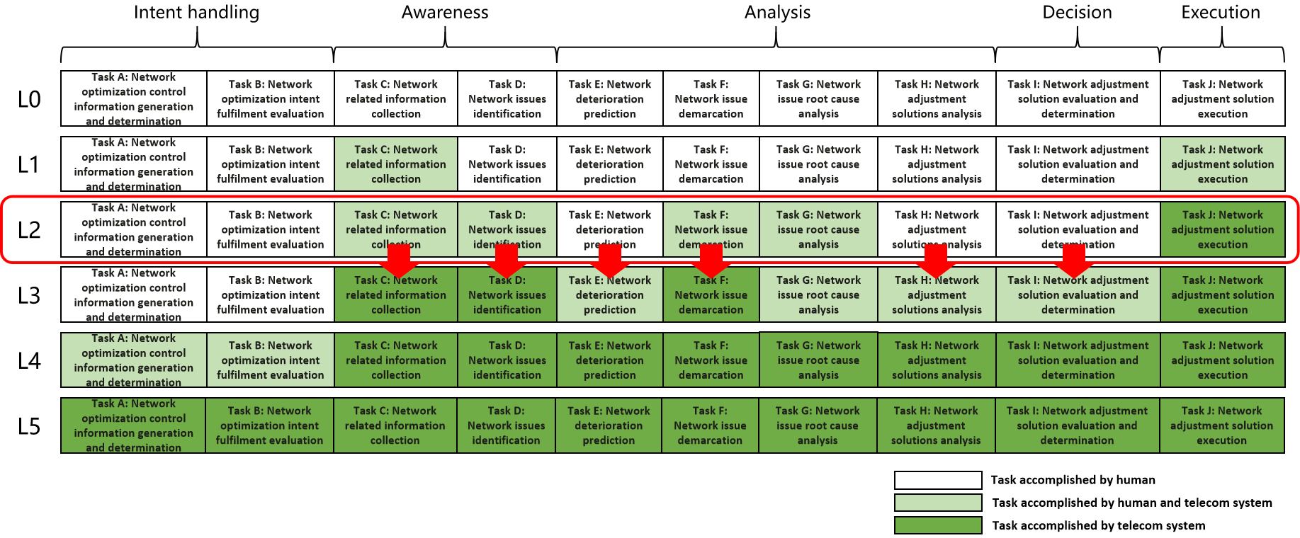

Figure 5.2.1-1 autonomous network level example for network optimization

**Consideration-3**: Different tasks have different implementation difficulty to improve the autonomy capability from one level to a higher level. Using the network optimization for example, if operators want to upgrade their telecom system from level 2 to level 3, the autonomy capability for 6 tasks needs to be improved (see figure 5.2.1-1). Telecom system may take more effort to improve the autonomy capability for certain task (e.g. Task D: Network deterioration prediction) than other task (Task C: Network related information collection), the autonomy capability for telecom system corresponding to different tasks may need to be differentiated.

Thus, the weight of each task (which represents the implementation difficulty for the autonomy capability) for ANLS calculation needs to be considered for autonomous network level evaluation. The detailed value for the weight of each task is implementation dependent, which will not be standardized.

**Consideration-4**: Different telecom systems have different effect by introducing different autonomy capabilities. For example, telecom system A takes 5 days to optimize the radio network and obtain the 10% coverage performance gains, while telecom system B takes one day to optimize the radio network and obtain the 20% coverage performance gains. The autonomy capability for telecom system A and telecom system B may need to be differentiated according to the efforts they spent for the same purpose.

Thus, the KEI (which describes the effective of introducing autonomy capability into telecom system) needs to be considered for autonomous network level evaluation.

**Consideration-5**: Different telecom systems achieve the autonomy capability with different solutions for different scenarios. For example, following telecom system have the different autonomy capability for radio network coverage optimization. In this case, the autonomy capability for different telecom system corresponding to different scenarios may need to be differentiated.

- Telecom system A achieve the autonomous network level 3 of radio network coverage optimization for NR outdoor coverage optimization.

- Telecom system B achieve the autonomous network level 3 of radio network coverage optimization for NR indoor coverage optimization.

- Telecom system C achieve the autonomous network level 3 of radio network coverage optimization for EUTRAN and NR indoor coverage optimization.

Thus, autonomous network level evaluation for a specific scenario and autonomous network level evaluation for multiple scenario or the whole telecom system needs to be considered. The autonomous network level evaluation result (ANLS) for multiple scenario or all scenario is derived from the autonomous network level evaluation result (ANLS) for each scenario.

|  |
| --- |
| **End of Changes** |