3GPP TSG-SA5 Meeting #143e S5-223268

e-meeting, 9-17 May 2022

Source: Huawei

Title: pCR 28.903 adding key issue for package management

Document for: Approval

Agenda Item: 6.5.23.1

1 Decision/action requested
The group is asked to discuss and agree on the proposal.

2 References
[1] 3GPP TS 28.903-010 “Study on alignment with ETSI MEC for Edge computing management”
[2] S5-222551 Collection of Rel-18 3GPP SA5 OAM WoP

3 Rationale
Add key issue for Edge application package management.

4 Detailed proposal
It is proposed to apply following changes in [1].
1st modified section

5 Issue investigations and potential solutions for alignment with ETSI MEC

5.X Key Issue#1: Edge application package management

5.X.1 Description
Edge application package is mainly used for deployment of an edge application, e.g., a EAS instance or MEC application instance. ETSI GS MEC 010-2 [3] provides the application package management procedures with or without use of NFV MANO.

This key issue aims at investigating on potential solutions on alignment with ETSI MEC for EAS application package management.

5.X.2 Potential solutions

5.x.2.1 Potential solution # 1: Edge application package management interface produced by ETSI MEC
There are several ways of application package management procedure introduced in ETSI GS MEC 010-2 [3],
1, Figure 5.x.2.1-1 shows the On-board application package procedure without interaction with ETSI NFV MANO, see clause 5.2.2 in ETSI GS MEC 010-2 [3].
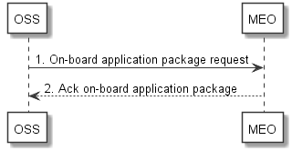
Figure 5.x.2.1-1: On-board application package without interwaction with ETSI NFV MANO

2, Figure 5.x.2.1-2 shows the On-board application package procedure through MEAO to NFVO, see clause 5.6.2 in ETSI GS MEC 010-2 [3].
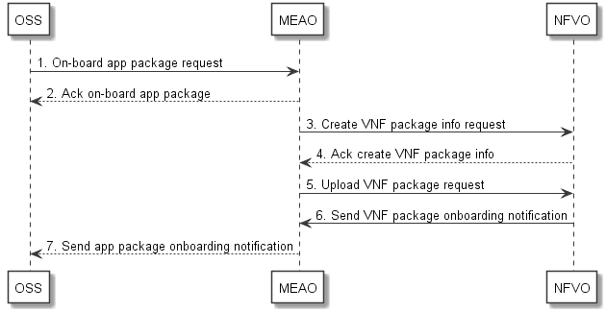
Figure 5.x.2.1-2: On-board application package procedure through MEAO to NFVO

3, Figure 5.x.2.1-3 shows the On-board application package as VNF package to NFVO , see clause 5.6.2 in ETSI GS MEC 010-2 [3].
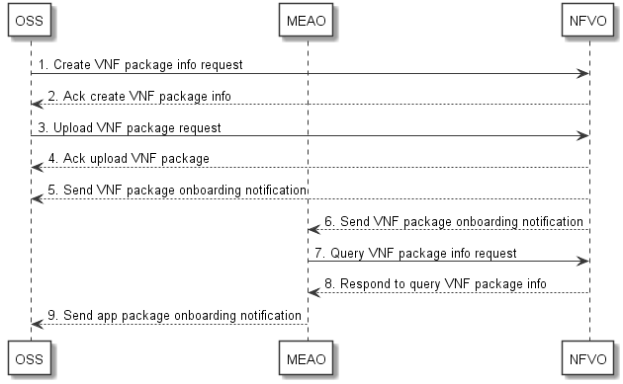
Figure 5.x.2.1-3: On-board application package as VNF package to NFVO

As long as the application package format complies with VNF package as specified in ETSI GS NFV-SOL 004 [x], using the application package management interface produced by ETSI MEC can satisfy the EAS package management requirements either in ETSI MEC system or ETSI NFV MANO system.
End of modification

