**3GPP TSG-SA5 Meeting #143-e *S5-222258rev1***

e-meeting, 9 - 17 May 2022

**Source: Huawei**

**Title: Add concept of service profile and slice profile**

**Document for: Approval**

**Agenda Item: 6.5.4**

# Decision/action requested

This tdoc is for approval.

# 2 Rational

This document is to add the concept of service profile, slice profile, introduce the existing solution of those when create a network slice. This document is also to add the analysis that the use of intent may impact the requirements expressed in service profile.

# 3 Proposed changes

The start of the change

# 4 Concepts and Overview

### 4.1 General

Network slicing is one of the key 5G features. The lifecycle of a Network Slice instance can be described by the following: commissioning, operation and decommissioning. Before a NetworkSlice instance can be created there is a preparation phase. The different phases are described in more detail in TS 28.530 [2].

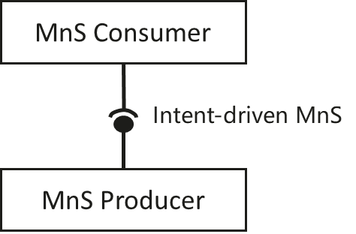

Figure 4.1-1: Intent-driven MnS

In Intent-driven management, the MnS consumer provides its intent to the MnS producer. The producer of an Intent-driven MnS shall allow the consumer to manage the service and / or network resources through the use of intents.

Second change

### 4.x Background information of service profile and slice profile.

As described in TS 28.541-h50 [x], ServiceProfile is described in network slice IOC as one of data types. The ServiceProfile data type represent the properties of the network slice related requirements supported by a NetworkSlice instance. The SliceProfile is described to represent network slice subnet related requirement that should be supported by the NetworkSliceSubnet instance.

CNSliceSubnetProfile, RANSliceSubnetProfile and TopSliceSubnetProfile are the data type as specified in TS 28.541 [x], to present the slice profile that defines the requirements for CN domain, RAN domain and top/root network slice subnet.

As described in TS 28.531 [3], the parameters specified in ServiceProfile in TS 28.541 [x] can be input parameters to request network slice provisioning MnS which provides to allocate a network slice instance.

As described in TS 28.531 [3], the parameters specified in SliceProfile in TS 28.541[x] can input parameters to request network slice subnet provisioning MnS which provides to allocate a network subnet slice instance.

The end of the change