3GPP TSG-SA5 Meeting #143e S5-223256

E-meeting, 9-17 May 2022

Source: Huawei

Title: Add key issue for autonomous network level for 5GC network disaster recovery

Document for: Approval

Agenda Item: 6.5.1.3

1 Decision/action requested
The group is asked to discuss and approval.

2 References
[1] 3GPP draft TR 28.910: “Management and orchestration; Study on enhancement of autonomous network levels v0.1.0”.

3 Rationale
This contribution proposes to add autonomous network level for 5GC network disaster recovery including generic workflow, generic autonomous network level.

4 Detailed proposal
It proposes to make the following changes to TR 28.910 [1].
1st Change

6.X Key Issue# 6-x: Autonomous network level for 5GC network disaster recovery

6.X.1 Description

6.x.1.1 Use case
When a major service interruption disaster occurs (e.g. call disconnected), it is important to quickly recovery the service. One way to recovery the service is to switch the signalling to the backup NFs or to other available NFs. For virtualised 5GC network, the switch may happen within the same data center or ocross different data centers. Currently, the manual-based method requires a long process, including disacter detection, swiching preparation and manual switching which takes a long time. This leads the service recovery time is often very long. So introducing the autonomous network level for 5GC network disaster recovery will benefit for operator to achieve the full autonomy goal step by step and have clear view on which typical issues can be addressed by utilizing autonomy mechanism in corresponding steps. The requirements for each autonomous level for 5GC network disaster recovery are different.

6.X.1.2 Workflow
Following are the entire workflow for 5GC network disaster recovery:
Intent handling:
- Task A: 5GC network disaster recovery goal and policy generation. This task generates the 5GC network disaster recovery related policies, including disacter discovery policy (e.g. monitoring objects and KPI), switching feasibility policy and signalling control policy (e.g, affected objects, data consistency, signalling control configuration parameters)
- Task B: 5GC network disaster recovery intent evaluation, the tasks of evaluating 5GC 5GC network disaster recovery fulfilment information (e.g. satisfied or not).
Awareness:
- Task C: 5GC network information collection, the tasks of collecting the 5GC network information (e.g. PM, FM and virtualised resource information ).
Analysis:
- Task D: 5GC network disaster discovery, based on the collected network information, discovery the disaster event.
- Task E: 5GC network switch for recovery feasibility analysis , the task analysis whether and when switch the signalling to the backup NFs or to other available NFs is possible. Whether the switch is within the same data center or ocross different data centers
Task F: 5GC network switch signalling impact analysis, based on the affected NFs, users and services (e.g. PDU sessions), analysis the signalling impact when switch the signalling to the backup NFs or to other available NFs, and generate the signalling control solutions.
Task G: 5GC network disaster recovery solution analysis, generates the 5GC network disaster recovery solution based on the analysis, including which NFs need to be switched, the order of the switch, signalling control parameter for the new NFs.
Decision:
- Task H: 5GC network disaster recovery solution determination, the tasks of evaluating and determining the 5network disaster recovery solution.
Execution:
- Task I: 5GC network disaster recovery execution , the tasks of executing the 5GC network disaster recovery switch based on the determined solution.

6.X.1.3 Classification of autonomous network level
Level 0:
- All the tasks in the 5GC network disaster recovery workflow (Task A, Task B, Task C, Task D, Task E, Task F, Task G, Task H, Task I) are accomplished by human.
Level 1:
- Telecom system executes tasks of 5GC network disaster recovery based on determined solution (Task I) and tasks of collecting network information (e.g. PM, FM and virtualised resource information ) based on specified rules(Task C).
- All the other tasks in the 5GC network disaster recovery workflow (Task A, Task B, Task D, Task E, Task F, Task G, Task H) are accomplished by human.
Level 2:
- Compared to Level 1, telecom system additionally executes the tasks of collecting 5GC network information (Task C). Telecom system also can execute the tasks of 5GC network disaster discovery and 5GC network switch for recovery feasibility analysis based on pre-defined rules specified by human(Task D and Task E) . The tasks of 5GC network disaster recovery execution (Task I) are fully accomplished by telecom system.
- All the other tasks in the 5GC network disaster recovery workflow (Task A, Task B, Task F, Task G, Task H) are accomplished by human.
Level 3:
- Compared to Level 2, the telecom system additionally executes tasks of 5GC network switch signalling impact analysis and 5GC network disaster recovery solution analysis based on policies specified by human (Task F and Task G). Telecom system also can executes tasks of (Task H). The tasks of 5GC network information collection (Task C), 5GC network switch for recovery feasibility analysis (Task D) and 5GC network switch for recovery feasibility analysis (Task E) are fully accomplished by telecom system.
- All the other tasks in the 5GC network disaster recovery workflow (Task A, Task B) are accomplished by human.
Level 4:
- Compared to Level 3, the telecom system can additionally execute the tasks of 5GC network disaster recovery goal and policy generation generation (Task A) and 5GC network disaster recovery intent evaluation (Task B) based on intent handling policies specified by human. The tasks of 5GC network switch signalling impact analysis (Task F), 5GC network disaster recovery solution analysis (Task G) and 5GC network disaster recovery solution determination (Task H) are fully accomplished by telecom system.
- The intent handling policies maybe pre-defined and specified by human.
Level 5:
- Telecom system can autonomously execute the entire workflow of 5GC network disaster recovery for all scenarios,

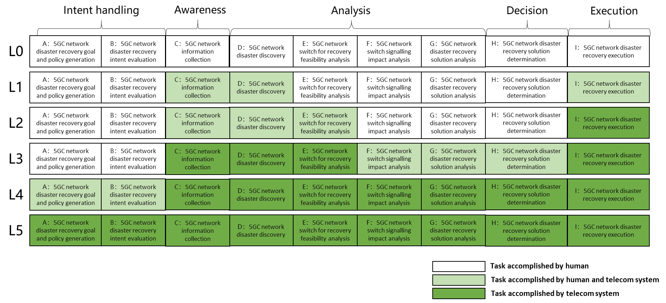
Figure 6.X.1.3-1 Classification of autonomous network level for 5GC network disaster recovery

6.x.2 Potential solutions
TBD

End of changes

