3GPP TSG-SA5 Meeting #143e S5-223255

E-meeting, 9-17 May 2022

Source: Huawei

Title: Add key issue for autonomous network level for 5GC NF deployment

Document for: Approval

Agenda Item: 6.5.1.3

1 Decision/action requested
The group is asked to discuss and approval.

2 References
[1] 3GPP draft TR 28.910: “Management and orchestration; Study on enhancement of autonomous network levels v0.1.0”.

3 Rationale
This contribution proposes to add generic autonomous network level for 5GC NF deployment including generic workflow, generic autonomous network level, generic requirements and possible solutions.

4 Detailed proposal
It proposes to make the following changes to TR 28.910 [1].
1st Change

6.X Key Issue# 6-x: Autonomous network level for 5GC NF deployment

6.X.1 Description
5GC NF deployment use case refers to the entire workflow of deploying a 5GC NF, full autonomy of 5GC NF deployment can help the network operator to reduce OPEX by reducing manual involvement in such tasks. However, full autonomy of 5GC NF deployment is a long term goal, it will be beneficial for operator to achieve this goal step by step and have clear view on which typical issues can be addressed by utilizing network autonomy mechanisms in corresponding steps. The requirements for each autonomous level for 5GC NF deployment are different.

.Potet6.X.21.1 Generic workflow
Follwing are the entire workflow for 5GC NF deployment:
Intent handling:
- Task A: 5GC NF deployment policy generation based on received 5GC NF deployment intent （e.g. type of the 5GC NF, capability of the 5GC NF）. The tasks of generating and determining the 5GC NF deployment related policies (e.g. 5GC NF configuration data generation policies, dialing test policies and 5GC NF virtualised resource feasibility polices).
- Task B: 5GC NF deployment intent evaluation, the tasks of evaluating 5GC NF deployment fulfilment information (e.g. satisfied or not).
Awareness:
- Task C: 5GC NF information collection, this task includes collecting the network environment data before deployment of 5GC NF information and collecting the 5GC NF and related network data when the 5GC NF is deployed (e.g. PM, FM and virtualised resource information).
Analysis:
- Task D: 5GC NF deployment data analysis, the tasks of analysing and generating the recommended configuration data and required virtualised resource information (e.g. VNFD, flavour ID) for deployment of the 5GC NF.
- Task E: 5GC NF virtualised resource feasibility check analysis, the tasks of analysing there is enough virtualised resource is available for deployment of the 5GC NF.
Task F: 5GC NF commissioning test and dialing test, the tasks of performing the 5GC NF commissioning test and dialing test before putting 5GC NF into service (e.g. ensure the configuration and network connection (including 5GC NF configuration and transport network configuration) is correct).
Decision:
- Task G: 5GC NF configuration data and virtualised resource information determination, the tasks of evaluating and determining the 5GC configuration data and virtualised resource information (e.g. VNF package) to be used for deploying the 5GC NF.
Execution:
- Task H: 5GC NF deployment, the tasks of deploying the 5GC NF based on determined VNF package, flavour ID and configuring theation data C NF determined data.

6.X.1.2 eneric autonomous network level
Level 0:
- All the tasks in the 5GC NF deployment workflow (Task A, Task B, Task C, Task D, Task E, Task F, Task G, Task H) are accomplished by human.
Level 1:
- Telecom system executes tasks of deploying the 5GC NF based on onboarded VNF package and activating configuration data prepared by human (Task H) and tasks of collecting part of 5GC NF information (inlcuding virtualised resource information) based on specified rules(Task C).
- All the other tasks in the 5GC NF deployment workflow (Task A, Task B, Task D, Task E, Task F, Task G) are accomplished by human.
Level 2:
- Compared to Level 1, telecom system additionally executes the tasks of collecting 5GC information (inlcuding virtualised resource information) (Task C). Telecom system also can execute the tasks of analysing the deployment data for the 5GC based on the network function generation rules (e.g. configuration template) specified by human (Task D). The tasks of 5GC NF deployment (Task H) are fully accomplished by telecom system.
- All the other tasks in the 5GC NF deployment workflow (Task A, Task B, Task E, Task F, Task G) are accomplished by human.
Level 3:
- Compared to Level 2, the telecom system additionally executes tasks of analysing and determining the deployment data for the 5GC NF based on the network configuration data generation policies specified by human (Task D). Telecom system also can executes tasks of performing 5GC virtualised resource feasibility check and commissioning/dialing test by human (Task E and Task F). The tasks of 5GC NF information collection (Task C) are fully accomplished by telecom system.
- All the other tasks in the5GC deployment workflow (Task A, Task B) are accomplished by human.
Level 4:
- Compared to Level 3, the telecom system can additionally execute the tasks of 5GC NF deployment policy generation (Task A) and 5GC NF deployment intent evaluation (Task B) based on intent handling policies specified by human. The tasks of 5GC deployment data analysis (Task D), 5GC virtualised resource feasibility check (Task E), 5GC NF commissioning and dialing test (Task F), 5GC NF configuration data and virtualised resource information determination (Task G) are fully accomplished by telecom system.
- The intent handling policies maybe pre-defined and specified by human.
Level 5:
- Telecom system can autonomously execute the entire workflow of 5GC NF deployment for all scenarios,

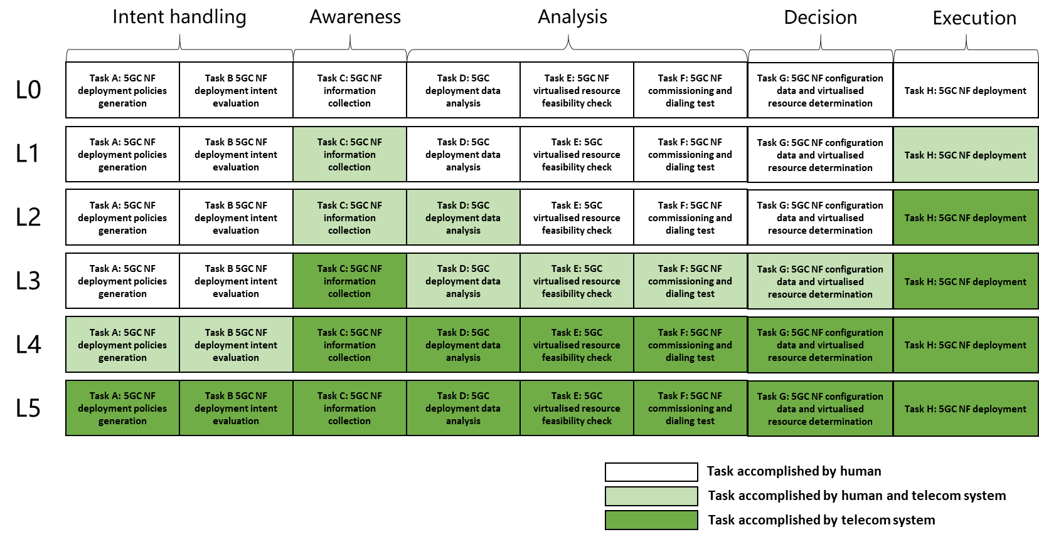
Figure 6.X.2.2-1 Classification of autonomous network level for 5GC NF deployment

6.X.1.3 eneric autonomoy capability description for management system
Level _1 for 5GC NF deployment: The 3GPP management system has the following autonomy capabilities:
- Configure 5GC NF with the specified 5GC configuration data
- Request deploying 5GC NF based on the VNF package
- Collect 5GC NF information based on the specified 5GC information collection rule

Level _2 for 5GC NF deployment: The 3GPP management system has the following autonomy capabilities:
- Analyse the deployment data for the 5GC NF based on the specified network function generation rules

Level _3 for 5GC NF deployment: The 3GPP management system has the following autonomy capabilities:
- Analyse and determine the deployment data for the 5GC NF based on the specified network function generation policies.
- Perform the 5GC NF commissioning and dialing test based on specified test policies.
- Perform the 5GC NF virtualised resource feasibility test based on specified virtualised resource feasibility test policies.

Level _4 for 5GC NF deployment: The 3GPP management system has the following autonomy capabilities:
- Determine or update 5GC deployment policies according to 5GC deployment intent based on specified intent translation policies.
- Evaluate 5GC deployment intent fulfilment result based on specified intent evaluation control information.

Level _5 for 5GC NF deployment: The 3GPP management system has the following autonomy capabilities:
- Generate the 5GC NF deployment intent translation and evaluation control information.

End of changes

