**3GPP TSG-SA5 Meeting #143-e *S5-223074***

e-meeting, 9 - 17 May 2022

|  |  |  |  |  |  |  |  |  |
| --- | --- | --- | --- | --- | --- | --- | --- | --- |
| *CR-Form-v12.1* | | | | | | | | |
| **CHANGE REQUEST** | | | | | | | | |
|  | | | | | | | | |
|  |  | **CR** |  | **rev** | **1** | **Current version:** |  |  |
|  | | | | | | | | |
| *For* [***HELP***](http://www.3gpp.org/3G_Specs/CRs.htm#_blank)*on using this form: comprehensive instructions can be found at* [*http://www.3gpp.org/Change-Requests*](http://www.3gpp.org/Change-Requests)*.* | | | | | | | | |
|  | | | | | | | | |

|  |  |  |  |  |  |  |  |  |
| --- | --- | --- | --- | --- | --- | --- | --- | --- |
| ***Proposed change affects:*** | UICC apps |  | ME |  | Radio Access Network | **x** | Core Network | **x** |

|  |  |  |  |  |  |  |  |  |  |  |
| --- | --- | --- | --- | --- | --- | --- | --- | --- | --- | --- |
|  | | | | | | | | | | |
| ***Title:*** |  | | | | | | | | | |
|  |  | | | | | | | | | |
| ***Source to WG:*** | Nokia, Nokia Shanghai Bell | | | | | | | | | |
| ***Source to TSG:*** | S5 | | | | | | | | | |
|  |  | | | | | | | | | |
| ***Work item code:*** | eNETSLICE_PRO | | | | |  | ***Date:*** | | | 2022-04-26 |
|  |  | | | |  | |  | | |  |
| ***Category:*** | **B** |  | | | | | ***Release:*** | | | Rel-17 |
|  | *Use one of the following categories:* ***F*** *(correction)* ***A*** *(mirror corresponding to a change in an earlier release)* ***B*** *(addition of feature),* ***C*** *(functional modification of feature)* ***D*** *(editorial modification)*  Detailed explanations of the above categories can be found in 3GPP [TR 21.900](http://www.3gpp.org/ftp/Specs/html-info/21900.htm). | | | | | | | | *Use one of the following releases: Rel-8 (Release 8) Rel-9 (Release 9) Rel-10 (Release 10) Rel-11 (Release 11) … Rel-15 (Release 15) Rel-16 (Release 16) Rel-17 (Release 17) Rel-18 (Release 18)* | |
|  |  | | | | | | | | | |
| ***Reason for change:*** | | The procedure of reservation and checking feasibility of network slice defined in Section 7.13 in TS 28.531 is not detailed and missing some important steps. | | | | | | | | |
|  | |  | | | | | | | | |
| ***Summary of change:*** | | Update the procedure of reservation and checking feasibility of network slice | | | | | | | | |
|  | |  | | | | | | | | |
| ***Consequences if not approved:*** | | Network Slice reservation procedure is not clear in the current 7.13 procedure and hence it can not be implemented in a uniform way across the consumers/producers of different vendors. | | | | | | | | |
|  | |  | | | | | | | | |
| ***Clauses affected:*** | | 5.1.6, 7.13 | | | | | | | | |
|  | |  | | | | | | | | |
|  | | **Y** | **N** |  | | | |  | | |
| ***Other specs*** | |  | **X** | Other core specifications | | | | TS/TR ... CR ... | | |
| ***affected:*** | |  | **x** | Test specifications | | | | TS/TR ... CR ... | | |
| ***(show related CRs)*** | |  | **x** | O&M Specifications | | | | TS/TR ... CR ... | | |
|  | |  | | | | | | | | |
| ***Other comments:*** | | 1. This CR refers to FeasibilityCheckAndReservation IOC and its attributes introduced by #142e tDoc # S5-222724 | | | | | | | | |
|  | |  | | | | | | | | |
| ***This CR's revision history:*** | | 1. Correction to Step#1 in clause 7.13, ‘network slice subnet related requirements’ corrected to ‘network slice related requirements’. | | | | | | | | |

|  |
| --- |
| **1st Change** |

### 5.1.6 Network slice feasibility check

| Use case stage | Evolution/Specification | <<Uses>> Related use |
| --- | --- | --- |
| **Goal** | To check the feasibility of provisioning a network slice to determine whether the network slice requirements can be satisfied at a particular point in time (e.g., in terms of resources), and optionally reserve resources to satisfy the network slice requirements. |  |
| **Actors and Roles** | Network slice management service consumer. For example, CSP providing NSaaS plays the role of network slice management service consumer. |  |
| **Telecom resources** | Network slice management service provider. |  |
| **Assumptions** | Network slice management service consumer has decided to check the feasibility of provisioning a network slice based on, for example, internal decision or to facilitate an external service requests.  Network slice management service consumer has optionally decided to request reservation of the resources to satisfy the network slice requirements. |  |
| **Pre-conditions** | Network slice requirements have been derived or received by network slice management service consumer. |  |
| **Begins when** | Network slice management service provider receives the request to evaluate the feasibility of provisioning a network slice and optionally reserve resources, according to the network slice requirements at a particular point in time. |  |
| **Step 1 (M)** | Network slice management service provider identifies the network slice subnets according to the requirements. |  |
| **Step 2 (M)** | Network slice management service provider obtains the information necessary to evaluate the feasibility of provisioning a network slice by requesting the network slice subnet service provider(s) to evaluate the availability of resources under their contol.  If the Network slice management service consumer has requested reservation of resources, then Network slice management service provider requests network slice subnet service provider(s) to reserve resources. |  |
| **Step 3 (M)** | Network slice subnet management service provider(s) checks the feasibility of provisioning a slice subnet(s) by analysing network constituents to ensure that their capabilities, e.g., resources, management services, etc. are (or will be) adequate to provision network slice instance, satisfying all requirements without impacting existing services. For the purpose of checking the feasibility of provisioning a network slice subnet(s) of the network slice, network slice subnet management service provider(s) may obtain information from the network (e.g., current or predicted load level information from the NWDAF).  If the Network slice management service provider has requested reservation of resources, then Network slice subnet management service provider(s) reserves the resrources necessary to provision the network slice instance. | 5.1.21 Network slice subnet feasibility check |
| **Ends when** | Feasibility check results have been provided to network slice management service consumer.  If the Network slice management service consumer has requested reservation of resources, then resources to satisfy the network slice requirements are reserved. |  |
| **Exceptions** | One of the mandatory steps fails. |  |
| **Post-conditions** | N/A |  |
| **Traceability** | REQ-PRO_NSSI-FUN-12, REQ-PRO_NSSI-FUN-13, REQ-PRO_NSI-FUN-8. |  |

|  |
| --- |
| **2nd Change** |

## 7.13 Procedure of reservation and checking feasibility of NSI

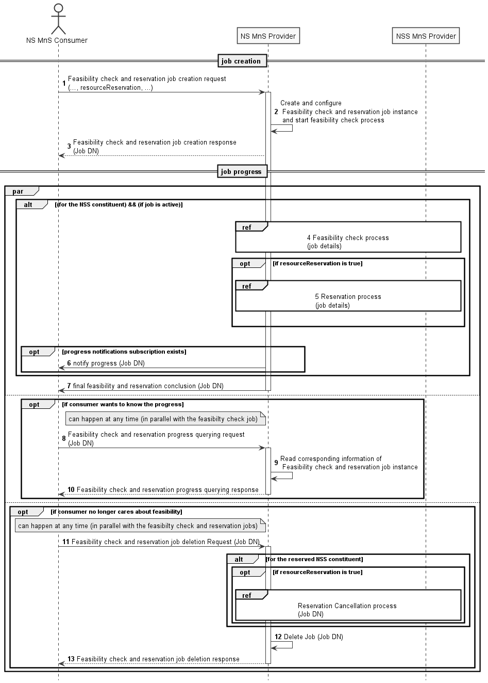

Figure 7.13-1 Network slice feasibility check procedure

1) Network Slice Management Service Provider (NS MnS Provider) receives a feasibility check with or without reservation job creation request (see createMOI operation defined in TS 28.532 [8]) from Network Slice Management Service Consumer (NS MnS Consumer) with feasibility check and reservation requirements (see FeasibilityCheckAndReservationJob IOC defined in TS 28.541 [6]). The request is to check whether the network slice related requirements (i.e., ServiceProfile) can be satisfied and optionally be requested to be reserved. The resourceReservation attribute in the request may indicate whether reservation is also requested or not.

2) NS MnS Provider creates the FeasibilityCheckAndReservationJob instance and configures the attribute "ServiceProfile" and other attributes received from the request and NS MnS Provider starts the executing the feasibility check process.

3) NS MnS Provider sends the feasibility check and reservation job creation response with the FeasibilityCheckAndReservation job DN (see createMOI operation defined in TS 28.532 [8]) to NS MnS Consumer.

4) NS MnS Provider performs feasibility check locally on whether the resources are available.

NS MnS Provider may invoke the feasibility check and reservation procedure for the constituent network slice subnet as described in clause 7.14

5) NS MnS Provider performs resource reservation process when resourceReservation is True and feasibilityCheckResult is feasible.

6) The NS MnS Consumer may subscribe for the attribute value change notifications for this specific Job DN or for any of the job(s) created by it to receive any asynchronous job progress notifications for those Job(s). NS MnS Provider then sends the asynchronous job progress notification for feasibility check and reservation process.

7) NS MnS Provider sends the final notification with the feasibility check and reservation status.

8-10) Once after step 3, NS MnS Consumer can query NS MnS Provider any time, to know the feasibility check and reservation job status and receive the feasibility check and reservation job status.

11-13) NS MnS consumer can request to delete the feasibility check and reservation job any time and the NS MnS Provider deletes the Job and sends the Job deletion response. NS MnS Provider will cancel the resource reservation when the feasibility check and reservation job is deleted.

|  |
| --- |
| **End of change** |