**3GPP TSG-SA5 Meeting #142e *S5-222755d1***

**e-meeting, 04 - 12 Apr. 2022 Revision of 222346**

**Source: CMCC，Lenovo, Motorola Mobility**

**Title: pCR - 28.819 Proposed overall process**

**Document for: Approval,**

**Agenda Item: 6.5.14**

# 1 Decision/action requested

***The group is asked to discuss and approve.***

# 2 References

[1] 3GPP SA5 TR 28.819 v0.5.0(2022-02):" Technical Specification Group Services and System Aspects; Management and Orchestration; Study on continuous integration continuous delivery support for 3GPP NFs"

# 3 Rationale

Add process based on the scenarios and solutions approved.

# 4 Detailed proposal

It proposes to make the following changes to TR 28.819[1].

Start of changes

# 7. Proposed Process for Multi-Vendor CI-CD

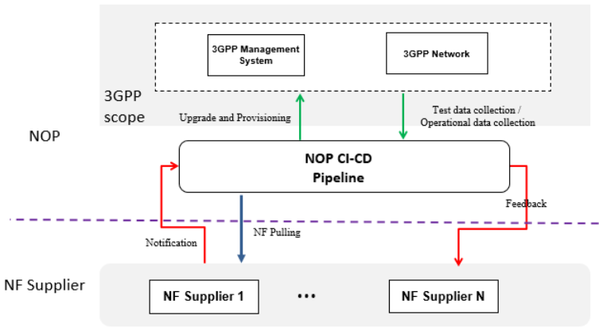

Figure 7.1 High level NF CICD process

The above figure describes the high level NF CICD process between NOP and the NF supplier. There may include the following stages and process:

-The new NF software is notified from the NF supplier to the NOP.

- The NOP CI-CD Pipeline pulls the new NF software.

-The NOP CI-CD Pipeline informs 3GPP management system to do upgrade and provisioning.

-The 3GPP system executes the upgrade and provisioning.

- The NOP CI-CD Pipeline subscribes CICD related data which can be monitored and collected by the 3GPP management system.

- The NOP CI-CD Pipeline gives a feedback to NF supplier about the result of NF software upgrade and provisioning after necessary data handling.

In above high level processes, only upgrade and provisioning, monitoring and data collection (two green lines) processes have requirements and related potential normative works to 3GPP system.

End of changes