**3GPP TSG-SA5 Meeting #142-e *S5-222464***

**e-meeting, 4 - 12 April 2022**

**Source: Huawei**

**Title: pCR TR 28.908 Add Key Issue of Model deployment for MDA**

**Document for: Approval**

**Agenda Item: 6.5.5**

# 1 Decision/action requested

***In this box give a very clear / short /concise statement of what is wanted.***

# References

[1] SP-211443 New Study on AI/ ML management

[2] 3GPP TS 28.104 Management and orchestration; Management Data Analytics (MDA)

[3] 3GPP TS 28.105 Management and orchestration; Artificial Intelligence / Machine Learning (AI/ML) management

[4] 3GPP TR 28.908 Study on Artificial Intelligence / Machine Learning (AI/ML) management

# 3 Rationale

The approved new SI [1] proposed to study the AI/ML management capabilities and management services to support/coordinate AI/ML in 5GS (3GPP management system, 5GC and NG-RAN). One of the AI/ML management capabilities is the deployment of AI/ML model, and Management Data Analytics (MDA) [2] is a typical AI/ML-enabled functions in 3GPP management system. This contribution proposes to add a key issue of model deployment for MDA.

# 4 Detailed proposal

It is proposed to add the following chapter in TR 28.908 [4].

|  |
| --- |
| **1st modified section** |

## X.Y Key Issue #XX: Model deployment for MDA

### X.Y.1 Description

Management Data Analytics (MDA), as a key enabler of automation and intelligence, is considered a foundational capability for mobile networks and services management and orchestration. The MDA provides a capability of processing and analysing data related to network and service events and status. There is a possibility for MDA to be used in conjunction with AI/ML technologies. That is to say, the MDA can utilize historical management data and AI/ML model to generate analysis result as illustrated in Figure X.Y.1-1.

This key issue studies how the AI/ML model is deployed to support MDA.

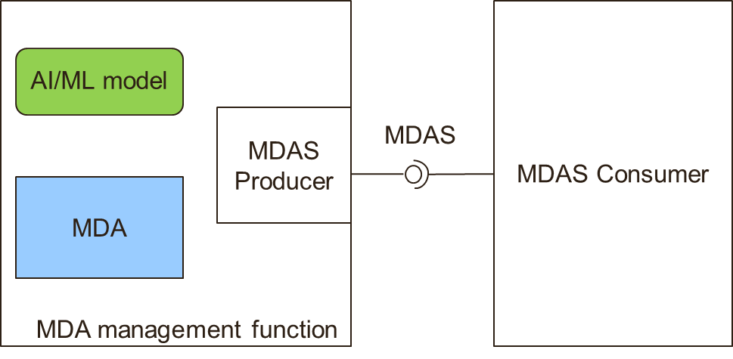

**Figure X.Y.1-1: MDA with AI/ML utilization**

|  |
| --- |
| **End of modified section** |