**3GPP TSG-SA5 Meeting #142-e *S5-222354***

**e-meeting, 4 - 12 April** **2022**

**Source: Huawei**

**Title: pCR TR 28.925 Add issue on the applicable content from TS 32.101 section 7**

**Document for: Approval**

**Agenda Item: 6.5.8**

# 1 Decision/action requested

***Discuss and approve on the proposal.***

# 2 References

[1] 3GPP TR 28.925 enhancement of service based management architecture v0.4.0

# 3 Rationale

There are descriptions on management functions in TS 32.101. Some of the management functions are still valid in SBMA and there are also some enhanced features provided in SBMA. Some analysis needs to be done to check whether the content in section 7 of TS 32.101 could be applicable to service based archietecture. It’s useful to have an overall description on the management features which can be supported by SBMA with the similar approach as in TS 32.101.

It is proposed to add solutions to add a issue in TR 28.925 [1].

=====================Extract from TS 32.101 start=====================

## 7.1 TM architectural aspects

The basic aspects of a TM architecture, which can be, considered when planning and designing a TM are:

- the functional architecture;

- the information architecture;

- the physical architecture.

The management requirements from the business needs are the base for the functional architecture, which describe the functions that have to be achieved. The information architecture defines what information that has to be provided so the functions defined in the functional architecture can be achieved. The physical architecture has to meet both the functional architecture and the information architectures. These relationships are shown in figure 5.

The present document addresses the functional architecture. The physical architecture is addressed in TS 32.102 [101].



Figure 4: Architectural relationship

Allmanagement processes have functions in several management areas. By identifying only those processes and interfaces relating to a certain management function, for example performance management, it is possible to take a slice through the Enhanced Telecom Operations Map that details the functional architecture for performance management, this will be the approach taken by the present document.

The management functions are:

- Performance management;

- Roaming management;

- Fraud management;

- Fault management;

- Security management;

- Software management

- Configuration management;

- Accounting management;

- Subscription management;

- Quality of Service (QoS) management (see informative annex D);

- User equipment management.

The 3GPP IRP methodology focuses on providing the definitions for the O&M operations and notifications needed to support the business requirements provided by the eTOM framework for such management functions.

=====================Extract from TS 32.101 end=====================

# 4 Detailed proposal

This document proposes the following changes in TR 28.925 [1].

|  |
| --- |
| **1st Change** |

## 4.x Issue #X:

### 4.x.1 Description

The following information is documented in TS 32.101 to describe the TMN architecture aspects and the management functions.

### 

Analysis:

1. TS 32.101 defines the management principles and high-level requirements for the management of PLMNs. The descriptions in clause 7 of this TS which can be improved and applies for SBMA.

|  |  |
| --- | --- |
| Sections | Analysis |
| 7.1 TM architectural aspects | The concept is generally applicable, SBMA concept should be integrated with the TM architectural aspects. |
| 7.2 Performance Management | The overview and Standardisation objectives are generally applicable with some improvement on the text to adjust with SBMA. |
| 7.3 Roaming management overview | The concept is applicable and can be reused. |
| 7.4 Fraud management overview | The concept is applicable and can be reused. |
| 7.5 Fault Management | The overview and Standardisation objectives are generally applicable with some improvement on the text to adjust with SBMA. |
| 7.6 Security Management | The overview are generally applicable with some improvement on the text to adjust with SBMA. |
| 7.7 Software Management | The concepts are generally applicable with some improvement on the text to adjust with SBMA. |
| 7.8 Configuration Management | The concepts are generally applicable with some improvement on the text to adjust with SBMA. |
| 7.9 Accounting Management | CH related, need to be checked with CH group. |
| 7.10 Subscription Management | The concepts are generally applicable with some improvement on the text to adjust with SBMA. |
| 7.11 Subscriber and Equipment Trace Management | The concepts are generally applicable with some improvement on the text to adjust with SBMA. |
| 7.12 OAM&P of the PLMN "Management Infrastructure" | The concepts are generally applicable with some improvement on the text to adjust with SBMA. |
| 7.13 Service Level Trace Management | The concepts are generally applicable with some improvement on the text to adjust with SBMA. |
| 7.14 Management of QoE measurement collection | The concepts are generally applicable with some improvement on the text to adjust with SBMA. |

2. The following management features are captured in annex of TS 28.533, as follows.

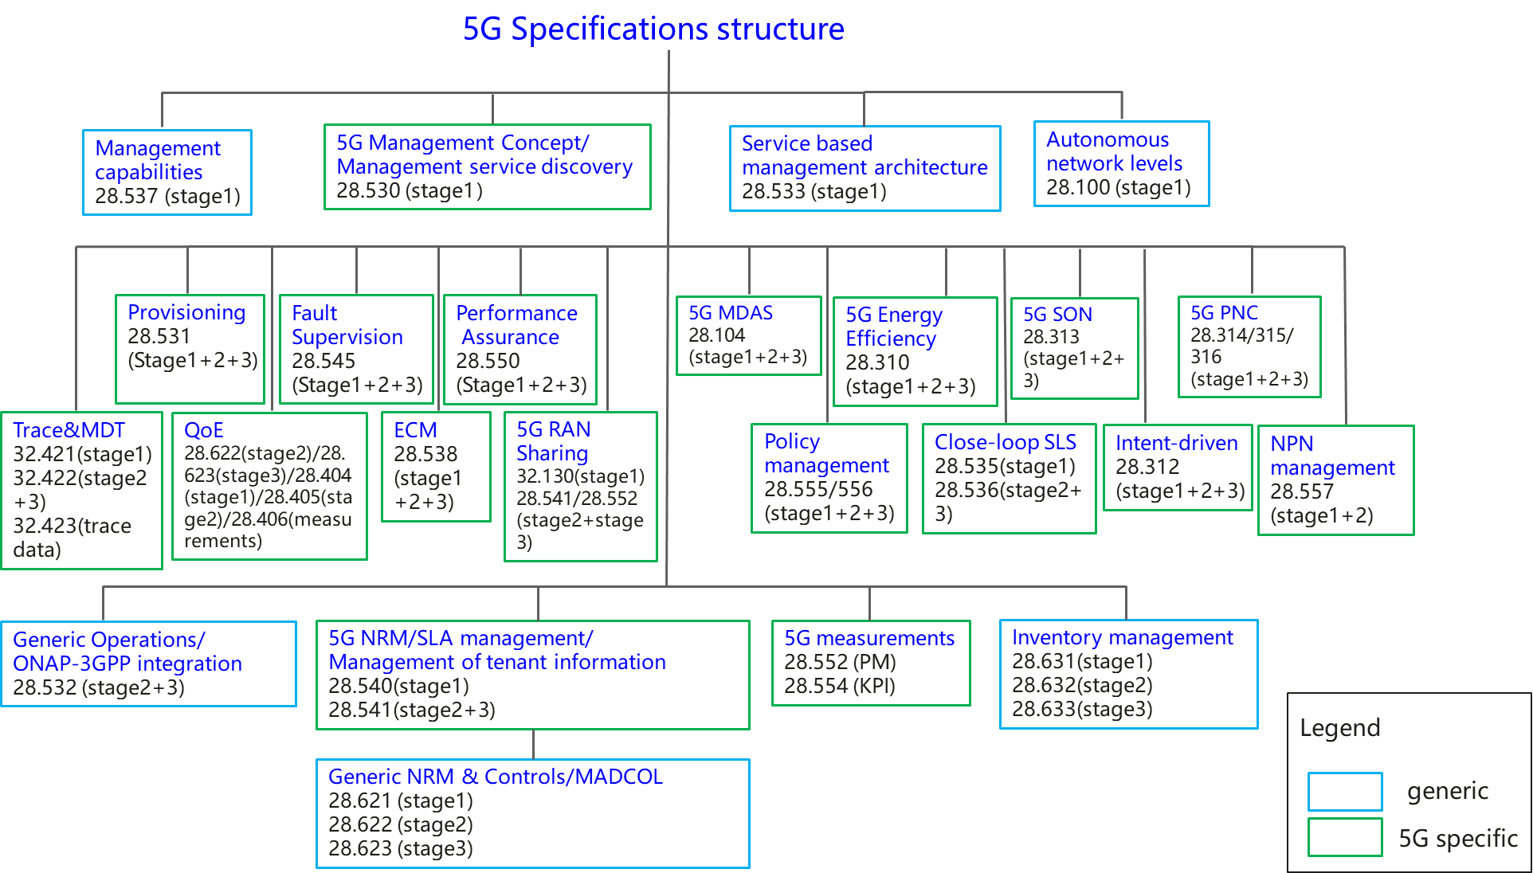

**Figure x: Overview of 5G management specifications**

In the above figure, some features are generic management features which are applied to management of different network technologies, and some features are 5G specific management features which apply for management of 5G network only.

* For the generic management features, some functional overviews of each management feature are already captured in clause 7 of TS 32.101[3], some improvement are needed to adjust with SBMA and captured in TS 28.533[2].
* For 5G specific management features, the high-level functional overviews of each management feature should be added in TS 28.533[2].

### 4.x.2 Potential solutions

TS 28.533 should be extended to include the functional overviews of the management features.

Introduce new section to describe management features.

* Add 5G specific management features defined in 3GPP TS 28.533 [2]
* Add generic management features description using inputs from TS 32.101[3]

|  |
| --- |
| **End of change** |