**3GPP TSG-SA5 Meeting #142-e *S5-222196rev1***

**e-meeting, 4 - 12 April 2022**

**Source: MATRIXX Software**

**Title: pCR TR 28.827 Add** **CHF to CHF solution for SMS in 7.2**

**Document for: Agreement**

**Agenda Item: 7.5.3**

# 1 Decision/action requested

**This pCR is to introduce CHF to CHF solution for SMS in 7.2**

# 2 References

[1] 3GPP TR 28.827 "Study on 5G charging for additional roaming scenarios and actors"

# 3 Rationale

This pCR is to introduce CHF to CHF solution for SMS in 7.2

# 4 Detailed proposal

The following changes are proposed to be incorporated into TR 28.827 [1]

|  |
| --- |
| **First change** |

#### 7.2.4.x Solution #2.x: V-CHF communicating with H-CHF for retail charging of SMS

##### 7.2.4.x.1 General

A possible solution for key issues #2x and #2y, retail charging for SMS provided to the home MNO’s users by the visited MNO, in roaming scenario.

The visited CHF performs converged charging for interconnect, while the home CHF performs converged charging for the subscriber.

##### 7.2.4.x.2 Reference architecture

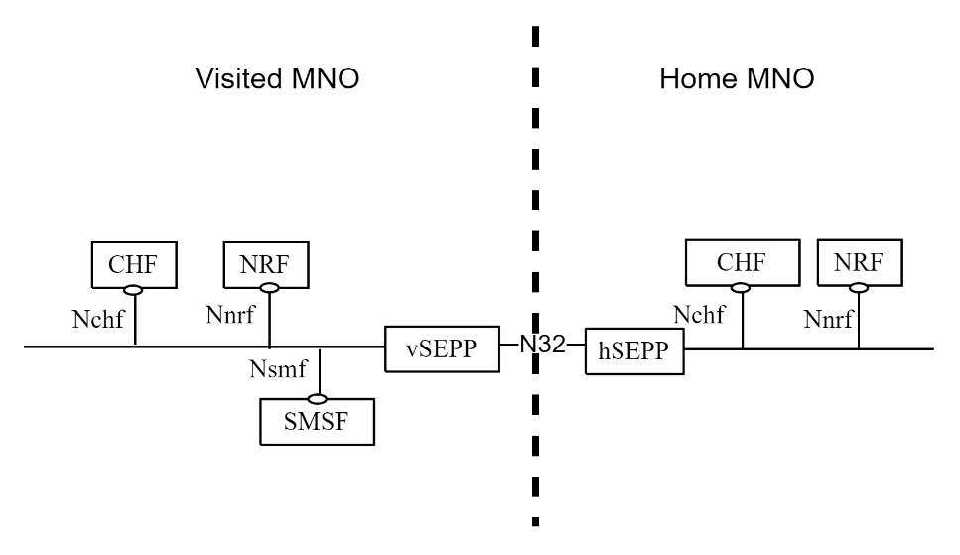

Figure 7.2.4.x.2-1: Roaming SMS in service-based interface representation

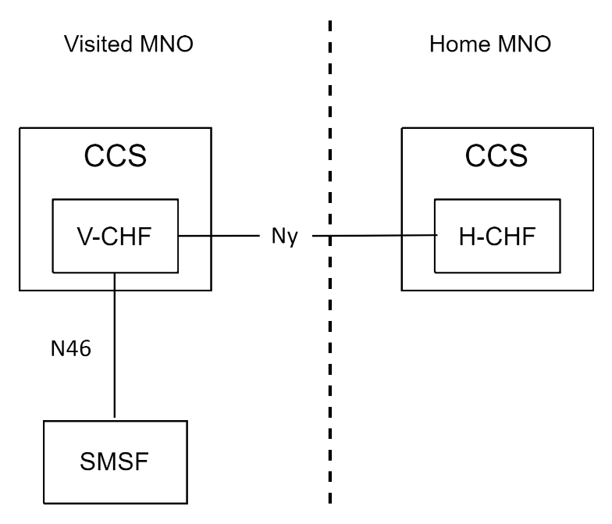

Figure 7.2.4.x.2-2: Roaming SMS in reference point representation

|  |
| --- |
| **Next change** |

##### 7.2.4.x.3 Message flows

Figure 7.2.4.x.3-1 shows a scenario for SMS PEC with CHF to CHF communication.



Figure 7.2.4.x.3-1: Roaming PEC SMS - two CHFs communication

1- 3. Initial procedures as per clause 5.4.2.5 of TS 32.274 [x].

4. The SMSF in VPLMN sends Charging Data Request [Event] to V-CHF in VPLMN for the SMS.

5. The V-CHF determines the interaction with H-CHF is needed and which H-CHF to contact.

6. The V-CHF sends Charging Data Request [Event] to H-CHF for the SMS.

7. The H-CHF creates a CDR for this SMS.

8. The H-CHF acknowledges by sending Charging Data Response [Event] to the V-CHF.

9. The V-CHF creates a CDR for this SMS.

10. The V-CHF acknowledges by sending Charging Data Response[Event] to the SMSF in VPLMN.

11. Forward SMS as per clause 5.4.2.5 of TS 32.274 [x].

|  |
| --- |
| **End of changes** |