**3GPP TSG-SA5 Meeting #142-eS5-222135**

**e-meeting, 04 - 12 April 2022**

**Source: Ericsson, Deutsche Telekom**

**Title: Add procedure for consumption of exposed MnS after service order completed**

**Document for: Approval**

**Agenda Item: 6.5.22**

# 1 Decision/action requested

***The group is asked to agree the detailed propsal.***

# 2 References

[1] 3GPP [TS 28.533](https://www.3gpp.org/DynaReport/28533.htm) Management and orchestration; Architecture framework

[2] 3GPP [TS 23.501](https://www.3gpp.org/DynaReport/23501.htm) System architecture for the 5G System (5GS)

[3] 3GPP [TS 23.502](https://www.3gpp.org/DynaReport/23502.htm) Procedures for the 5G System (5GS)

[4] 3GPP [TS 23.222](https://www.3gpp.org/DynaReport/23222.htm) Common API Framework for 3GPP Northbound APIs

[5] 3GPP [TS 23.434](https://www.3gpp.org/DynaReport/23434.htm) Service Enabler Architecture Layer for Verticals (SEAL); Functional architecture and information flows

[6] 3GPP [TS 33.122](https://www.3gpp.org/DynaReport/33122.htm) Security aspects of Common API Framework (CAPIF) for 3GPP northbound APIs

[7] 3GPP [TS 33.501](https://www.3gpp.org/dynareport/33501.htm) Security architecture and procedures for 5G System

[8] 3GPP [TS 28.530](https://www.3gpp.org/DynaReport/28530.htm) Management and orchestration; Concepts, use cases and requirements

[9] 3GPP TS 28.541

# 3 Rationale

The procedures described in clause 4.1.4 show the interaction between an NSC and an NSP when NSC orders a product/service and the NSP accepts and completes the order. After the product order and service order have been completed, the ordered service may be consumed by the NSC using the CAPIF (Common API Framework).

There is no description in the study what happens after the service order is completed nor how CAPIF may be used.

It is proposed to add a concept description in clause 4 and a solution description in clause 7.

# 4 Detailed proposal

***1st Change***

# 2 References

The following documents contain provisions which, through reference in this text, constitute provisions of the present document.

- References are either specific (identified by date of publication, edition number, version number, etc.) or non‑specific.

- For a specific reference, subsequent revisions do not apply.

- For a non-specific reference, the latest version applies. In the case of a reference to a 3GPP document (including a GSM document), a non-specific reference implicitly refers to the latest version of that document *in the same Release as the present document*.

[1] 3GPP TR 21.905: "Vocabulary for 3GPP Specifications".

[2] TM Forum TMF622 Product Order API REST Specification

[3] TM Forum TMF641 Service Ordering API

[4] TM Forum TMF652 Resource Order Management API

[5] 3GPP TS 28.531: "Management and orchestration; Concepts, use cases and requirements"

[6] 3GPP TS 28.202: "Charging management; Network slice management charging in the 5G System (5GS); Stage 2"

[7] 3GPP TR23.700-99 “Study on Network Slice Capability Exposure for Application Layer Enablement (NSCALE)”

[8] 3GPP TS23.434 “Service Enabler Architecture Layer for Verticals (SEAL); Functional architecture and information flows.”

[9] 3GPP TS 28.541: "Management and orchestration; 5G Network Resource Model (NRM); Stage 2 and stage 3"

[10] 3GPP TS 28.537: "Management and orchestration; Management capabilities"

[11] 3GPP TS 28.533: "Management and orchestration; Architecture framework"

[12] TM Forum TMF633 Service Catalogue Management API

[13] TM Forum TMF620 Product Catalogue Management API

[x] 3GPP TS 23.222: "Common API Framework for 3GPP Northbound APIs"

***2nd Change***

#### 4.1.4.X Procedure for consumption of exposed MnS after service order is completed

The procedure for consumption of an exposed MnS after the product and service order are completed is shown in 4.1.4.X.1. The MnS is produced by OSS of the NSP, depending on deployment scenario the MnS provider resides in OSS_SML or OSS_NML. An MnS is already being produced before CAPIF 1 service is requested. The CAPIF 2 service is a scoped/filtered version of the MnS. The scoping/filtering is within the responsibility of the CAPIF_Core_API_Provider.

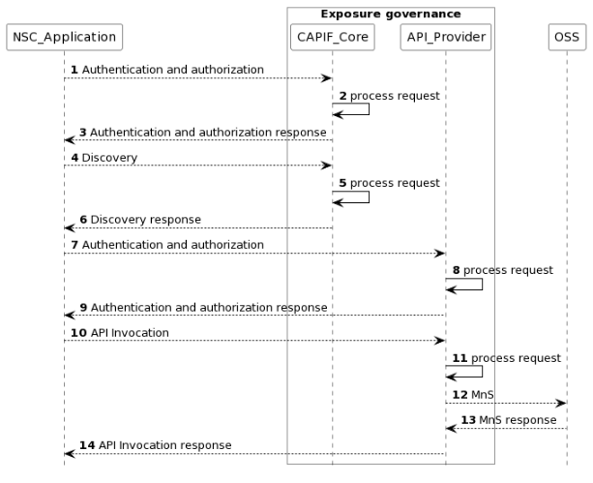 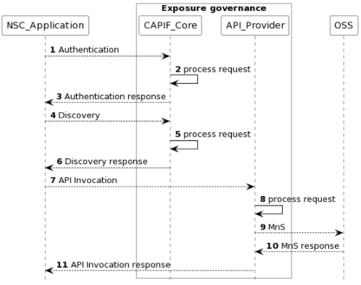

Figure 4.1.4.X.1 Procedure for consumption of exposed MnS after service order is completed

NOTE: For simplicity reasons the CAPIF Core Function and API Provider defined in TS 23.222 [x] are combined into Exposure governance and any communicaiotn between them is also not included.

1) The CAPIF_Core receives an authenticating and authorization request from the NSC_Application based on the identity and other information required for authentication and authorization of the NSC_Application.

2) The CAPIF_Core processes the authentication and authorization request.

3) The CAPIF_Core provides the appropriate response to the NSC_Application.

4) The CAPIF_Core receives a request for the discovery of service APIs information.

5) The CAPIF_Core processes the discovery.request.

6) The CAPIF_Core provides the appropriate response to the NSC_Application.

7) The API_Provider receives an authorization request from the NSC_Application based on the identity and other information required for authorization of the NSC_Application.

8) The API_Provider processes the authorization request.

9) The API_Provider provides the appropriate response to the NSC_Application.10) The API_Provider receives a request for the invocation of the service API(s) from the NSC_Application.

11) The API_Provider processes the request for discovery.

12) The OSS receives request from API_Provider for MnS.

13) The OSS provides the appropriate response to the API_Provider.

14) The API_Provider the appropriate response to the NSC_Application.

***3rd Change***

## 7.X Potential solution for consumption of exposed MnS after service order completed

This clause describes a solution for the procedure for consumption of exposed MnS after service order completed described which is described in clause 4.1.4.X. For each step in the procedure Table 7.X.1 identifies the following:

- if an interface is Internal to an operator, i.e. internal to the NSP or External between a NSC and NSP, or None in case the step is an internal process and there is no interface requirement,

- which operation or notification is used by that step, and

- which specification describes the interface (stage 2 and stage 3).

|  |  |  |  |  |
| --- | --- | --- | --- | --- |
| **Step** | **Description in step** | **Interface** | **Reference** | **Description in reference** |
| 1 | Authentication and authorization request | Internal | 3GPP TS 23.222[x], clause 6.4.2 | CAPIF-1 |
| 2 |  | None | - | - |
| 3 | Authentication and authorization response | Internal | 3GPP TS 23.222[x], clause 6.4.2 | CAPIF 1 |
| 4 | Discovery request | Internal | 3GPP TS 23.222[x], clause 6.4.2 | CAPIF-1 |
| 5 |  | None | - | - |
| 6 | Discovery response | Internal | 3GPP TS 23.222[x], clause 6.4.2 | CAPIF-1 |
| 7 | Authorization and authorization request |  |  | CAPIF-2 |
| 8 |  | None |  |  |
| 9 | Authization and authorization response |  |  | CAPIF-2 |
| 10 | API invocation | Internal | 3GPP TS 23.222[x], clause 6.4.2 | CAPIF-2 |
| 11 |  | None |  |  |
| 12 | MnS request | Internal | 3GPP TS 28.532 | MnS/Service order? |
| 13 | MnS response | Internal | 3GPP TS 28.532 | MnS/Service order? |
| 14 | API invocation response | Internal | 3GPP TS 23.222[x], clause 6.4.2 | CAPIF 2 |

Table 7.X.1 Solution for consumption of exposed MnS within the operator trusted domain (NSC_Application is inside operator trusted domain)

|  |  |  |  |  |
| --- | --- | --- | --- | --- |
| **Step** | **Description in step** | **Interface** | **Reference** | **Description in reference** |
| 1 | Authentication and authgorizationrequest | External | 3GPP TS 23.222[4], clause 6.4.2 | CAPIF-1e |
| 2 |  | None | - | - |
| 3 | Authentication and authorization response | External | 3GPP TS 23.222[4], clause 6.4.2 | CAPIF 1e |
| 4 | Discovery reqeust | External | 3GPP TS 23.222[4], clause 6.4.2 | CAPIF-1e |
| 5 |  | None | - | - |
| 6 | Discovery response | External | 3GPP TS 23.222[4], clause 6.4.2 | CAPIF-1e |
| 7 | Authorization and authorization request |  |  | CAPIF-2e |
| 8 |  | None |  |  |
| 9 | Authization and authorization response |  |  | CAPIF-2e |
| 10 | API invocation | External | 3GPP TS 23.222[4], clause 6.4.2 | CAPIF-2e |
| 11 |  | None |  |  |
| 12 | MnS request | Internal | 3GPP TS 28.532 | MnS/Service order? |
| 13 | MnS response | Internal | 3GPP TS 28.532 | MnS/Service order? |
| 14 | API invocation response | External | 3GPP TS 23.222[4], clause 6.4.2 | CAPIF 2e |

Table 7.X.2 Solution for consumption of exposed MnS outside operator trusted domain (NSC_Application is inside operator trusted domain)

***4th Change***

# Annex A UML code of the diagrams

### A.x Figure: Procedure for consumption of exposed MnS after service order is completed

@startuml

skinparam sequence {

ArrowColor Black

ActorBorderColor Black

ActorBackgroundColor White

ParticipantBorderColor Black

ParticipantBackgroundColor White

LifeLineBorderColor Black

}

skinparam NoteBackgroundColor White

skinparam NoteBorderColor White

skinparam NoteColor White

skinparam shadowing false

hide footbox

autonumber

participant NSC_Application

box "Exposure governance" #white

participant CAPIF_Core

participant API_Provider

end box

participant OSS

NSC_Application --> CAPIF_Core : Authentication and authorization

CAPIF_Core -> CAPIF_Core: process request

NSC_Application <-- CAPIF_Core : Authentication and authorization response

NSC_Application --> CAPIF_Core : Discovery

CAPIF_Core -> CAPIF_Core: process request

NSC_Application <-- CAPIF_Core : Discovery response

NSC_Application --> API_Provider : Authentication and authorization

API_Provider -> API_Provider: process request

NSC_Application <-- API_Provider : Authentication and authorization response

NSC_Application --> API_Provider : API Invocation

API_Provider -> API_Provider: process request

API_Provider --> OSS: MnS

API_Provider <-- OSS: MnS response

NSC_Application <-- API_Provider : API Invocation response

@enduml

***End of Changes***