3GPP TSG-SA5 Meeting #139-e S5-215530d1
e-meeting, 11 - 20 October 2021

Title: LS to TM Forum, MEF and GSMA on overall architecture for network slice ordering, provisioning and assurance
Response to: N/A
Release: Release 17

Source: 3GPP SA5
To: TM Forum, MEF, GSMA
Cc: 3GPP SA

Contact Person:

Name: Jean-Michel CORNILY

E-mail Address: jeanmichel.cornily@orange.com

Send any reply LS to: 3GPP Liaisons Coordinator, mailto:3GPPLiaison@etsi.org

Attachments: none

1. Overall Description:
3GPP SA5 would like to inform TM Forum, MEF and GSMA that we have started a Release 17 study on network slice management capability exposure.
3GPP SA5 is currently working on two main use cases for the ordering and provisioning of network slices.
These use cases involve the following roles:
- NSP: Network Slice Provider
- NSC: Network Slice Customer
- NOP: Network Operator
- CSC: Communication Service Customer
- CSP: Communication Service Provider
, and the following systems:
- BSS: Business Support System
- OSS: Operations Support System, made up of the two following sub-systems:
  - SML: Service Management Layer
  - NML: Network Management Layer (for sake of simplicity, network management and network element / function management are both in the NML).

- Use case No. 1: Simple case

In this use case, Vertical-V, as playing the Network Slice Customer (NSC) role, chooses a product from Company-A (playing the role of Network Slice Provider (NSP)) product offerings and sends a request to Company-A to order the product which is a network slice, via Interface Type-A.
Company-A can satisfy Vertical-V’s requirements by itself. It doesn’t have to count on partners.
In this use case, Interface Type-A, Type-1 and Type-2 are involved.

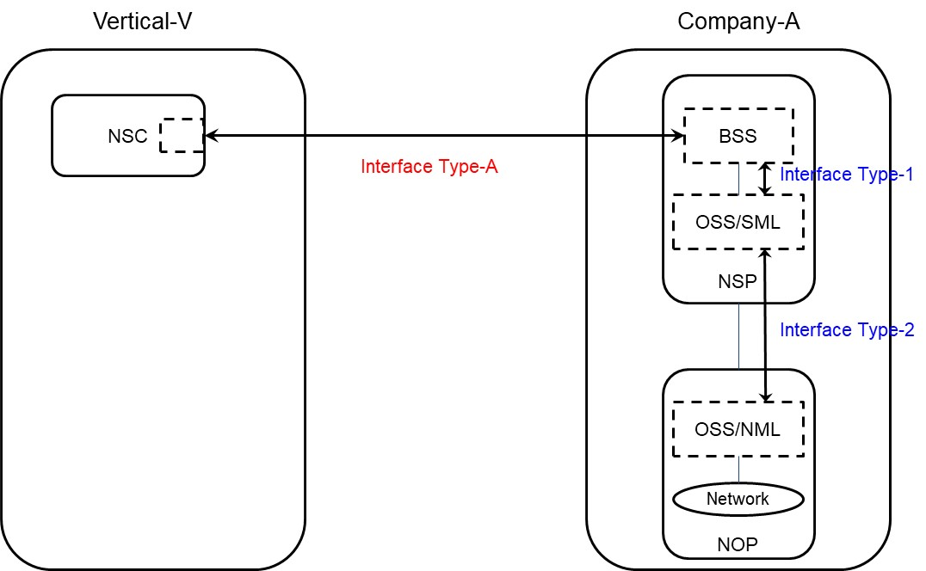

- Use case No. 2: Partners involved

In this use case, Vertical-V chooses a product from Company-A product offerings and sends a request to Company-A to order the product which is a network slice via Interface Type-A.
As Company-A can’t satisfy Vertical-V’s requirements by itself, it has to count on partners (Company-X and Company-Y), e.g. to provide RAN coverage in their respective service areas.
In this use case, Interface Type-A, Type-1, Type-2 and Type-X are involved.

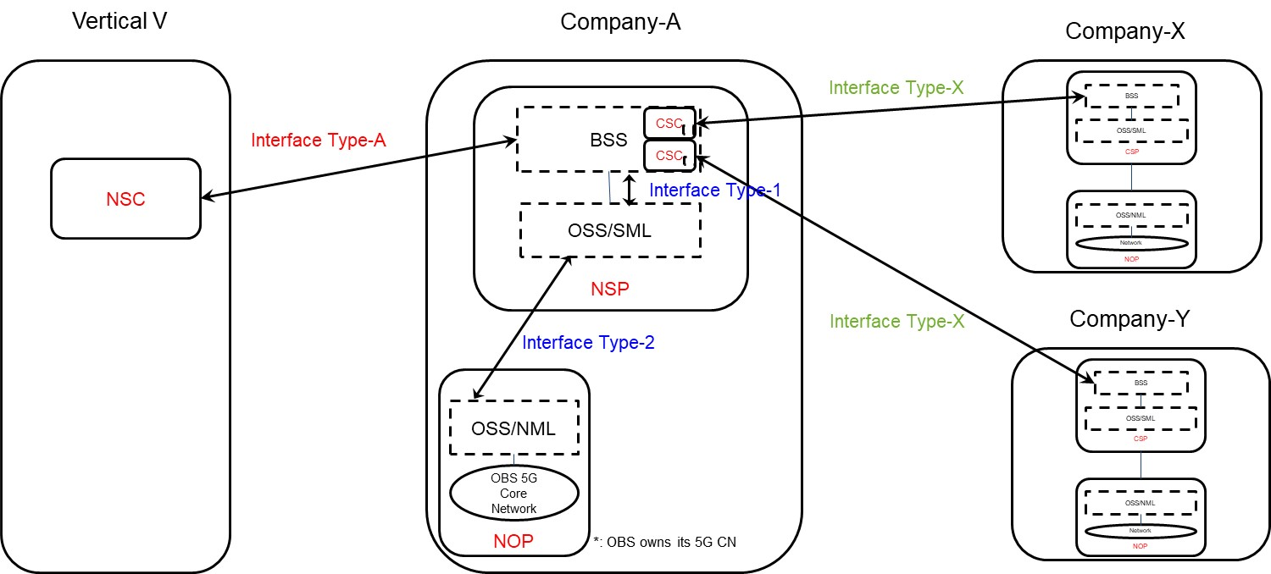

In the two above architectures, the various types of interfaces can be categorized as:
  - Inter-organization interfaces (represented East-West):

    - Between the organizational entity playing the Network Slice Customer (NSC) role, named Vertical V here, and the organizational entity playing the Network Slice Provider (NSP) role, named Company A here:

      - Interface Type-A to:
        - create a product (network slice) order,
        - retrieve information concerning a product (network slice) order,
        - update a product (network slice) order,
        - delete a product (network slice) order.

Candidate APIs for Interface Type-A include, but are not limited to, TMF API 622 (Product ordering). The related information model may be the Product Order resource model from TMF 622.
Network slice ordering via Interface Type-A can be based on NG.116 GST attributes, S-NEST and P-NEST.
Interface Type-A specification is not in the scope of 3GPP SA5.
    - Between the organizational entity playing the Network Slice Provider (NSP) role, named Company A here, and the two organizational entities playing the Communication Service Provider (CSP) role, acting as ‘partners’ and named Company X and Company Y respectively:

      - Interface Type-X to:
        - create a product order,
        - retrieve information concerning a product order,
        - update a product order,
        - delete a product order.

An example of Interface Type-X usage is when Company-A is not able to meet Vertical-V’s requirements in terms of RAN coverage and needs to partner with Company-X and Company-Y to provide RAN coverage in their respective countries.
Candidate APIs for Interface Type-X include, but are not limited to, TMF API 622 (Product ordering). The related information model may be the Product Order resource model from TMF 622.
Interface Type-X specification is not in the scope of 3GPP.

  - Intra-organization interfaces (represented North-South), internal to the organizational entity playing the Network Slice Provider (NSP) role:

    - Interface Type-1, between its BSS and its OSS/Service Management Layer (SML), to:
      - create a service order,
      - retrieve information concerning a service order,
      - update a service order,
      - delete a service order.

Candidate APIs for Interface Type-1 include, but are not limited to, TMF API 641 (Service ordering). The related information model may be the Service Order resource model from TMF 641. Assuming tis, Interface Type-1 specification is not in the scope of SA5.
Alternatively, assuming a 3GPP TS 28.541 NetworkSlice object can be considered as a service, the Interface Type-1 can be used to:
      - create a NetworkSlice Managed Object Instance (MOI),
      - retrieve information concerning a NetworkSlice MOI,
      - update a NetworkSlice MOI,
      - delete a NetworkSlice MOI.
Assuming this, Interface Type-1 specification is not in the scope of 3GPP.

    - Interface Type-2, between its OSS/SML and its OSS/Network Management Layer (NML), to:
      - create a network slice or network slice subnet,
      - retrieve information concerning a network slice or network slice subnet,
      - update a network slice or network slice subnet,
      - delete a network slice or network slice subnet,
      - collect PM and FM date concerning a network slice or network slice subnet;

Candidate APIs for Interface Type-2 include, but are not limited to, 3GPP TS 28.531, TS 28.532, TS 28.545, TS 28.550.
Interface Type-2 specification is in the scope of SA5.

3GPP SA5 would like to collect your feedback on the above statements.
It should be noted that the Assurance part of the network slice is not yet addressed. Candidate i and APIs shall be identified, for interface types listed here above.
3GPP SA5 is also thinking about new use cases in which the Network Slice Customer (NSC) could be willing to have access to more technical information concerning the network slice, than only the information exposed via the Network Slice Provider (NSP) product catalogue at BSS level. Such use cases are still under investigation.
Finally, 3GPP SA5 is also studying whether and how intent-based management may be used in this architecture, in particular when abstraction is required between the two sides of interfaces, and when multiple APIs are candidate for the same purpose.

3GPP SA5 would be happy to collaborate further on all this with TMF, MEF and GSMA.

References:
- 3GPP TS 28.541: Management and orchestration; 5G Network Resource Model (NRM); Stage 2 and stage 3 (https://portal.3gpp.org/desktopmodules/Specifications/SpecificationDetails.aspx?specificationId=3400)
- 3GPP TS 28.531: Management and orchestration; Provisioning (https://portal.3gpp.org/desktopmodules/Specifications/SpecificationDetails.aspx?specificationId=3274)
- 3GPP TS 28.532: Management and orchestration; Generic management services (https://portal.3gpp.org/desktopmodules/Specifications/SpecificationDetails.aspx?specificationId=3427)
- 3GPP TS 28.545: Management and orchestration; Fault Supervision (FS) (https://portal.3gpp.org/desktopmodules/Specifications/SpecificationDetails.aspx?specificationId=3418)
- 3GPP TS 28:550: Management and orchestration; Performance assurance (https://portal.3gpp.org/desktopmodules/Specifications/SpecificationDetails.aspx?specificationId=3411)

2. Actions:
To TMF, MEF and GSMA:

ACTION: 3GPP SA5 respectfully requests TM Forum, MEF and GSMA to consider this information and provide feedback.

3. Date of Next TSG-SA WG5 Meetings:
SA5#140e 15 - 24 November 2021 Electronic meeting
SA5#141e 24 - 28 January 2022 Electronic meeting

