**3GPP TSG-SA5 Meeting #139-eS5-215422**

**e-meeting, 11 - 20 October 2021**

**Source: Ericsson, Deutsche Telekom**

**Title: Service management scenarios between CSC, CSP and NSP**

**Document for: Approval**

**Agenda Item: 6.5.6**

# 1 Decision/action requested

***The group is asked to approve the detailed proposal in section 4.***

# 2 References

[1] TM Forum TMF622 Product Order API REST Specification

[2] TM Forum TMF641 Service Ordering API

[3] TM Forum TMF652 Resource Order Management API

[4] 3GPP TS 28.531: "Management and orchestration; Concepts, use cases and requirements"

[5] 3GPP TS 28.202: "Charging management; Network slice management charging in the 5G System (5GS); Stage 2"

# 3 Rationale

As previously discussed in #138e (e.g. S5-214077) an external product order from an NSC (enterprise) to a NSP may result in changes in the NSP network (in case fully owned by NSP) or in the NSP network and 3rd party networks (in case 3rd party CSP’s are involved).

The input to the TR (section 4) describes the different procedures. This contribution propose to add the following procedures to the TR:

- Procedure invoking internal service order after receiving product order from NSC

- Procedure invoking external product order after receiving product order from NSC

- Procedure invoking external service order after receiving product order from NSC

The procedures described in this contribution are aligned with the procedures described in the merged contribution of S5-215374 and S5-215421:

- create a product (network slice) order,

- retrieve information concerning a product (network slice) order,

- update a product (network slice) order,

- delete a product (network slice) order;

During the time after a product order has been created and before a product order is completed the consumer (NSC) may want to check the status of the product order (retrieve information) or update the product order. Once the product order is completed the product order procedure is completed. Once the service order is completed the service order procedure is completed. After the service order procedure is compled the NSC may start using the service.

# 4 Detailed proposal

|  |
| --- |
| **1st change** |

# 2 References

The following documents contain provisions which, through reference in this text, constitute provisions of the present document.

- References are either specific (identified by date of publication, edition number, version number, etc.) or non‑specific.

- For a specific reference, subsequent revisions do not apply.

- For a non-specific reference, the latest version applies. In the case of a reference to a 3GPP document (including a GSM document), a non-specific reference implicitly refers to the latest version of that document *in the same Release as the present document*.

[1] 3GPP TR 21.905: "Vocabulary for 3GPP Specifications".

[a] TM Forum TMF622 Product Order API REST Specification[b] TM Forum TMF641 Service Ordering API

[c] TM Forum TMF652 Resource Order Management API

[d] 3GPP TS 28.531: "Management and orchestration; Concepts, use cases and requirements"

[e] 3GPP TS 28.202: "Charging management; Network slice management charging in the 5G System (5GS); Stage 2"

|  |
| --- |
| **2nd change** |

### 4.1.X Procedures related to network management capability exposure

#### 4.1.x.1 Introduction

When an NSP receives an order from an NSC for a network slice enabled product, the order is decomposed by the NSP’s BSS. Depending if the NSP employs services from 3rd party CSP’s different procedures may apply for the same order. The different procedures applicable to the same order may be invoked asynchronously and treated as independent procedures, however it may not result in loss of traceability between the original order and the orders that are created as result of decomposition. The following procedures have been identified:

- Procedure invoking internal service order after receiving product order from NSC

- Procedure invoking external product order after receiving product order from NSC

- Procedure invoking external service order after receiving product order from NSC

#### 4.1.x.2 Procedure invoking internal service order after receiving product order from NSC

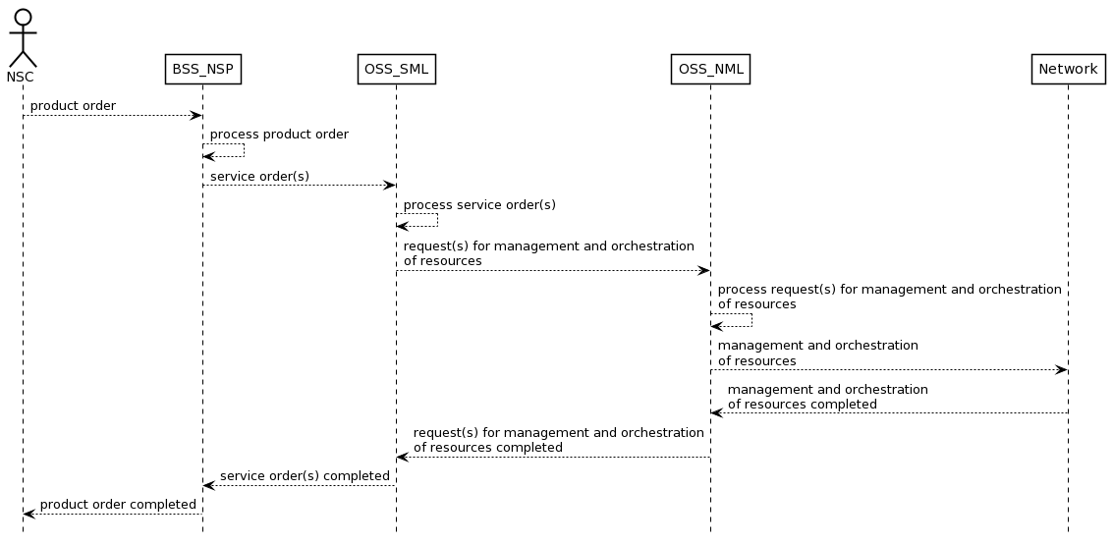

Figure 4.1.x.2.1 Procedure invoking internal service order after receiving product order from NSC

Editor’s Note: The details and the description of the steps in the sequence diagram as well as the actual names of requests and responses are FFS

#### 4.1.x.3 Procedure invoking external product order after receiving product order from NSC

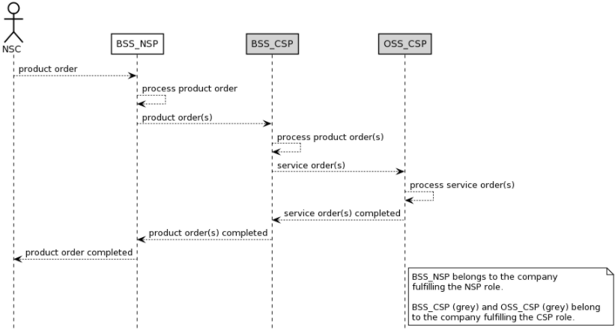

Figure 4.1.x.3.1 Procedure invoking external product order after receiving product order from NSC

Editor’s Note: The details and the description of the steps in the sequence diagram as well as the actual names of requests and responses are FFS

#### 4.1.x.4 Procedure invoking external service order after receiving product order from NSC

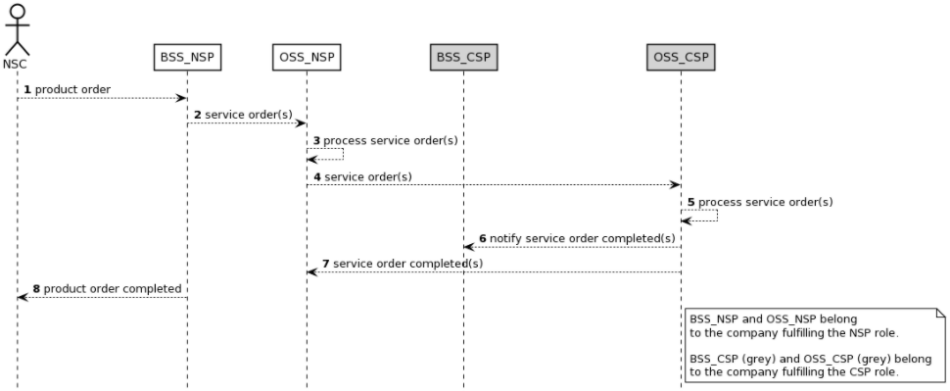

Figure 4.1.x.4.1 Procedure invoking external service order after receiving product order from NSC

Editor’s Note: The details and the description of the steps in the sequence diagram as well as the actual names of requests and responses are FFS

|  |
| --- |
| **3rd change** |

Annex X (informative):  
Appendix with UML code of the sequence diagrams

## X.1 UML code for Figure 4.1.x.2.1

@startuml

skinparam sequence {

ArrowColor Black

ActorBorderColor Black

ActorBackgroundColor White

ParticipantBorderColor Black

ParticipantBackgroundColor White

LifeLineBorderColor Black

BackGroundColor <<BSS_Prov>> Black

}

skinparam NoteBackgroundColor White

skinparam NoteBorderColor Black

skinparam shadowing false

hide footbox

actor NSC

participant BSS_NSP

participant OSS_SML

participant OSS_NML

participant Network

NSC --> BSS_NSP : product order

BSS_NSP --> BSS_NSP : process product order

BSS_NSP --> OSS_SML : service order(s)

OSS_SML --> OSS_SML : process service order(s)

OSS_SML --> OSS_NML : request(s) for management and orchestration\nof resources

OSS_NML --> OSS_NML : process request(s) for management and orchestration\nof resources

OSS_NML --> Network : management and orchestration\nof resources

OSS_NML <-- Network : management and orchestration\nof resources completed

OSS_SML <-- OSS_NML : request(s) for management and orchestration\nof resourcescompleted

BSS_NSP <-- OSS_SML : service order(s) completed

NSC <-- BSS_NSP : product order completed

## @endumlX.2 UML code for Figure 4.1.x.3.1

@startuml

skinparam sequence {

ArrowColor Black

ActorBorderColor Black

ActorBackgroundColor White

ParticipantBorderColor Black

ParticipantBackgroundColor White

LifeLineBorderColor Black

BackGroundColor <<BSS_Prov>> Black

}

skinparam NoteBackgroundColor White

skinparam NoteBorderColor Black

skinparam shadowing false

hide footbox

actor NSC

participant BSS_NSP

participant BSS_CSP #lightgrey

participant OSS_CSP #lightgrey

NSC --> BSS_NSP : product order

BSS_NSP --> BSS_NSP : process product order

BSS_NSP --> BSS_CSP : product order(s)

BSS_CSP --> BSS_CSP : process product order(s)

BSS_CSP --> OSS_CSP : service order(s)

OSS_CSP --> OSS_CSP : process service order(s)

BSS_CSP <-- OSS_CSP : service order(s) completed

BSS_NSP <-- BSS_CSP : product order(s) completed

NSC <-- BSS_NSP : product order completed

note right of OSS_CSP

BSS_NSP belongs to the company

fulfilling the NSP role.

BSS_CSP (grey) and OSS_CSP (grey) belong

to the company fulfilling the CSP role.

end note

@enduml

## X.3 UML code for Figure 4.1.x4.1

@startuml

skinparam sequence {

ArrowColor Black

ActorBorderColor Black

ActorBackgroundColor White

ParticipantBorderColor Black

ParticipantBackgroundColor White

LifeLineBorderColor Black

BackGroundColor <<BSS_Prov>> Black

}

skinparam NoteBackgroundColor White

skinparam NoteBorderColor Black

skinparam shadowing false

hide footbox

autonumber

actor NSC

participant BSS_NSP

participant OSS_NSP

participant BSS_CSP #lightgrey

participant OSS_CSP #lightgrey

NSC --> BSS_NSP : product order

BSS_NSP --> OSS_NSP : service order(s)

OSS_NSP --> OSS_NSP : process service order(s)

OSS_NSP --> OSS_CSP : service order(s)

OSS_CSP --> OSS_CSP : process service order(s)

OSS_CSP --> BSS_CSP : notify service order completed(s)

OSS_NSP <-- OSS_CSP : service order completed(s)

NSC <-- BSS_NSP : product order completed

note right of OSS_CSP

BSS_NSP and OSS_NSP belong

to the company fulfilling the NSP role.

BSS_CSP (grey) and OSS_CSP (grey) belong

To the company fulfilling the CSP role.

end note

@enduml

|  |
| --- |
| **End of changes** |