3GPP TSG SA WG5 Meeting 139-e S5-215371rev1

e-meeting, 11th - 20th Oct. 2021

Source: AsiaInfo, Alibaba Group

Title: Possible solution to support eMnS discovery service

Document for: Approval
Agenda Item: 6.5.4

1 Decision/action requested
The group is asked to discuss and approve the proposal..

2 References
[1] 3GPP TR 28.824: " Study on network slice management capability exposure " V0.2.0

3 Rationale
The use cases, issues and potential requirements for eMnS discovery service was discussed and agreed in TR 28.824[1]. This pCR is to propose possible solutions to support eMnS discovery service.

4 Detailed proposal
This contribution adds possible solutions for the use case – eMnS discovery service and the use case – eMnS support to discovery systems.
Start of 1st Change

7.X Possible solutions for eMnS discovery service
This clause provides potential solutions for the use case of eMnS discovery service (see clause 5.3). It is assumed that the MnS discovery service has been deployed.
This solution applies to the scenario that eMnS discovery service is provided by a dedicated eMnS discovery service producer (e.g. EGMF) in the existing 3GPP management system.
To enable communication between eMnS consumers and eMnS producers, eMnS consumers need a mechanism to discover eMnS producers that are available in the 3GPP management system.
A MnS discovery service consumer in EGMF sends a request to the MnS discovery service producer to obtain the available MnS data. The 3GPP management system obtains the stored MnS data of the management service(s) and decides if the MnS data of the management service(s) can satisfy the expose request. The EGMF transfers the MnS data into eMnS data according to the mechanism (e.g. exposure level, pre-existing contract permission, and generic rules defined by operator). The EGMF configures and publishes the eMnS data to the eMnS discovery service producer.
Note: The operator decides the rules or polices of what should be exposed, EGMF implements the rules.
The eMnS discovery service consumer sends a request to eMnS discovery service producer to obtain the eMnS data. The request may optionally request that the eMnS data is filtered by exposure levels.

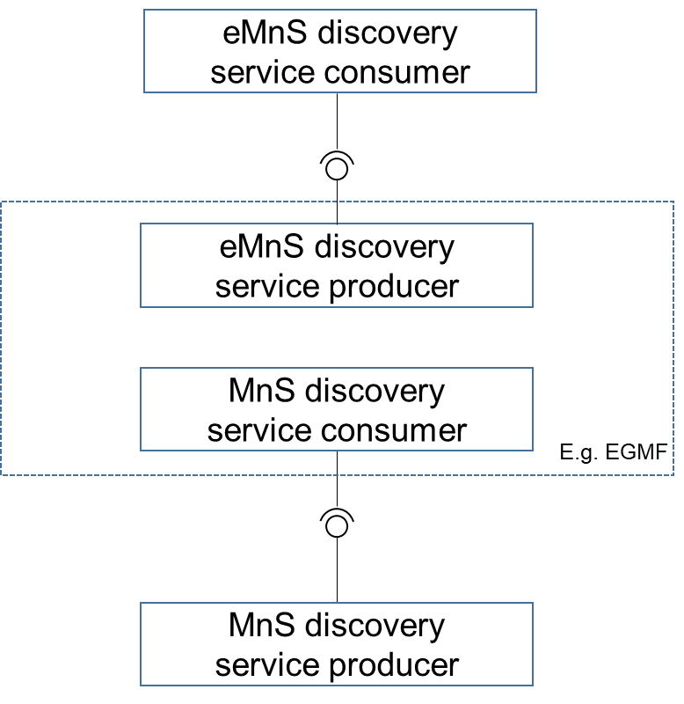
Figure 7.X-1 eMnS discovery service provided by a dedicated producer
The following figure shows the procedure for exposed MnS discovery:
Figure 7.X-2 Exposed MnS discovery procedure
1-2. The MnS discovery service consumer in EGMF obtains the available MnS data;
3.The EGMF transfers the MnS data into eMnS data;
4. The exposed MnS discovery service consumer conducts authentication and authorization for accessing eMnS discovery service;
5. The exposed MnS discovery service consumer sends request to exposed MnS discovery service producer;
6. The exposed MnS discovery service producer sends a response, including eMnS data with the information of exposed MnS instance.

End of Change

