**3GPP TSG- Meeting # *rev1***

**, , -**

|  |  |  |  |  |  |  |  |  |
| --- | --- | --- | --- | --- | --- | --- | --- | --- |
| *CR-Form-v12.1* | | | | | | | | |
| **CHANGE REQUEST** | | | | | | | | |
|  | | | | | | | | |
|  |  | **CR** |  | **rev** |  | **Current version:** |  |  |
|  | | | | | | | | |
| *For* [***HE******LP***](http://www.3gpp.org/3G_Specs/CRs.htm#_blank)*on using this form: comprehensive instructions can be found at* [*http://www.3gpp.org/Change-Requests*](http://www.3gpp.org/Change-Requests)*.* | | | | | | | | |
|  | | | | | | | | |

|  |  |  |  |  |  |  |  |  |
| --- | --- | --- | --- | --- | --- | --- | --- | --- |
| ***Proposed change affects:*** | UICC apps |  | ME |  | Radio Access Network | **X** | Core Network | **X** |

|  |  |  |  |  |  |  |  |  |  |  |
| --- | --- | --- | --- | --- | --- | --- | --- | --- | --- | --- |
|  | | | | | | | | | | |
| ***Title:*** | Rel-17 Input to DraftCR 28.622 Add solution for reporting and storing data | | | | | | | | | |
|  |  | | | | | | | | | |
| ***Source to WG:*** | Nokia, Nokia Shanghai Bell | | | | | | | | | |
| ***Source to TSG:*** | SA5 | | | | | | | | | |
|  |  | | | | | | | | | |
| ***Work item code:*** | MADCOL | | | | |  | ***Date:*** | | |  |
|  |  | | | |  | |  | | |  |
| ***Category:*** |  |  | | | | | ***Release:*** | | |  |
|  | *Use one of the following categories:* ***F*** *(correction)* ***A*** *(mirror corresponding to a change in an earlier release)* ***B*** *(addition of feature),* ***C*** *(functional modification of feature)* ***D*** *(editorial modification)*  Detailed explanations of the above categories can be found in 3GPP [TR 21.900](http://www.3gpp.org/ftp/Specs/html-info/21900.htm). | | | | | | | | *Use one of the following releases: Rel-8 (Release 8) Rel-9 (Release 9) Rel-10 (Release 10) Rel-11 (Release 11) … Rel-15 (Release 15) Rel-16 (Release 16) Rel-17 (Release 17) Rel-18 (Release 18)* | |
|  |  | | | | | | | | | |
| ***Reason for change:*** | | Requirements for reporting and storing are agreed. This contribution proposes the corresponding data NRM fragment. | | | | | | | | |
|  | |  | | | | | | | | |
| ***Summary of change:*** | |  | | | | | | | | |
|  | |  | | | | | | | | |
| ***Consequences if not approved:*** | | The WI MADCOL cannot progress. | | | | | | | | |
|  | |  | | | | | | | | |
| ***Clauses affected:*** | |  | | | | | | | | |
|  | |  | | | | | | | | |
|  | | **Y** | **N** |  | | | |  | | |
| ***Other specs*** | |  | **X** | Other core specifications | | | | TS/TR ... CR ... | | |
| ***affected:*** | |  | **X** | Test specifications | | | | TS/TR ... CR ... | | |
| ***(show related CRs)*** | |  | **X** | O&M Specifications | | | | TS/TR ... CR ... | | |
|  | |  | | | | | | | | |
| ***Other comments:*** | | Baseline DraftCR for MADCOL: None. | | | | | | | | |
|  | |  | | | | | | | | |
| ***This CR's revision history:*** | |  | | | | | | | | |

|  |
| --- |
| **First modification** |

## 4.2 Class diagrams

### 4.2.1 Relationships

This clause depicts the set of classes (e.g. IOCs) that encapsulates the information relevant for this IRP. This clause provides the overview of the relationships of relevant classes in UML. Subsequent clauses provide more detailed specification of various aspects of these classes.

The following figure shows the containment/naming hierarchy and the associations of the classes defined in the present document. See Annex A of a class diagram that combines this figure with Figure 1 of [2], the class diagram of UIM.



NOTE 1: ManagedElement may be contained either

- in a SubNetwork (since *SubNetwork* inherits from *Domain*_ and *ManagedElement* inherits from *ManagedElement*_ and *Domain*_ name-contained *ManagedElement_* as observed in the figure of Annex A) or

- in a MeContext instance as observed by the above figure or in the figure of Annex A.

This either-or relation cannot be shown by using an {xor} constraint in the above figure.

ManagedElement may also have no parent instance at all.

NOTE 2: Void

NOTE 3: If the configuration contains several instances of SubNetwork, exactly one SubNetwork instance shall directly or indirectly contain all the other SubNetwork instances.

NOTE 4: The SubNetwork instance not contained in any other instance of SubNetwork is referred to as "the root SubNetwork instance".

NOTE 5: ManagementNode shall be contained in the root SubNetwork instance.

NOTE 6: If contained in a SubNetwork instance, MnsAgent shall be contained in the root SubNetwork instance.

NOTE 7: For a clarification on the choice of containment of the IRPAgent (since it has three possible parents), see the definition of MnsAgent.

NOTE 8: The MnsAgent shall be replaced by the IRPAgent in deployments using the IRP framework as defined in TS 32.102 [2].

Figure 4.2.1-1: NRM fragment

Each Managed Object is identified with a Distinguished Name (DN) according to 3GPP TS 32.300 [13] that expresses its containment hierarchy. As an example, the DN of a ManagedElement instance could have a format like:

SubNetwork=Sweden,MeContext=MEC-Gbg-1,ManagedElement=RNC-Gbg-1.



NOTE 8: Void

NOTE 9: Void

Figure 4.2.1-2: Vendor specific data container NRM fragment

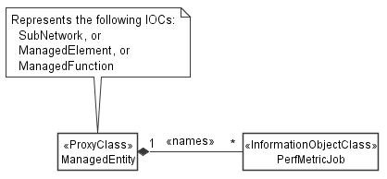

Figure 4.2.1-3: PM control NRM fragment

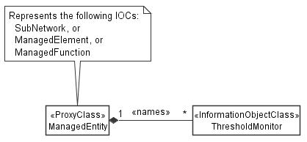

Figure 4.2.1-4: Threshold monitoring control NRM fragment

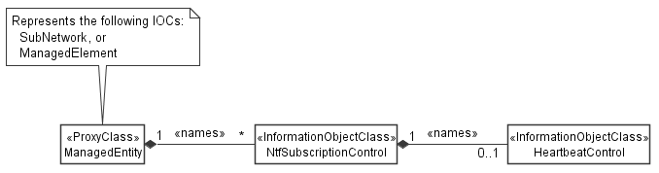

Figure 4.2.1-5: Notification subscription and heartbeat notification control NRM fragment

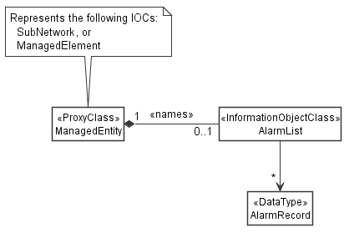

Figure 4.2.1-6: FM control NRM fragment

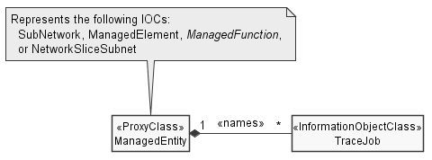

Figure 4.2.1-7: Trace control NRM fragment

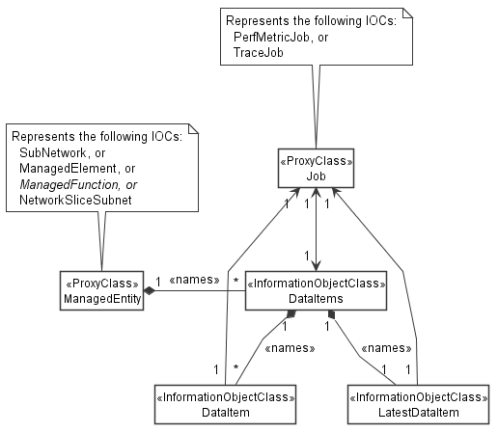

Figure 4.2.1-10: Data NRM fragment

### 4.2.2 Inheritance

This clause depicts the inheritance relationships.





Figure 4.2.2-1: NRM fragment

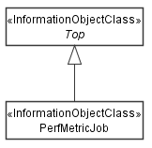

Figure 4.2.2-2: PM control NRM fragment

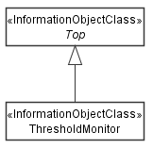

Figure 4.2.2-3: Threshold monitoring control NRM fragment

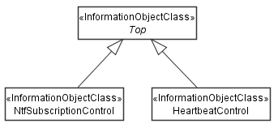

Figure 4.2.2-4: Notification subscription and heartbeat notification control NRM fragment

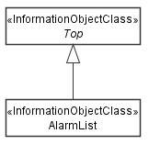

Figure 4.2.2-5: FM control NRM fragment

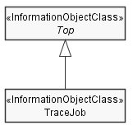

Figure 4.2.2-6: Trace control NRM fragment

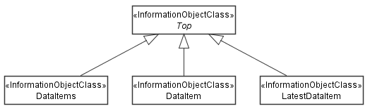

Figure 4.2.2-9: Data NRM fragment

|  |
| --- |
| **Next modification** |

### 4.3.X DataItems

#### 4.3.X.1 Definition

This IOC represents a collection of data items. It contains meta data about the management data stored in the collection, but not the actual data.

"DataItems" can be name-contained by "ManagedElement", "ManagedFunction" or "SubNetwork". In addtion, it can be name-contained by "NetworkSliceSubnet" (3GPP TS 28.541 [c]). The name-containment links "DataItems" to the object that the data relates to. For example, data collected on a network element of type XYZ is name-contained under the "XYzFunction" that represents the network element in the management system.

"DataItems" instances are created, updated and deleted by the MnS producer. They cannot be created nor updated nor deleted by MnS consumers.

The meta data attributes of "DataItems" specify the management data type ("dataType"), the total size of the data collection ("size"), the time window when the data was collected ("startTime", "endTime"), the time when the data will be deleted ("deletionTime") and the reliability of the data ("reliability"). The MnS producer shall update the meta data attributes when data items are added to or deleted from the collection, or when existing data items are changed, for example, when new data is added.

When the data NRM fragment is used by data collection jobs ("PerfMetricJob" or "TraceJob") for making collected data available to MnS consumers the following provisions shall apply:

* The "DataItems" object shall be created at the same time as the object representing the data collection job.
* The attributes "jobRef" and "jobId" shall be supported and present in a "DataItems" instance. They shall identify the job that the data items in the data item collection relate to.
* A "DataItems" instance shall contain data items related to one and only one job.
* The data items produced by one job shall be contained in one and only one "DataItems" instance.
* The job object shall support an attribute with a link to the created "DataItems" instance ("_linkToCreatedDataItems").
* The attribute "_linkToCreatedDataItems" shall be returned in the job creation response.

*Editor's note: "_linkToCreatedDataItems" still needs to be added to "PerfMetricJob"*

#### 4.3.X.2 Attributes

|  |  |  |  |  |  |
| --- | --- | --- | --- | --- | --- |
| Attribute name | S | isReadable | isWritable | isInvariant | isNotifyable |
| dataType | M | T | F | F | F |
| size | M | T | F | F | F |
| startTime | M | T | F | F | F |
| endTime | M | T | F | F | F |
| deletionTime | M | T | F | F | T |
| reliability | O | T | F | F | F |
| **Attributes related to roles** |  |  |  |  |  |
| jobRef | CM | T | F | T | F |
| jobId | CM | T | F | T | F |

#### 4.3.X.2a Attribute definitions

| Attribute Name | Documentation and Allowed Values | Properties |
| --- | --- | --- |
| dataType | Management data types stored in the collection.  allowedValues:  - PERFORMANCE_MANAGEMENT  - KPI  - TRACE  - MDT  - ANALYTICS  *Editor's note: ENUM needs to be aligned across all SA5 TS, could be an item for common cdefinitions.* | Type: ENUM  multiplicity: 1  isOrdered: N/A  isUnique: N/A  defaultValue: None  isNullable: False |
| size | Size of the "DataCollection". Unit is byte.  allowedValues: non-negative integers | Type: Integer  multiplicity: 1  isOrdered: N/A  isUnique: N/A  defaultValue: None  isNullable: False |
| startTime | Start time of the data, i.e. the time stamp of the first data element of the first "DataItem" in the "DataCollection". This attribute is set once only and is never updated.  allowedValues: N/A | Type: DateTime  multiplicity: 1  isOrdered: N/A  isUnique: N/A  defaultValue: None  isNullable: False |
| endTime | End time of the data, i.e. the time stamp of the last data element of the last "DataItem" in the "DataCollection". This attribute is updated always when a new "DataItem" is added.  allowedValues: N/A | Type: DateTime  multiplicity: 1  isOrdered: N/A  isUnique: N/A  defaultValue: None  isNullable: False |
| deletionTime | Time when the MnS producer will delete the "DataCollection", populated only with a valid value when no more data items are added to the collection.  allowedValues: N/A | Type: DateTime  multiplicity: 1  isOrdered: N/A  isUnique: N/A  defaultValue: None  isNullable: False |
| reliability | Reliability of the data in the "DataCollection". TRUE indicates the data is reliable, FALSE indicates the data is not reliable.  allowedValues: N/A | Type: Boolean  multiplicity: 1  isOrdered: N/A  isUnique: N/A  defaultValue: None  isNullable: False |

#### 4.3.B.3 Attribute constraints

|  |  |
| --- | --- |
| Name | Definition |
| jobRef  Support Qualifier | Condition: This attribute shall be supported when "PerfMetricJob" or "TraceJob" are supported. |
| jobId  Support Qualifier | Condition: This attribute shall be supported when "PerfMetricJob" or "TraceJob" are supported. |

#### 4.3.B.4 Notifications

The common notifications defined in clause W4.5 are not valid for this IOC. The set of notifications defined in the following table is valid.

| Name | S | Notes |
| --- | --- | --- |
| notifyMOIObjectCreation | M |  |
| notifyMOIObjectDeletion | M |  |
| notifyMOIAttributeValueChanges | O |  |
| notifyMOIChanges | O |  |

### 4.3.Y DataItem

#### 4.3.Y.1 Definition

A "DataItem" contains the collected management data. A "DataCollection" instance name-contains one or more "DataItem" instances.

"DataItem" instances are created, updated and deleted by the MnS producer. They cannot be created nor updated nor deleted by a MnS consumer. The deletion time is indicated by the "deletionTime" attribute. Note that by always deleting the last item only the MnS consumer can maintan a set of "DataItem" instances representing the data that was collected over a sliding time window. This allows to control the size of the stored data allowing for diverse deployment scenarios of the data NRM fragment. For example, a base station that shall report data only, may have only one or two "DataItem" instances at any point in time. For data store functions, the number of "DataItem" instances may become very large.

The MnS producer shall emit to subscribed MnS consumers a normal object creation notification as defined in 3GPP TS 28.532 ("notifyMOICreation") with the complete object representation. This notification contains all management data collected during a reporting period. Data consumers wishing to receive newly collected data need to subscribe to this notification. Alternatively, data cansumers can read the latest "DataItem" object in a "DataCollection".

When the data NRM fragment is used by data collection jobs ("PerfMetricJob" or "TraceJob") for making collected data available to MnS consumers the following provisions shall apply:

* The attributes "jobRef" and "jobId" shall be supported and present. They shall identify the job the file is related to.

The presence of "jobRef" and "jobId" in "DataItem" allows to set notification filters in the subscription in such a way that only configuration notifications are sent to subscribed MnS consumers if the "DataItem" represents data related to jobs that the subscribed MnS consumer created or is interested in.

In addition, when the data NRM fragment is used by data collection jobs, which use a reporting period for making collected data available to MnS consumers ("PerfMetricJob"), the following provisions shall apply:

* When a reporting period expires, a new "DataItem" instance shall be created that represents the data collected during the elapsed reporting period.

When data reporting involves no reporting period, the MnS producer decides based on other considerations when to open and close "DataItem" instances.

When the data NRM fragment is not used by data collection jobs for reporting purposes it can be used by management functions to re-expose collectd data to data consumers. When re-exposing data, the data collection jobs used for collecting the data and reporting periods used for reporting the collected data to the management function paly no role anymore. For that reason, the following provisions shall apply:

* The attributes "jobRef" and "jobId" shall not be supported.
* The requirement to put the data collected during a reporting period into a single "DatItem" is relaxed. The MnS producer can decide based on other considerations how to structure data into "DataItem" instances.

*Editor's note: It is ffs if the creation of the latest "DataItem" instance shall be notified or the update of the "LatestDataItemCopy" or both.*

#### 4.3.Y.2 Attributes

|  |  |  |  |  |  |
| --- | --- | --- | --- | --- | --- |
| Attribute name | S | isReadable | isWritable | isInvariant | isNotifyable |
| managementDataType | M | T | F | F | T |
| size | M | T | F | F | T |
| startTime | M | T | F | F | T |
| endTime | M | T | F | F | T |
| deletionTime | M | T | F | F | T |
| reliability | O | T | F | F | T |
| data | M | T | F | F | T |
| **Attributes related to roles** |  |  |  |  |  |
| jobRef | CM | T | F | T | F |
| jobId | CM | T | F | T | F |

#### 4.3.Y.2a Attribute definitions

| Attribute Name | Documentation and Allowed Values | Properties |
| --- | --- | --- |
| managementDataType | Management data types stored in the "DataItem".  allowedValues:  - PERFORMANCE_MANAGEMENT  - KPI  - TRACE  - MDT  - ANALYTICS | Type: ENUM  multiplicity: 1  isOrdered: N/A  isUnique: N/A  defaultValue: None  isNullable: False |
| size | Size of the "DataItem". Unit is byte.  allowedValues: non-negative integers | Type: Integer  multiplicity: 1  isOrdered: N/A  isUnique: N/A  defaultValue: None  isNullable: False |
| startTime | Start time of the data, i.e. the time stamp of the first data element in the "DataItem". This attribute is set once only and is never updated.  allowedValues: N/A | Type: DateTime  multiplicity: 1  isOrdered: N/A  isUnique: N/A  defaultValue: None  isNullable: False |
| endTime | End time of the data, i.e. the time stamp of the last data element in the "DataItem".  allowedValues: N/A | Type: DateTime  multiplicity: 1  isOrdered: N/A  isUnique: N/A  defaultValue: None  isNullable: False |
| deletionTime | Time when the MnS producer will delete the "DataItem".  allowedValues: N/A | Type: DateTime  multiplicity: 1  isOrdered: N/A  isUnique: N/A  defaultValue: None  isNullable: False |
| reliability | Reliability of the data in the "DataCollection" in percent. 100% indicates the data is fully reliable.  allowedValues: N/A | Type: Integer  multiplicity: 1  isOrdered: N/A  isUnique: N/A  defaultValue: None  isNullable: False |
| data | Data that is represented by the "DataItem".  *Editor's note: The data format is ffs.* | Type: tbc  multiplicity: 1  isOrdered: N/A  isUnique: N/A  defaultValue: None  isNullable: False |

#### 4.3.Y.3 Attribute constraints

|  |  |
| --- | --- |
| Name | Definition |
| jobRef  Support Qualifier | Condition: This attribute shall be supported when "PerfMetricJob" or "TraceJob" are supported. |
| jobId  Support Qualifier | Condition: This attribute shall be supported when "PerfMetricJob" or "TraceJob" are supported. |

#### 4.3.Y.4 Notifications

The common notifications defined in clause W4.5 are not valid for this IOC. The set of notifications defined in the following table is valid.

| Name | S | Notes |
| --- | --- | --- |
| notifyMOIObjectCreation | M |  |
| notifyMOIObjectDeletion | M |  |
| notifyMOIAttributeValueChanges | O |  |
| notifyMOIChanges | O |  |

### 4.3.Z LatestDataItem

#### 4.3.Z.1 Definition

The "LatestDataItem" contains a copy of the latest "DataItem" in the collection. "LatestDataItem" is name-contained under "DataCollection". Instances of "LatestDataItem" are created by the MnS producer. The "id" shall be set to "1".

The purpose of this object is to allow for easy read operations querying the latest data in a collection. For that reason, this object does not support any notifications.

#### 4.3.Z.2 Attributes

Same as for "DataItem", except for that "isNotifyable" is false ("F") for all attributes.

#### 4.3.Z.2a Attribute definitions

Same as for "DataItem".

#### 4.3.Z.3 Attribute constraints

Same as for "DataItem".

#### 4.3.Z.4 Notifications

There is no notification defined.

|  |
| --- |
| **End of modifications** |