**3GPP TSG-SA5 Meeting #138-e *S5-215361rev1***

**Online, , 23rd Aug 2021 - 31st Aug 2021**

|  |  |  |  |  |  |  |  |  |
| --- | --- | --- | --- | --- | --- | --- | --- | --- |
| *CR-Form-v12.1* | | | | | | | | |
| **CHANGE REQUEST** | | | | | | | | |
|  | | | | | | | | |
|  | **28.622** | **CR** | **Draft CR** | **rev** | **-** | **Current version:** | **16.9.0** |  |
|  | | | | | | | | |
| *For* [***HE******LP***](http://www.3gpp.org/3G_Specs/CRs.htm#_blank)*on using this form: comprehensive instructions can be found at* [*http://www.3gpp.org/Change-Requests*](http://www.3gpp.org/Change-Requests)*.* | | | | | | | | |
|  | | | | | | | | |

|  |  |  |  |  |  |  |  |  |
| --- | --- | --- | --- | --- | --- | --- | --- | --- |
| ***Proposed change affects:*** | UICC apps |  | ME |  | Radio Access Network | **X** | Core Network | **X** |

|  |  |  |  |  |  |  |  |  |  |  |
| --- | --- | --- | --- | --- | --- | --- | --- | --- | --- | --- |
|  | | | | | | | | | | |
| ***Title:*** | Rel-17 Input to DraftCR 28.622 Add file download control NRM fragment | | | | | | | | | |
|  |  | | | | | | | | | |
| ***Source to WG:*** | Nokia, Nokia Shanghai Bell | | | | | | | | | |
| ***Source to TSG:*** | SA5 | | | | | | | | | |
|  |  | | | | | | | | | |
| ***Work item code:*** | FIMA | | | | |  | ***Date:*** | | | 2021-10-01 |
|  |  | | | |  | |  | | |  |
| ***Category:*** | **B** |  | | | | | ***Release:*** | | | 17 |
|  | *Use one of the following categories:* ***F*** *(correction)* ***A*** *(mirror corresponding to a change in an earlier release)* ***B*** *(addition of feature),* ***C*** *(functional modification of feature)* ***D*** *(editorial modification)*  Detailed explanations of the above categories can be found in 3GPP [TR 21.900](http://www.3gpp.org/ftp/Specs/html-info/21900.htm). | | | | | | | | *Use one of the following releases: Rel-8 (Release 8) Rel-9 (Release 9) Rel-10 (Release 10) Rel-11 (Release 11) … Rel-15 (Release 15) Rel-16 (Release 16) Rel-17 (Release 17) Rel-18 (Release 18)* | |
|  |  | | | | | | | | | |
| ***Reason for change:*** | | Requirements for file download were agreed at SA5#138. This contribution proposes the corresponding file download control NRM fragment. | | | | | | | | |
|  | |  | | | | | | | | |
| ***Summary of change:*** | |  | | | | | | | | |
|  | |  | | | | | | | | |
| ***Consequences if not approved:*** | | The WI FIMA cannot progress. | | | | | | | | |
|  | |  | | | | | | | | |
| ***Clauses affected:*** | |  | | | | | | | | |
|  | |  | | | | | | | | |
|  | | **Y** | **N** |  | | | |  | | |
| ***Other specs*** | |  | **X** | Other core specifications | | | | TS/TR ... CR ... | | |
| ***affected:*** | |  | **X** | Test specifications | | | | TS/TR ... CR ... | | |
| ***(show related CRs)*** | |  | **X** | O&M Specifications | | | | TS/TR ... CR ... | | |
|  | |  | | | | | | | | |
| ***Other comments:*** | | Baseline DraftCR for FIMA: S5-214758 | | | | | | | | |
|  | |  | | | | | | | | |
| ***This CR's revision history:*** | |  | | | | | | | | |

|  |
| --- |
| **First modification** |

## 4.2 Class diagrams

### 4.2.1 Relationships

This clause depicts the set of classes (e.g. IOCs) that encapsulates the information relevant for this IRP. This clause provides the overview of the relationships of relevant classes in UML. Subsequent clauses provide more detailed specification of various aspects of these classes.

The following figure shows the containment/naming hierarchy and the associations of the classes defined in the present document. See Annex A of a class diagram that combines this figure with Figure 1 of [2], the class diagram of UIM.



NOTE 1: ManagedElement may be contained either

- in a SubNetwork (since *SubNetwork* inherits from *Domain*_ and *ManagedElement* inherits from *ManagedElement*_ and *Domain*_ name-contained *ManagedElement_* as observed in the figure of Annex A) or

- in a MeContext instance as observed by the above figure or in the figure of Annex A.

This either-or relation cannot be shown by using an {xor} constraint in the above figure.

ManagedElement may also have no parent instance at all.

NOTE 2: Void

NOTE 3: If the configuration contains several instances of SubNetwork, exactly one SubNetwork instance shall directly or indirectly contain all the other SubNetwork instances.

NOTE 4: The SubNetwork instance not contained in any other instance of SubNetwork is referred to as "the root SubNetwork instance".

NOTE 5: ManagementNode shall be contained in the root SubNetwork instance.

NOTE 6: If contained in a SubNetwork instance, MnsAgent shall be contained in the root SubNetwork instance.

NOTE 7: For a clarification on the choice of containment of the IRPAgent (since it has three possible parents), see the definition of MnsAgent.

NOTE 8: The MnsAgent shall be replaced by the IRPAgent in deployments using the IRP framework as defined in TS 32.102 [2].

Figure 4.2.1-1: NRM fragment

Each Managed Object is identified with a Distinguished Name (DN) according to 3GPP TS 32.300 [13] that expresses its containment hierarchy. As an example, the DN of a ManagedElement instance could have a format like:

SubNetwork=Sweden,MeContext=MEC-Gbg-1,ManagedElement=RNC-Gbg-1.



NOTE 8: Void

NOTE 9: Void

Figure 4.2.1-2: Vendor specific data container NRM fragment

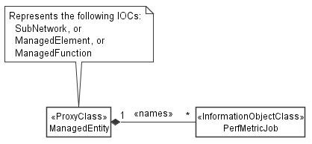

Figure 4.2.1-3: PM control NRM fragment

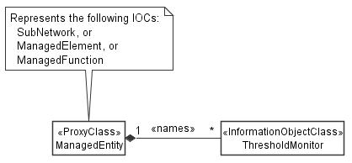

Figure 4.2.1-4: Threshold monitoring control NRM fragment

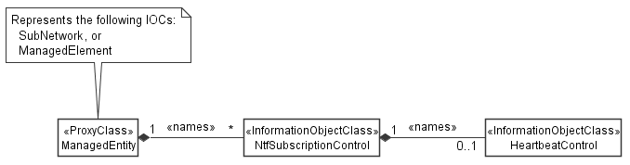

Figure 4.2.1-5: Notification subscription and heartbeat notification control NRM fragment

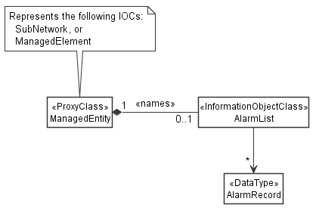

Figure 4.2.1-6: FM control NRM fragment

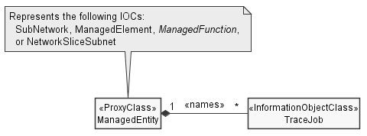

Figure 4.2.1-7: Trace control NRM fragment

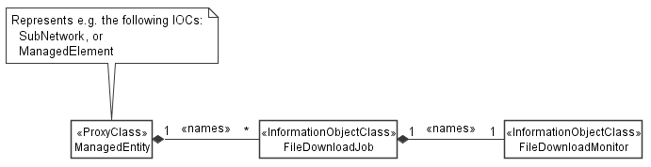

Figure 4.2.1-9: File download control NRM fragment

### 4.2.2 Inheritance

This clause depicts the inheritance relationships.





Figure 4.2.2-1: NRM fragment

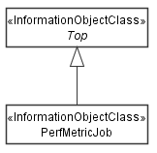

Figure 4.2.2-2: PM control NRM fragment

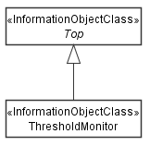

Figure 4.2.2-3: Threshold monitoring control NRM fragment

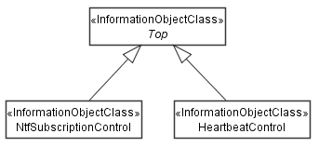

Figure 4.2.2-4: Notification subscription and heartbeat notification control NRM fragment

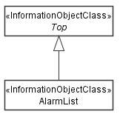

Figure 4.2.2-5: FM control NRM fragment

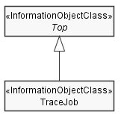

Figure 4.2.2-6: Trace control NRM fragment

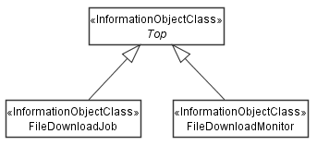

Figure 4.2.2-8: File download control NRM fragment

|  |
| --- |
| **Next modification** |

### 4.3.A FileDownloadJob

#### 4.3.A.1 Definition

The "FileDownloadJob" represents a job on a MnS producer that downloads a file from a MnS consumer. It can be name-contained by "ManagedElement" or "SubNetwork".

A "FileDownloadJob" is created by a MnS consumer on a MnS producer. The creation requests the MnS producer to download a file from the MnS consumer to the MnS producer. Upon completion of the file download, the MnS consumer shall delete the "FileDownloadJob".

The creation request contains the information required by the MnS producer to download the file. The attributes "fileName" and "fileLocation" specify where the file can be downloaded. The attributes "fileCompressionType" and "fileSize" specify the properties of the and the attribute "downloadProtocol" the protocal to be used for the file transfer.

To cancel a file download, the MnS consumer shall set the " cancellationRequested "attribute to "TRUE". Cancellation is possible in the "NOT_STARTED" and "ONGOING" state.

The "FileDownloadJob" creation response shall include a link to the created "_linkToFileDownloadMonitor". This allows for simple deployments not relying on notifications for reporting the status of the file download job, where the MnS consumer can poll the "FileDownloadMonitor" in regular intervals.

#### 4.3.A.2 Attributes

|  |  |  |  |  |  |
| --- | --- | --- | --- | --- | --- |
| Attribute name | S | isReadable | isWritable | isInvariant | isNotifyable |
| operationalState | M | T | F | F | T |
| administrativeState | M | T | T | F | T |
| fileName | M | T | F | T | F |
| fileLocation | M | T | F | T | F |
| fileCompressionType | M | T | F | T | F |
| fileSize | O | T | F | T | F |
| downloadProtocol | M | T | F | T | F |
| notificationRecipientAddress | O | T | F | T | F |
| cancellationRequested | O | T | T | F | T |
| _linkToFileDownloadMonitor | M | T | F | T | F |

#### 4.3.A.2a Attribute definitions

| Attribute Name | Documentation and Allowed Values | Properties |
| --- | --- | --- |
| downloadProtocol | Protocol to be used for the file download.  allowedValues:  - SFTP  - FTPES  - HTTPS | Type: ENUM  multiplicity: 1  isOrdered: N/A  isUnique: N/A  defaultValue: None  isNullable: False |
| notificationRecipientAddress |  |  |
| cancellationRequested |  |  |

#### 4.3.A.3 Attribute constraints

None.

#### 4.3.A.4 Notifications

The common notifications defined in clause 4.5 are valid for this IOC, without exceptions or additions.

### 4.3.B FileDownloadMonitor

#### 4.3.B.1 Definition

A "FileDownloadMonitor" represents the status of a file download job in a general manner independent from details of the file transer protocol. It is name-contained by the "FileDownloadJob" whose status is represented by the monitor.

A "FileDownloadMonitor" is created by the MnS producer together with the associated "FileDownloadJob" upon receiving a "FileDownloadJob" creation request. Its attributes are populated and updated by the MnS producer as the file download progresses. The MnS producer shall delete the monitor shortly after the file download terminted and the "status" attribute is either "SUCCESS, "FAILURE" or "CANCELLED".

The "FileDownloadJob" creation response shall include a link to the created "FileDownloadMonitor".

#### 4.3.B.2 Attributes

|  |  |  |  |  |  |
| --- | --- | --- | --- | --- | --- |
| Attribute name | S | isReadable | isWritable | isInvariant | isNotifyable |
| status | M | T | F | F | T |
| errorReason | M | T | F | F | T |
| progress | M | T | F | F | T |
| durationSinceStart | O | T | F | F | T |
| durationUntilEnd | O | T | F | F | T |

#### 4.3.B.2a Attribute definitions

| Attribute Name | Documentation and Allowed Values | Properties |
| --- | --- | --- |
| status | Status of the file download process.  allowedValues:  - NOT_STARTED  - ONGOING  - SUCCESS  - FAILURE  - CANCELLED | Type: ENUM  multiplicity: 1  isOrdered: N/A  isUnique: N/A  defaultValue: None  isNullable: False |
| errorReason | Error reason, only present when the file download failed and "status"="FAILURE".  allowedValues:  tbc | Type: ENUM  multiplicity: 1  isOrdered: N/A  isUnique: N/A  defaultValue: None  isNullable: False |
| progress | Indicates how much of the file is already downloaded.  Unit is percent.  Allowed values:  integer between 0 and 100 with increments of 5 | Type: Integer  multiplicity: 1  isOrdered: N/A  isUnique: N/A  defaultValue: None  isNullable: False |
| durationSinceStart | Time elapsed since the start of the file download process.  allowedValues: N/A | Type: DateTime  multiplicity: 1  isOrdered: N/A  isUnique: N/A  defaultValue: None  isNullable: False |
| durationUntilEnd | Estimated time until completion of the file download process.  allowedValues: N/A | Type: DateTime  multiplicity: 1  isOrdered: N/A  isUnique: N/A  defaultValue: None  isNullable: False |

#### 4.3.B.4 Notifications

The common notifications defined in clause W4.5 are not valid for this IOC. The set of notifications defined in the following table is valid.

| Name | S | Notes |
| --- | --- | --- |
| notifyMOIObjectCreation | M |  |
| notifyMOIObjectDeletion | M |  |
| notifyMOIAttributeValueChanges | M |  |
| notifyMOIChanges | M |  |

|  |
| --- |
| **End of modifications** |