3GPP TSG SA WG5 Meeting 139-e S5-215355

electronic meeting, online, 11 Oct – 20 Oct 2021

Source: Ericsson

Title: Solutions and Recommendations for RAN Sharing Scenario

Document for: Approval
Agenda Item: 6.5.2

1 Decision/action requested
The group is asked to discuss and approve the proposal.

2 References
[1] 3GPP TR 28.811: "Management and orchestration; Network Slice Management Enhancement"
[2] 3GPP TS 28.530: " Management and orchestration; Concepts, use cases and requirements "
[3] 3GPP TS 28.531: " Management and orchestration; Provisioning"
[4] 3GPP TS 28.541: " Management and orchestration; 5G Network Resource Model (NRM); Stage 2 and stage 3"

3 Rationale
In the TR for Network Slice Management Enhancement [1], multiple solutions are described in clause 7.2 for the multi-operator scenario based on RAN sharing. One of the main differences between the solution alternatives is whether the RAN coverage service is mapped in Company-NB systems to a NetworkSlice and ServiceProfile or NetworkSliceSubnet and SliceProfile. These potential solutions would impact existing specifications in different ways if pursued.
The purpose of this pCR is to further analyze the impact on specifications for each main alternative and based on this analysis provide some recommendations.
An editorial change is also proposed to move possible solutions for the national roaming scenario from 7.2 to separate clause.

4 Detailed proposal

Start of 1st Change

7.2 Possible solutions for network slice using multiple networks scenario 1 – RAN sharing

7.2.1 Alternative 1: solution based on the existing NRM with related exposure

7.2.1.1 Description
This clause describes how 3GPP management capabilities may be used to allow Company-NA to manage a network slice which is provided by Company-NB.
As part of the provisioning phase, the top NetworkSliceSubnet MOI in Company-NA’s management system should be configured with a reference to the top RAN NetworkSliceSubnet MOI in Company-NB’s management system. To obtain this reference, Company-NA’s management system may read the NetworkSlice instance which was returned by Company-NB after allocateNsi operation (cf. 28.531 [3], clause 6.5.1), and read the attribute NetworkSliceSubnetRef. This assumes that Company-NA has read access to the generic provisioning management service of Company-NB, and has the authority to read the NetworkSlice instance.
Therefore, to allow Company-NA to manage the network slice using a 3GPP Management System, Company-NB may allow Company-NA read access to the managed object NetworkSlice via the getMOIAttributes operation, defined in 28.532 [5]. This will allow Company-NA to read the operationalState and administrativeState of the NetworkSlice instance, and also the networkSliceSubnetRef of the NetworkSliceSubnet.
If Company-NB wishes to allow Company-NA to control the adminstrativeState of the NetworkSlice instance, Company-NB may allow Company-NA write access to the managed object NetworkSlice via the modifyMOIAttributes operation, defined in 28.532 [5]. However, this would also allow Company-NA to alter the ServiceProfileList, which may not be desirable. Therefore, Company-NB must implement checks on any change to the attribute ServiceProfileList, see “Procedure of Network Slice Instance Modification” in 28.531 [3] and any undesirable changes should be rejected.
If Company-NB wishes to allow Company-NA to view alarms related to the NetworkSlice instance, Company-NB may expose the “FS Data Report for NSI” Service, as described in 28.545 [6]. Company-NB should only allow operations by Company-NA where the baseObjectInstance is equal to the DN of the NetworkSlice instance.
If Company-NB wishes to allow Company-NA to manage alarms related to the NetworkSlice instance, Company-NB may expose the “FS Control for NSI” Service, as described in 28.545 [6]. Company-NB should only allow operations by Company-NA where the baseObjectInstance is equal to the DN of the NetworkSlice instance.
If Company-NB wishes to allow Company-NA to view performance measurements related to the NetworkSlice instance, Company-NB may expose the operations and notificationsdescribed in 28.550 [7]. Company-NB should only expose measurements related to the S-NSSAI of the NetworkSlice instance.
If Company-NB wishes to allow Company-NA to view KPIs related to the NetworkSlice, Company-NB may expose the KPIs as described in 28.554 [8]. Company-NB should only expose KPIs related to the NetworkSlice instance or KPIs related to the S-NSSAI of the NetworkSlice instance.

7.2.1.2 Solution analysis
The solution in 7.2.1.1 mainly based on existing management capabilities could have potential business, security issues, as well as technical gap. E.g. The solution proposes the top NetworkSliceSubnet MOI in NOP-A’s management system could aggregate RAN NetworkSliceSubnet MOI in NOP-B’s management system. The network slice topology resulting from the provisioning according to this solution would look like figure 7.2.1.2-1.
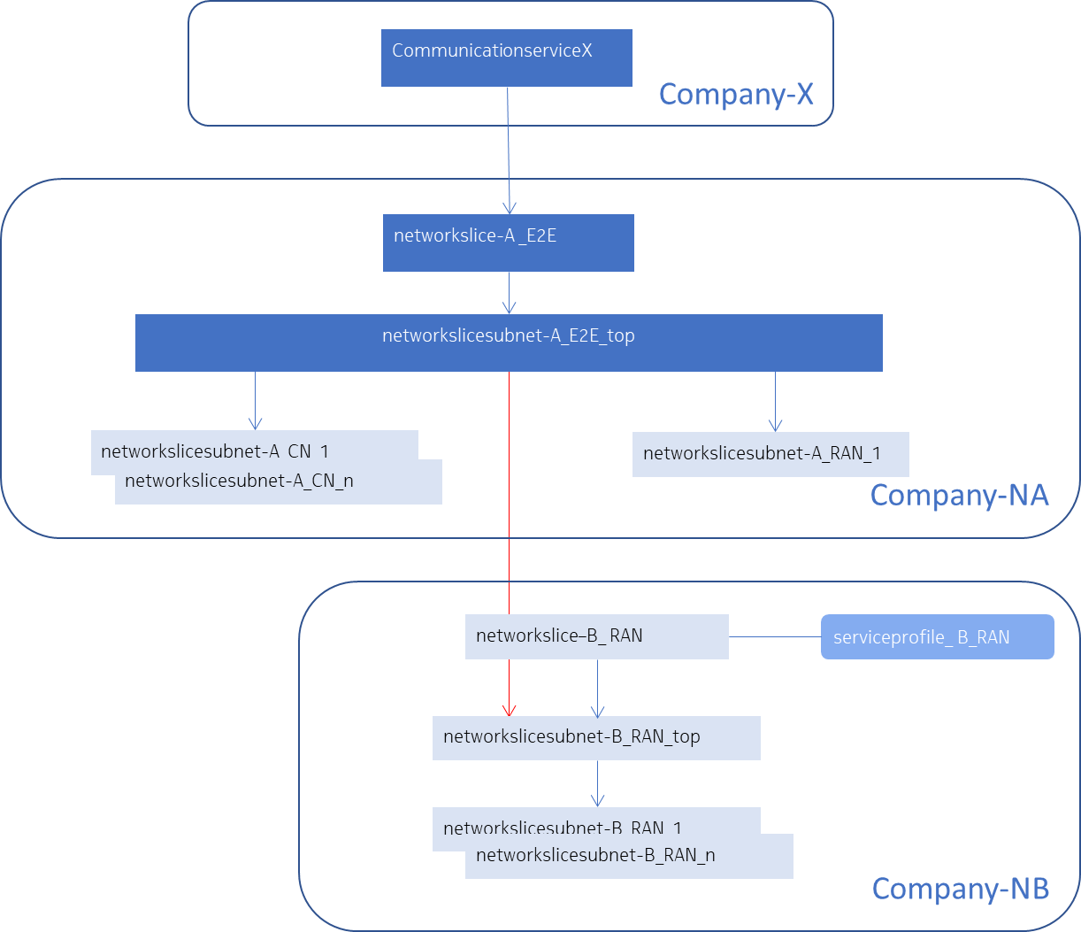
Figure 7.2.1.2-1 Topology view between Company-NA and Company-NB
The problems/limitations of the solution include:
1. It breaks the layering principles for a Telecommunications Management Network defined by ITU-T, where different layers have different views (scope, abstraction level, exposure etc.) to the network.
2. Generally, the service provider (SP) offers service to its customer (SC) as a Blackbox without exposing detailed network/resource topology (encapsulation/abstraction principle) in order to avoid leaking unnecessary sensitive information (need to know principle) and potential mis-use and mis-operation. Therefore, in a normal case, only service level object and related attributes would be exposed to the service consumer instead of exposing lower layer resources to external customer, especially when the resource is shared by multiple services of difference customers. In other words, generally an SC is not allowed to “decompose” or "reverse-engineer" the service (e.g. network slice) it gets from the SP and to use just a "building block" of the consumed service, such as partial resource of the service (i.e. a single network slice subnet or network function out of the entire network slice as a service). The service decomposition or reverse-engineering is usually explicitly prohibited (by the terms of the contract / SLA) as causing threat/risk to SP’s network.
3. Company-NA’s management system holds a reference to the top NetworkSliceSubnet MOI in Company-NB’s management system, and therefore the related SliceProfile. But there is no similar reference to the NetworkSlice MOI in Company-NB’s management system, and the related ServiceProfile. This implies that Company-NA is unable to track the SLA/SLS related to the ServiceProfile. Note that a reference to the NetworkSlice MOI in Company-NB’s management system is returned in the response to the allocateNsi operation, but the 3GPP NRM does not standardize how this should be stored in Company-NA’s management system.
4. The ServiceProfile is currently not suitable for expressing RAN only requirements. Attributes are expected to express e2e requirements. See descriptions as well as use of sources such as GSMA GST and TS 22.261. The ServiceProfile also doesn’t allow providing PLMN ID or S-NSSAI information. These values will be selected by Company-NA/NOP-A, and for RAN level must be part of input requirements.

7.2.2 Alternative 2: solution based on NRM extension - dual views of network slice
Company-NA sends to Company-NB an AllocateNsi operation request (cf. TS 28.531 clause 6.5.1) to ask to allocate a NetworkSlice instance to satisfy its network slice related requirements;
Company-NB sends back the AllocateNsi operation result to Company-NA. This result includes the relevant network slice instance information (an existing NetworkSlice instance may have been modified or a new NetworkSlice instance may have been created to satisfy the network slice related requirements - see TS 28.531 clause 6.5.1);
Company-NA can then create its end-to-end network slice based on local network slices provided by Company-NB.
Suggest to model network slice as combination (dual views) of service and resource. From one perspective, network slice can be treated as a service (commercial exposure) when it offered by network slice provider (NSP) to network slice customer (NSC). From another perspective, a network slice (either provided by the same operator in network slice as NOP internal mode or offered by a different operator in network slice as a service (NSaaS) mode) can be treated as a resource and therefore, stitched to a resource collection object (e.g. network slice subnet) to build another network slice. That implies a NetworkSlice MOI could be aggregated by a resource collection object, e.g. NetworkSliceSubnet MOI.
Editor's Note: the model details can be further elaborated.

7.2.3 Alternative 3: solution based on NRM extension - recursive network slice
Company-NA sends to Company-NB an AllocateNsi operation request (cf. TS 28.531 clause 6.5.1) to ask to allocate a NetworkSlice instance to satisfy its network slice related requirements;
Company-NB sends back the AllocateNsi operation result to Company-NA. This result includes the relevant network slice instance information (an existing NetworkSlice instance may have been modified or a new NetworkSlice instance may have been created to satisfy the network slice related requirements - see TS 28.531 clause 6.5.1);
Company-NA can then create its end-to-end network slice based on local network slices provided by Company-NB.
Suggest to update TS 28.541 Figure 6.2.1-1 to represent that a NetworkSlice IOC instance can be composed of other NetworkSlice IOC instances

7.2.4 Alternative 4: solution based on - support network slice subnet as a service
This clause describes how 3GPP management capabilities may be used to allow Company-NA to manage a network slice subnet service which is provided by Company-NB.
When receiving request for RAN coverage service, Company-NB BSS can issue a corresponding allocateNssi request to its own 3GPP management system with SliceProfile for RAN based on based on parameters received from Company-NA, also taking into account any existing agreements. The pLMNInfoList of the SliceProfile will capture PLMN ID of NOP-A as well as S-NSSAI within that PLMN selected by Company-NA/NOP-A. If successful, relevant and needed identifiers associated with the provided service are returned to Company-NA. Company-NA/NOP-A can then include this information as part of network slice representation in its own management system. This high-level ordering and provisioning procedure is illustrated in figure 7.2.4-1.
Editor’s note: Details of how to model an external constituent in NOP-A management system is for further study.
NOTE: The NetworkSliceSubnet instance allocated in NOP-B’s management system can be newly created or an existing instance can be used following procedure for allocateNssi, see TS 28.531 [3] clause 6.5.2 and clause 7.3. Compared to use cases without sharing, it is possible that for some NetworkSliceSubnet instances there will be no reference from other NetworkSliceSubnet instance or indirectly any NetworkSlice instance within NOP-B’s management system.
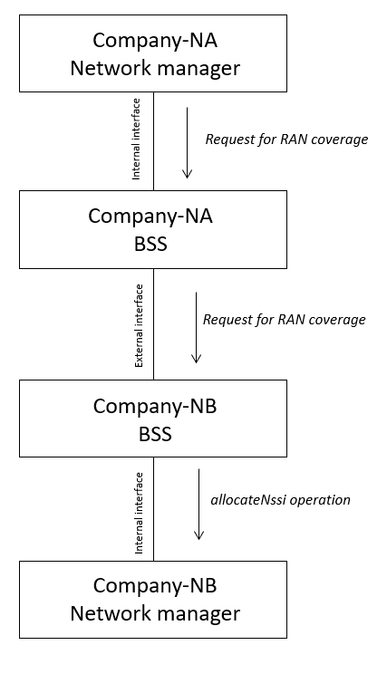
Figure 7.2.4-1 Provisioning phase
For basic support of the RAN sharing use case, it is not necessary for Company-NB to expose any capabilities beyond service lifecycle operations. But based on agreement Company-NB may expose additional management capabilities in provisioning or monitoring areas. This is illustrated in figure 7.2.4-2.
Such exposure should be setup to ensure that only capabilities related to the service provided to Company-NA are exposed. And if any provisioning operations are allowed, these must not interfere with use of network resources by other users.
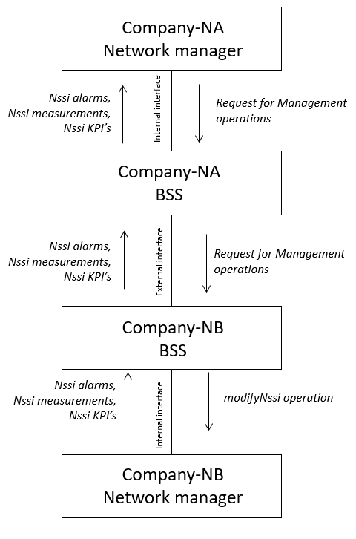
Figure 7.2.4-2 Operation phase

If Company-NB wishes to allow Company-NA to view operationalState or administrativeState of the NetworkSliceSubnet instance, Company-NB may allow Company-NA to interact with the BSS, the BSS has read access to the managed object NetworkSliceSubnet via the getMOIAttributes operation, defined in 28.532 [5].
If Company-NB wishes to allow Company-NA to control the adminstrativeState of the NetworkSliceSubnet instance, Company-NB may allow Company-NA to interact with the BSS, the BSS has write access to the managed object NetworkSliceSubnet via the modifyMOIAttributes operation, defined in 28.532 [5].
If Company-NB wishes to allow Company-NA to view alarms related to the NetworkSliceSubnet instance, Company-NB may expose management capabilities to the “FS Data Report for NSSI” Service via BSS, as described in 28.545 [6]. BSS in this case is allowed operations on behalf of Company-NA where the baseObjectInstance is equal to the DN of the NetworkSliceSubnet instance.
If Company-NB wishes to allow Company-NA to manage alarms related to the NetworkSliceSubnet instance, Company-NB may expose management capabilities to the “FS Control for NSSI” Service, via BSS as described in 28.545 [6]. BSS in this case is allowed operations on behalf of Company-NA where the baseObjectInstance is equal to the DN of the NetworkSliceSubnet instance.
If Company-NB wishes to allow Company-NA to view performance measurements related to the NetworkSliceSubnet instance, Company-NB may expose management capabilities to the operations and notifications described in 28.550 [7] via BSS. BSS should only expose measurements related to the S-NSSAI of the NetworkSliceSubnet instance.
If Company-NB wishes to allow Company-NA to view KPIs related to the NetworkSliceSubnet, Company-NB may expose the KPIs as described in 28.554 [8] via BSS. Company-NB should only expose KPIs related to the NetworkSliceSubnet instance or KPIs related to the S-NSSAI of the NetworkSliceSubnet instance.

7.2.x Solution analysis

7.2.x.1 Overview
One of the main differences between the described solution alternatives is whether the RAN coverage service is mapped in Company-NB systems to a NetworkSlice and ServiceProfile or NetworkSliceSubnet and SliceProfile. The chosen approach will have impact on a number of areas:
- Network slicing concepts and terminology
- NRM used to represent network slices and slice constituents in both Company-NA and Company-NB management systems
Below the main alternatives are compared in these areas followed by a summary and conclusions.

7.2.x.2 Concepts and Terminology Impact

7.2.x.2.1 Basic definitions
The basic definitions for network slicing are found in TS 28.530 [x] clause 3.1.
Impact if RAN service is based on network slice:
- The definition of network slice in TS 28.530 includes the following note: NOTE 2: Represent network slice defined in TS 23.501 [3] with added service properties. The specification TS 23.501 [z] mentioned here is produced by the SA2 WG, thus this note and reference ensures that the network slice definition remains consistent across 3GPP WGs. Looking further at TS 23.501, the following is stated in clause 5.15.1: A Network Slice instance is defined within a PLMN and shall include: - the Core Network Control Plane and User Plane Network Functions, as described in clause 4.2, […]. Thus according to definition in this specification a network slice cannot consist only of a RAN part. So for the solution alternative with RAN service based on network slice, the impact is very significant since it means alignment with other WGs for basic definitions is no longer maintained, and the corresponding reference must be removed from TS 28.530. This is also likely to cause confusion for readers of the specifications.
Impact if RAN service is based on network slice subnet:
- The use of network slice subnet should not introduce any conflicts with respect to definitions, since in single operator scenario the RAN part is already considered a network slice subnet.

7.2.x.2.2 Service provider terminology
Currently NSaaS is defined as concept for providing a network slice as a service, see TS 28.530 clause 4.1.6. A communication service provider supporting NSaaS in turn may be referred to as NSP, see TS 28.530 clause 4.8.
Impact if RAN service is based on network slice:
- No or minor impact, the current NSaaS and NSP concepts can still be used. However, meaning of NSaaS will vary depending on scenario.
Impact if RAN service is based on network slice subnet:
- For this alternative, it is necessary to introduce and describe concept of NSSaaS in TS 28.530. NSaaS would be kept as concept for scenario where e2e network slice is provided as a service. If NSSaaS is added, the NSP role should also be updated to reflect that it refers to provider of either NSaaS or NSSaaS communication service. Alternatively, addition of separate NSSP role could also be considered.

7.2.x.3 NRM Impact

7.2.x.3.1 Model in Company-NB management system
Note: When discussing use of ServiceProfile or SliceProfile below to provide input requirements, in both alternatives the profiles are assumed to be internal to Company-NB. Thus the set of attributes exchanged on the external interface between companies might not be identical. The detailed specification of APIs as well as attributes and allowed values are out of scope for 3GPP to specify and will also depend on business agreements.
Impact if RAN service is based on network slice:
- Object Model: The object hierarchy would include a NetworkSlice instance referencing a top NetworkSliceSubnet instance. But the NetworkSlice instance wouldn’t actually represent an entire e2e network slice in this case. This doesn’t match definition of NetworkSlice instance in 28.530 clause 3.1 which is directly connected to the network slice definition. Thus use of NetworkSlice IOC as well requires breaking alignment with other WGs fpr basic definitions.
- Profile attributes: Use of network slice would mean use of ServiceProfile to provide input requirements. But the ServiceProfile is currently not suitable for expressing RAN only requirements. Attributes are expected to express e2e requirements. See descriptions as well as use of sources such as GSMA GST and TS 22.261. One example is the latency attribute which describes latency as combination of latency from multiple domains. In addition, if the ServiceProfile would not always represent e2e requirements, it would likely be needed to define a mechanism for a consumer to specify what a particular ServiceProfile actually presents, e g e2e or RAN.
Impact if RAN service is based on network slice subnet:
- Object Model: The RAN service would have a corresponding SliceProfile supported by an allocated NetworkSliceSubnet instance. But unless the subnet instance is shared, there would not be any NetworkSlice or top NetworkSliceSubnet instance in Company-NB/NOP-B’s 3GPP management system referring to the RAN NetworkSliceSubnet instance. But this can be considered aligned with fact that Company-NA is responsible for the e2e network slice in this scenario. (Though due to being provided as abstracted RAN service, there would not be any direct references from Company-NA management system either.) The relationship diagram in TS 28.541 clause 6.2.1 already allows a NetworkSliceSubnet instance to exist without being referred to by any other NetworkSliceSubnet, and this is already needed e g for top slice subnets. An existing problem which is not unique to the multi-operator scenario is that according to the relationship diagram all NetworkSliceSubnet instances have a direct reference from a NetworkSlice instance which is not correct. So this error should in any case be addressed.
- Profile attributes: Use of network slice subnet would mean use of ServiceProfile to provide input requirements. SliceProfile can already be used to specify RAN-level requirements. The consumer also provides PLMN ID and S-NSSAI as input which is needed for this use case. In summary no impact on SliceProfile has yet been identified.

7.2.x.3.2 Model in Company-NA management system
If Company-NA wants to represent the RAN service obtained from Company-NB in it’s own management system, the current slice NRM cannot be used directly. The reason is that what is visible to Company-NA is the RAN service, while the NRM object instances in Company-NB’s management system are in general not directly visible or accessible. So to support this scenario, the slice NRM would have to be updated to support also references to externally provided services when used as network slice constituents. While the modelling might be slightly different depending on solution alternative, the impact should be similar.

7.2.x.4 Summary and conclusions
Based on analysis above, a solution is recommended where the RAN coverage service is mapped in Company-NB to a NetworkSliceSubnet instance and SliceProfile. The main reason is to ensure that the definition of network slice remains aligned across 3GPP WGs. This is also important to avoid confusion for specification readers and implementers. It is also believed that the impact on the slice NRM is smaller, since the SliceProfile datatype is already able to represent RAN only requirements.
In line with recommendation above it is additionally proposed to introduce the concept of NSSaaS and make corresponding updates mainly in TS 28.530.

7.x Possible solutions for network slice using multiple networks scenario 2 – national roaming
Editor’s Note: The solution for national roaming is FFS

Start of 2nd Change

8 Conclusions and recommendations

8.1 Conclusions
The following issues are identified in this study
- Depending on agreements between Network Operators, one Network Operator may expose management capabilities to the other Network Operator. This issue is in the scope of Work Item FS_NSCE.
- The network slice NRM in TS 28.541 [x] needs to be updated:
  - To allow use of NetworkSliceSubnet to realize a network slice subnet as a service
  - To support modelling of external network slice constituents
- The concepts clause (4.1) in 28.530 [4] needs to be updated and extended with NSSaaS, and role descriptions in clause 4.8 needs be updated to cover both NSaaS or NSSaaS.
- There is a need to correct any usage of network slice or NetworkSlice instance that is not consistent with definitions in TS 28.530 clause 3.1 or TS 23.501, focusing primarily on TS 28.530 and TS 28.531.
- The NetworkSlice IOC defined in 28.541 [2] should be updated to support outbound/inbound roaming.
- The Network Resource Model defined in 28.541 [2] should be updated to support granular isolation requirements on the network slice.
- The Network Resource Model defined in 28.541 [2] should be updated to support grouping of network slices with same isolation requirements and security level.
- NRM for Edge Configuration Server should include S-NSSAI for the edge application service. This issue is in the scope of Work Item FS_Eedge_Mgt.
- The NetworkSlice IOC defined in 28.541 [2] should be updated to support service level edge protection requirements.
- The NetworkSlice IOC defined in 28.541 [2] should be updated to support Network Slice Specific Authentication and Authorization (NSSAA) requirements.

8.2 Recommendations
The improvements to the Network Resource Model (as described in clause 7) are not currently in the scope of any existing Work Item. It is proposed that the scope of existing Work Item adNRM should be extended to add the following issues
- Support use of NetworkSliceSubnet to realize a network slice subnet as a service
- Support modelling of external network slice constituents
- Network slice support for outbound/inbound roaming
- Improved isolation for a network slice
- Grouping of network slices
- Support for service level edge protection requirements
- Support for Network Slice Specific Authentication and Authorization (NSSAA) requirements

Needed updates related to concepts and use of new and existing concepts originally identified in the network slicing RAN sharing scenario (clause 5.1 and 7.2) and as also described in conclusions (clause 8.1) are not currently in scope of any work item. It is proposed to make the following updates as part of Work Item MANS:
- Introduction of NSSaaS concept and update of roles in TS 28.530
- Updates related to any usage of network slice or NetworkSlice instance in TS 28.530 or TS 28.531 that is not consistent with current definitions

End of Change

