**3GPP TSG-SA5 Meeting #139-e *S5-215283***

**e-meeting, 11 - 20 October 2021**

**Source: ZTE**

**Title:** **Add potential solution for NRM enhancement to support MOCN network sharing**

**Document for: Approval**

**Agenda Item: 6.5.7**

# 1 Decision/action requested

***The group is asked to discuss and approve the proposals.***

# 2 References

[1] 3GPP TR 28.825: “Management and orchestration; Study on Management Aspects of 5G Network Sharing”

[2] 3GPP TS 28.541: “Management and orchestration; 5G Network Resource Model (NRM); Stage 2 and stage 3”

# 3 Rationale

This contribution proposes to add a potential solution for NRM enhancement to support MOCN network sharing.

# 4 Detailed proposal

|  |
| --- |
| **1st Change** |

## 5.Y Scenario #Y MOCN NG-RAN sharing with multiple CellIds

### 5.Y.1 Scenario description

For MOCN NG-RAN sharing with multiple cell identity broadcast scenario, different POPs use different PLMN Id, NR Cell Identity and TAC. For this scenario, several requirements have been identified which are listed in clause 5.Y.2. To fulfil these requirements, the enhancement of the NRMs is needed.

### 5.Y.2 Mangement requirements

**Req-MOCN-MultiCellId-Cfg-CON-2** The 3GPP management system shall have the capability to configure PLMN-IdentityInfo (including PLMNId, CellId, TAC) individually for each supported network operator.

**Req-MOCN-MultiCellId-Perf-CON-3** The 3GPP management system shall have the capability to collect and report some measurements (e.g. active UEs measurements, packet delay measurements) in PLMN granularity for different network operator.

**REQ-NS_NG-CON-1** The 3GPP management system of the MOP shall support a capability to manage both the non-shared network elements and shared network elements in a NG-RAN network at the same time.

**REQ-NS_NG-CON-2** The 3GPP management system of the MOP shall support a capability to configure the NG-RAN network element to start the sharing of one currently non-shared NG-RAN network element or stop the sharing of one currently shared NG-RAN network element.

**REQ-NS_NG-CON-3** The 3GPP management system of the MOP shall support a capability to configure the POP-specific attributes of the shared NG-RAN individually based on the POPs’ requirements.

### 5.Y.3 Potential solution

To fulfil the requirements listed in clause 5.Y.2, the following enhancements are proposed.

1. Add new IOCs DUCommonPart and CellCommonPart

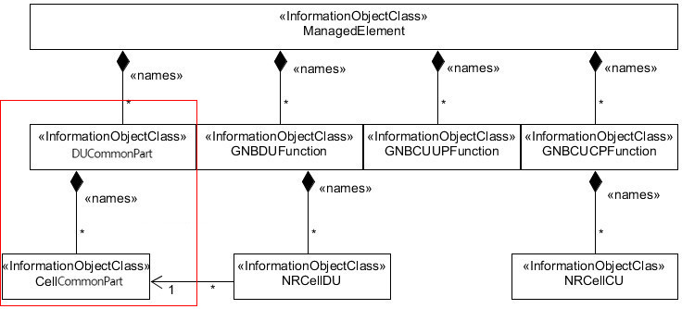

* **DUCommonPart(O)**

This IOC represents the common part of a shared DU.

Note: If NG-RAN sharing with multiple Cell Identities is not supported, then this IOC is not used.

The DUCommonPart IOC includes attributes inherited from TOP IOC (defined in TS 28.622[30]) and the following attributes:

|  |  |  |  |  |  |
| --- | --- | --- | --- | --- | --- |
| Attribute name | Support Qualifier | isReadable | isWritable | isInvariant | isNotifyable |
| masterPLMNId | M | T | T | F | T |
| sharedDUId | M | T | T | F | T |

* **CellCommonPart (O)**

This IOC represents the common part of a physical cell on a DU.

Note: If NG-RAN sharing with multiple Cell Identities is not supported, then this IOC is not used.

The CellCommonPart IOC includes attributes inherited from TOP IOC (defined in TS 28.622[30]) and the following attributes:

|  |  |  |  |  |  |
| --- | --- | --- | --- | --- | --- |
| Attribute name | Support Qualifier | isReadable | isWritable | isInvariant | isNotifyable |
| physicalCellDUId | M | T | T | F | T |
| operationalState | M | T | F | F | T (see Note 2) |
| administrativeState | M | T | T | F | T (see Note 2) |
| cellState | M | T | F | F | T (see Note 2) |
| nRPCI | M | T | T | F | T |
| ssbFrequency | CM | T | T | F | T |
| ssbPeriodicity | M | T | T | F | T |
| ssbSubCarrierSpacing | CM | T | T | F | T |
| ssbOffset | M | T | T | F | T |
| ssbDuration | M | T | T | F | T |
| arfcnDL | M | T | T | F | T |
| arfcnUL | CM | T | T | F | T |
| arfcnSUL | CM | T | T | F | T |
| bSChannelBwDL | M | T | T | F | T |
| bSChannelBwUL | CM | T | T | F | T |
| bSChannelBwSUL | CM | T | T | F | T |
| **Attribute related to role** |  |  |  |  |  |
| nRSectorCarrierRef | M | T | T | F | T |
| bWPRef | M | T | T | F | T |
| nRFrequencyRef | CO | T | T | F | T |
| victimSetRef | CM | T | T | F | T |
| aggressorSetRef | O | T | T | F | T |
| Note 1: No state propagation is implied.  Note 2: The attribute value change is conveyed by the notifyStateChange notification. | | | | | |

1. Change support qualifier of existing IOC NRCellDU

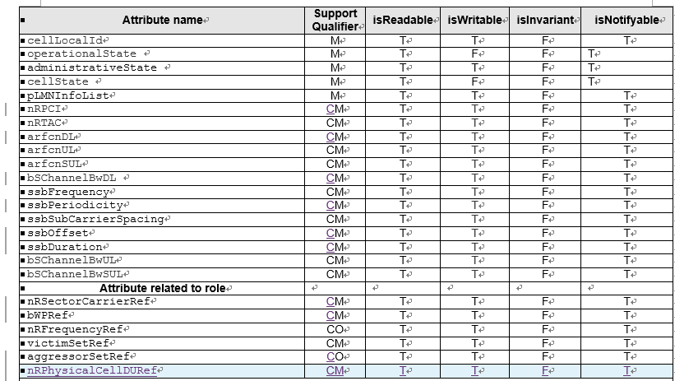

Condition: NG-RAN sharing with multiple Cell Identities is not supported.

1. Change the relationships of IOCs BWP and NRSectorCarrier for the MOCN NG-RAN sharing with multiple Cell-Ids scenario

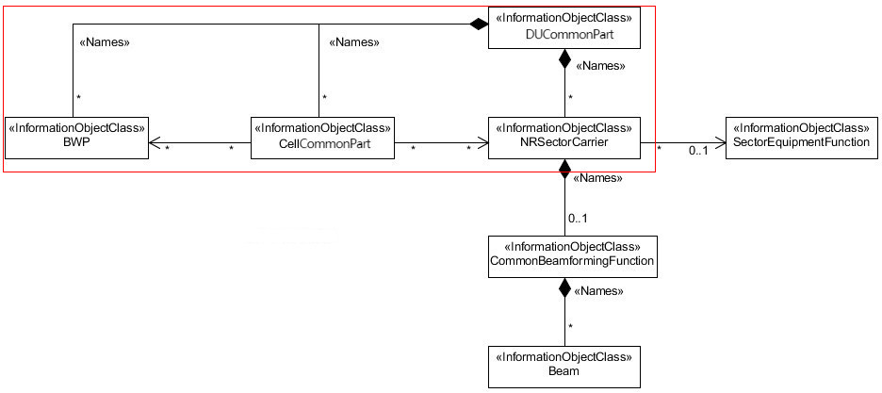

Editor’s Note: above potential solution need to be revisited according to further discussion based on other existing requirements or new requirements

|  |
| --- |
| **End of Changes** |