3GPP TSG-SA5 Meeting #139e S5-215226

e-meeting, 11 – 20 Oct 2021

Source: Nokia, Nokia Shanghai Bell

Title: TD enhance management service to support authentication

Document for: Discussion and Endorsement
Agenda Item: 6.4.23

1 Decision/action requested
Please discuss and endorse

2 References
[1] 3GPP TR 28.817: "Management and orchestration; Study on access control for management service".
[2] 3GPP TS 28.622: "Telecommunication management; Generic Network Resource Model (NRM) Integration Reference Point (IRP); Information Service (IS)".
[3] 3GPP TS 28.623: "Telecommunication management; Generic Network Resource Model (NRM) Integration Reference Point (IRP); Solution Set (SS) definitions".
[4] 3GPP TS 28.532: "Management and orchestration; Generic management services".

3 Rationale
According to conclusion in TR 28.817, the service based management architecture, Network Resource Model and Generic Management Service should be updated to support authentication, authorization and audit capabilities.
Solution to enhance Service Based Management Architecture (SBMA) to support authentication capability was proposed in TR 28.817 as following:
- Authentication service producer provides identity management capabilities. Identity management of MnS consumers and producers includes creating, reading, updating and deleting identities.
- Authentication service producer provides credential management capabilities. Credential management of MnS consumers includes creating, reading, updating and deleting credentials.
- Authentication service producer provides authentication policy management capabilities. Authentication policy management of MnS consumers and producers includes creating, reading, updating and deleting authentication policies.
- Authentication service producer provides capabilities for authentication of MnS consumer. Authentication service producer issues an assertion to the MnS consumer after successfully authenticated the MnS consumer.
- MnS producer validates the assertion issued by trusted authentication service producer to authenticate a MnS consumer.
What is the exact change in stage 2 and stage 3 will be decided in normative phase.
This discussion paper proposed solution to enhance generic NRM and management service to support authentication.

4 Detailed proposal

4.1 Add following authentication procedure of 3GPP management system in an Annex of 28.533, 28.532 or 28.622

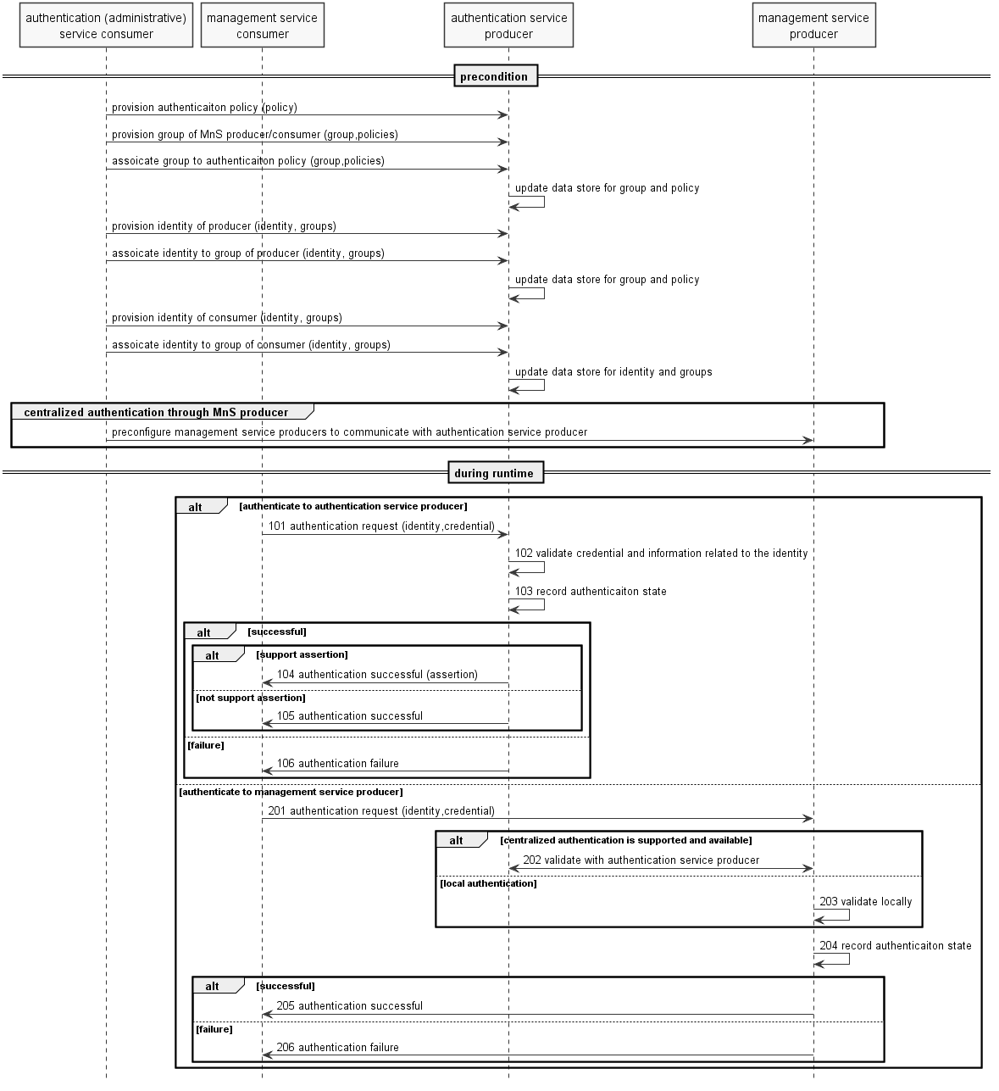

Note: the authentication (administrative) service consumer could be portal or other tool of operator on which acting on behalf of administrator of operator.
Assumption: mutual authentication between authentication (administrative) service consumer and authentication/management service producer, as well as between management service producer and authentication service producer, has been done, which is operator's implementation dependant.
Precondition:
- Authentication service producer creates/updates/deletes an authentication policy when received policy provisioning request.
- Authentication service producer creates/updates/deletes a group of MnS producers/consumers when received group provisioning request. The Authentication service producer may associate the group to authentication policies if the policies are in the request, otherwise the producer may assign default policies to the group.
- Authentication service producer updates data store with the group and policies information.
- Authentication service producer creates/updates/deletes an identity of producer/consumer when received identity provisioning request. The Authentication service producer may associate the identity to group(s) if group information is in the request, otherwise the producer associates the identity to a default/preconfigured groups according to type, domain, organization, etc., in the identity information.
- Authentication service producer updates data store with the identity and group(s) information.
- In case management service consumer authenticates to management service producer and centralized authentication service is supported and available, the management service producer is preconfigured to communicate with the authentication service producer. The configuration information including, e.g. connectivity related info, security communication related info, as well as identity and policy related info.
Note: potential identity, group and policy update in management service producer to support local authentication is implementation dependent. Identity, group and policy management in authentication service producer should support authentication requests from either MnS consumer or MnS producer.

Procedure:
Assumption: The MnS consumer successfully authenticated (or validate the authenticity of) authentication/management service producer.
Option 1: management service consumer authenticates with common authentication service producer
101. When receives authentication request, authentication service producer gets the identifier and credential of the MnS consumer, probably other context information (e.g. address of the client) from the request.

Note 1: challenges may be exchanged between management service consumer and authentication service producer before send credential for some authentication protocols.
102. Based on identifier in the request, authentication service producer gets identity information, e.g. status of the identity, associated group(s) of the identity, credential of the identity, etc., from data store. Then the producer authenticates the MnS consumer by validating the identity information and other context (e.g. time, location of the consumer) according to authentication policies (e.g. authentication factor, protocol, supported time, location, status of the consumer, etc. ) associated to the group(s) the MnS consumer belongs to.
103. The authentication service producer updates the authentication state of the MnS consumer in the data store after authenticated the MnS consumer.
Note 2: If authenticate successfully and authentication assertion is supported by the protocol, the authentication service producer constructs authentication assertion and may update the assertion of the MnS consumer in the data store.

104. If authenticate successfully and authentication assertion is supported by the protocol, the authentication service producer sends successful response with an authentication assertion to the consumer.
105. If authenticate successfully and authentication assertion is not supported by the protocol, the authentication service producer sends successful response without authentication assertion to the consumer.
106. If fail for authentication, the authentication service producer sends failure response to the consumer.
Option 2: management service consumer authenticates with management service producer
201. When receives authentication request, management service producer gets the identifier and credential of the MnS consumer, probably other context information (e.g. address of the client) from the request.
Note 3: it could be "implicit" authentication request which is part of management session setup request in some protocols.
Note 4: challenges may be exchanged between management service consumer and authentication service producer before send credential for some authentication protocols.

202. If centralized authentication is required according to policy and authentication service producer is available, management service producer passes identity information (e.g. identifier, credential) of the management service consumer to the authentication service producer. The authentication service producer validates the identity information together with other context according to authentication policies associated to the group(s) the MnS consumer belongs to, and returns authentication result to the management service producer.
203. If centralized authentication is not supported or available, and local authentication is supported by management service producer and accepted according to policy, management service producer authenticates the MnS consumer by validating the identity information and other context according to local configuration.

204. The management service producer updates the authentication state of the MnS consumer in the data store.
205/206. The management service producer returns the authentication result to the consumer.

4.2 Add authentication related NRM fragment in generic NRM.

4.3 Add authentication related operation in 28.532.

Please endorse proposal 4.1, 4.2 and 4.3

