3GPP TSG-SA5 Meeting #139-e S5-215208rev2

e-meeting, 11 - 20 October 2021

Source: Huawei

Title: Add MDA analysis report reporting related service component

Document for: Approval
Agenda Item: 6.4.18

1 Decision/action requested
This contribution is for approval.

2 References
[1] 3GPP TR 28.809 Management and orchestration; Study on enhancement of Management Data Analytics (MDA)
[2] 3GPP TS 28.104-000 Management and orchestration; Management Data Analytics (MDA)

3 Rationale
This pCR is proposed to add MDA analysis report reporting related service component in TS 28.104[2].

4 Detailed proposal
It is proposed to add the following chapter in TS 28.104[2].
1st Change

2 References
The following documents contain provisions which, through reference in this text, constitute provisions of the present document.
- References are either specific (identified by date of publication, edition number, version number, etc.) or non-specific.
- For a specific reference, subsequent revisions do not apply.
- For a non-specific reference, the latest version applies. In the case of a reference to a 3GPP document (including a GSM document), a non-specific reference implicitly refers to the latest version of that document in the same Release as the present document.
[1] 3GPP TR 21.905: "Vocabulary for 3GPP Specifications".
[2] 3GPP TS 32.500: "Telecommunication management; Self-Organizing Networks (SON); Concepts and requirements".
[3] 3GPP TS28.535: “Management services for communication service assurance; Requirements”.
[4] 3GPP TS 28.552: "Management and orchestration; 5G performance measurements".
[5] 3GPP TS 28.554: "5G end to end Key Performance Indicators (KPI)".
[6] 3GPP TS 32.422: "Telecommunication management; Subscriber and equipment trace; Trace control and configuration management".
[7] 3GPP TS 32.423: "Telecommunication management; Subscriber and equipment trace; Trace data definition and management".
[8] 3GPP TS 28.405: "Telecommunication management, Quality of Experience (QoE) measurement collection; Control and configuration".
[9] 3GPP TS 28.406: "Telecommunication management; Quality of Experience (QoE) measurement collection; Information definition and transport".
[10] 3GPP TS 23.288: "Architecture enhancements for 5G System (5GS) to support network data analytics services".
[11] 3GPP TS 28.532: "Management and orchestration; Generic management services".
[y] 3GPP TS 28.622: "Telecommunication management; Generic Network Resource Model (NRM) Integration Reference Point (IRP); Information Service (IS)".
[z] 3GPP TS 28.541: "Management and orchestration; 5G Network Resource Model (NRM); Stage 2 and stage 3".

Next Change

9 Information model definitions for MDA

9.1 Imported and associated information entities

9.1.1 Imported information entities and local labels
Label reference | Local label
TS 28.622 [y], IOC, ManagedFunction | ManagedFunction
TS 28.622 [y], IOC, ManagedElement | ManagedElement
TS 28.622 [y], IOC, SubNetwork | SubNetwork

9.1.2 Associated information entities and local labels
Label reference | Local label
TS 28.622 [y], IOC, ManagedElement | ManagedElement
TS 28.622 [y], IOC, SubNetwork | SubNetwork

9.2 Class diagram

9.2.1 Relationships
This clause provides the relationships of relevant classes in UML.

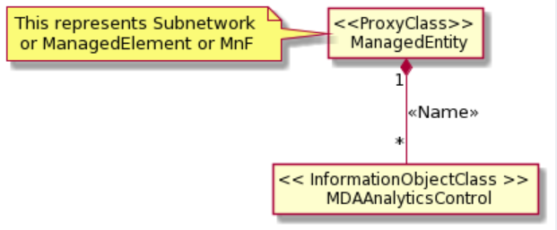
Figure 9.2.1-1: NRM fragment for MDA Analytics control
Note: The Subnetwork can be RAN Subnetwork or CN Subnetwork or Cross-domain Subnetwork, depends on the detailed use case.

9.2.2 Inheritance
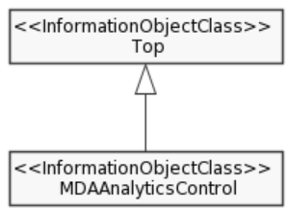
Figure 9.2.2-1: Inheritance Hierarchy

9.3 Class definitions

9.3.1 ClassName <<MDAAnalyticsControl>>

9.3.1.1 Definition
This <<IOC>> MDAAnalyticsControl represents the MDA analysis report request Control and Configuration parameters of MDA analysis service capabilities.
To request a desired MDA analysis report, a MDAS consumer has to create MDAAnalyticsControl object instance on the MDAS producer.

9.3.1.2 Attributes
Attribute name | Support Qualifier | isReadable | isWritable | isInvariant | isNotifyable
analyticsType | M | T | T | F | T
reportingMethod | M | T | T | F | T

9.3.1.3 Attribute constraints
None.

9.3.1.4 Notifications
The common notifications defined in clause 4.5 as defined in TS 28.541[z] are valid for this IOC, without exceptions or additions.

9.4 Attribute definitions

9.4.1 Attribute properties
Attribute Name | Documentation and Allowed Values | Properties
analyticsType | It indicates the type of MDA capability for analysis.  AllowedValues:  Editor's Note: the allowed value is FFS which depends on the detailed analytic use case. | type: String  multiplicity: 1  isOrdered: N/A  isUnique: N/A  defaultValue: None  isNullable: True
reportingMethod | It indicates the report method include file or stream of MDA report reporting.  AllowedValues:  File or stream  Editor's Note: the detailed allowed value is FFS | type: Integer  multiplicity: 1  isOrdered: N/A  isUnique: N/A  defaultValue: NULL  isNullable: False

9.4.2 Constraints
Name | Affected attribute(s) | Definition

9.5 Common notifications
This clause presents notifications that may be referred to by any class defined in the specification. This information is provided in tables.

9.5.1 Alarm notifications
Name | Qualifier | Notes

9.5.2 Configuration notifications
Name | Qualifier | Notes

9.5.3 Threshold Crossing notifications
Name | Qualifier | Notes

Next Change

10 MDA related service components
Editor’s note: Whether putting section 8 (MDA capability data definitions) and section 9 (Information model definitions for MDA) inside section 10 (MDA related service components) is to be evaluated for better readability when we have related content in this specification.

10.1 MDA MnS Service components

10.1.1 General
TBD

10.1.2 MDA report request and control

10.1.2.1 Service components

10.1.2.1.1 Service component A
See clause 11.1.1 of TS 28.532 [x] for operations related to MDA request control.

10.1.2.1.2 Service component B
See MDAAnalyticsControl IOC defined in clause 9.

8

8

MnS component type B

End of changes

