3GPP TSG SA WG5 Meeting 139-e S5-215157
Electronic meeting, online, 11 - 20 October 2021

Source: Huawei

Title: pCR TS28.100 Add Autonomous network level for service experience optimization

Document for: Approval
Agenda Item: 6.4.9

1 Decision/action requested
The group is asked to discuss and approval.

2 References
[1] 3GPP draft TS 28.100: “Management and orchestration; Levels of autonomous network v0.5.0”.

3 Rationale
This contribution proposes to add autonomous network level for service experience optimization including workflow, autonomous network levels.

4 Detailed proposal
It proposes to make the following changes to TS 28.100 [1].
1st Change

6.4 Network and service optimization scenarios
Editor's Note: this clause will contain the typical management use cases corresponding to telecom network and communication service optimization scenarios and related management requirements for each autonomous levels. The management requirements include architecture requirements, enhancements of management and orchestration, important data and data collection policy and key management requirements on autonomous network related features.

6.4.1 Autonomous network level for radio network coverage optimization
Radio networks are geographically distributed, and mobile user activity varies significantly in different places and at different times of day. To achieve the optimal coverage, a set of initial coverage configuration parameters (e.g. coverageShape, digitalTilt and digitalAzimuth) may not always meet the requirements. Therefore, the coverage configuration parameters need to be adjusted in a differentiated manner with the change of the radio network environment. It’s complex for the adjustment due to multiple factors needs to be considered, e.g. interference control, huge data and frequent traffic changes. So introducing the autonomous network level for radio network coverage optimization will benefit for operator to achieve the full autonomy goal step by step and have clear view on which typical issues can be addressed by utilizing autonomy mechanism in corresponding steps. The requirements for each autonomous level for radio network coverage optimization are different.

6.4.2 Autonomous network level for RAN UE throughput optimization
RAN UE throughput is a key performance for radio network, and, numerous radio feature parameters with broad value ranges affect the RAN UE throughput. There are many radio feature parameters of RAN NE level or cell level, for examples, MLB related parameters, resource schedule related parameters, cell reselection related parameters, handover related parameters, different radio feature parameters affect each other and the combination number of various parameter values is large. Therefore, it’s complex to adjust radio feature configuration parameters to achieve the optimized RAN UE throughput. So introducing the autonomous network level for Service experience optimization will be benefit for operator to achieve the full autonomy goal step by step and have clear view on which typical issues can be addressed by utilizing autonomy mechanism in corresponding steps. The requirements for each autonomous level for RAN UE throughput optimization are different.
6.4.3 Autonomous network level for service experience optimization
Service experience optimization use case refers to the entire workflow of network service experience optimization, autonomy of service experience optimization can help the network operator to reduce OPEX by reducing manual involvement in such tasks and to optimize service experience. However, full autonomy of service experience optimization is a long term goal, it will be beneficial for operator to achieve this goal step by step and have clear view on which typical issues can be addressed by utilizing network autonomy mechanism in corresponding steps. The requirements for each autonomous level for service experience optimization autonomy are different.
2nd Change

7.x Generic autonomous network level for service experience optimization

7.x.1 Generic workflow

Following are the entire workflow for the service experience optimization:
Intent handling:
- Task A: Service experience optimization policies generation and determination. The tasks of generating and determining the service experience optimization related policies based on received sService experience optimization intent (e.g. service experience optimization targets for a hotspot).
- Task B: Service experience optimization intent fulfilment evaluation. The tasks of evaluating service experience optimization intent fulfilment information (e.g. corresponding service experience optimization targets are satisfied or not).
Awareness:
- Task C: Service experience related information collection. The tasks of data collecting, filtering and sorting, service identification: The tasks of collecting service experience related data (e.g. user-plane data，signalling data, UE related data, performance data and alarms).
Analysis:
- Task D: Service recognition. The tasks of identifying the service type (e.g. DASH, MTSI) based on the collected data information.
- Task E: Service experience issues identification. The tasks of analysing the service experience issues (e.g. service quality deterioration comparing to the desired values or desired models,).
- Task F: Service experience issues demarcation. The task of analysing the corresponding domain of the service experience issues (e.g. RAN, CN).
- Task G: Service experience issue analysis. The tasks of analysing the root cause (e.g. capacity issue, congestion of a specified domain) of the identified service experience issues.
- Task H: Service experience adjustment solutions generation. The tasks of generating the recommended service experience adjustment solutions which can address the identified or predicted service experience issues (e.g. the corresponding domain need to be adjusted, QCI update of users).
Decision:
- Task I: Service experience adjustment solutions evaluation and determination; The decision of requesting domain to act according to the recommended solutions. The tasks of evaluating the recommended service experience adjustment solutions, and deciding the request to the domain or the users to act according to the recommendations.
Execution:
- Task J: Service experience adjustment solutions execution. The tasks of sending the request to domain to do the execution of service experience adjustment solutions and the domain executes the adjusting of the service experience optimization related parameters.

7.x.2 Generic autonomous network level
Level 0:
- All the tasks in the Service experience optimization workflow (Task A, Task B, Task C, Task D, Task E, Task F, Task G, Task H) are accomplished by human.
Level 1:
- Telecom system executes the tasks of service experience adjustment solutions execution based on the specified service experience related parameters (Task J). Telecom system also can execute the tasks of service experience related information collection based on the specified collection rule (Task C). At this level, telecom system can assist human to improve the execution and awareness efficiency for service experience optimization.
- All the other tasks in the Service experience optimization workflow (Task A, Task B, TaskD, Task E, Task F, Task G, Task H, Task I) are accomplished by human.
Level 2:
- Compared to Level 1, telecom system additionally executes the tasks of service experience issues identification, service experience issue demarcation and service experience issue analysis based on the specified analysis rules (Task E, Task F, Task G). The tasks of service experience adjustment solutions execution (Task J) is fully accomplished by telecom system.
- All the other tasks in the service experience optimization workflow (Task A, Task B, Task D, Task H, Task I) are accomplished by human.
Level 3:
- Compared to Level 2, telecom system additionally executes the tasks of service recognition (Task D), Service experience adjustment solutions generation (Task H), service experience adjustment solutions evaluation and determination (Task I) based on the specified service experience adjustment policies and evaluation policies. Telecom system fully executes the service experience related information collection (Task C).
- All the other tasks in the Sservice experience optimization workflow (Task A, Task B) are accomplished by human.
Level 4:
- Compared to Level 3, the telecom system additionally executes the tasks of service experience optimization policies determination (Task A), and service experience optimization intent evaluation (Task B) based on received service experience optimization intent and intent translation/evaluation policies. The tasks of service recognition(Task D), service experience issues identification (Task E), service experience issues demarcation(Task F), service experience issue analysis (Task G), service experience adjustment solutions generation (Task H) and Service experience adjustment solutions evaluation and determination (Task I) are fully accomplished by telecom system.
- The intent translation and evaluation policies maybe pre-defined and specified by human to assist the telecom system.
Level 5:
- Telecom system can autonomously execute the entire workflow of service experience optimization for all scenarios, which means the telecom system can achieve the full autonomy for service experience optimization for full scenarios.
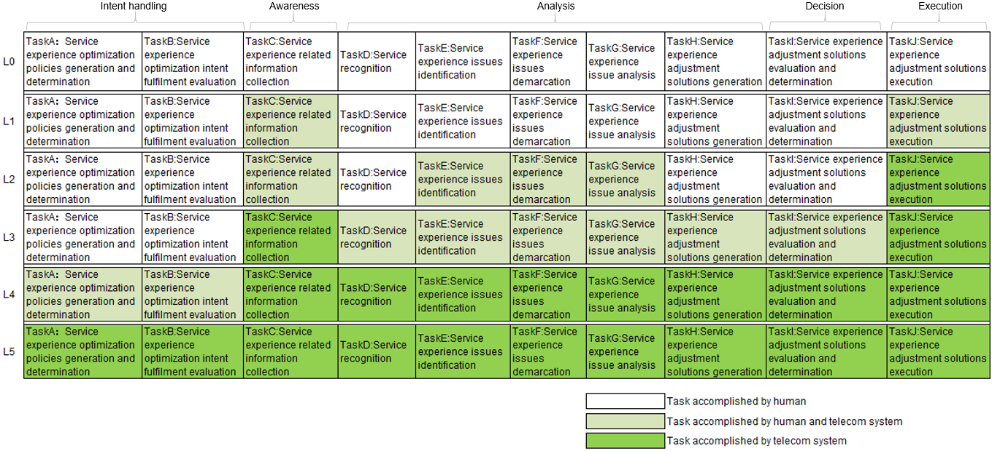
Figure X Classification of autonomous network level for service experience optimization

7.x.3 Generic autonomoy capability description
Level 1 for Service Experience Optimization: The 3GPP management system has the following autonomy capabilities:
- Collect service experience related data based on specified collection rules
Level 2 for Service Experience Optimization: The 3GPP management system has following autonomty capabilities:
- Identify the service experience issues based on service experience issues identification rules.
- Demarcate the service experience issues based on the service experience issues demarcation rules.
- Analyse the service experience issue root cause based on the service experience issue root cause analysis rules.
Level 3 for Service Experience Optimization: The 3GPP management system has the following autonomy capabilities:
- Recognize the service type based on the service recognition policies.
- Generate the recommended service experience optimization mechanism and determine the service experience optimization actions to be executed based on specified service experience optimization mechanism analysis and decision policies.

7.3.4 Generic MnS requirements

7.x.4.1 MnS requirements to support autonomous network level 1
REQ-ANL-SerExpOpt-Level_1-MnS-1 The 3GPP management system shall have the capability allowing its authorized consumer to obtain service experience related data (e.g. user-plane data，signalling data, UE related data, performance data and alarms, QoE data.)
This is implemented by file data reporting MnS and streaming data report MnS defined in TS 28.532 [4] with measurements defined in TS 28.552 [7], KPI defined in TS 28.554[8], MDT data defined in TS 32.422 [9], QoE measurement defined in TS 28.405 [X].

7.x.4.2 Additional MnS requirements to support autonomous network level 2
REQ-ANL-SerExpOpt-Level_2-MnS-1 The 3GPP management system shall have the capability allowing its authorized consumer to specify service experience issues identification control information.

REQ-ANL-SerExpOpt-Level_2-MnS-2 The 3GPP management system shall have the capability allowing its authorized consumer to specify the service experience issues demarcation control information.

REQ-ANL-SerExpOpt-Level_2-MnS-3 The 3GPP management system shall have the capability allowing its authorized consumer to specify the service experience issue root cause analysis control information.

7.x.4.3 Additional MnS requirements to support autonomous network level 3
REQ-ANL-SerExpOpt-Level_3-MnS-1 The 3GPP management system shall have the capability allowing its authorized consumer to specify the service recognition control information.

REQ-ANL-SerExpOpt-Level_3-MnS-2 The 3GPP management system shall have the capability allowing its authorized consumer to specify the service experience adjustment solutions control information.

REQ-ANL-SerExpOpt-Level_3-MnS-3 The 3GPP management system shall have the capability allowing its authorized consumer to specify the service experience adjustment solution decision control information.

3rd Change

7.3.X Solutions for generic MnS requirements
Autonomous Network Level | Requirements  (Defined in Clause 7.1.4) | Corresponding solutions
Level 1 | REQ-ANL-SerExpOpt-Level_1-MnS-1 | This is implemented by file data reporting MnS and streaming data report MnS defined in TS 28.532 [4] with measurements defined in TS 28.552 [7], KPI defined in TS 28.554[8], MDT data defined in TS 32.422 [9], QoE measurement defined in TS 28.405 [X].
Level2 | REQ-ANL-SerExpOpt-Level_2-MnS-1 | This can be implemented by provisioning MnS (e.g, createMOI) defined in TS 28.532 [4] to specify service experience issues identification control information.
Level2 | REQ-ANL-SerExpOpt-Level_2-MnS-2 | This is implemented by generic provisioning MnS defined in TS 28.532 [4] to specify the service experience issues demarcation control information.
Level2 | REQ-ANL-SerExpOpt-Level_2-MnS-3 | This is implemented by generic provisioning MnS defined in TS 28.532 [4] to specify the service experience issue root cause analysis control information.
Level3 | REQ-ANL-SerExpOpt-Level_3-MnS-1 | This can be implemented by using generic provisioning MnS defined in TS 28.532 [4] to specify the service recognition control information.
Level3 | REQ-ANL-SerExpOpt-Level_3-MnS-2 | This can be implemented by using generic provisioning MnS defined in TS 28.532 [4] to specify the service experience adjustment solutions control information.
Level3 | REQ-ANL-SerExpOpt-Level_3-MnS-3 | This can be implemented by using generic provisioning MnS defined in TS 28.5326 [4] to specify the service experience adjustment solution decision control information.

End of changes

