3GPP TSG SA WG5 Meeting 138-e S5-215152rev5

e-meeting, 11th - 20th Oct. 2021

Source: Alibaba Group, AsiaInfo

Title: Solution for eMnS discovery service

Document for: Approval
Agenda Item: 6.5.4

1 Decision/action requested
The group is asked to discuss and approve the proposal..

2 References
[1] 3GPP TR 28.824: " Study on network slice management capability exposure " V0.2.0

3 Rationale
This contribution provides the solution for the use case – eMnS discovery service and the use case – eMnS support to discovery systems.

4 Detailed proposal
Start of 1st Change

7.X Solutions for eMnS discovery service

7.X.1 General
This subclause provides potential solutions for use case - eMnS discovery service (see subclause 5.3) and use case – eMnS support to discovery systems (see subclause 5.4).

7.X.2 exposed MnS discovery service
This solution is to propose a mechanism for exposed MnS discovery. TS 28.533 describes an MnS discovery service mechanism. The MnS producer can register its MnS data, containing the information of available MnS instance, to the MnS discovery service producer. An MnS discovery service consumer can make request for MnS discovery service.
In the context of capability exposure, there is a similar need to register the eMnS data so that potential eMnS consumers can discover the exposed network slice capabilities. For example, an exposed MnS instance (e.g exposed MnS instance regarding NetworkSlice) may only have limited capabilities (e.g. Read only, alarm only, etc) for external consumer. Therefore, the exposed MnS data is different from MnS data because the exposed MnS data may indicate the MnS instances with different capabilities.
Editor’s notes: What is the role of external consumer of exposed MnS discovery service is FFS.
The following figure shows the procedure for exposed MnS discovery:
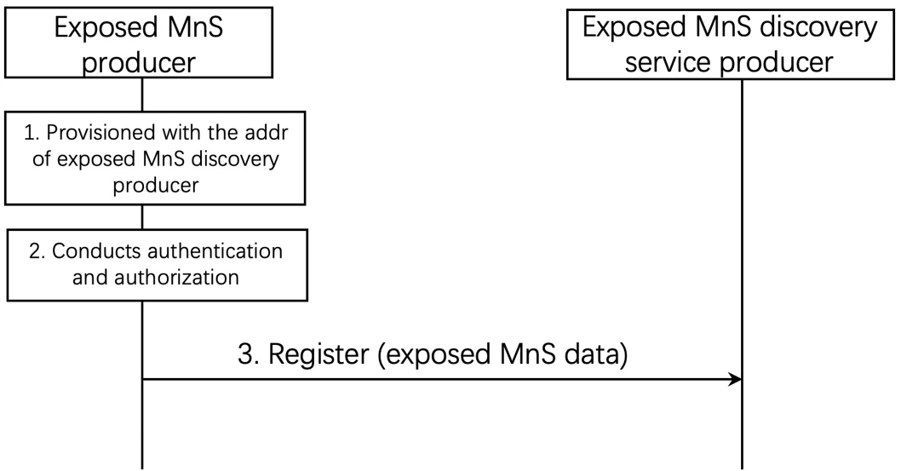
Figure 7.x.2-1 Exposed MnS discovery service registration
1-2. The exposed MnS producer is provisioned with the address of exposed MnS discovery producer and conducts the authentication and authorization for accessing exposed MnS discovery service;
3. The exposed MnS producer sends registration request, containing exposed MnS data, to the exposed MnS discovery service producer. The exposed MnS data contains the information of exposed MnS instance (e.g. exposed MnS instance regarding NetworkSlice, notification).
The operator may design and implement an EGMF which is capable of exposing the eMnS. This EGMF publishes the eMnS data to the appropriate discovery service/system (e.g. eMnS discovery service producer).

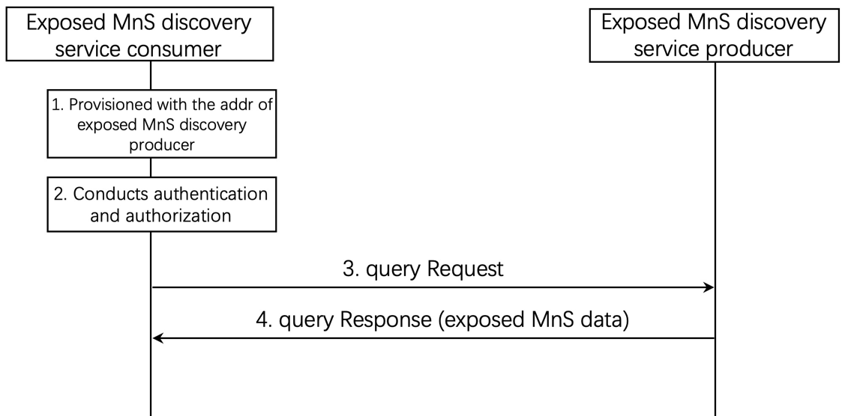

Figure 7.x.2-2 Exposed MnS discovery
1. The exposed MnS discovery service consumer is provisioned with the address of exposed MnS discovery producer;

2. The exposed MnS discovery service consumer conducts authentication and authorization for accessing exposed MnS discovery service;

3. The exposed MnS discovery service consumer sends request to exposed MnS discovery service producer;
4. Upon the receipt of the request, the exposed MnS discovery service producer sends a response, containing exposed MnS data which includes information of the exposed MnS instance, to the exposed MnS discovery service consumer.
End of Change

