3GPP TSG SA WG5 Meeting 139-e S5-215115

electronic meeting, online, 11 -20 October 2021

Source: China Unicom

Title: Add requirement and potential solution for NRM enhancement to support network sharing

Document for: Approval
Agenda Item: 6.5.7

1 Decision/action requested
It proposes to discuss and endorse

2 References
[1] S5-211444 Discussion paper for NR NRM support 5G MOCN network sharing scenario
[2] S5-205304 Discussion on NR NRM update to support MOCN network sharing scenario
[3] S5-212270 RAN Sharing NRM support for MOCN
[4] S5-212197 Rel-17 CR TS 28.541 Enhance the NRM definitions to support NG-RAN network sharing
[5] 3GPP TS 32.130 Telecommunication management; Network sharing; Concepts and requirements

3 Rationale
NR NRM for MOCN network sharing has been discussed several times, and now has formed two solutions:
- S5-212197 proposes to increase IOC PhysicalDU and NRPhysicalCellDU. It is used to indicate the part that cannot be differentiated by the operator in the sharing scenario; and modify some attributes of the existing GNBDUFunction and NRCellDU and update them to configurations.
- S5-212270 increase IOCs of LogicalDU and NRLogicalCellDU. It adds the attributes that operators need to configure independently to these new IOCs, and modify some attributes of the existing GNBDUFunction and NRCellDU and update them to configurations

Discussions and way forward

1. The existing NRM cannot meet the requirements, and IOC needs to be added to enable NRM to support operator-based configuration, which should at least include: multiple PLMN configuration, multiple CellId configuration, and some attributes in the SIB.
2. For the above two models, it can be seen that the common point is that both GNBDUFunction and NRCellDU have been modified, which means that the attributes that can be independently configured by operators in the multi-operator scenario need to be split; the main issue is that which part the new IOC should belong to.

4 Detailed proposal
The following changes are proposed to be incorporated into TR 28.825 [1]
1st Change

5.X Scenario #1 NG-RAN MOCN Network Sharing

5.X.1 Scenario description
NG-RAN MOCN Network Sharing scenario is captured by following figure in TS 32.130 [1]. This is to support network sharing scenarios for the exist NRM. In addition to being oriented to public users, 5G networks are also oriented to a variety of industry applications, and should be integrated into more flexible and cost-effective service methods.
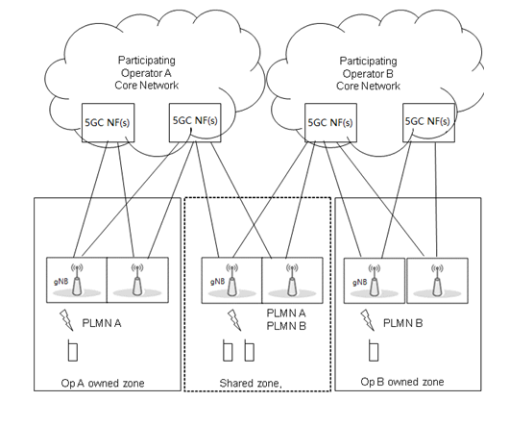
Figure 5.X.1-1 NG-RAN MOCN Network Sharing scenario

1st Change

5.X.2 Management requirements
Req-MOCN-CellId-Cfg-CON-X, the 3GPP management system of the MOP shall support to query and count all performance, load and otherstatistical indicators generated by physical and logical equipment network elements (including shared and non-shared gNB).
Req-MOCN-CellId-Cfg-CON-Y, the 3GPP management system of the MOP and POP shall support to query all the alarm information generated by all physical equipment and logical network elements (including shared and non-shared gNBs).

2nd Change

5.X.3 Potential solution
To the Req-MOCN-CellId-Cfg-CON-X and Req-MOCN-CellId-Cfg-CON-Y , according to the above two options, we propose a new option(figure below), which adds IOC LogicalDU, inherited from ManagedFunction IOC. The LogicalDU includes IOC LogicalCellDU. The arrow1 means a NRCellDU may associate to several NRLogicalCellDU. This can be created and configured specific for one operator (including MOP and POP). This solution combines option 1 and option 2 together, the achitecture looks more clear.
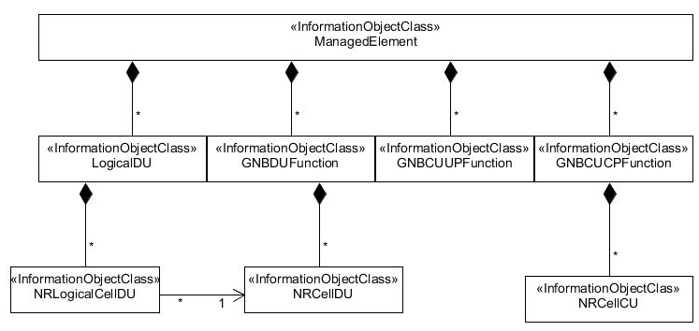

Figure 5.X.3-1 NR NRM enhancement to suport NG-RAN sharing MOCN network sharing
- New IOC LogicalDUFunction
The new IOC LogicalDUFunction at the same level as the original GNBDUFunction: split the gNBId and gNBIdLength of GNBDUFunction into LogicalDUFunction, and mark the original attribute as optional:
The original GNBDUFunction attribute list, updated with yellow as the conditional configuration, not configured when the network is shared.
Attribute name | Support Qualifier
gNBDUId | M
gNBDUName | O
gNBId | CM
gNBIdLength | CM
rimRSReportConf | O

For the new IOC LogicalDUFunction, the IOC exists in the network sharing scenario, otherwise it does not exist.
Attribute name | Support Qualifier
gNBId | M
gNBIdLength | M

- New IOC LogicalCellDU
The new IOC LogicalCellDU is at the same level as the original NRCellDU, and the two are associated through nRCellDuRef.
In the original NRCellDU attribute list, update the yellow item as the conditional configuration:
Attribute name | Support Qualifier
cellLocalId | CM
operationalState | M
administrativeState | M
cellState | M
pLMNInfoList | CM
nRPCI | M
nRTAC | CM
arfcnDL | M
arfcnUL | CM
arfcnSUL | CM
bSChannelBwDL | M
ssbFrequency | CM
ssbPeriodicity | M
ssbSubCarrierSpacing | CM
ssbOffset | M
ssbDuration | M
bSChannelBwUL | CM
bSChannelBwSUL | CM

The new IOC LogicalCellDU, the IOC exists in the network sharing scenario, otherwise it does not exist.
Attribute name | Support Qualifier
cellLocalId | M
pLMNInfoList | M
nRTAC | CM
administrativeState | M
Attribute related to role
nRCellDURef | M

End of Changes

