3GPP TSG-SA5 Meeting #139-e S5-215113

e-meeting 11 - 20 October 2021

Source: Huawei

Title: Discussion on coordination between closed control loop

Document for: Approval
Agenda Item: 6.4.12

1 Decision/action requested
The group is asked to discuss and agree on the proposal.

2 References
[1] 3GPP TS 28.533; Management and orchestration; Architecture framework
[2] 3GPP TS 28.535; Management and orchestration; Management services for communication service assurance; Requirements
[3] 3GPP TS 28.536; Management and orchestration; Management services for communication service assurance; Stage 2 and stage 3
[4] ETSI ZSM009-1; Closed-loop automation; Enablers

3 Rationale
In subclause 5.3 in TS 28.533 [1], an example of Management Service deployment framework is depicted as the following figure:
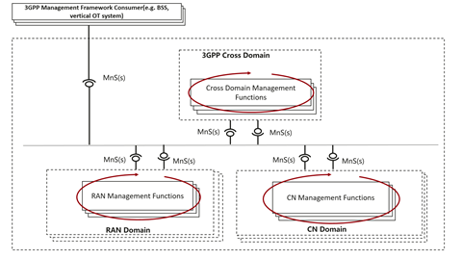
Figure 5.3-1: An example of Management Service deployment framework [1]
The closed control loop SLS assurance (COSLA) is an example of the closed loop in ZSM framework. COSLA can be deployed at domain level or cross domain level.
Interactions between ACCLs at cross domain level and domain level are based on SBMA architecture.
An example of ACCLs coordination could be an ACCL in the Cross Management Domain decomposes assurance goals to the RAN or CN management domain. If the RAN or CN Management Domain is not able to fulfil the goal upon feasibility check or during operation phase, it may request the ACCL in Cross Management Domain to modify the goals. ACCL in Cross Management Domain may allocate modified goals according to goal fulfilment status monitoring etc. ACCLs are not operated completely independent with each other. One of the impacts on NRM are goal and goal status fulfilment information. The request for goal adjustment will also have NRM impacts.
Figure 4.2.1.1 in TS 28.535 [2] provides a high level description of interaction process involved in the management closed control loop, the descriptions are extracted as follows:
For communication service assurance one can identify two interactions of management control loops:
1) Between the CSC and the CSP: In this case, the CSC provides the requirements for an assured communication service to the CSP, the CSP provides the corresponding communication service, the CSP also provides feedback to the CSC. The CSP adjusts the resources used by a communication service or the CSC adjusts the SLS continuously to achieve the assured requirements.
2) Between the CSP and the NSP: the communication service provided by CSP requires the network capabilities. For example, the CSP requires a certain network latency. The NSP management system adjusts the network or CSP adjusts the latency requirement continuously to satisfy the latency requirement.
Figure 4.2.1.1: Communication service closed control loop assurance [2]
Figure A.1.1 in TS 28.536 [3] provides another example of interactions between closed control loops at different layers, the descriptions are extracted as follows:
This example gives a high-level view of control loops deployed in different layers, which consists of control loop in communication service layer, control loop in network slice layer, control loop in network slice subnet layer and control loop in NF layer, as described as Figure A.1.1, where the analytic could be leverage MDAS, and different control loops can provide input (interact with) to other control loops (in the same layer or different layers) and obtain the output from other control loops (in the same layer or different layers).
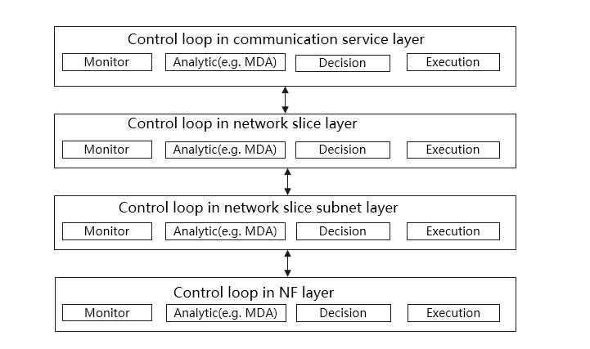
Figure A.1.1: Control loop in different layers [3]
Input and output of the ACCLs are assurance goals and monitoring information as defined in the ACCL models in TS 28.536 [3].
Closed Loop Coordination (CLC) is also described in ETSI GS ZSM 009-1 [4]. CLC involves different types of interactions e.g. for delegation and escalation of goals or issues, or for coordination of actions, or for coordination of conflicting CLs etc. The following descriptions are extracted from subclause 8.2.3:
The subordinate CLs deployed in the E2ES MDs or in the MDs perform local optimizations which might not result in a global, end-to-end optimum or which might even be in conflict to each other. To this end the superior CLs shall be able to coordinate the decisions of subordinate CLs. Such coordination can happen in the following, not exclusive ways:
• Delegation - The superior CLs delegates respective goal(s) to the subordinate CLs, e.g. by setting the policies and/or the intents in a way that allow the subordinate CL to act autonomously.
• Escalation - If a subordinate CL is not able to achieve the goal(s) assigned to it, it escalates the situation to the superior CL in the E2ES MD.
ETSI GS ZSM 009-1 [4] provide more background information on coordination types and contents. The concrete information to be coordinated in 3GPP scope can refer to the NRM model specified in TS 28.536, e.g. assurance goal and assurance goal fulfilment status. More information is FFS which may be further discussed based on potential new use cases and solutions.

Proposal 1: It is proposed to add reference to ZSM009-1 to provide more background information for interactions between ACCLs.

4 Detailed proposal
In this contribution, the following proposals are made:
Proposal 1: It is proposed to add reference to ZSM009-1 to provide more background information for interactions between ACCLs.

