3GPP TSG-SA5 Meeting #139-e S5-215108

e-meeting 11 - 20 October 2021

Source: Huawei

Title: Discussion on assurance report for closed control loop

Document for: Approval
Agenda Item: 6.4.12

1 Decision/action requested
The group is asked to discuss and agree on the proposal.

2 References
[1] 3GPP TS 28.535: “Management and orchestration; Management services for communication service assurance; Requirements”, Rel-17 v17.0.0
[2] 3GPP TS 28.536: “Management and orchestration; Management services for communication service assurance; Stage 2 and stage 3”, Rel-17 v16.2.1
[3] 3GPP TS 28.311: “Management and orchestration; Network policy management for mobile networks based on Network Function Virtualization (NFV) scenarios”, Rel-16 v16.0.0
[4] 3GPP TS 28.532: “Management and orchestration; Generic management services”, Rel-16 v16.5.1
[5] S5-212120 DP on assurance report for closed control loop
[6] ETSI ZSM009-1; Closed-loop automation Enablers
[7] 3GPP TS 32.331 V16.0.0 Notification Log (NL) Integration Reference Point (IRP); Requirements
[8] S5-213329 DP on assurance report for closed control loop
[9] S5-213687 DP on assurance report for closed control loop
[10] S5-214292 DP on assurance report for closed control loop

3 Rationale
In SA5#137-e, [9] was endorsed, there was concensus to introduce AssuranceReport IOC to accommodate the Assurance goal fulfilment status of a closed control loop. Existing attributes AssuranceGoalStatusObserved and AssuranceGoalStatusPredicted should be moved to the AssuranceReport IOC. Similar handling can also be applied to the AssuranceTargetStatusObserved and AssuranceTargetStatusPredicted.
Some other information which may be included in the AssuranceReport IOC have been discussed for multiple meetings, for example: ACCL actions and results, associated policies, root cause, analytical information etc. With these information, the MnS consumer may have more hints on how to adjust the assurance goal, assurance policies or configurations for the ACCL according to the assurance report. More detail examples of AssuranceReport were discussed in S5-212120 [5], S5-213329 [8], S5-213687 [9] and S5-214292 [10], etc. It is considered beneficial to include some of information mentioned in these contributions. However concensus has not been achieved for these new attributes in previous meetings. It is proposed to implement the parts which have concensus firstly and handle the potential new attributes in the future when the benefits are acknowledged.
Proposal 1: It is proposed to introduce the AssuranceReport IOC to accommodate the Assurance goal fulfilment status and Assurance target fulfilment status of a closed control loop.

There is an open issue from SA5#137-e as follows:
The relationship between AssuranceReport (abbr. AR), AssuranceGoal (abbr. AG) and AssuranceClosedControlLoop (abbr. ACCL) will be revisited. The following options are possible.
- For ACCL to AR
Option 1: name containment 1..*
Explanation: The relation for ACCL to AG is name containment 1..*. One AR may correspond to one AG.
Option 2: name containment 1..1
Explanation: Once ACCL only have 1 report. That report can be delivered multiple time though with different content.
Option 3: delete the relation between ACCL and AR, and may bring it back in the future.
Explanation: It is also possible that AR does not directly associate with ACCL, only model the relation between AR to AG.
- For AR to AG
Option 1: *..1, one AG status (including target fulfilment status list) may have multiple AR
Explanation: Since one AG status may contain multiple target status, this kind of modelling will treat one AR as the unit to associate with some target status.
Option 2: 1..*, one AR may contain multiple AG status
Explanation: One AR is used to accommodate all the relevant AG status and target status for the observation time.
Option 3: (0..1)..*, zero or one AR may contain multiple AG status
Explanation: AR may or may not be generated according to the MnS consumer’s subscriptions.
Option 4: *..*
Explanation: The combination of the above options.
Option 5: remove the relationship AR-AG.
Explanation: Not modelling the association between AR and AG.
There were further discussions on modelling in SA5#138-e. The assuranceGoalStatus and assuranceTargetStatus could be modelled separately from flexibility perspective. One or multiple assuranceGoalStatus and one or multiple assuranceTargetStatus are included in the AssuranceReport. The above options just list all the possibilities, not all of them are justified.
According to email discussions, there is a preference as follows:
The relationship of ACCL to AR could be Option 3, i.e. not model the ACCL to AR relationship directly. .
For the relationship of AR to AG, it is proposed to adopt option 2, One AR may related to multiple AG.
Proposal 2: It is proposed to adopt option 3 for the relationship of ACCL to AR, and adopt Option 2 for the relationship of AR to AG.
The modelling would be like the following figure:
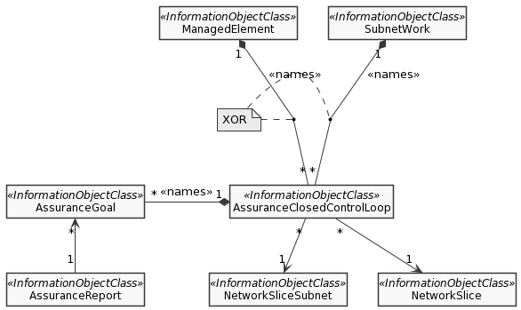
Assurance management NRM fragment

4 Detailed proposal
In this contribution, the following proposals are made:
Proposal 1: It is proposed to introduce the AssuranceReport IOC to accommodate the Assurance goal fulfilment status and Assurance target fulfilment status of a closed control loop.
Proposal 2: It is proposed to adopt option 3 for the relationship of ACCL to AR, and adopt Option 2 for the relationship of AR to AG.

