3GPP TSG SA WG5 Meeting 137-e S5-214759

electronic meeting, online, 10 - 19 May 2021
CR-Form-v12.0
CHANGE REQUEST
 | 28.405 | CR |  | rev |  | Current version: | 16.0.0
For HELP on using this form: comprehensive instructions can be found at
http://www.3gpp.org/Change-Requests.

Proposed change affects: | UICC apps |  | ME |  | Radio Access Network | X | Core Network | X

Title: | DraftCR for WI eQoE
Source to WG: | Ericsson
Source to TSG: | S5
Work item code: | eQoE |  |  |  |  |  | Date: |  |  | 2021-01-14
Category: | B |  |  |  |  |  | Release: |  |  | Rel-17
 | Use one of the following categories:  F (correction)  A (mirror corresponding to a change in an earlier release)  B (addition of feature),  C (functional modification of feature)  D (editorial modification)  Detailed explanations of the above categories can  be found in 3GPP TR 21.900. |  |  |  |  |  |  |  | Use one of the following releases:  Rel-8 (Release 8)  Rel-9 (Release 9)  Rel-10 (Release 10)  Rel-11 (Release 11)  …  Rel-15 (Release 15)  Rel-16 (Release 16)  Rel-17 (Release 17)  Rel-18 (Release 18)
Reason for change: |  | This draftCR incorporates the following agreed contributions under WI eQoE - S5-211232  - S5-212273  - S5-213509  - S5-2144248  The detailed reason for change can be found in the contribution.
Summary of change: |  | Add Signalling Based Activation for UTRAN and LTE
Consequences if not approved:
Clauses affected: |  | 4
 |  | Y | N
Other specs |  |  | x | Other core specifications |  |  |  | TS/TR ... CR ...
affected: |  |  | x | Test specifications |  |  |  | TS/TR ... CR ...
(show related CRs) |  |  | x | O&M Specifications |  |  |  | TS/TR ... CR ...
Other comments:
This CR's revision history:

First change

4.x Signalling based activation in UTRAN

4.x.1 Activation of measurement collection job in UTRAN
In Signalling based activation, the QoE measurement collection is sent to the UE from the OAM via CN. The messages from EMS propagated to HSS, MSE Server/SGSN and RNC. QoE measurement collection activation request is propagated to UE.
When HSS activates the QoE measurement collection for a job, the MSC Server/SGSN can send the QoE measurement collection to the UE through RNC, the following configuration parameters shall be included in the message: serviceType, areaScope, qoECollectionEntityAddress, pLMNTarget, qoETarget, qoEReference and QMC configuration file.
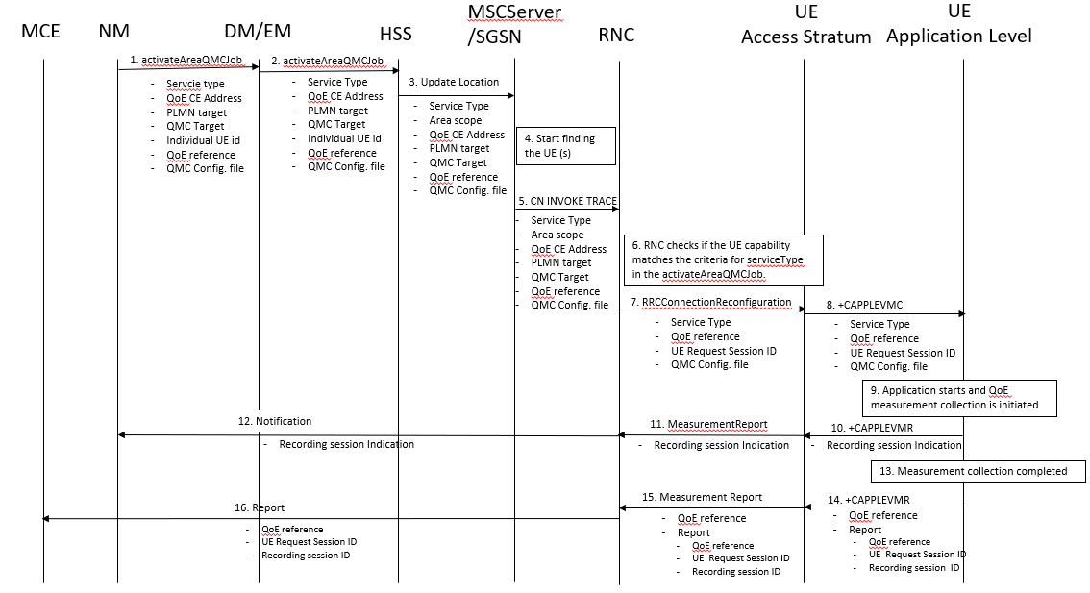

- The NM sends activateAreaQMCJob to DM/EM that controls the impacted RNC(s), and includes the parameters: serviceType, areaScope, qoECollectionEntityAddress, pLMNTarget, qMCTarget, Individual UE Id, qoEReference and QMC configuration file.
- The DM/EM sends activateAreaQMCJob to HSS that controls the impacted RNC(s), and includes the parameters: serviceType, areaScope, qoECollectionEntityAddress, pLMNTarget, qoETarget, Individual UE Id,qoEReference and QMC configuration file.
- The HSS forwards it to the MSC Server/SGSN that controls the impacted RNC(s).
- The MSC Server/SGSN starts finding the UE and check if that the UE capability matches the criteria for ServiceType in activateAreaQMCJob
- The MSC Server/SGSN sends message CN INVOKE TRACE to the RNC and includes the parameters: serviceType, areaScope, qoECollectionEntityAddress, pLMNTarget, qoETarget,qoEReference and QMC configuration file.
- The RNC checks for connections where the UE has the UE Application Layer Measurement Capability that match the criteria for serviceType in the activateAreaQMCJob.
- The RNC start a UE request session and stores the associated QoECollectionEntityAddress, sends the message RRCConnectionReconfiguration to the UE, and includes the following: serviceType, qoEReference and QMC configuration file.
- The access stratum in the UE sends the AT command +CAPPLEVMC to application level and includes the following: serviceType, qoEReference and QMC configuration file.
- When the application in the serviceType starts, the QMC is initiated.
- The application layer sends the AT command +CAPPLEVMR including a recording session indication that a session has started to the access stratum.
- The UE sends the message MeasurementReport including the recording session indication to the RNC.
- The RNC sends a notification including the recording session indication to the NM.
- When the QMC is completed, the recorded information is collected in a QMC report, including qoEReference and recordingSessionId. The qoEReference, Client Id, in the reporting container (that represent the UE request session), and recordingSessionId are needed in the QMC collection entity for post processing purposes.
- The application layer sends the AT command +CAPPLEVMR including qoEReference and the QMC report to the access stratum.
- The UE sends the message MeasurementReport including qoEReference and the QMC report to the RNC.
- The RNC sends the QMC report to the MCE associated to the qoEReference.

4.x.2 Handling of measurement collection at handover in UTRAN
See clause 4.1.2.

4.x.3 Deactivation of measurement collection job in UTRAN

4.x.3.1 Pre-set time has elapsed in UTRAN
When the pre-set time is elapsed, the HSS or SGSN and the RNC sets the network request session to ended, but do not delete the UE request session id and the Collection Entity Address parameters [3], due to that reports still can come from the UE that has to be transferred to the collection centre. The UE request session id and the Collection Entity Address parameters [3] are deleted when the session is ended.

4.x.3.2 Forced deactivation in UTRAN
If the operator technician or the management application wants to deactivate a measurement collection job before the pre-set time has expired, the management system sends the deactivateQoEJob operation [3] to the HSS or SGSN, that propagate it to the RNC. The RNC sets the network request session to ended, but does not delete the UE request session id and the Collection Entity Address parameters [3], as the UE still may send reports which shall be send to the collection centre. For UE request sessions which have reported that a recording session is started, the RNC sends the MeasurementControl message [4] with the DeactivateJob request to relevant UEs. The Access stratum sends +CAPPLEVMC AT command [5] to the application with the DeactivateJob request. The application stops the recording session and stops recording of the requested information. The UE request session id and the Collection Entity Address parameters [3] in the RNC are deleted when the UE request session is ended.

4.x.3.3 Deactivation of recording session in UTRAN
See clause 4.1.3.3.

next change

4.y Signalling based activation in LTE

4.y.2 Activation of measurement collection for a UE in LTE
Actvation of measurement collection for a UE can be done before UE attachment or after UE is attached.
4.y.2.1 Activation of QoE measurement task before UE attaches to the network
When HSS activates the QoE measurement collection for a job, to the MME the following configuration parameters shall be included in the message: serviceType, areaScope, qoECollectionEntityAddress, pLMNTarget, qoETarget, qoEReference and QMC configuration file.
At UE attachment the configuration parameters for the QoE measurement collection for a job is propagated to the UE.
The MME receives and stores QoE measurement collection job as part of Update Location Answer (or Insert Subscriber Information). Then the same procedure for activation of measurement collection job is applied as after UE is attached, described in see 4.y.2.2.
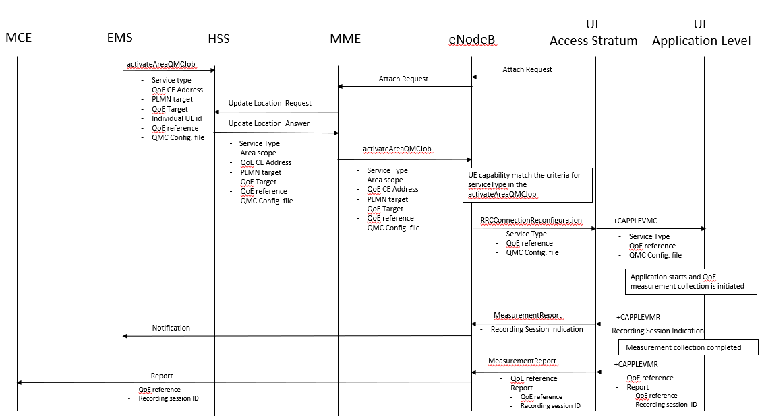
4.y.2.2 Activation of QoE measurement task after UE attachement to the network
The QoE measurement collection is sent to the UE from the OAM via CN. The messages from EMS propagated to HSS, MME and eNodeB are the same as previous section. QoE measurement collection activation request is propagated to UE finally.
When MME can send the QoE measurement collection to the UE through eNodeB, the following configuration parameters shall be included in the message: serviceType, areaScope, qoECollectionEntityAddress, pLMNTarget, qoETarget, qoEReference and QMC configuration file. QoE measurement collection activation request is propagated to UE.
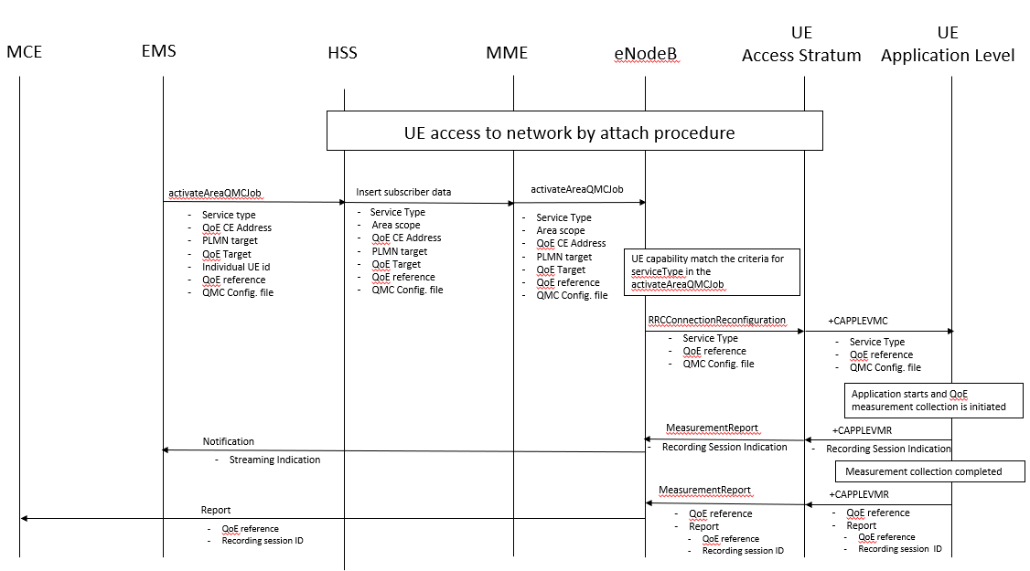

- The EMS sends activateAreaQMCJob to HSS that controls the impacted eNB(s), and includes the parameters: serviceType, areaScope, qoECollectionEntityAddress, pLMNTarget, qoETarget, qoEReference and QMC configuration file.
- The HSS inserts subscriber related data and forwards it to the MME.
- The MME forwards activateAreaQMCJob to impacted eNB(s), and includes the parameters: serviceType, areaScope, qoECollectionEntityAddress, pLMNTarget, qoETarget, qoEReference and QMC configuration file.
- The eNB checks if the UE capability that matches the criteria for serviceType in the activateAreaQMCJob.
- If the UE has the wanted UE capability, the eNB starts a UE request session and stores the associated QoECollectionEntityAddress, sends the message RRCConnectionReconfiguration to the UE, and includes the following: serviceType, qoEReference and QMC configuration file.
5. The access stratum in the UE sends the AT command +CAPPLEVMC to application level and includes the following: serviceType, qoEReference and QMC configuration file.
6. When the application in the serviceType starts, the QMC is initiated.
7. The application layer sends the AT command +CAPPLEVMR including a recording session indication that indicates that a session is started to the access stratum.
8. The UE sends the message MeasReportAppLayer including the recording session indication to the eNB.
9. The eNB sends a notification including the recording session indication to the NM.
10. When the QMC is completed, the recorded information is collected in a QMC report [6], [7], including qoEReference and recordingSessionId. The qoEReference, Client Id [6] and [7] in the reporting container (that represent the UE request session), and recordingSessionId are needed in the QMC collection entity for post processing purposes.
11. The application layer sends the AT command +CAPPLEVMR including qoEReference and the QMC report to the access stratum.
12. The UE sends the message MeasReportAppLayer including qoEReference and the QMC report to the eNB.
13. The eNB sends the QMC report to the MCE associated to the qoEReference.

4.y.3 Handling of measurement collection at handover in LTE
See clause 4.2.2.

4.y.5 Deactivation of measurement collection for a UE in LTE

4.y.5.1 Pre-set time has elapsed in LTE
When the pre-set time is elapsed, the MME and the eNB sets the network request session to ended, but do not delete the UE request session id and the Collection Entity Address parameters [3], due to that reports still can come from the UE that has to be transferred to the collection centre. The UE request session id and the Collection Entity Address parameters [3] are deleted when the session is ended.

4.y.5.2 Forced deactivation in LTE
When the operator technician or the management application wants to deactivate a measurement collection job before the pre-set time has expired, the management system sends the deactivateQMCJob operation [3] to the MME that propgates to the eNB . The eNB sets the network request session to ended, but does not delete the UE request session id and the Collection Entity Address parameters [3], as the UE still may send reports which shall be send to the collection centre. For UE request sessions which have reported that a recording session is started, the eNB sends the RRCConnectionReconfiguration message [8] to relevant UEs. The RRCConnectionReconfiguration message is including measConfigAppLayer set to discard application layer measurement report information in otherConfig [8]. The Access stratum sends +CAPPLEVMC AT command [5] to the application with the discard request. The application stops the recording session and stops recording of the requested information. The UE request session id and the Collection Entity Address parameters [3] in the eNB are deleted when the UE request session is ended.

4.y.5.3 Deactivation of recording session in LTE
See clause 4.2.3.2.

End change

