**3GPP TSG-SA5 Meeting #138-e *S5-214386rev2***

**Online, , 23rd Aug 2021 - 31st Aug 2021**

|  |  |  |  |  |  |  |  |  |
| --- | --- | --- | --- | --- | --- | --- | --- | --- |
| *CR-Form-v12.1* | | | | | | | | |
| **CHANGE REQUEST** | | | | | | | | |
|  | | | | | | | | |
|  | **28.531** | **CR** | **0081** | **rev** | **-** | **Current version:** | **16.10.0** |  |
|  | | | | | | | | |
| *For* [***HE******LP***](http://www.3gpp.org/3G_Specs/CRs.htm#_blank)*on using this form: comprehensive instructions can be found at* [*http://www.3gpp.org/Change-Requests*](http://www.3gpp.org/Change-Requests)*.* | | | | | | | | |
|  | | | | | | | | |

|  |  |  |  |  |  |  |  |  |
| --- | --- | --- | --- | --- | --- | --- | --- | --- |
| ***Proposed change affects:*** | UICC apps |  | ME | **X** | Radio Access Network | **X** | Core Network | **X** |

|  |  |  |  |  |  |  |  |  |  |  |
| --- | --- | --- | --- | --- | --- | --- | --- | --- | --- | --- |
|  | | | | | | | | | | |
| ***Title:*** | Rel-16 CR 28.531 updating NSSI deallocation | | | | | | | | | |
|  |  | | | | | | | | | |
| ***Source to WG:*** | Samsung R&D Institute UK | | | | | | | | | |
| ***Source to TSG:*** | S5 | | | | | | | | | |
|  |  | | | | | | | | | |
| ***Work item code:*** | TEI16,NETSLICE-PRO_NS | | | | |  | ***Date:*** | | | 2021-08-13 |
|  |  | | | |  | |  | | |  |
| ***Category:*** | **F** |  | | | | | ***Release:*** | | | Rel-16 |
|  | *Use one of the following categories:* ***F*** *(correction)* ***A*** *(mirror corresponding to a change in an earlier release)* ***B*** *(addition of feature),* ***C*** *(functional modification of feature)* ***D*** *(editorial modification)*  Detailed explanations of the above categories can be found in 3GPP [TR 21.900](http://www.3gpp.org/ftp/Specs/html-info/21900.htm). | | | | | | | | *Use one of the following releases: Rel-8 (Release 8) Rel-9 (Release 9) Rel-10 (Release 10) Rel-11 (Release 11) … Rel-15 (Release 15) Rel-16 (Release 16) Rel-17 (Release 17) Rel-18 (Release 18)* | |
|  |  | | | | | | | | | |
| ***Reason for change:*** | | Current step 3-b simply states that NF deletion or modification procedure is invoked if NSSI consists of NFs without examining all possibilities e.g. deleting a NF can cause serious consequences if it is in use by other NSSIs. | | | | | | | | |
|  | |  | | | | | | | | |
| ***Summary of change:*** | | Modifying a step in NSSI deallocation in clause 7.5 | | | | | | | | |
|  | |  | | | | | | | | |
| ***Consequences if not approved:*** | | Incorrect and ambiguous specification | | | | | | | | |
|  | |  | | | | | | | | |
| ***Clauses affected:*** | | 7.5 | | | | | | | | |
|  | |  | | | | | | | | |
|  | | **Y** | **N** |  | | | |  | | |
| ***Other specs*** | |  | **X** | Other core specifications | | | | TS/TR ... CR ... | | |
| ***affected:*** | |  | **X** | Test specifications | | | | TS/TR ... CR ... | | |
| ***(show related CRs)*** | |  | **X** | O&M Specifications | | | | TS/TR ... CR ... | | |
|  | |  | | | | | | | | |
| ***Other comments:*** | |  | | | | | | | | |
|  | |  | | | | | | | | |
| ***This CR's revision history:*** | |  | | | | | | | | |

************************************ First Change ************************************

## 7.5 Procedure of network slice subnet instance deallocation

Figure 7.5-1 depicts the procedure of deallocating a network slice subnet instance by the network slice subnet management service provider to satisfy the NSSI deallocation request received from an authorized consumer.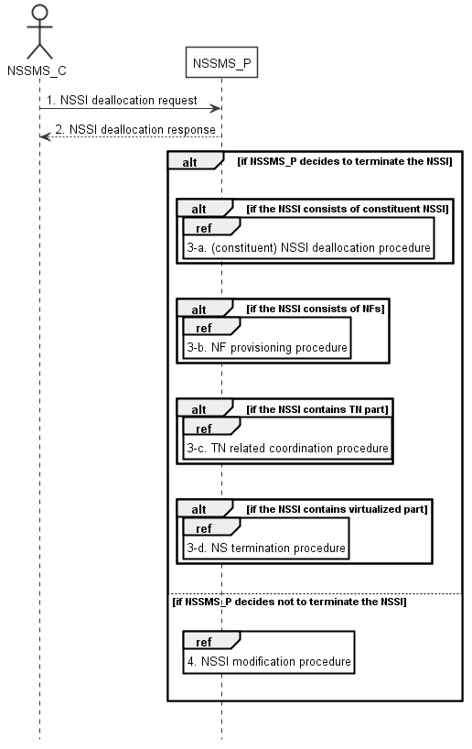

Figure 7.5-1: Network slice subnet instance deallocation procedure

1) The network slice subnet management service provider (NSSMS_P) receives NSSI deallocation request (see DeallocateNssi operation defined in clause 6.5.4) from network slice subnet management service consumer (NSSMS_C).

2) NSSMS_P sends response (see DeallocateNssi operation defined in clause 6.5.4) of NSSI deallocation service to NSSMS_C.

3-a) NSSMS_P may decide to terminate the NSSI, it invokes (constituent) NSSI deallocation procedure as described in clause 7.5 if the NSSI consists of constituent NSSI.

3-b) NSSMS_P invokes NF deletion procedure as described in clause 7.12 only if the NF is dedicated for this NSSI and not being used by any other NSSI in the network, otherwise, the NSSMS_P invokes NF modification procedure as described in clause 7.11

3-c) NSSMS_P invokes TN related coordination procedure with responsible manager as described in clause 7.9 if the NSSI consists of TN part.

3-d) NSSMS_P invokes NS termination procedure if the NSSI contains virtualized part.

Note: NS termination procedure is described in TS 28.526 [7].

4) NSSMS_P may decide not to terminate the NSSI, it invokes NSSI modification procedure as described in clause 7.7.