3GPP TSG-SA5 Meeting #138-e S5-214212

e-meeting, 23 - 31 August 2021

Source: Huawei, China Telecom, China Mobile,AsiaInfo

Title: Update intent information model

Document for: Approval
Agenda Item: 6.4.10

1 Decision/action requested
The group is asked to discuss and approval.

2 References
[1] 3GPP draft TS 28.312: “Management and orchestration; Intent driven management services for mobile networks v0.5.0”.

3 Rationale
This contribution proposes to update stage2 information model definition for intent.

4 Detailed proposal
It proposes to make the following changes to TS 28.312[1].
1st Change

6.2.1.1 Class diagram

6.2.1.1.1 Relationship

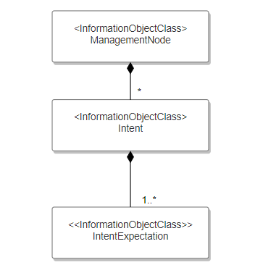
Figure 6.2.1.1.1-1 Relationship UML diagram for intent
Editor’s Note: The detailed information for intentExpectation is FFS.

6.2.1.1.2 Inheritance
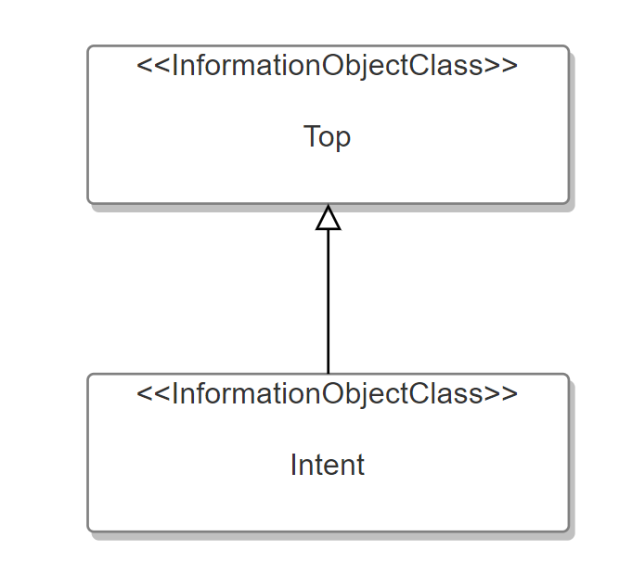
Figure 6.2.1.1.2-1 Inheritance UML diagram for intent

6.2.1.2 Class definition

6.2.1.2.1 Intent <<IOC>>

6.2.1.2.1.1 Definition
This IOC represents the properties of an Intent. The Intent IOC contains one or multiple intentExpectation(s) which includes MnS consumer’s requirements, goals and constraints given to a 3GPP system.
To express a new intent, a MnS consumer needs to request MnS producer to create an Intent instance and containing sub-classes (i.e. intentExpectations). For ultimate deleting an expressed intent, the MnS consumer should request MnS producer to delete the Intent instance and containing sub-classes (i.e. intentExpectations).
The Intent IOC includes the attribute objectClass and objectInstance from the TOP IOC. The value of attribute objectClass is “Intent” and the value of attribute objectInstance is the DN of the instance of Intent IOC.
For temporary deactivation of intent instance, the MnS consumer can manipulate the value of the administrative state attribute to “LOCKED”. The MnS producer also has the capability to suspend intent instance as well (which means the intent instance is disabled by MnS producer for internal behaviour), for example when the MnS producer confirms that the intent instance is not satisfied for a long time according to the collected network performance data which related to the intent. This situation is indicated by the MnS producer by setting the operational state attribute to “DISABLED” and the state is informed to the MnS consumer by the MnS producer. The MnS producer also has the capability to resume the disabled intent instance), for example when the MnS producer predicted that the intent instance can be continually executed and satisfied. This situation is indicated by the MnS producer by setting the operational state attribute to “ENABLED” and the state is informed to the MnS consumer by the MnS producer. For activation of intent instance, the MnS consumer can manipulate the value of the administrative state attribute to “UNLOCKED”.

6.2.1.2.1.2 Attributes
The Intent includes attributes inherited from TOP IOC (defined in TS 28.622) and the following attributes:
Attribute Name | Support Qualifier | isReadable | isWritable | isInvariant | isNotifyable
userLabel | M | T | T | F | T
intentFulfilState | M | T | F | F | T
administrativeState | M | T | T | F | T
operationalState | M | T | F | F | T

Editor’s Note: whether other the attributes are needed for the Intent IOC needs further discussion.

6.2.1.2.1.3 Attribute constraints
None

6.2.1.3 DataType definition
None

6.2.1.4 Attribute definition
Attribute Name | Documentation and Allowed Values | Properties
userLabel | A user-friendly (and user assignable) name of the intent.  allowedValues: Not Applicable | type: String  multiplicity: 1  isOrdered: F  isUnique: F  defaultValue: None  isNullable: False
intentFulfilState | It describes the current status of the intent fulfilment result, which is configured by MnS producer and can be read by MnS consumer.  allowedValues: "FULFILLED", “NOT_FULFILLED  Editor’s Note: whether other allowed values should be supported is FFS, and the name for the attribute intentFulfilStatus is FFS. | type: ENUM  multiplicity: 1  isOrdered: N/A  isUnique: N/A  defaultValue: None  isNullable: False
administrativeState | It describes the intent instance is administratively prohibited from executing or permitted to execute, which can be configured by MnS consumer to trigger to activate and deactivate the intent instance.  allowedValues: “LOCKED”, “UNLOCKED”. | type: ENUM  multiplicity: 1  isOrdered: F  isUnique: F  defaultValue: None  isNullable: False
operationalState | It describes if an intent instance is operable ("ENABLED") or inoperable ("DISABLED"). This state is set by the MnS producer to suspend or resume intent for the internal behaviour and can be read by MnS consumer.  allowedValues: “ENABLED”, “DISABLED”. | type: ENUM  multiplicity: 1  isOrdered: F  isUnique: F  defaultValue: None  isNullable: False

End of changes

