|  |  |
| --- | --- |
| 3GPP TR 28.925 V0.0.2 (2021-05) | |
| Technical Report | |
| 3rd Generation Partnership Project;  Technical Specification Group Services and System Aspects;  Management and orchestration;  Study on enhancement of service based management architecture (Release 17) | |
|  | |
| *5G-logo_175px* | 3GPP-logo_web |
|  | |
| The present document has been developed within the 3rd Generation Partnership Project (3GPP TM) and may be further elaborated for the purposes of 3GPP. The present document has not been subject to any approval process by the 3GPPOrganizational Partners and shall not be implemented. This Specification is provided for future development work within 3GPPonly. The Organizational Partners accept no liability for any use of this Specification. Specifications and Reports for implementation of the 3GPP TM system should be obtained via the 3GPP Organizational Partners' Publications Offices. | |

|  |
| --- |
|  |
| ***3GPP***  Postal address  3GPP support office address  650 Route des Lucioles - Sophia Antipolis  Valbonne - FRANCE  Tel.: +33 4 92 94 42 00 Fax: +33 4 93 65 47 16  Internet  http://www.3gpp.org |
| ***Copyright Notification***  No part may be reproduced except as authorized by written permission. The copyright and the foregoing restriction extend to reproduction in all media.  © 2021, 3GPP Organizational Partners (ARIB, ATIS, CCSA, ETSI, TSDSI, TTA, TTC).  All rights reserved.  UMTS™ is a Trade Mark of ETSI registered for the benefit of its members  3GPP™ is a Trade Mark of ETSI registered for the benefit of its Members and of the 3GPP Organizational Partners LTE™ is a Trade Mark of ETSI registered for the benefit of its Members and of the 3GPP Organizational Partners  GSM® and the GSM logo are registered and owned by the GSM Association |

Contents

Foreword 4

Introduction 4

1 Scope 5

2 References 5

3 Definitions of terms, symbols and abbreviations 6

3.1 Terms 6

3.2 Symbols 6

3.3 Abbreviations 6

4 Issue investigations and potential issue solutions 7

4.1 Issue #1: Scope of specifications 7

4.1.1 Description 7

4.1.2 Potential solutions 7

4.1.2.1 Solution #1-1 scope of 28.533 [2] 7

4.1.2.2 Solution #1-2 new SBMA TS for Generic NRM 8

4.2 Issue #2: Content errors 8

4.2.1 Description 8

4.2.2 Potential solutions 8

4.2.2.1 Solution #2-1 3GPP specific information in TSs classified as generic 8

4.2.2.2 Solution #2-2 for stage 1 content in stage 2 TS 28.533 [2] 8

4.3 Issue #3: Reference errors 9

4.3.1 Description 9

4.3.2 Potential solutions 9

4.3.2.1 Solution #3-1 Make not used references void 9

4.4 Issue #4: SBMA supporting manangement of 5G SA and NSA scenarios 9

4.4.1 Description 9

4.4.1.1 Analysis of the existing specification capabilities 9

4.4.1.2 Management support for NG-RAN Overall Architecture 9

4.4.1.3 Management support for EN-DC Overall Architecture 11

4.4.2 Potential solutions #4-1 12

4.5 Issue #5: SBMA supporting management architecture and frameworks in other SDOs 12

4.5.1 Description 12

4.5.2 Potential solutions 13

4.5.2.1 ETSI ISG ZSM 13

4.5.2.1.1 Introduction 13

4.5.2.1.2 Potential solutions #5-1 13

5 Conclusion and Recommendation 14

5.X Issue #X 14

5.Y Issue #Y 14

Annex <X> (informative): Change history 15

# Foreword

This Technical Report has been produced by the 3rd Generation Partnership Project (3GPP).

The contents of the present document are subject to continuing work within the TSG and may change following formal TSG approval. Should the TSG modify the contents of the present document, it will be re-released by the TSG with an identifying change of release date and an increase in version number as follows:

Version x.y.z

where:

x the first digit:

1 presented to TSG for information;

2 presented to TSG for approval;

3 or greater indicates TSG approved document under change control.

y the second digit is incremented for all changes of substance, i.e. technical enhancements, corrections, updates, etc.

z the third digit is incremented when editorial only changes have been incorporated in the document.

# Introduction

This report is to study on enhancement of service based management architecture.

# 1 Scope

The present document studies on the potential enhancement of service based management architecture based on the existing 5G service-based management architecture.

# 2 References

The following documents contain provisions which, through reference in this text, constitute provisions of the present document.

- References are either specific (identified by date of publication, edition number, version number, etc.) or non‑specific.

- For a specific reference, subsequent revisions do not apply.

- For a non-specific reference, the latest version applies. In the case of a reference to a 3GPP document (including a GSM document), a non-specific reference implicitly refers to the latest version of that document *in the same Release as the present document*.

[1] 3GPP TR 21.905: "Vocabulary for 3GPP Specifications".

[2] 3GPP TS 28.533: "Management and orchestration; Architecture framework".

[3] 3GPP TS 32.101: "Telecommunication management; Principles and high level requirements".

[4] 3GPP TS 38.300: "NR; NR and NG-RAN Overall Description; Stage 2".

[5] 3GPP TS 37.340: "Evolved Universal Terrestrial Radio Access (E-UTRA) and NR; Multi-connectivity; Stage 2".

[6] ETSI GS ZSM 002: “Zero-touch network and Service Management (ZSM); Reference Architecture”.

[7] 3GPP TS 28.510: "Configuration Management (CM) for mobile networks that include virtualized network functions; Requirements".

[8] 3GPP TS 28.511: "Configuration Management (CM) for mobile networks that include virtualized network functions; Procedures".

[9] 3GPP TS 28.512: "Configuration Management (CM) for mobile networks that include virtualized network functions; Stage 2".

[10] 3GPP TS 28.513: "Configuration Management (CM) for mobile networks that include virtualized network functions; Stage 3".

[11] 3GPP TS 28.515: "Fault Management (FM) for mobile networks that include virtualized network functions; Requirements".

[12] 3GPP TS 28.516: "Fault Management (FM) for mobile networks that include virtualized network functions; Procedures".

[13] 3GPP TS 28.517: "Fault Management (FM) for mobile networks that include virtualized network functions; Stage 2".

[14] 3GPP TS 28.518: "Fault Management (FM) for mobile networks that include virtualized network functions; Stage 3".

[15] 3GPP TS 28.520: "Performance Management (PM) for mobile networks that include virtualized network functions; Requirements".

[16] 3GPP TS 28.521: "Performance Management (PM) for mobile networks that include virtualized network functions; Procedures".

[17] 3GPP TS 28.522: "Performance Management (PM) for mobile networks that include virtualized network functions; Stage 2".

[18] 3GPP TS 28.523: "Performance Management (PM) for mobile networks that include virtualized network functions; Stage 3".

[19] 3GPP TS 28.525: "Life Cycle Management (LCM) for mobile networks that include virtualized network functions; Requirements".

[20] 3GPP TS 28.526: "Life Cycle Management (LCM) for mobile networks that include virtualized network functions; Procedures".

[21] 3GPP TS 28.527: "Life Cycle Management (LCM) for mobile networks that include virtualized network functions; Stage 2".

[22] 3GPP TS 28.528: "Life Cycle Management (LCM) for mobile networks that include virtualized network functions; Stage 3".

[23] 3GPP TS 28.622: "Generic Network Resource Model (NRM) Integration Reference Point (IRP); Information Service (IS)".

[24] 3GPP TS 32.103: "Integration Reference Point (IRP) overview and usage guide".

[25] 3GPP TS 28.537: "Management capabilities ".

[26] 3GPP TS 32.425: "Performance measurements Evolved Universal Terrestrial Radio Access Network (E-UTRAN".

[27] 3GPP TS 28.552: "5G performance measurements".

[28] 3GPP TS 28.500, "Concepts, use cases and requirements".

[29] 3GPP TS 32.111-2: "Telecommunication management; Fault Management; Part 2: Alarm Integration Reference Point (IRP): Information Service (IS)".

[30] 3GPP TS 32.662: "Telecommunication management; Configuration Management (CM); Kernel CM Information Service (IS)".

# 3 Definitions of terms, symbols and abbreviations

## 3.1 Terms

For the purposes of the present document, the terms given in 3GPP TR 21.905 [1] and the following apply. A term defined in the present document takes precedence over the definition of the same term, if any, in 3GPP TR 21.905 [1].

## 3.2 Symbols

For the purposes of the present document, the following symbols apply:

<symbol> <Explanation>

## 3.3 Abbreviations

For the purposes of the present document, the abbreviations given in 3GPP TR 21.905 [1] and the following apply. An abbreviation defined in the present document takes precedence over the definition of the same abbreviation, if any, in 3GPP TR 21.905 [1].

BSS Business Support System

MnS Management Service

PM Performance Management

SBMA Service Based Management Architecture

WI Work Item

# 4 Issue investigations and potential issue solutions

## 4.1 Issue #1: Scope of specifications

### 4.1.1 Description

The scopes of specifications are not clear.

**TS 28.533** [2] (the TS is only valid for 5G and exists in Rel-15 and 16):

Scope:

There is no limitation in the scope that the TS is only valid for 5G (or rather not valid for 2G, 3G and legacy 4G.

There are no borders for where the SBMA is valid, which gives some problems when dealing with external entities governed by other fora, e.g. interfaces with MANO, towards verticals, other operators etc. All that control is left to access control, which is not (yet) specified. There is a link with the studies FS\_MNSAC and FS\_NSCE.

References:

28.510 [7], 28.511 [8], 28.512 [9], 28.513 [10], 28.515 [11], 28.516 [12], 28.517 [13], 28.518 [14], 28.520 [15], 28.521 [16], 28.522 [17], 28.523 [18], 28.525 [19], 28.526 [20], 28.527 [21] and 28.528 [22] are referred, but those TSs are not valid for 5G, They are used in Annex A.4, which is informative.

**TS: 28.622** [23] (The TS is valid for 3G, 4G and 5G and exists in Rel-15 and 16):

This TS is made for IRP architecture, but is applied also for Service Based Management Architecture, SBMA.

Introduction:

It is stated that the TS is part of a set that is used for management and orchestration of 5G.

Scope:

SBMA is not included according to scope. However, it is nothing is written whether the IRP architecture is valid for 5G. The scope does not say anything about this TS being valid for 5G (which the Introduction does).

The information that the TS is an IRP TS, with the information above in Introduction and Scope a logical conclusion is that IRPs are allowed to be used for 5G. However, the evolution of most IRP TSs has not been in par with the SBMA TSs.  
There is a connection with the WI adNRM.

### 4.1.2 Potential solutions

#### 4.1.2.1 Solution #1-1 scope of 28.533 [2]

a. Introduce the limitation that the TS is not valid for 2G, 3G and 4G in the Scope clause.b. Introduce text that 28.533 [2] is valid for SBMA.  
c. Introduce text that access rights for interfaces are outside the scope tfor this TS (this is be replaced with a TS number when such a TS is published).   
Also to be discussed whether access rights per external (and internal) interfaces are to be documented in some way.

Editor's Note: The internal and external access rights are connected to architectural discussions.

#### 4.1.2.2 Solution #1-2 new SBMA TS for Generic NRM

a. Replace 28.622 [23] with a new 5G TS for SBMA

b. Keep 28.622 [23] to be valid for IRP methodology. Move all information about SBMA to a new SBMA TS, i.e. endorse the contribution S5-213040.

Editor's Note: Discuss and agree on whether it is allowed to use IRP methodology in 5G. The result shall be specified in the Scope of IRP and SBMA TSs (e.g. in IRP TSs it is specified that they are valid for 2G, 3G and 4G, while SBMA TSs it is specified that they are valid for 5G. Or it is specified in IRP TSs that they are valid for 2G, 3G, 4G and 5G, while SBMA TSs is specifying that they are valid for 5G).

4.1.2.3 Solution #1-3 scope of referred TSs in 28.533 [2]

The TSs 28.510 [7], 28.511 [8], 28.512 [9], 28.513 [10], 28.515 [11], 28.516 [12], 28.517 [13], 28.518 [14], 28.520 [15], 28.521 [16], 28.522 [17], 28.523 [18], 28.525 [19], 28.526 [20], 28.527 [21] and 28.528 [22] are present in an informative annex so they can be removed.

## 4.2 Issue #2: Content errors

### 4.2.1 Description

**TS 28.533** [2]:

Content error:

TS 32.103 [24] claims that 28.533 [2] is a "generic" TS (in contrast to "5G specific"), yet clause 4.6 is using 5G entities, clause 5.2 and 5.4 are specifying 3GPP management system interactions with NFV MANO and NWDAF.  
Clause 4.2.2: MnS component type A is said to be generic wrt operations and notifications. But is really PM notifications etc. generic?

Clause 6 contains use cases and requirements, which should not be included in a stage 2 TS.

28.533 [2] clams to be the architecture TS for SBMA, but it does not have any boundaries for where it is valid (e.g. is service management and BSS included?).

Implementation errors:

Clause 6: The requirement tag **REQ-MnSD-FUN-X** has not been given a number.

### 4.2.2 Potential solutions

#### 4.2.2.1 Solution #2-1 3GPP specific information in TSs classified as generic

28.533 [2] clause 4.2.2: Discuss whether operations and notifications used in 5G that are specific for a certain functionality is included in MnS component A which is stated to be generic. The TS is to be changed accordingly to the agreement.

Atl.1 28.533 [2] should be generic, so the not generic content should be deleted,   
Alt.2 28.533 [2] should be 5G specific, so all information about generic and 5G specific TSs should be removed.

#### 4.2.2.2 Solution #2-2 for stage 1 content in stage 2 TS 28.533 [2]

Move clause 6 in 28.533 [2] to 28.537 [25].

Change **REQ-MnSD-FUN-X** to **REQ-MnSD-FUN-1** (but not in 28.533 [2]).

## 4.3 Issue #3: Reference errors

### 4.3.1 Description

**TS 28.533** [2]:

32.101 [3] is referenced, but that TS is not valid for 5G. But the reference is only present in clause 2.

32.425 [26] is referenced, but that TS is not valid for 5G (also 28.552 [27] refers to 32.425 [26])

28.500 [28] is referenced, but that TS is not valid for 5G.

28.622 [23] is referenced, but that is an IRP TS (but used for 5G).

**TS: 28.622** [23]:

32.111-2 [29] is referenced, but the reference is only present in Clause 2.

32.662 [30] is referenced, but the reference is only present in Clause 2.

### 4.3.2 Potential solutions

#### 4.3.2.1 Solution #3-1 Make not used references void

* 1. Make reference to 32.101 [3] void in 28.533 [2].
  2. Make the references to 32.111-2 [29] and 32.662 [30] void in 28.622 [23].

## 4.4 Issue #4: SBMA supporting manangement of 5G SA and NSA scenarios

### 4.4.1 Description

#### 4.4.1.1 Analysis of the existing specification capabilities

Service based management architecture (SBMA) and corresponding MnS are introduced in 5G management architecture in TS 28.533 [2], and a different management reference model (i.e. IRP) had been used to manage the network before 5G era in 3GPP TS32.101 [3].

The analysis is based on the following understanding of the existing specification capabilities:

* The management mechanism of LTE supports interface IRP and NRM IRP models.
* The management mechanism of 5G supports MnS which includes MnS component A (Operation/Notification), MnS component B (NRM models) and MnS component C (Alarm/Performance information).
* LTE NRM (with enhancement of YAML or YANG solution set) can be used as MnS component type B and work together with MnS component type A.

#### 4.4.1.2 Management support for NG-RAN Overall Architecture

As description in 3GPP TS 38.300 [4], an NG-RAN node is either a gNB or an ng-eNB which are interconnected with each other by means of the Xn interface and connected with 5GC by means of the NG interface, more specifically to the AMF by means of the NG-C interface and to the UPF by means of the NG-U interface. The NG-RAN architecture is introduced in 3GPP TS 38.300 [4], as follows.



**Figure 4.4.1.2-1: NG-RAN Overall Architecture**

NOTE: The ng-eNB node provides E-UTRA user plane and control plane protocol terminations towards the UE, and connects via the NG interface to the 5GC.

In order to provide management support for NG-RAN, the 3GPP management system needs to support the management for gNB, ng-eNB and 5GC. There are potential 2 management options to support, as follows.

**NG-RAN management Option#1**

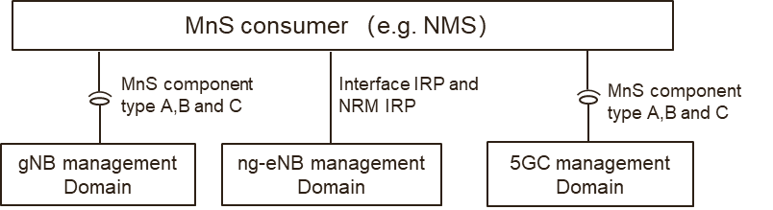

**Figure 4.4.1.2-2: NG-RAN management Option#1**

In the NG-RAN management Option#1:

* The gNB management domain provides MnS (including MnS component type A, B and C) for the management of gNB.
* The ng-eNB management domain provides IRP (including interface IRP and NRM IRP) for the management of ng-eNB.
* The 5GC management domain provides MnS (including MnS component type A, B and C) for the management of 5GC.

**NG-RAN management Option#2**

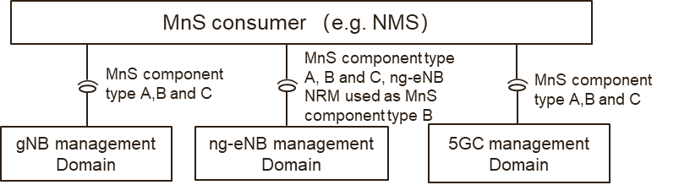

**Figure 4.4.1.2-3: NG-RAN management Option#2**

In the NG-RAN management Option#2:

* The gNB management domain provides MnS(including MnS component type A, B and C) for the management of gNB
* The ng-eNB management domain provides MnS ((including MnS component type A, B and C) for the management of ng-eNB. In this case, ng-eNB NRM used as MnS component type B, which means the YAML/YANG solution set for ng-eNB needs to be provided.
* The 5GC management domain provides MnS (including MnS component type A, B and C) for the management of 5GC.

#### 4.4.1.3 Management support for EN-DC Overall Architecture

NG-RAN supports Multi-Radio Dual Connectivity (MR-DC) operation whereby a UE in RRC\_CONNECTED is connected to two different nodes, one providing NR access and the other one providing either E-UTRA or NR access. One node acts as the MN and the other as the SN. The MN and SN are connected via a network interface and at least the MN is connected to the core network (e.g. EPC).

The following figure illustrates the MR-DC with EPC (i.e. EN-DC) architecture in TS 37.340 [5].

**

**Figure 4.4.1.2-4: EN-DC Overall Architecture**

NOTE: the en-gNB node provides NR user plane and control plane protocol terminations towards the UE, and acts as Secondary Node in EN-DC.

In order to provide management support for EN-DC, 3GPP management system needs to provide the management for en-gNB, eNB and EPC. There are also potential 2 management options to support, as follows.

**EN-DC management Option#1**

*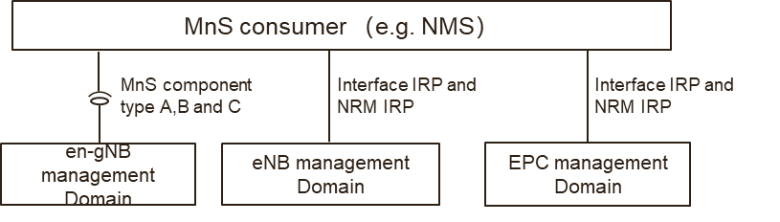*

**Figure 4.4.1.2-5: EN-DC management option#1**

In EN-DC management option#1,

* The en-gNB management domain provides MnS (including component type A, B and C) for management of en-gNB.
* The eNB management domain provides IRP (including interface IRP and NRM IRP) for the management of eNB.
* The EPC management domain provides IRP (including interface IRP and NRM IRP) for the management of EPC.

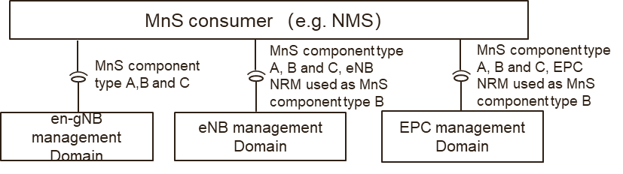

**Figure 4.4.1.2-6: EN-DC management Option#2**

**EN-DC management Option#2**

In EN-DC management option#2,

* The en-gNB management domain provides MnS (including component type A, B and C) for management of en-gNB.
* The eNB management domain provides MnS (including component type A, B and C) for management of eNB. In this case, eNB NRM used as MnS component type B, which means the YAML/YANG solution set for eNB NRM needs to be provided.
* The EPC management domain provides MnS (including component type A, B and C) for management of EPC. In this case, EPC NRM used as MnS component type B, which means the YAML/YANG solution set for EPC NRM needs to be provided.

### 4.4.2 Potential solutions #4-1

The above potential 4 management mechanism options described in clause 4.4.1 could be classified as two management options, as follows.

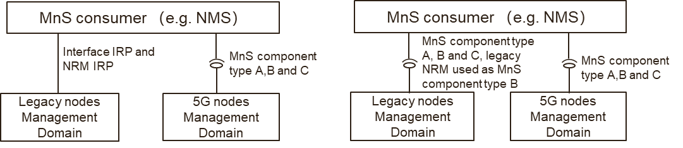

**Figure 4.4.2-1: Management Option A and B for 5G SA and NSA**

**Option#A (including above NG-RAN management Option#1 and EN-DC management Option#1)**

* The legacy nodes (e.g. eNB, ng-eNB and EPC) management domain provides IRP (including interface IRP and NRM IRP) for the management of legacy nodes.
* The 5G nodes (e.g. gNB, en-gNB and 5GC) provides MnS (including MnS component type A, B and C) for the management of 5G nodes.

**Option#B (including above NG-RAN management Option#2 and EN-DC management Option#2)**

* The legacy nodes (e.g. eNB, ng-eNB and EPC) management domain provides MnS (including MnS component type A, B and C) for the management of legacy node. In this case, legacy node NRM used as MnS component type B, which means the YAML/YANG solution set for legacy node NRM needs to be provided.
* The 5G nodes (e.g. gNB, en-gNB and 5GC) provides MnS (including MnS component type A, B and C) for the management of 5G nodes.

## 4.5 Issue #5: SBMA supporting management architecture and frameworks in other SDOs

### 4.5.1 Description

There are some relevant works on the architectures and frameworks for automation of management and orchestration in other Standards Developing Organizations (SDOs) in industry. This clause provides a brief overview on the works in the related SDOs.

### 4.5.2 Potential solutions

#### 4.5.2.1 ETSI ISG ZSM

##### 4.5.2.1.1 Introduction

The goal of ETSI ZSM is to enable zero-touch automated network and service management in a multivendor environment.

As documented in ETSI GS ZSM 002 [6], it provides the ZSM framework reference architecture as shown in figure 4.5.2.1.1-1 and distributed management and data services, organized into management domains and integrated via an integration fabric. The integration fabric is used to enable management service consumption, communication, and integration with 3rd party management systems. The cross-domain data service allows data sharing across domains. All management services provide a set of capabilities for their consumption.

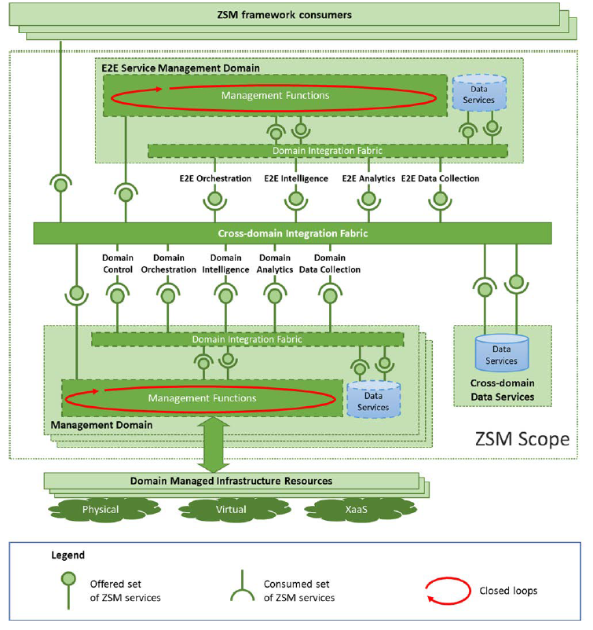

**Figure 4.5.2.1.1-1: ZSM framework reference architecture**

In figure 4.5.2.1.1-1, every management domain, as well as the E2E service management domain, provides a set of ZSM service capabilities by management functions that expose and/or consume set of service end-points. The cross-domain integration fabric facilitates providing capabilities and accessing endpoints cross-domain. Some services are only provided and consumed locally inside the management domain.

##### 4.5.2.1.2 Potential solutions #5-1

Editor's Note: this clause will specify the solutions for supporting the ZSM framework reference architecture by SBMA in 3GPP SA5. The details of the potential solution is FFS.

# 5 Conclusion and Recommendation

## 5.X Issue #X

## 5.Y Issue #Y

Annex <X> (informative):  
Change history

|  |  |  |  |  |  |  |  |
| --- | --- | --- | --- | --- | --- | --- | --- |
| **Change history** | | | | | | | |
| **Date** | **Meeting** | **TDoc** | **CR** | **Rev** | **Cat** | **Subject/Comment** | **New version** |
| 04-2021 | SA5#137e | S5-213042 |  |  |  | Initial skeleton | 0.0.0 |
| 04-2021 | SA5#137e | S5-213043 |  |  |  | Correction on title | 0.0.1 |
| 05-2021 | SA5#137e | S5-213572  S5-213573  S5-213574 |  |  |  | Update approved tdocs in SA5#137e | 0.0.2 |