3GPP TSG SA WG5 Meeting 137-e S5-213428rev2

electronic meeting, online, 10 - 19 May 2021 revision for S5-21xxxx

Source: Ericsson, Nokia, Nokia Shanghai Bell, Hewlett Packard Enterprise, Orange, Huawei

Title: Update to multi-operator scenario

Document for: Approval
Agenda Item: 6.5.3

1 Decision/action requested
The group is asked to discuss and approve the proposal..

2 References
[1] 3GPP TR 28.811: "Management and orchestration; Network Slice Management Enhancement"
[2] 3GPP TS 28.541: " Management and orchestration; 5G Network Resource Model (NRM); Stage 2 and stage 3"
[3] 3GPP TS 28.530: " Management and orchestration; Concepts, use cases and requirements "

3 Rationale
The existing scenario named, “Network Slice use in multiple networks scenario 1” in clause 5.1 is unclear and some technical issues have been identified. The solution in 7.2 description has been updated accordingly.
For clause 5.1 proposed change:
- The scenario title is still not clear, and it is proposed to change to “Network Slice using multiple networks”.
For clause 5.1.1 proposed changes:
We propose several changes for clarifications and discussion.
- What MOI’s that NOP A (and NOP B) have in its 3GPP management system is part of the solution description in 7.2 and should not be in scenario description, it is proposed to use the word object instead.
- The term “cross-domain NetworkSliceSubnet MOI” is used, our understanding is that we mean the topNetworkSliceSubnet.
- The relationships between NOP-A and NOP-B and associated interfaces is unclear, it is proposed to add some figures in the scenario description to clarify this.
For clause 5.1.2
- The technical issues identified is updated
For clause 5.2 proposed change:
- The scenario title is still not clear, and it is proposed to change to “Network Slice using multiple networks”.
For clause 7.2 it is proposed to add new solution description for RAN sharing. The accommodate this clause is split into two clauses one for RAN sharing (new content) and one for national roaming.
In addition, there're still some business, security and technical concerns on existing proposal, especially when the networks are owned by different operators.
This pCR further studies potential problem and proposes alternative solutions.

4 Detailed proposal

Start of 1st Change

5.1 Network Slice using multiple networks scenario 1

5.1.1 Description RAN sharing
Company-X (plays role of CSP) wishes to provide a communication service in multiple countries or regions. The Company-X has selected Company-NA (plays role of NSP, NOP and NSC) as network slice provider. Company-NA does not have RAN coverage in all of the geographical areas that are required by the Company-X.
Company-NA selects Company-NB (plays role of NSP and NOP) to provide RAN coverage for one or more geographical areas, and agrees service requirements related to RAN coverage with Company-NB.
Company-NA orders a service from BSS of Company-NB which will cover the required RAN coverage. Company-NA may issue the service allocation request to Company-NB’s 3GPP management system directly, or Company-NB may issue the service allocation request to its own 3GPP management system from its own BSS or portal based on the agreed order from Company-NA.
Note 1: how does Company-NA order service product from BSS of Company-NB and negotiate SLA with each other is out the scope of this use case.
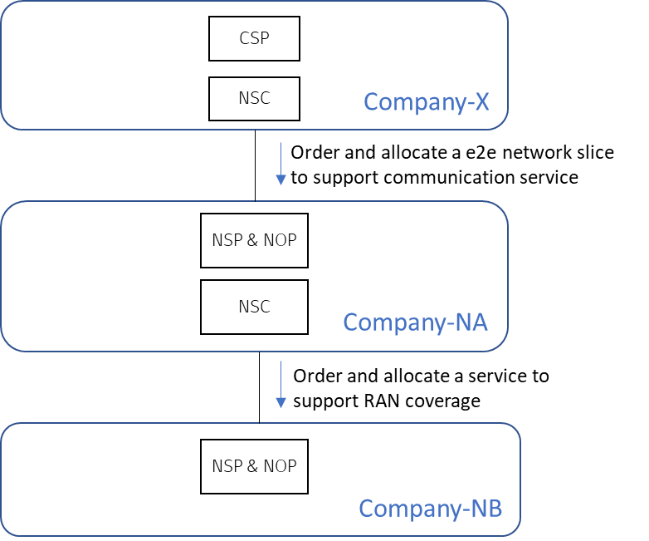
Figure 5.1-1 Order and allocate a network slice across multiple operators
During operation phase, Company-NA may provision or monitor the RAN coverage service provided by Company-NB through Company-NB’s 3GPP management system directly, or Company-NB may issue the request to its own 3GPP management system from its own BSS or portal based on the agreed SLA with Company-NA.
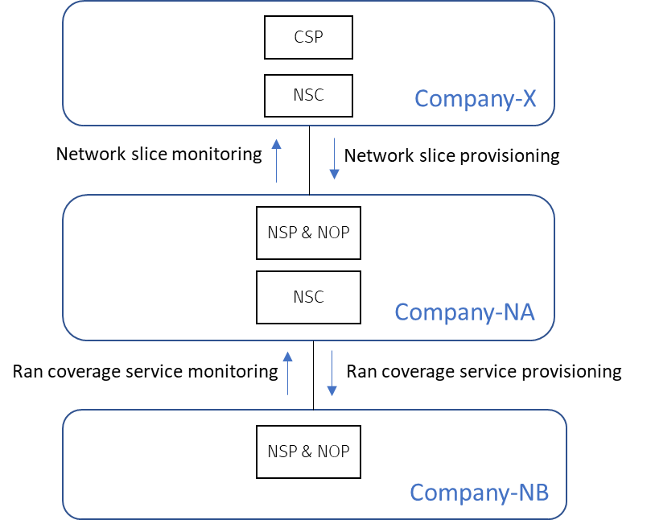
Figure 5.1-2 Order and allocate a network slice across multiple operators
Note 2: How does Company-X interact with Company-NA to order, provision and monitor a E2E network slice is out the scope of this use case, it's fallen into general network slice management scope.

5.1.2 Identified problems
According to network slice NRM fragment defined in TS 28.541, Company-NA’s management system will contain a NetworkSlice MOI, the top NetworkSliceSubnet MOI, and the CN NetworkSliceSubnet MOI. Company-NB’s management system will contain a NetworkSlice MOI and RAN NetworkSliceSubnet MOI. As part of the provisioning phase, the top NetworkSliceSubnet MOI in Company-NA’s management system could be configured with a reference to the RAN NetworkSliceSubnet MOI in Company-NB’s management system. Please see the potential solution alternative 1 in 7.2.1. But there is no guidance for a NSP/NOP on the management capabilities that should be exposed to allow different management levels for a network slice.
Editor’s note: It is FFS how MCEG and EGMF can be used to expose different management levels for a network slice.
The solution based on existing management capabilities could have potential business, security issues, as well as technical gap. E.g. The solution proposed in 7.2 supposed top NetworkSliceSubnet MOI in NOP-A’s management system could aggregate RAN NetworkSliceSubnet MOI in NOP-B’s management system. The network slice topology resulting from the provisioning according to this solution would be looked like figure 5.1.2-1.
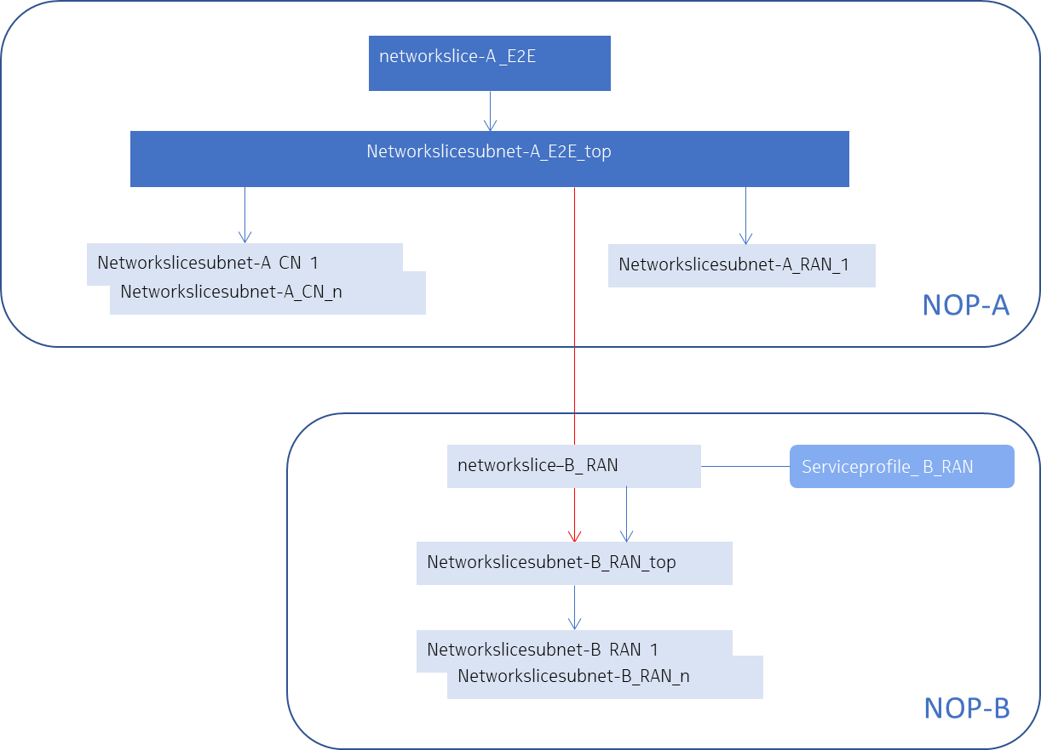
The problems/limitations of the solution includes:
1. It breaks the layering principles for a Telecommunications Management Network defined by ITU-T, where different layers have different views (scope, abstraction level, exposure etc.) to the network.
2. Generally, the service provider (SP) offers service to its customer (SC) as a Blackbox without exposing detailed network/resource topology (encapsulation/abstraction principle) in order to avoid leaking unnecessary sensitive information (need to know principle) and potential mis-use and mis-operation. Therefore, in a normal case, only service level object and related attributes would be exposed to the service consumer instead of exposing lower layer resources to external customer, especially when the resource is shared by multiple services of difference customers. In other words, generally an SC is not allowed to “decompose” or "reverse-engineer" the service (e.g. network slice) it gets from the SP and to use just a "building block" of the consumed service, such as partial resource of the service (i.e. a single network slice subnet or network function out of the entire network slice as a service). The service decomposition or reverse-engineering is usually explicitly prohibited (by the terms of the contract / SLA) as causing threat/risk to SP’s network.
3. There’s no reference from NetworkSliceSubnet MOI (representing the managed network or part of the network being used to satisfy the service customer's requirements) to NetworkSlice MOI (representing the commercial exposure to the service customer) in existing NRM, it’s impossible for NOP-A to track the SLA/SLS with NOP-B for the referred NetworkSliceSubnet MOI, hence NOP-A couldn’t know if the referred NetworkSliceSubnet MOI of NOP-B satisfied the SLA/SLS or not.
So there're three alternative solutions proposed in 7.2.2, 7.2.3 and 7.2.4
Note: BSS related issue is not in the scope of the use case, which will be discussed in SI FS_MNSAC and FS_NSCE

End of Change

Start of 2nd Change

7.2 Possible solutions for network slice covering multiple networks

7.2.1 Alternative 1: solution based on the existing NRM with related exposure
This clause describes how 3GPP management capabilities may be used to allow COMPANY-NA to manage a network slice which is provided by Company-NB.
As part of the provisioning phase, the top NetworkSliceSubnet MOI in Company-NA’s management system should be configured with a reference to the RAN NetworkSliceSubnet MOI in COMPANY-NB’s management system. To obtain this reference, Company-NA’s management system may read the NetworkSlice instance which was returned by COMPANY-NB after allocateNsi operation (cf. 28.531 [3], clause 6.5.1), and read the attribute NetworkSliceSubnetRef. This assumes that COMPANY-NA has read access to the generic provisioning management service of COMPANY-NB, and has the authority to read the NetworkSlice instance.
Therefore, to allow Company-NA to manage the network slice using a 3GPP Management System, Company-NB may allow COMPANY-NA read access to the managed object NetworkSlice via the getMOIAttributes operation, defined in 28.532 [5]. This will allow Company-NA to read the operationalState and administrativeState of the NetworkSlice instance, and also the networkSliceSubnetRef of the NetworkSliceSubnet.
If COMPANY-NB wishes to allow Company-NA to control the adminstrativeState of the NetworkSlice instance, Company-NB may allow Company-NA write access to the managed object NetworkSlice via the modifyMOIAttributes operation, defined in 28.532 [5]. However, this would also allow Company-NA to alter the ServiceProfileList, which may not be desirable. Therefore, Company-NB must implement checks on any change to the attribute ServiceProfileList, see “Procedure of Network Slice Instance Modification” in 28.531 [3] and any undesirable changes should be rejected.
If COMPANY-NB wishes to allow Company-NA to view alarms related to the NetworkSlice instance, Company-NB may expose the “FS Data Report for NSI” Service, as described in 28.545 [6]. Company-NB should only allow operations by Company-NA where the baseObjectInstance is equal to the DN of the NetworkSlice instance.
If COMPANY-NB wishes to allow Company-NA to manage alarms related to the NetworkSlice instance, Company-NB may expose the “FS Control for NSI” Service, as described in 28.545 [6]. COMPANY-NB should only allow operations by Company-NA where the baseObjectInstance is equal to the DN of the NetworkSlice instance.
If COMPANY-NB wishes to allow Company-NA to view performance measurements related to the NetworkSlice instance, COMPANY-NB may expose the operations and notificationsdescribed in 28.550 [7]. Company-NB should only expose measurements related to the S-NSSAI of the NetworkSlice instance.
If COMPANY-NB wishes to allow COMPANY-NA to view KPIs related to the NetworkSlice, COMPANY-NB may expose the KPIs as described in 28.554 [8]. COMPANY-NB should only expose KPIs related to the NetworkSlice instance or KPIs related to the S-NSSAI of the NetworkSlice instance.

7.2.x Alternative 2: solution based on NRM extension - dual views of network slice
Company-NA sends to Company-NB an AllocateNsi operation request (cf. TS 28.531 clause 6.5.1) to ask to allocate a NetworkSlice instance to satisfy its network slice related requirements;
Company-NB sends back the AllocateNsi operation result to Company-NA. This result includes the relevant network slice instance information (an existing NetworkSlice instance may have been modified or a new NetworkSlice instance may have been created to satisfy the network slice related requirements - see TS 28.531 clause 6.5.1);
Company-NA can then create its end-to-end network slice based on local network slices provided by Company-NB.
Suggest to model network slice as combination (dual views) of service and resource. From one perspective, network slice can be treated as a service (commercial exposure) when it offered by network slice provider (NSP) to network slice customer (NSC). From another perspective, a network slice (either provided by the same operator in network slice as NOP internal mode or offered by a different operator in network slice as a service (NSaaS) mode) can be treated as a resource and therefore, stitched to a resource collection object (e.g. network slice subnet) to build another network slice.
Editor's note: the model details can be further elaborated.

7.2.x Alternative 3: solution based on NRM extension - recursive network slice
Company-NA sends to Company-NB an AllocateNsi operation request (cf. TS 28.531 clause 6.5.1) to ask to allocate a NetworkSlice instance to satisfy its network slice related requirements;
Company-NB sends back the AllocateNsi operation result to Company-NA. This result includes the relevant network slice instance information (an existing NetworkSlice instance may have been modified or a new NetworkSlice instance may have been created to satisfy the network slice related requirements - see TS 28.531 clause 6.5.1);
Company-NA can then create its end-to-end network slice based on local network slices provided by Company-NB.
Suggest to update TS 28.541 Figure 6.2.1-1 to represent that a NetworkSlice IOC instance can be composed of other NetworkSlice IOC instances

7.2.z Alternative 4: solution based on business model extension - support network slice subnet as a service
This clause describes how 3GPP management capabilities may be used to allow COMPANY-NA to manage a network slice subnet service which is provided by COMPANY-NB.
As part of the provisioning phase, the top NetworkSliceSubnet MOI in COMPANY-NA’s management system should be configured with a reference to the RAN NetworkSliceSubnet MOI in COMPANY-NB’s management system. To obtain this reference, COMPANY-NA’s management system may read the NetworkSliceSubnet instance information which was returned by COMPANY-NB after allocateNssi operation (cf. 28.531 [3], clause 6.5.1).
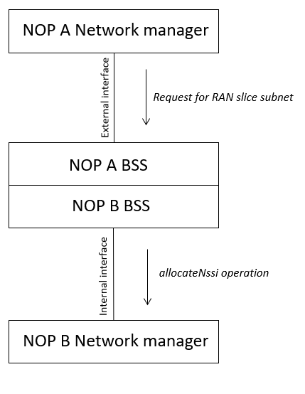
Figure 7.2.z-1 Provisioning phase

Therefore, to allow COMPANY-NA to manage the network slice subnet using a 3GPP Management System, COMPANY-NB may allow COMPANY-NA to interact with the NetworkSliceSubnet via a BSS, the BSS has read access to the managed object NetworkSliceSubnet via the getMOIAttributes operation, defined in 28.532 [5]. This will allow COMPANY-NA to read the operationalState and administrativeState of the NetworkSliceSubnet instance, via the BSS.
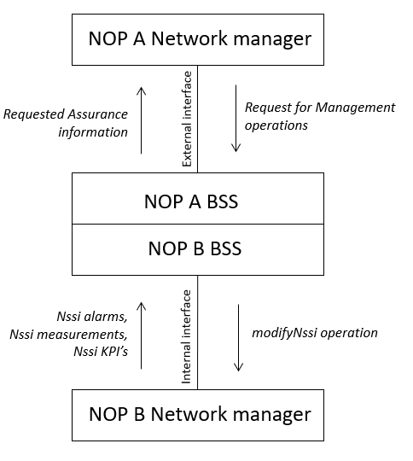
Figure 7.2.z-2 Operation phase

If COMPANY-NB wishes to allow COMPANY-NA to control the adminstrativeState of the NetworkSliceSubnet instance, COMPANY-NB may allow COMPANY-NA to interact with the BSS, the BSS has write access to the managed object NetworkSliceSubnet via the modifyMOIAttributes operation, defined in 28.532 [5].
If COMPANY-NB wishes to allow COMPANY-NA to view alarms related to the NetworkSliceSubnet instance, COMPANY-NB may expose management capabilities to the “FS Data Report for NSSI” Service via BSS, as described in 28.545 [6]. BSS in this case is allowed operations on behalf of COMPANY-NA where the baseObjectInstance is equal to the DN of the NetworkSliceSubnet instance.
If COMPANY-NB wishes to allow COMPANY-NA to manage alarms related to the NetworkSliceSubnet instance, COMPANY-NB may expose management capabilities to the “FS Control for NSSI” Service, via BSS as described in 28.545 [6]. BSS in this case is allowed operations on behalf of COMPANY-NA where the baseObjectInstance is equal to the DN of the NetworkSliceSubnet instance.
If COMPANY-NB wishes to allow COMPANY-NA to view performance measurements related to the NetworkSliceSubnet instance, COMPANY-NB may expose management capabilities to the operations and notifications described in 28.550 [7] via BSS. BSS should only expose measurements related to the S-NSSAI of the NetworkSliceSubnet instance.
If COMPANY-NB wishes to allow COMPANY-NA to view KPIs related to the NetworkSliceSubnet, COMPANY-NB may expose the KPIs as described in 28.554 [8] via BSS. COMPANY-NB should only expose KPIs related to the NetworkSliceSubnet instance or KPIs related to the S-NSSAI of the NetworkSliceSubnet instance.

7.2.2 Solution for national roaming
Editor’s Note: The solution for national roaming is FFS

End of Change

