3GPP TSG SA WG5 Meeting 137-e TDoc S5-213428rev1

electronic meeting, online, 10 - 19 May 2021

Source: Ericsson

Title: Update to multi-operator scenario

Document for: Approval
Agenda Item: 6.5.3

1 Decision/action requested
The group is asked to agree on the proposal.

2 References
[1] 3GPP TR 28.811 v 0.3.0 : "Management and orchestration; Network Slice Management Enhancement"
[2] 3GPP TS 28.530: "Management and orchestration; Concepts, use cases and requirements"

3 Rationale
The existing scenario named, “Network Slice use in multiple networks scenario 1” in clause 5.1 is unclear and some technical issues have been identified. The solution in 7.2 description has been updated accordingly.
For clause 5.1 proposed change:
- The scenario title is still not clear, and it is proposed to change to “Network Slice using multiple networks”.
For clause 5.1.1 proposed changes:
We propose several changes for clarifications and discussion.
- What MOI’s that NOP A (and NOP B) have in its 3GPP management system is part of the solution description in 7.2 and should not be in scenario description, it is proposed to use the word object instead.
- The term “cross-domain NetworkSliceSubnet MOI” is used, our understanding is that we mean the topNetworkSliceSubnet.
- The relationships between NOP-A and NOP-B and associated interfaces is unclear, it is proposed to add some figures in the scenario description to clarify this.
For clause 5.1.2
- The technical issues identified is updated
For clause 5.2 proposed change:
- The scenario title is still not clear, and it is proposed to change to “Network Slice using multiple networks”.
For clause 7.2 it is proposed to add new solution description for RAN sharing. The accommodate this clause is split into two clauses one for RAN sharing (new content) and one for national roaming.

4 Detailed proposal
To add the following updates into clause 5.1, 5.1.1, 5.1.2 and 7.2of TR 28.811 v 0.4.0.

Start of 1st Change

5 Scenarios for Network Slicing Management Enhancements

5.1 Network Slice using multiple networks scenario 1

5.1.1 Description RAN sharing
CSP wishes to provide a communication service using NOP-A as network slice provider. NOP-A does not have RAN coverage in all the geographical areas that are required by the CSP.
NOP-A selects NOP-B to provide RAN coverage for one or more geographical areas, and agrees slice subnet requirements with NOP-B.
NOP-A orders the allocation of a RAN slice subnet from NOP-B. The request is sent from NOP A’s network management system to NOP B’s business support system (BSS) using an external interface. NOP-B may issue the allocation of the RAN slice subnet request using the allocateNssi operation to its own network management system. The request flow is shown in Figure5.1.1.1.
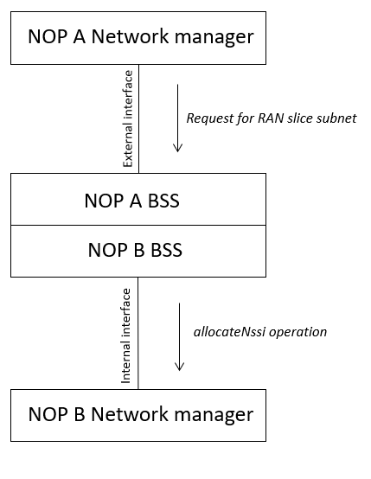
Figure 5.1.1.1 Provisioning phase
The network slice instance is modelled as a set of objects which partially (a subset of objects) exists in NOP-A’s network management system and partially (the remaining subset of objects) in NOP-B’s network management system.
NOP-A’s network management system will contain several objects, an object to represents the NetworkSlice instance, an object to represents the topNetworkSliceSubnet instance, an object to represents the RAN NetworkSliceSubnet instance and an object to represents the CN NetworkSliceSubnet instance.
NOP-B’s network management system will contain an object representing a RAN NetworkSliceSubnet instance including the information that this RAN NetworkSliceSubnet instance is used for RAN sharing.
The RAN NetworkSliceSubnet in NOP A’s network management system represents the RAN coverage that NOP-A provides via its own RAN. The RAN NetworkSliceSubnet in NOP B’s network management system represents the RAN coverage that NOP-B provides to the fulfil the communication service requirement (coverage area) from CSP.
As part of the provisioning phase, the topNetworkSliceSubnet object in NOP-A’s network management system should be configured with a reference to the RAN NetworkSliceSubnet object in NOP-B’s network management system.
As part of the operation phase, NOP-A’s management system can use management operations to modify the RAN NetworkSliceSubnet, see Figure 5.1.1.2
As part of the operation phase, the assurance information produced by the RAN pertaining to the RAN NetworkSliceSubnet should be provided to NOP-A’s network management system, see Figure 5.1.1.2.
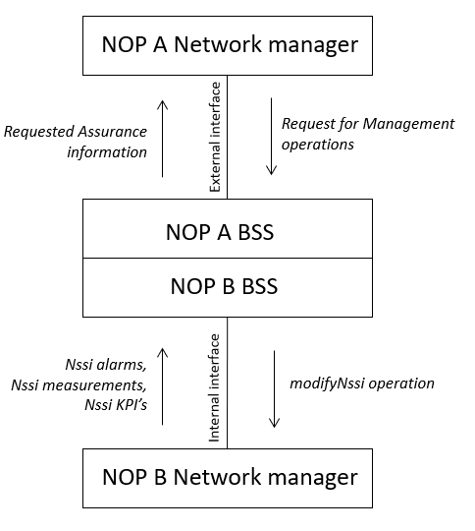
Figure 5.1.1.2 Operation phase

5.1.2 Identified problems

The documented use cases and requirements in 28.530 [2] do not describe the interaction between two NOP’s that provide NetworkSliceSubnet services.
The impact on the NRM for objects that represent information referring to objects in another NOP’s system
Editor’s Note: It is FFS how MCEG and EGMF can be used to expose different management levels for a network slice.

5.2 Network slice using multiple networks scenario 2

5.2.1 Description national roaming
CSP-A wishes to provide a communication service using NOP-A. NOP-A does not have RAN coverage in all of the geographical areas that are required by the CSP-A. CSP-A has a national roaming agreement with CSP-B to allow subscribers of NOP-A to roam into NOP-B.
NOTE: National roaming is an agreement between two MNOs, and both may have the roles of CSP, NOP, and NSP.
As part of the agreement with CSP-B, CSP-A requests CSP-B to support a communication service for inbound roamers with certain capabilities. CSP-A need to inform CSP-B about the S-NSSAI(s) used by inbound roamers and for the capabilities required for this communication service. CSP-B needs this information first of all to check (with NOP-B) on the NetworkSlice instance(s) to be used by the inbound roamers and whether there is a need to map the CSP-A S-NSSAI to CSP-B S-NSSAI. CSP-A may issue the request to CSP-B’s 3GPP management system, or CSP-B may issue the request to its own 3GPP management system.
For the NetworkSlice instance in NOP-A, this exists in NOP-A’s management system, including the information that the NetworkSlice instance is used for outbound roaming. For the NetworkSlice instance in NOP-B, this exists in NOP-B’s management system, including the information that the NetworkSlice instance is used for inbound roaming.

5.2.2 Identified problems
The national roaming agreement between CSP-A and CSP-B needs to be enhanced for 5G to also include required NetworkSlice instance information (identify needed enhancement).
For national roaming, 3GPP management enhancements may be needed to support required exchanges between CSP-A/NOP-A (as well as between CSP-B/NOP-B).
The NetworkSlice instance information in NOP-A and NOP-B needs to be updated to support outbound/inbound roaming. This is not currently supported in the NetworkSlice IOC defined in 28.541 [2].

Second Change

7.2 Possible solutions for network slice using multiple networks

7.2.1 Solution for RAN sharing
This clause describes how 3GPP management capabilities may be used to allow NOP-A to manage a network slice subnet service which is provided by NOP-B.
As part of the provisioning phase, the top NetworkSliceSubnet MOI in NOP-A’s management system should be configured with a reference to the RAN NetworkSliceSubnet MOI in NOP-B’s management system. To obtain this reference, NOP-A’s management system may read the NetworkSliceSubnet instance information which was returned by NOP-B after allocateNssi operation (cf. 28.531 [3], clause 6.5.1).
Therefore, to allow NOP-A to manage the network slice subnet using a 3GPP Management System, NOP-B may allow NOP-A to interact with the NetworkSliceSubnet via a BSS, the BSS has read access to the managed object NetworkSliceSubnet via the getMOIAttributes operation, defined in 28.532 [5]. This will allow NOP-A to read the operationalState and administrativeState of the NetworkSliceSubnet instance, via the BSS.
If NOP-B wishes to allow NOP-A to control the adminstrativeState of the NetworkSliceSubnet instance, NOP-B may allow NOP-A to interact with the BSS, the BSS has write access to the managed object NetworkSliceSubnet via the modifyMOIAttributes operation, defined in 28.532 [5].
If NOP-B wishes to allow NOP-A to view alarms related to the NetworkSliceSubnet instance, NOP-B may expose management capabilities to the “FS Data Report for NSSI” Service via BSS, as described in 28.545 [6]. BSS in this case is allowed operations on behalf of NOP-A where the baseObjectInstance is equal to the DN of the NetworkSliceSubnet instance.
If NOP-B wishes to allow NOP-A to manage alarms related to the NetworkSliceSubnet instance, NOP-B may expose management capabilities to the “FS Control for NSSI” Service, via BSS as described in 28.545 [6]. BSS in this case is allowed operations on behalf of NOP-A where the baseObjectInstance is equal to the DN of the NetworkSliceSubnet instance.
If NOP-B wishes to allow NOP-A to view performance measurements related to the NetworkSliceSubnet instance, NOP-B may expose management capabilities to the operations and notifications described in 28.550 [7] via BSS. BSS should only expose measurements related to the S-NSSAI of the NetworkSliceSubnet instance.
If NOP-B wishes to allow NOP-A to view KPIs related to the NetworkSliceSubnet, NOP-B may expose the KPIs as described in 28.554 [8] via BSS. NOP-B should only expose KPIs related to the NetworkSliceSubnet instance or KPIs related to the S-NSSAI of the NetworkSliceSubnet instance.

7.2.2 Solution for national roaming
Editor’s Note: The solution for national roaming is FFS

End of Changes

