**GPP TSG- Meeting #**

**, , -**

|  |  |  |  |  |  |  |  |  |
| --- | --- | --- | --- | --- | --- | --- | --- | --- |
| *CR-Form-v12.1* | | | | | | | | |
| **CHANGE REQUEST** | | | | | | | | |
|  | | | | | | | | |
|  |  | **CR** |  | **rev** |  | **Current version:** |  |  |
|  | | | | | | | | |
| *For* [***HE******LP***](http://www.3gpp.org/3G_Specs/CRs.htm#_blank)*on using this form: comprehensive instructions can be found at* [*http://www.3gpp.org/Change-Requests*](http://www.3gpp.org/Change-Requests)*.* | | | | | | | | |
|  | | | | | | | | |

|  |  |  |  |  |  |  |  |  |
| --- | --- | --- | --- | --- | --- | --- | --- | --- |
| ***Proposed change affects:*** | UICC apps |  | ME |  | Radio Access Network | **x** | Core Network | **x** |

|  |  |  |  |  |  |  |  |  |  |  |
| --- | --- | --- | --- | --- | --- | --- | --- | --- | --- | --- |
|  | | | | | | | | | | |
| ***Title:*** |  | | | | | | | | | |
|  |  | | | | | | | | | |
| ***Source to WG:*** | , Huawei, China Mobile | | | | | | | | | |
| ***Source to TSG:*** |  | | | | | | | | | |
|  |  | | | | | | | | | |
| ***Work item code:*** |  | | | | |  | ***Date:*** | | |  |
|  |  | | | |  | |  | | |  |
| ***Category:*** |  |  | | | | | ***Release:*** | | |  |
|  | *Use one of the following categories:* ***F*** *(correction)* ***A*** *(mirror corresponding to a change in an earlier release)* ***B*** *(addition of feature),* ***C*** *(functional modification of feature)* ***D*** *(editorial modification)*  Detailed explanations of the above categories can be found in 3GPP [TR 21.900](http://www.3gpp.org/ftp/Specs/html-info/21900.htm). | | | | | | | | *Use one of the following releases: Rel-8 (Release 8) Rel-9 (Release 9) Rel-10 (Release 10) Rel-11 (Release 11) … Rel-15 (Release 15) Rel-16 (Release 16) Rel-17 (Release 17) Rel-18 (Release 18)* | |
|  |  | | | | | | | | | |
| ***Reason for change:*** | | Information in L.2 on mapping GST attributes is not up to date and related KPIs and performance measurements are missing. | | | | | | | | |
|  | |  | | | | | | | | |
| ***Summary of change:*** | | Mapping fo GST attributes to SliceProfile and ServiceProfile is updated.  New table L.2.2 with information on the related KPIs and performance measurements added | | | | | | | | |
|  | |  | | | | | | | | |
| ***Consequences if not approved:*** | | The specification is inconsistent, incomplete | | | | | | | | |
|  | |  | | | | | | | | |
| ***Clauses affected:*** | | L.2 | | | | | | | | |
|  | |  | | | | | | | | |
|  | | **Y** | **N** |  | | | |  | | |
| ***Other specs*** | |  |  | Other core specifications | | | | TS/TR ... CR ... | | |
| ***affected:*** | |  |  | Test specifications | | | | TS/TR ... CR ... | | |
| ***(show related CRs)*** | |  |  | O&M Specifications | | | | TS/TR ... CR ... | | |
|  | |  | | | | | | | | |
| ***Other comments:*** | | None | | | | | | | | |
|  | |  | | | | | | | | |
| ***This CR's revision history:*** | |  | | | | | | | | |

|  |
| --- |
| **1st modified section** |

# L.2 GSMA GST, ServiceProfile and sliceProfile

The GSMA GST is used as the SLA information for the communication between the NSC (e.g. vertical industry) and the NSP. The SLA requirements can be fulfilled from management aspect and control aspect in a coordinated way. The SLS includes ServiceProfile information model.

As shown in figure L.2.1, the GST parameters [50] are translated and used as input to NRM ServiceProfile. The ServiceProfile, which is entered by the network slice consumer, defines the wanted service requirements for a wanted service. The ServiceProfile requirements are then translated to a Top SliceProfile (including specific TopSliceSubnetProfile attributes). Based on Top SliceProfile requirements, the corresponding requirements for the dedicated domain specific network slice subnets in the RAN/TN/5GC are defined. For example, a 5GC SliceProfile (including specific CNSliceSubnetProfile attributes) is used to carry 5GC domain requirements, a NG-RAN SliceProfile (including specific RANSliceSubnetProfile attributes) is used to carry NG-RAN domain requirements, and the TN requirements are derived and provide input to TN domain. Some of the information in 5GC SliceProfile and NG-RAN SliceProfile can be translated to configurable parameters of network function for the control plane SLA support purpose.

As shown in Table L.2.1 some of the attributes in 5GC SliceProfile and NG-RAN SliceProfile parameters can be translated to configurable parameters related to network function behaviour to satisfy SLA of the service in the control plane. While other information (e.g delay tolerance, determistic communication support) in 5GC SliceProfile and NG-RAN SliceProfile are kept at OAM domain and is used to determine the overall behaviour of the network slice.

The following table show the translation of GST attributes.

Table L.2.1: GST translation

|  |  |  |  |  |  |
| --- | --- | --- | --- | --- | --- |
| GST Attributes | ServiceProfile Parameter | SliceProfile Parameter | | | Configurable Parameter |
| TopSlice SubnetProfile | RANSlice SubnetProfile | CNSlice SubnetProfile |
| **Maximum number of UEs** | maxNumberofUEs | maxNumberofUEs | maxNumberofUEs | maxNumberofUEs | TBD |
| **Maximum number of PDU sessions** | maxNumberofPDUSessions | maxNumberofPDUSessions | N/A | maxNumberofPDUSessions | TBD |
| **Downlink maximum throughput per UE** | dLThptPerUE | dLThptPerUEPerSubne | dLThptPerUEPerSubne | dLThptPerUEPerSubne | TBD |
| **Uplink maximum throughput per UE** | uLThptPerUE | uLThptPerUEPerSubnet | uLThptPerUEPerSubnet | uLThptPerUEPerSubnet | TBD |

Editors note: The list of exact configurable parameters is to be revisted depending on the requirements from SA2 and RAN WGs.

There is also a number of SLA relevant measurements and KPIs defined as shown in the Table below

Table L.2.2: KPIs and Measurements defined for SLA support purpose

|  |  |
| --- | --- |
| GST Attributes | KPIs and Performance Measurements |
|
| **Maximum number of UEs** | FFS |
| **Maximum number of PDU sessions** | See clause 6.4.5 Maximum number of PDU sessions of network slice in TS 28.554 [27]  Note: this measurement sums up the max during ROP for all involved CN-nodes. The total max during ROP is probably a fair bit lower |
| **Downlink maximum throughput per UE** | See clause 5.1.1.3.2 Distribution of DL UE throughput in gNB in TS 28.552 [69]. |
| **Uplink maximum throughput per UE** | See clause 5.1.1.3.4 Distribution of UL UE throughput in gNB in TS 28.552 [69]. |

NOTE: Void.

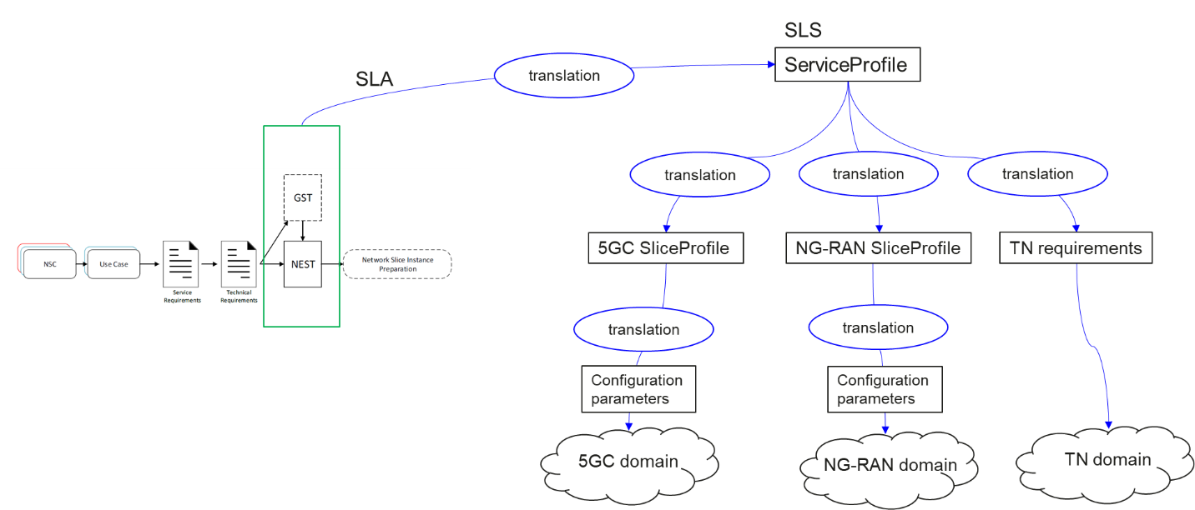

Figure L.2.1 Relation between GSMA GST, ServiceProfile and SliceProfile

|  |
| --- |
| **Next modified section** |