3GPP TSG SA WG5 Meeting 137-e S5-213403

electronic meeting, online, 10-19 May 2021

**Source: ZTE**

**Title:** **Discussion on MOCN NG-RAN network sharing**

**Document for: Discussion and Approval**

**Agenda Item: 6.4.17**

# 1 Decision/action requested

***The group is asked to discuss and approve the proposals.***

# 2 References

[1] 3GPP TS 23.501: “System architecture for the 5G System (5GS)”

[2] 3GPP TS 32.130: “Telecommunication management; Network sharing; Concepts and requirements”

[3] 3GPP TS 38.401: “NG-RAN; Architecture description”

[4] 3GPP TS 38.300: “NR; NR and NG-RAN Overall description; Stage-2”

# 3 Discussion

About MOCN NG-RAN sharing, we can find the following descriptions in the 3GPP TSs.

/*********************** Extracted from TS 32.130[2], 4.1 Begin ***********************/

## 4.1 RAN sharing scenarios

Various network sharing scenarios exist, amongst which one category is RAN sharing which can be divided into the following (non exhaustive) list of sub-categories:

- Passive RAN sharing, also known as infrastructure sharing (including site sharing).

- Active RAN sharing, where active network elements of the RAN are shared:

- RAN-only sharing (MOCN; see TS 23.251 [5] and TS 23.501 [7]), i.e. BTSs / BSCs (respectively NodeBs / RNCs and eNodeBs) in a 2G Radio Access Network (respectively a 3G Radio Access Network and an E-UTRA network) , and gNBs in a 5G NR network;

/*********************** Extracted from TS 32.130[2], 4.1 End ***********************/

/*********************** Extracted from TS 23.501[1], 5.18.1 Begin ***********************/

A network sharing architecture shall allow multiple participating operators to share resources of a single shared network according to agreed allocation schemes. The shared network includes a radio access network. The shared resources include radio resources.

The shared network operator allocates shared resources to the participating operators based on their planned and current needs and according to service level agreements.

/*********************** Extracted from TS 23.501 End ************************/

**Observation 1:** From 3GPP network perspective, the shared resources in the MOCN NG-RAN sharing scenarios should focus on the radio resources of gNBs.

Based on the abovementioned observation, if the radio resources of a gNB is shared by two or more operators, we can say this is a NG-RAN sharing scenario. For MOCN NG-RAN sharing, the shared radio resource can be the carrier.

From the perspective of deployment, different approaches can be adopted to represent and manage the shared NG-RAN resources based on different features provided by the RAN side.

The following contents introduce the different MOCN NG-RAN sharing deployment approaches based on the features provided by the RAN side.

/*********** MOCN NG-RAN sharing deployment approach examples – beginning **********/

### MOCN NG-RAN sharing deployment approach examples

When a gNB is not shared, its carrier resource is used by an operator alone, the gNB can be deployed as:

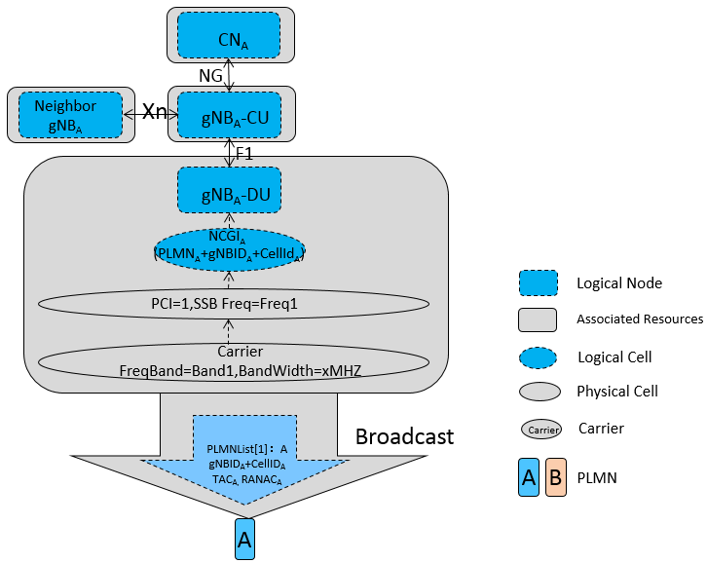

In this scenario, the PLMNList in the broadcasted SIB1 IE only have one PLMN Id.

When two operators Operator A and Operator D want to share the resources of the abovementioned gNB, if they do not have the isolation requirement, then the MOCN without Multiple CellIds feature can be used in the deployment, as follows:

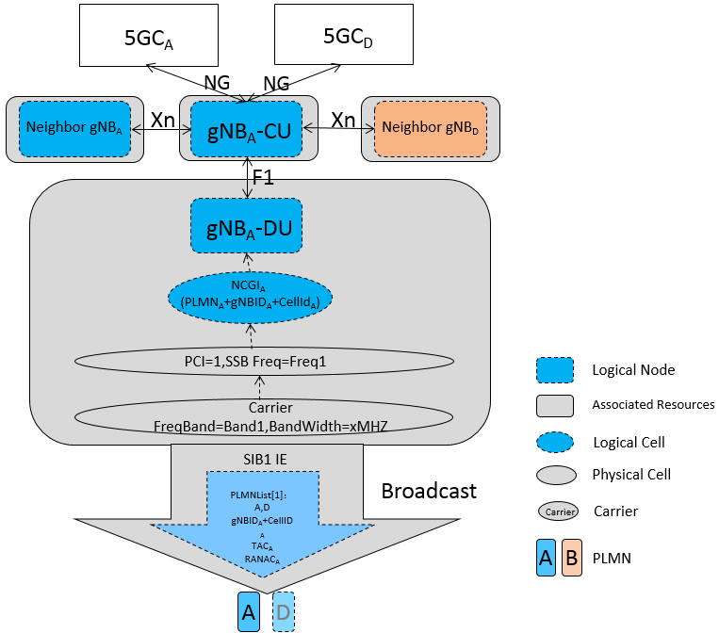

In this scenario, there is only one PLMNList in the broadcasted SIB1 IE, and the PLMNList have two PLMN Ids.

If the two operators Operator A and Operator D want to share the resources of the abovementioned gNB, and they do have the isolation requirement, then the MOCN with Multiple CellIds feature can be used in the deployment, as follows:

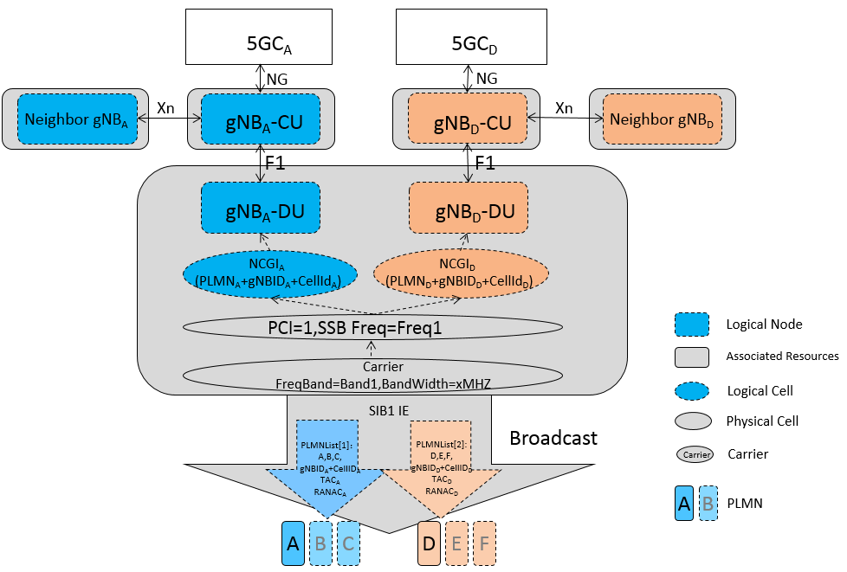

In this scenario, there are two PLMNLists in the broadcasted SIB1 IE, and every PLMNList has its own PLMN Ids.

/*********** MOCN NG-RAN sharing deployment approach examples – end **********/

# 4 Detailed proposal

It is proposed to agree with the follows:

1. From 3GPP network management perspective, the shared resources in the MOCN network sharing scenarios should focus on the radio resources, e.g. the gNB, cell, carrier.
2. Add the abovementioned MOCN NG-RAN sharing deployment approach examples to an annex in TS 32.130 or in a new TR.