**3GPP TSG-SA5 Meeting #137eS5-213377**

**e-meeting, 10 - 19 May 2021**

|  |  |  |  |  |  |  |  |  |
| --- | --- | --- | --- | --- | --- | --- | --- | --- |
| *CR-Form-v11.4* | | | | | | | | |
| **CHANGE REQUEST** | | | | | | | | |
|  | | | | | | | | |
|  | **28.541** | **CR** | **0498** | **rev** | **-** | **Current version:** | **17.2.0** |  |
|  | | | | | | | | |
| *For* [***HELP***](http://www.3gpp.org/3G_Specs/CRs.htm#_blank)*on using this form: comprehensive instructions can be found at* [*http://www.3gpp.org/Change-Requests*](http://www.3gpp.org/Change-Requests)*.* | | | | | | | | |
|  | | | | | | | | |

|  |  |  |  |  |  |  |  |  |
| --- | --- | --- | --- | --- | --- | --- | --- | --- |
| ***Proposed change affects:*** | UICC apps |  | ME |  | Radio Access Network | **X** | Core Network |  |

|  |  |  |  |  |  |  |  |  |  |  |
| --- | --- | --- | --- | --- | --- | --- | --- | --- | --- | --- |
|  | | | | | | | | | | |
| ***Title:*** | Add note for RRMPolicy | | | | | | | | | |
|  |  | | | | | | | | | |
| ***Source to WG:*** | Nokia, Nokia Shanghai Bell | | | | | | | | | |
| ***Source to TSG:*** | S5 | | | | | | | | | |
|  |  | | | | | | | | | |
| ***Work item code:*** | TEI17 | | | | |  | ***Date:*** | | | 2021-04-29 |
|  |  | | | |  | |  | | |  |
| ***Category:*** | **F** |  | | | | | ***Release:*** | | | Rel-17 |
|  | *Use one of the following categories:* ***F*** *(correction)* ***A*** *(mirror corresponding to a change in an earlier release)* ***B*** *(addition of feature),* ***C*** *(functional modification of feature)* ***D*** *(editorial modification)*  Detailed explanations of the above categories can be found in 3GPP [TR 21.900](http://www.3gpp.org/ftp/Specs/html-info/21900.htm). | | | | | | | | *Use one of the following releases: Rel-8 (Release 8) Rel-9 (Release 9) Rel-10 (Release 10) Rel-11 (Release 11) Rel-12 (Release 12) Rel-13 (Release 13) Rel-14 (Release 14) Rel-15 (Release 15) Rel-16 (Release 16)* | |
|  |  | | | | | | | | | |
| ***Reason for change:*** | | How could the RRMPolicyRatio could be used in call processing was not clear. | | | | | | | | |
|  | |  | | | | | | | | |
| ***Summary of change:*** | | Add simple notes to describe how could the resource related to RRMPolicyRatio could be used in call processing. | | | | | | | | |
|  | |  | | | | | | | | |
| ***Consequences if not approved:*** | | May cause inconsistent implantation of RRMPolicyRatio in gNB | | | | | | | | |
|  | |  | | | | | | | | |
| ***Clauses affected:*** | | 4.3.36 | | | | | | | | |
|  | |  | | | | | | | | |
|  | | **Y** | **N** |  | | | |  | | |
| ***Other specs*** | |  | **X** | Other core specifications | | | | TS/TR ... CR ... | | |
| ***affected:*** | |  | **X** | Test specifications | | | | TS/TR ... CR ... | | |
| ***(show related CRs)*** | |  | **X** | O&M Specifications | | | | TS/TR ... CR ... | | |
|  | |  | | | | | | | | |
| ***Other comments:*** | | No stage 3 code impacted | | | | | | | | |

|  |
| --- |
| **Start of 1st modification** |

### 4.3.36 RRMPolicyRatio

#### 4.3.36.1 Definition

This IOC represents the properties of RRMPolicyRatio. RRMPolicyRatio is one realization of abstract *RRMPolicy_ IOC.* RRMPolicyRatio has three attributes, apart from those inherited (DN, resourceType, rRMPolicyMemberList).

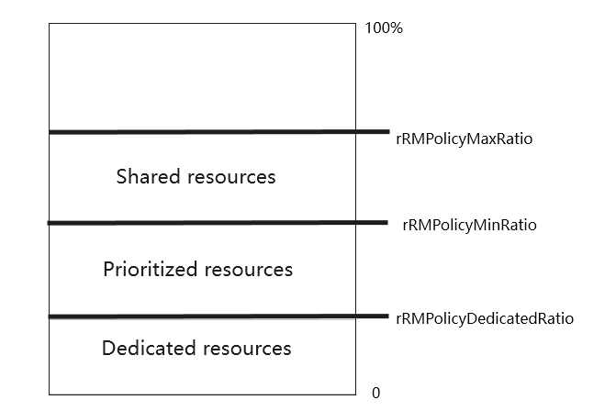

Figure 4.3.36-1 Structure of RRMPolicyRatio

- The attribute rRMPolicyMaxRatio defines the maximum resource usage quota for the associated rRMPolicyMemberList, including at least one of shared resources, prioritized resources and dedicated resources. The sum of the ‘rRMPolicyMaxRatio’ values assigned to all RRMPolicyRatio(s) name-contained by same MangedEntity can be greater than 100.

- The attribute rRMPolicyMinRatio defines the minimum resource usage quota for the associated RRMPolicyMemberList, including at least one of prioritized resources and dedicated resources, which means the resources quota that need to be guaranteed for use by the associated rRMPolicyMemberList. The sum of the ‘rRMPolicyMinRatio’ values assigned to all RRMPolicyRatio(s) name-contained by same MangedEntity shall be less or equal 100.

- The attribute rRMPolicyDedicatedRatio defines the dedicated resource usage quota for the RRMPolicyMemberList, including dedicated resources. The sum of the ‘rRMPolicyDedicatedRatio’ values assigned to all RRMPolicyRatio(s) name-contained by same MangedEntity shall be less or equal 100.

The following are the definition for above mentioned three resource categories:

**- Shared resources**: means the resources that are shared with other rRMPolicyMemberList(s) (i.e. the rRMPolicyMemberList(s) defined in RRMPolicyRatio(s) name-contained by the same ManagedEntity). The shared resources are not guaranteed for use by the associated rRMPolicyMemberList. The shared resources quota is represented by [rRMPolicyMaxRatio-rRMPolicyMinRatio].

**- Priortized resources:** means the resources are preferentially used by the associated RRMPolicyMemberList. These resources are guaranteed for use by the associated RRMPolicyMemberList when it needs to use them. When not used, these resources may be used by other rRMPolicyMemberList(s) (i.e. the rRMPolicyMemberList(s) defined in RRMPolicyRatio(s) name-contained by the same ManagedEntity). The prioritized resources quota is represented by [rRMPolicyMinRatio-rRMPolicyDedicatedRatio]

**- Dedicated resources:** means the resources are dedicated for use by the associated RRMPolicyMemberList. These resources can not be shared even if the associated RRMPolicyMember does not use them. The Dedicated resources quota is represented by [rRMPolicyDedicatedRatio].

Note: The resources shown in Figure 4.3.36-1 could be reserved or allocated for user and bearer related requests, e.g. a user connection, a PDU session, etc., if the user is entitled to use the allocated resources according the ratios defined above.

|  |
| --- |
| **End of modification** |