3GPP TSG-SA5 Meeting #137e S5-213373

e-meeting, 10 – 19 May 2021

Source: Nokia, Nokia Shanghai Bell

Title: TD enhance 5GC NRM to support plug and play of 5GC NF

Document for: Discussion and Endorsement
Agenda Item: 6.4.4

1 Decision/action requested
Please discuss and endorse

2 References
[1] 3GPP TS 28.541: "Management and orchestration; 5G Network Resource Model (NRM); Stage 2 and Stage 3".
[2] 3GPP TS 29.510.: "5G system; Network Function Repository Services; Stage 3".

3 Rationale
Plug and play, as well self configuration are specified for RAN network function. The similar requirements could be appilcalbe to core network funciton, especially to support network slice management and automation for 5G network. The diagram below shows a typical workflow of deploying 5GC NF, and bring it into service.
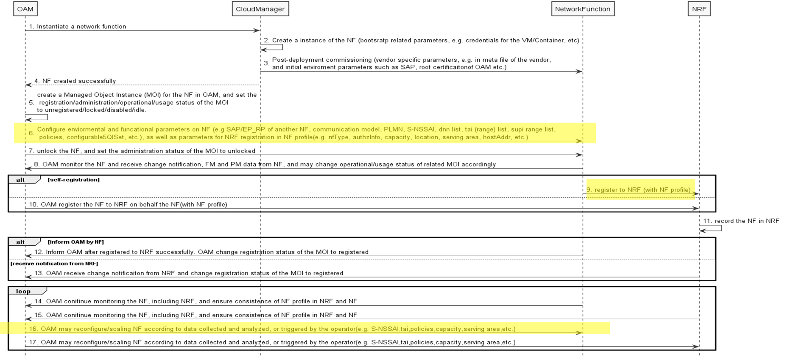
Procedures:
- Step 1-4, allocate infrastructure resource for NF, which could be VMs, Containers, etc.
Note: How would cloud manager instantiate VNF/CNF and provision initinal parameters on VNF/CNF in Steps 2 and 3 are out the scope of 3GPP
- Step 5, OAM create Managed Object Instance (MOI) in OAM inventory
- Step 6, OAM configure environmental, functional, as well as NF profile parameters on NF
- Step 9, The NF is “active” after step 8, so it can register to NRF by itself with NF profile pre-configured in step 6

- Step 10, Alternatively, on behalf of the NF, OAM could call Nnrf_NFManagement Service to register NF to NRF, or update nFProfileList of NRF MOI to add new NFProfile record in NRF MOI for the NF.
Note: How would NF/OAM register to NRF and how would NRF record the NF instance (step 9 & 11) are out the scope of 3GPP SA5

- Step 12: NF could notify OAM about the registration status change via notifyMOIAttributeValueChanges management service of OAM
- Step 13: Alternatively, NRF could notify OAM for the change of nFProfileList through notifyMOIAttributeValueChanges management service of OAM after it record the NF in NRF in step 11
- Step 14 -15, OAM continue monitoring the NFs including NRF and may trigger reconfiguration according to collected data or analytics or on demand of the operator.
- Step 16 - 17, OAM could reconfigure NFs including NRF during runtime
To automate the procedures in the workflow, different parameters are required in each step. e.g.
- bootstrap related parameters (e.g. credentials for the VM/Container to support NF, etc), initial environment parameters of VM/container/NF (e.g. access address, root certificate of OAM, certificate of NF, etc. ) could be needed for step 1-4;
Note: definition of those parameteres is out of 3GPP scope
- environmental parameters (e.g. address of NRF, SCP, NSSF, probably SAP/EP_RP of other functional Core NFs or gNB, transport endpoint, communication model, etc.) could be configured in step 6;
- functional parameters on NF level (e.g. PLMN list, S-NSSAI list, optional/conditional NSI Id, dnn list, tai (range) list, supi (range) list, policies, configurable5QISet, etc.,according to NF type, some of those parameters are part of NF profile) could be configured/reconfigured in step 6 and 16;
- parameters for NF registration and discovery could be required for step 9 and configured in step 6
- there could be some vendor specific paramters which are not visible to operator, definition of those attributes are out of 3GPP scope
The parameters of bullets 2, 3, 4 need to be defined in NRM to enanble multi-vendor inter-operatability.
Observation 1: Most attributes listed in bullets 2, 3, 4 are not supported 5GC NRM
Observatoin 2: The attribute structure of current 5GC NRM couldn't correctly reflect OAM procedures Most envionmental and functional parameters of 5GC NF are used to support functionality/service of the NF regardless if NRF existed or not. So those parameters are not part of ManagedNFProfile in OAM view although some of the parameters are put to NF profile to support signaling procedure, e.g. registrer, discovery, for communication model B, C, D. Therefore, except parameters specifically used for NRF registration and discovery, all other attributes should be moved out from ManagedNFProfile.
Observatoin 3: In the objective of WI PACMAN, it mentioned "The solution may cover not only radio network nodes but can also include other node types in need of Plug and Connect", maybe WI PACMAN could be extended to support Plus and Connect, even Plus and Play of 5GC NFs.

4 Detailed proposal

4.1 Fill the gap of 5GC NRM, please see CR S5-213423 for AMF IOC in 28.541

4.2 Restructure 5GC NRM.
Move envionmental and functional parameters of 5GC NF out of ManagedNFProfile, and define an abstract ManagedFunciton5GC which includes common attributes of all 5GC MFs.

4.3 Capture 5GC NF deployment workflow in SA5 TS or TR, e.g. informative annex of TS 28.314 or TS 28.541.

