3GPP TSG SA WG5 Meeting 137-e S5-213330

electronic meeting, online, 10 - 19 May 2021
CR-Form-v12.0
CHANGE REQUEST
 | 28.405 | CR |  | rev |  | Current version: | 16.0.0
For HELP on using this form: comprehensive instructions can be found at
http://www.3gpp.org/Change-Requests.

Proposed change affects: | UICC apps |  | ME |  | Radio Access Network | X | Core Network | X

Title: | Adding Signalling Based Activation for LTE
Source to WG: | Ericsson
Source to TSG: | S5
Work item code: | eQoE |  |  |  |  |  | Date: |  |  | 2021-04-28
Category: | B |  |  |  |  |  | Release: |  |  | Rel-17
 | Use one of the following categories:  F (correction)  A (mirror corresponding to a change in an earlier release)  B (addition of feature),  C (functional modification of feature)  D (editorial modification)  Detailed explanations of the above categories can  be found in 3GPP TR 21.900. |  |  |  |  |  |  |  | Use one of the following releases:  Rel-8 (Release 8)  Rel-9 (Release 9)  Rel-10 (Release 10)  Rel-11 (Release 11)  …  Rel-15 (Release 15)  Rel-16 (Release 16)  Rel-17 (Release 17)  Rel-18 (Release 18)
Reason for change: |  | Signalling Based Activation was missing
Summary of change: |  | Add Signalling Based Activation for LTE
Consequences if not approved:
Clauses affected: |  | 4
 |  | Y | N
Other specs |  |  | x | Other core specifications |  |  |  | TS/TR ... CR ...
affected: |  |  | x | Test specifications |  |  |  | TS/TR ... CR ...
(show related CRs) |  |  | x | O&M Specifications |  |  |  | TS/TR ... CR ...
Other comments: |  | To be included in a draft CR
This CR's revision history:

First change

4.y Signalling based activation in LTE

4.y.2 Activation of measurement collection for a UE in LTE
Actvation of measurement collection for a UE can be done before UE attachment or after UE is attached.
4.y.2.1 Activation of QoE measurement task before UE attaches to the network
When HSS activates the QoE measurement collection job, to the MME the following configuration parameters shall be included in the message: serviceType, areaScope, qoECollectionEntityAddress, pLMNTarget, qoETarget, qoEReference and QMC configuration file.
At UE attachment the configuration parameters for the QoE measurement collection for a job is propagated to the UE.
The MME receives and stores QoE measurement collection job as part of Update Location Answer (or Insert Subscriber Information). Then the same procedure for activation of measurement collection job is applied as after UE is attached, described in see 4.y.2.2.
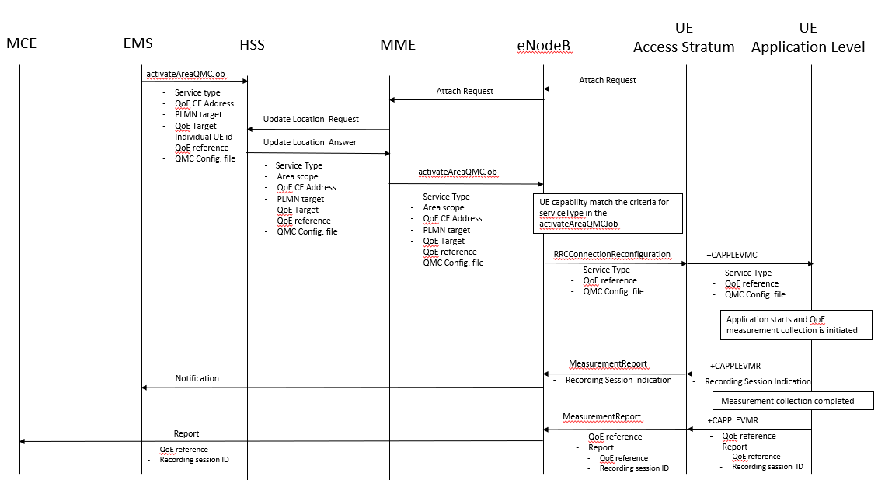

4.y.2.2 Activation of QoE measurement task after UE attachement to the network
The QoE measurement collection is sent to the UE from the OAM via CN. The messages from EMS propagated to HSS, MME and eNodeB are the same as previous section.
When MME sends the QoE measurement collection to the UE through eNodeB, the following configuration parameters shall be included in the message: serviceType, areaScope, qoECollectionEntityAddress, pLMNTarget, qoETarget, qoEReference and QMC configuration file. QoE measurement collection activation request is propagated to UE.
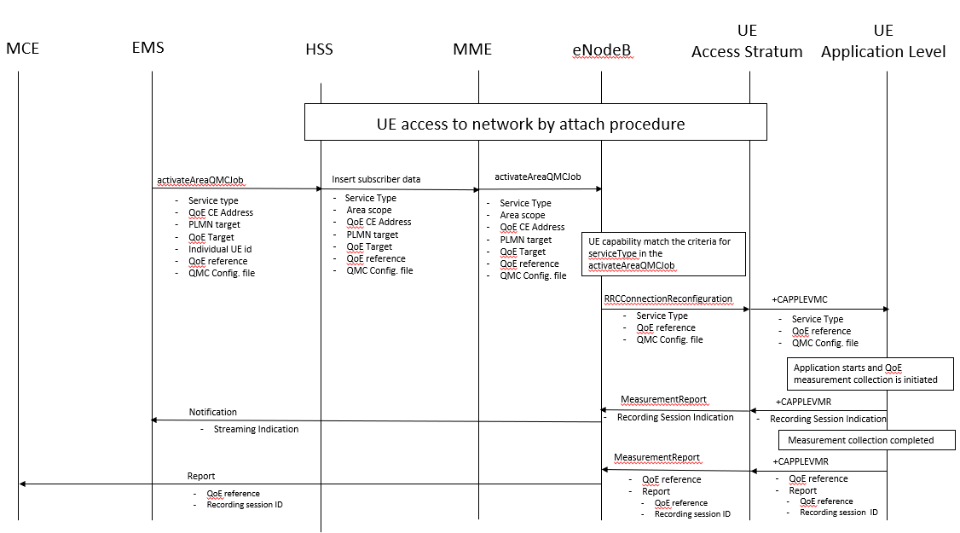

- The EMS sends activateAreaQMCJob to HSS that controls the impacted eNB(s), and includes the parameters: serviceType, areaScope, qoECollectionEntityAddress, pLMNTarget, qoETarget, qoEReference and QMC configuration file.
- The HSS inserts subscriber related data and forwards it to the MME.
- The MME forwards activateAreaQMCJob to impacted eNB(s), and includes the parameters: serviceType, areaScope, qoECollectionEntityAddress, pLMNTarget, qoETarget, qoEReference and QMC configuration file.
- The eNB checks if the UE capability that matches the criteria for serviceType in the activateAreaQMCJob.
- If the UE has the wanted UE capability, the eNB starts a UE request session and stores the associated QoECollectionEntityAddress, sends the message RRCConnectionReconfiguration to the UE, and includes the following: serviceType, qoEReference and QMC configuration file.
5. The access stratum in the UE sends the AT command +CAPPLEVMC to application level and includes the following: serviceType, qoEReference and QMC configuration file.
6. When the application in the serviceType starts, the QMC is initiated.
7. The application layer sends the AT command +CAPPLEVMR including a recording session indication that indicates that a session is started to the access stratum.
8. The UE sends the message MeasReportAppLayer including the recording session indication to the eNB.
9. The eNB sends a notification including the recording session indication to the NM.
10. When the QMC is completed, the recorded information is collected in a QMC report [6], [7], including qoEReference and recordingSessionId. The qoEReference, Client Id [6] and [7] in the reporting container (that represent the UE request session), and recordingSessionId are needed in the QMC collection entity for post processing purposes.
11. The application layer sends the AT command +CAPPLEVMR including qoEReference and the QMC report to the access stratum.
12. The UE sends the message MeasReportAppLayer including qoEReference and the QMC report to the eNB.
13. The eNB sends the QMC report to the MCE associated to the qoEReference.

End change

