3GPP TSG-SA5 Meeting #137e S5-213296rev1

e-meeting, 10 - 19 March 2021 Revision of S5-21xxxx

Source: Orange, AT&T, Deutsche Telekom, Telefonica SA

Title: Conclusion for Key Issue No. 1

Document for: Approval
Agenda Item: 6.5.1

1 Decision/action requested
The group is asked to discuss and agree on the proposal.

2 References
[1] TR 28.813 0.5.0: Study on new aspects of Energy Efficiency (EE) for 5G

3 Rationale
This contribution proposes a conclusion to KI#1 (EE KPI in case of NG-RAN sharing).

4 Detailed proposal
This document proposes the following changes in TR 28.813 [1].

1st Change

4.1 Key Issue #1: EE KPI in case of NG-RAN sharing

4.1.1 Description

4.1.1.1 Existing NG-RAN EE KPI and related measurements
In TS 28.554 [5] – clause 6.7.1, the NG-RAN data Energy Efficiency KPI is defined as follows:
EE_{MN,DV}
- for non-split gNBs;
- for split-gNBs.

For non-split gNBs, the data volume measurements used in this KPI are defined in TS 28.552 [4] – clause 5.1.2.1, as follows:
- UL PDCP SDU Data Volume: provides the Data Volume (amount of PDCP SDU bits) in the uplink delivered from PDCP layer to higher layers. The measurement is calculated per PLMN ID and per QoS level (mapped 5QI) and per S-NSSAI;
- DL PDCP SDU Data Volume: provides the Data Volume (amount of PDCP SDU bits) in the downlink delivered to PDCP layer. The measurement is calculated per PLMN ID and per QoS level (mapped 5QI) and per S-NSSAI.
NOTE: for the rest of the discussion, it is important to note that these measurements can be obtained per PLMN ID.

4.1.1.2 5G RAN sharing
TS 23.501 [2] – figure 5.1.18-1 gives a network sharing architecture allowing multiple Participating Operators (POP) (see TS 32.130 [3]) to share resources of a single shared radio access network made available by a Master Operator (MOP) [3] according to a RAN sharing contract.
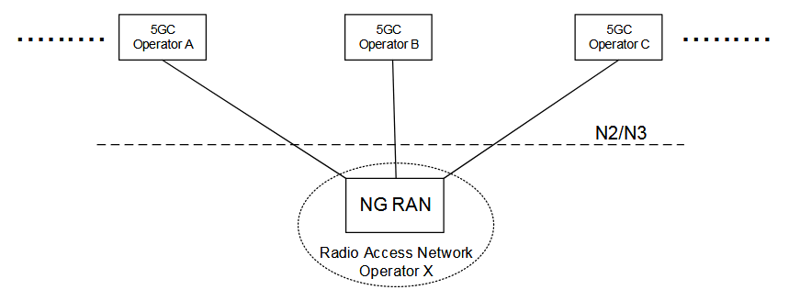

4.1.1.3 Problem statement
In case of RAN sharing:
- The energy consumed, which measurement (cf. PEE.Energy [4]) is collected by the Master Operator and calculated per gNB only, with no split between Master and Participating Operators;
- The data volume measurements are collected by the Master Operator and calculated:
- at gNB level, i.e. not per PLMN ID. In this case, these measurements don’t separate the traffic between the Master Operator and each Participating Operator. As a consequence, the existing EE KPI is obtained by dividing all Operators included Data Volume, by gNB Energy Consumption
- for the Master Operator, the resulting EE KPI value does not reflect that the gNB is shared,
- for Participating Operators, they are unable to measure the EE KPI value for this shared gNB, though they have some traffic across this shared gNB
- per PLMN ID. In this case, these measurements can be obtained separately for the Master Operator and for each Participating Operator
- For the Master Operator and all Participating Operators, the resulting EE KPI value is the per Operator Data Volume divided by the all Operators included Energy Consumption of the shared gNB.

As explained above, in case of a shared gNB, the value of the existing EE_{MN,DV} may be biased depending on how it is calculated.

4.1.2 Potential solutions

4.1.2.1 Potential solution #1: EE KPI with estimated Energy Consumption

4.1.2.1.1 Introduction
In this potential solution, a per Operator EE KPI is defined as follows:
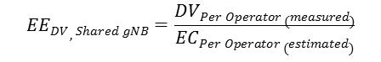
, where:
- EE_{DV, Shared gNB} is the per Operator EE KPI in case of a shared gNB,
- DV_{Per Operator (measured)} is the per Operator Data Volume, measured
- EC_{Per Operator (estimated)} is the per Operator Energy Consumption, estimated. An estimation can be made by calculating the proportion of each Operator Data Volume over all Operators included Data Volume, and then apply this proportion in the estimation of the per Operator Energy Consumption.

4.1.2.1.2 Description
In this potential solution #1, given that each Operator Energy Consumption (EC) is estimated proportionally to its measured Data Volume (DV), the resulting EE KPI value is the same for all Operators, i.e. for the Master Operator (MOP) and the Participating Operators (POP).
In a RAN sharing deployment, depending on the agreement between the MOP and the POPs:
- either the MOP provides each POP with its own measured DV and estimated EC values, and each POP calculates the resulting EE KPI value,
- or the MOP calculates the EE KPI per POP and provide each POP with its own value.

4.1.2.2 Potential solution #2: EE KPI with measured Energy Consumption

4.1.2.2.1 Introduction
In this potential solution, the per Operator EE KPI is defined as follows:
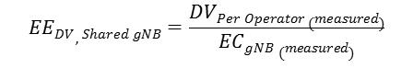
, where:
- EE_{DV, Shared gNB} is the per Operator EE KPI in case of a shared gNB,
- DV_{Per Operator (measured)} is the per Operator Data Volume, measured over a given period of time,
- EC_{gNB} is the gNB Energy Consumption, measured over the same period of time.

4.1.2.2.2 Description
In this potential solution #2, the EE KPI value is, for each operator sharing the gNB, proportional to the Data Volume carried by the gNB on behalf of the operator. The higher the Data Volume used by a sharing operator via a shared gNB is, the higher his EE KPI is.
In a RAN sharing deployment using this potential solution, depending on the agreement between the MOP and the POPs:
- either the MOP provides each POP with its own measured DV and measured global gNB EC value, and each POP calculates the resulting EE KPI value,
- or the MOP calculates the EE KPI per POP and provide each POP with its own value.

4.1.3 Conclusion
The ultimate goal of this key issue analysis is to define a per-Operator EE KPI in case of shared gNB.
The potential solution #1, if it was applied, would result in that Participating Operators would all have the same EE KPI value, regardless of their traffic volume. This potential solution brings little value.
The potential solution #2, if it was applied, would consider the whole shared gNB (measured) EC, instead of a per-Operator EC, given that there is so far no standardized means to measure the energy consumed by each Participating Operator separately. Each POP EE KPI value would be a proportion of the total shared gNB EC value, based on each POP data volume. This potential solution would thus not provide a realistic EE KPI value.
Consequently, none of the above potential solutions are proposed to be introduced into TS 28.554 [5].

End of changes

