**3GPP TSG-SA5 Meeting #137-e *S5-213227***

**Online, , 10th May 2021 - 19th May 2021**

|  |  |  |  |  |  |  |  |  |
| --- | --- | --- | --- | --- | --- | --- | --- | --- |
| *CR-Form-v12.1* | | | | | | | | |
| **CHANGE REQUEST** | | | | | | | | |
|  | | | | | | | | |
|  | **28.313** | **CR** | **-** | **rev** | **-** | **Current version:** | **17.0.0** |  |
|  | | | | | | | | |
| *For* [***HE******LP***](http://www.3gpp.org/3G_Specs/CRs.htm#_blank)*on using this form: comprehensive instructions can be found at* [*http://www.3gpp.org/Change-Requests*](http://www.3gpp.org/Change-Requests)*.* | | | | | | | | |
|  | | | | | | | | |

|  |  |  |  |  |  |  |  |  |
| --- | --- | --- | --- | --- | --- | --- | --- | --- |
| ***Proposed change affects:*** | UICC apps |  | ME |  | Radio Access Network | **x** | Core Network |  |

|  |  |  |  |  |  |  |  |  |  |  |
| --- | --- | --- | --- | --- | --- | --- | --- | --- | --- | --- |
|  | | | | | | | | | | |
| ***Title:*** | Rel-17 Input to DraftCR 28.313 MLB procedure | | | | | | | | | |
|  |  | | | | | | | | | |
| ***Source to WG:*** | Huawei | | | | | | | | | |
| ***Source to TSG:*** | S5 | | | | | | | | | |
|  |  | | | | | | | | | |
| ***Work item code:*** | eSON_5G | | | | |  | ***Date:*** | | | 2021-04-30 |
|  |  | | | |  | |  | | |  |
| ***Category:*** | **B** |  | | | | | ***Release:*** | | | Rel-17 |
|  | *Use one of the following categories:* ***F*** *(correction)* ***A*** *(mirror corresponding to a change in an earlier release)* ***B*** *(addition of feature),* ***C*** *(functional modification of feature)* ***D*** *(editorial modification)*  Detailed explanations of the above categories can be found in 3GPP [TR 21.900](http://www.3gpp.org/ftp/Specs/html-info/21900.htm). | | | | | | | | *Use one of the following releases: Rel-8 (Release 8) Rel-9 (Release 9) Rel-10 (Release 10) Rel-11 (Release 11) … Rel-15 (Release 15) Rel-16 (Release 16) Rel-17 (Release 17) Rel-18 (Release 18)* | |
|  |  | | | | | | | | | |
| ***Reason for change:*** | | This contribution proposes to add the load balancing optimization procedure for to DraftCR 28.313. | | | | | | | | |
|  | |  | | | | | | | | |
| ***Summary of change:*** | | Add the load balancing optimization procedure. | | | | | | | | |
|  | |  | | | | | | | | |
| ***Consequences if not approved:*** | | The load balancing optimization function would not be clear. | | | | | | | | |
|  | |  | | | | | | | | |
| ***Clauses affected:*** | | 8.2.X | | | | | | | | |
|  | |  | | | | | | | | |
|  | | **Y** | **N** |  | | | |  | | |
| ***Other specs*** | |  | **x** | Other core specifications | | | | TS/TR ... CR ... | | |
| ***affected:*** | |  | **x** | Test specifications | | | | TS/TR ... CR ... | | |
| ***(show related CRs)*** | |  | **x** | O&M Specifications | | | | TS/TR ... CR ... | | |
|  | |  | | | | | | | | |
| ***Other comments:*** | | **Input to DraftCR to 28.313 for capturing Rel-17 MLB procedure** | | | | | | | | |
|  | |  | | | | | | | | |
| ***This CR's revision history:*** | |  | | | | | | | | |

|  |
| --- |
| **1st modified section** |

##### 7.1.x.2.x Policy information

Table 7.1.x.2.x-1: LBO policy

| Policy parameter | Definition | Legal Values |
| --- | --- | --- |
| LBO Allowed | This attribute indicates if load balancing is allowed or prohibited from source cell to target cell. See attribute isMLBAllowed in TS 28.541 [13]. | Boolean  On, off |

|  |
| --- |
| **2nd modified section** |

# 8 SON procedures

## 8.2 Distributed SON management

### 8.2.x LBO(Load Balancing Optimisation)

Figure 8.2.x-1 depicts a procedure that describes how D-SON management function can manage the LBO function.

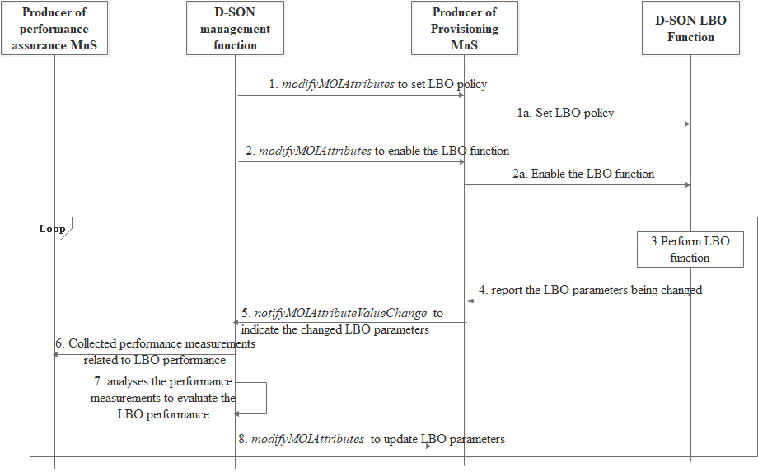

Figure 8.2.x-1: The management of distributed LBO procedure

1. The D-SON management function consumes the Producer of provisioning MnS with *modifyMOIAttributes* operation to configure the LBO policy for NR cell(s).

1.a The MnS of provisioning sets the LBO policy at the D-LBO LBO function (NOTE)

2. The D-SON management function consumes the Producer of provisioning MnS with *modifyMOIAttributes* operation to enable the D-LBO function for NR cell(s).

2.a The MnS of provisioning enables the D-LBO LBO function (NOTE).

3. The D-LBO function determines it is necessary to optimize the load distribution by executing the LBO actions.

4. The D-LBO function reports the LBO parameters (e.g. the handover and/or cell reselection parameters and/or isLBallowed parameters) changes to Producer of provisioning MnS.

5. The Producer of provisioning MnS sends a notification *notifyMOIAttributeValueChange* to D-SON management function to indicate the LBO parameters have been changed.

6. The D-SON management function collects LBO related performance measurements.

7. The D-SON management function analyzes the measurements to evaluate the LBO performance.

8. The D-SON management function consumes the MnS of NF provisioning with *modifyMOIAttributes* operation to update the LBO parameters (e.g. the handover and/or cell reselection parameters and/or isLBallowed parameters) of the NR cell or its neighbors. The MnS of provisioning update the LBO parameters at the D-LBO function (NOTE).

NOTE: The interface between MnS of provisioning and D-LBO function is not subject to standardization.

|  |
| --- |
| **End of modified section** |