3GPP TSG SA WG5 Meeting 137-e S5-213223

electronic meeting, online, 10 - 19 May 2021

Source: Huawei

Title: Add key issue SBMA supporting manangement of 5G SA and NSA scenarios

Document for: Approval
Agenda Item: 6.5.8

1 Decision/action requested
Discuss and approve on the proposal.

2 References
[1] 3GPP TR 28.925, enhancement of service based management architecture
[2] 3GPP TS 28.533, Management and orchestration; Architecture framework
[3] 3GPP TS 32.101, Telecommunication management; Principles and high level requirements
[4] 3GPP TS 38.300, NR and NG-RAN Overall Description; Stage 2
[5] 3GPP TS 37.340, Evolved Universal Terrestrial Radio Access (E-UTRA) and NR; Multi-connectivity; Stage 2

3 Rationale

3.1 Analysis of the existing specification capabilities
Service based management architecture (SBMA) and corresponding MnS are introduced in 5G management architecture in TS 28.533, and a different management reference model (i.e. IRP) had been used to manage the network before 5G era in 3GPP TS32.101.
The analysis is based on the following understanding of the existing specification capabilities:
- The management mechanism of LTE supports interface IRP and NRM IRP models.
- The management mechanism of 5G supports MnS which includes MnS component A (Operation/Notification), MnS component B (NRM models) and MnS component C (Alarm/Performance information).
- LTE NRM (with YAML/YANG solution set) can be used as MnS component type B and work together with MnS component type A.

3.2 Management support for NG-RAN Overall Architecture
As description in 3GPP TS 38.300[2], an NG-RAN node is either a gNB or an ng-eNB which are interconnected with each other by means of the Xn interface and connected with 5GC by means of the NG interface, more specifically to the AMF by means of the NG-C interface and to the UPF by means of the NG-U interface. The NG-RAN architecture is introduced in 3GPP TS 38.300[3], as follows.
Figure 1: NG-RAN Overall Architecture
NOTE: The ng-eNB node provides E-UTRA user plane and control plane protocol terminations towards the UE, and connects via the NG interface to the 5GC.
In order to provide management support for NG-RAN, the 3GPP management system needs to support the management for gNB, ng-eNB and 5GC. There are potential 2 management options to support, as follows.
NG-RAN management Option#1
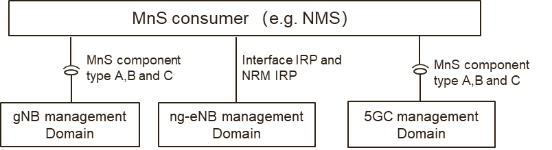
Figure 2: NG-RAN management Option#1
In the NG-RAN management Option#1:
- The gNB management domain provides MnS (including MnS component type A, B and C) for the management of gNB.
- The ng-eNB management domain provides IRP (including interface IRP and NRM IRP) for the management of ng-eNB.
- The 5GC management domain provides MnS (including MnS component type A, B and C) for the management of 5GC.

NG-RAN management Option#2
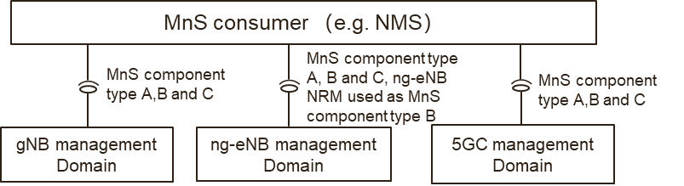
Figure 3: NG-RAN management Option#2
In the NG-RAN management Option#2:
- The gNB management domain provides MnS(including MnS component type A, B and C) for the management of gNB
- The ng-eNB management domain provides MnS ((including MnS component type A, B and C) for the management of ng-eNB. In this case, ng-eNB NRM used as MnS component type B, which means the YAML/YANG solution set for ng-eNB needs to be provided.
- The 5GC management domain provides MnS (including MnS component type A, B and C) for the management of 5GC.

3.3 Management support for EN-DC Overall Architecture
NG-RAN supports Multi-Radio Dual Connectivity (MR-DC) operation whereby a UE in RRC_CONNECTED is connected to two different nodes, one providing NR access and the other one providing either E-UTRA or NR access. One node acts as the MN and the other as the SN. The MN and SN are connected via a network interface and at least the MN is connected to the core network (e.g. EPC).
The following figure illustrates the MR-DC with EPC (i.e. EN-DC) architecture in TS 37.340[3].
Figure 4: EN-DC Overall Architecture
NOTE: the en-gNB node provides NR user plane and control plane protocol terminations towards the UE, and acts as Secondary Node in EN-DC.
In order to provide management support for EN-DC, 3GPP management system needs to provide the management for en-gNB, eNB and EPC. There are also potential 2 management options to support, as follows.
EN-DC management Option#1
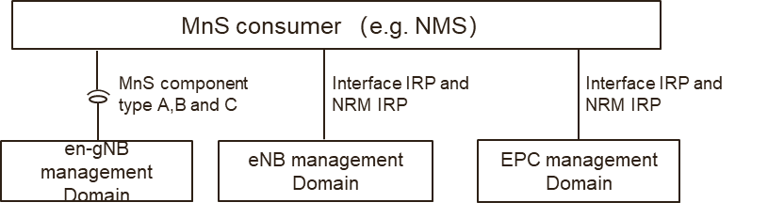
Figure 5: EN-DC management option#1

In EN-DC management option#1,
- The en-gNB management domain provides MnS (including component type A, B and C) for management of en-gNB.
- The eNB management domain provides IRP (including interface IRP and NRM IRP) for the management of eNB.
- The EPC management domain procides IRP (including interface IRP and NRM IRP) for the management of EPC.
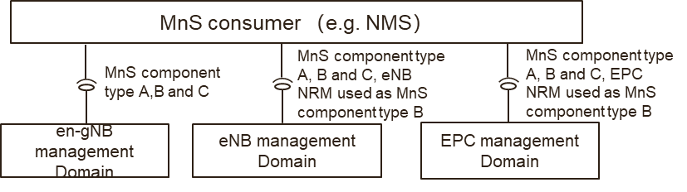
Figure 6: EN-DC management Option#2

EN-DC management Option#2
In EN-DC management option#2,
- The en-gNB management domain provides MnS (including component type A, B and C) for management of en-gNB.
- The eNB management domain provides MnS (including component type A, B and C) for management of eNB. In this case, eNB NRM used as MnS component type B, which means the YAML/YANG solution set for eNB NRM needs to be provided.
- The EPC management domain procides MnS (including component type A, B and C) for management of EPC. In this case, EPC NRM used as MnS component type B, which means the YAML/YANG solution set for EPC NRM needs to be provided.

3.4 Summary
Actually, the above potential 4 management options could be classified as two management options, as follows.
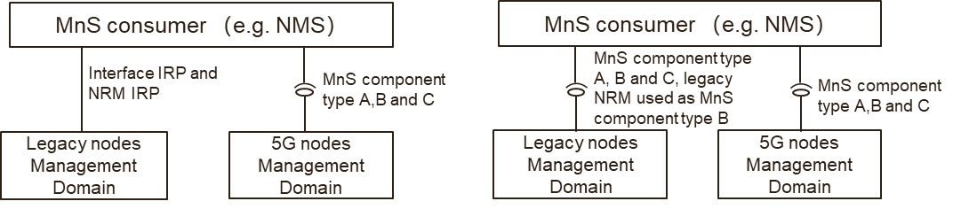
Figure 7: Management Option A and B for 5G SA and NSA
Option#A (including above NG-RAN management Option#1 and EN-DC management Option#1)
- The legacy nodes (e.g. eNB, ng-eNB and EPC) management domain provides IRP (including interface IRP and NRM IRP) for the management of legacy nodes.
- The 5G nodes (e.g. gNB, en-gNB and 5GC) provides MnS (including MnS component type A, B and C) for the management of 5G nodes.
Option#B (including above NG-RAN management Option#2 and EN-DC management Option#2)
- The legacy nodes (e.g. eNB, ng-eNB and EPC) management domain provides MnS (including MnS component type A, B and C) for the management of legacy node. In this case, legacy node NRM used as MnS component type B, which means the YAML/YANG solution set for legacy node NRM needs to be provided.
- The 5G nodes (e.g. gNB, en-gNB and 5GC) provides MnS (including MnS component type A, B and C) for the management of 5G nodes.

4 Proposal
It is proposed to add a new Key issue of 5G SBMA supporting manangement of SA and NSA scenarios. This document proposes the following changes in TR 28.925 [1].

1st Change

2 References
The following documents contain provisions which, through reference in this text, constitute provisions of the present document.
- References are either specific (identified by date of publication, edition number, version number, etc.) or non-specific.
- For a specific reference, subsequent revisions do not apply.
- For a non-specific reference, the latest version applies. In the case of a reference to a 3GPP document (including a GSM document), a non-specific reference implicitly refers to the latest version of that document in the same Release as the present document.
[1] 3GPP TR 21.905: "Vocabulary for 3GPP Specifications".
[x1] 3GPP TS 28.533: "Management and orchestration; Architecture framework".
[x2] 3GPP TS 32.101: " Telecommunication management; Principles and high level requirements".
[x3] 3GPP TS 38.300: " NR; NR and NG-RAN Overall Description; Stage 2".
[x4] 3GPP TS 37.340: "Evolved Universal Terrestrial Radio Access (E-UTRA) and NR; Multi-connectivity; Stage 2".

2nd Change

4.X Issue #X: SBMA supporting manangement of 5G SA and NSA scenarios

4.X.1 Description

4.X.1.1 Analysis of the existing specification capabilities
Service based management architecture (SBMA) and corresponding MnS are introduced in 5G management architecture in TS 28.533[x1], and a different management reference model (i.e. IRP) had been used to manage the network before 5G era in 3GPP TS32.101[x2].
The analysis is based on the following understanding of the existing specification capabilities:
- The management mechanism of LTE supports interface IRP and NRM IRP models.
- The management mechanism of 5G supports MnS which includes MnS component A (Operation/Notification), MnS component B (NRM models) and MnS component C (Alarm/Performance information).
- LTE NRM (with YAML/YANG solution set) can be used as MnS component type B and work together with MnS component type A.

4.X.1.2 Management support for NG-RAN Overall Architecture
As description in 3GPP TS 38.300[x3], an NG-RAN node is either a gNB or an ng-eNB which are interconnected with each other by means of the Xn interface and connected with 5GC by means of the NG interface, more specifically to the AMF by means of the NG-C interface and to the UPF by means of the NG-U interface. The NG-RAN architecture is introduced in 3GPP TS 38.300[x3], as follows.
Figure 4.X.1-1: NG-RAN Overall Architecture
NOTE: The ng-eNB node provides E-UTRA user plane and control plane protocol terminations towards the UE, and connects via the NG interface to the 5GC.
In order to provide management support for NG-RAN, the 3GPP management system needs to support the management for gNB, ng-eNB and 5GC. There are potential 2 management options to support, as follows.
NG-RAN management Option#1
Figure 4.X.1-2: NG-RAN management Option#1
In the NG-RAN management Option#1:
- The gNB management domain provides MnS (including MnS component type A, B and C) for the management of gNB.
- The ng-eNB management domain provides IRP (including interface IRP and NRM IRP) for the management of ng-eNB.
- The 5GC management domain provides MnS (including MnS component type A, B and C) for the management of 5GC.

NG-RAN management Option#2
Figure 4.X.1-3: NG-RAN management Option#2
In the NG-RAN management Option#2:
- The gNB management domain provides MnS(including MnS component type A, B and C) for the management of gNB
- The ng-eNB management domain provides MnS ((including MnS component type A, B and C) for the management of ng-eNB. In this case, ng-eNB NRM used as MnS component type B, which means the YAML/YANG solution set for ng-eNB needs to be provided.
- The 5GC management domain provides MnS (including MnS component type A, B and C) for the management of 5GC.

4.X.1.3 Management support for EN-DC Overall Architecture
NG-RAN supports Multi-Radio Dual Connectivity (MR-DC) operation whereby a UE in RRC_CONNECTED is connected to two different nodes, one providing NR access and the other one providing either E-UTRA or NR access. One node acts as the MN and the other as the SN. The MN and SN are connected via a network interface and at least the MN is connected to the core network (e.g. EPC).
The following figure illustrates the MR-DC with EPC (i.e. EN-DC) architecture in TS 37.340[x4].
Figure 4.X.1-4: EN-DC Overall Architecture
NOTE: the en-gNB node provides NR user plane and control plane protocol terminations towards the UE, and acts as Secondary Node in EN-DC.
In order to provide management support for EN-DC, 3GPP management system needs to provide the management for en-gNB, eNB and EPC. There are also potential 2 management options to support, as follows.
EN-DC management Option#1
Figure 4.X.1-5: EN-DC management option#1

In EN-DC management option#1,
- The en-gNB management domain provides MnS (including component type A, B and C) for management of en-gNB.
- The eNB management domain provides IRP (including interface IRP and NRM IRP) for the management of eNB.
- The EPC management domain procides IRP (including interface IRP and NRM IRP) for the management of EPC.
Figure 4.X.1-6: EN-DC management Option#2

EN-DC management Option#2
In EN-DC management option#2,
- The en-gNB management domain provides MnS (including component type A, B and C) for management of en-gNB.
- The eNB management domain provides MnS (including component type A, B and C) for management of eNB. In this case, eNB NRM used as MnS component type B, which means the YAML/YANG solution set for eNB NRM needs to be provided.
- The EPC management domain procides MnS (including component type A, B and C) for management of EPC. In this case, EPC NRM used as MnS component type B, which means the YAML/YANG solution set for EPC NRM needs to be provided.

4.X.2 Potential solutions
The above potential 4 management mechanism options described in clause 4.X.1 could be classified as two management options, as follows.
Figure 4.X.2-1: Management Option A and B for 5G SA and NSA
Option#A (including above NG-RAN management Option#1 and EN-DC management Option#1)
- The legacy nodes (e.g. eNB, ng-eNB and EPC) management domain provides IRP (including interface IRP and NRM IRP) for the management of legacy nodes.
- The 5G nodes (e.g. gNB, en-gNB and 5GC) provides MnS (including MnS component type A, B and C) for the management of 5G nodes.
Option#B (including above NG-RAN management Option#2 and EN-DC management Option#2)
- The legacy nodes (e.g. eNB, ng-eNB and EPC) management domain provides MnS (including MnS component type A, B and C) for the management of legacy node. In this case, legacy node NRM used as MnS component type B, which means the YAML/YANG solution set for legacy node NRM needs to be provided.
- The 5G nodes (e.g. gNB, en-gNB and 5GC) provides MnS (including MnS component type A, B and C) for the management of 5G nodes.

End of change

