3GPP TSG SA WG5 Meeting 137-e S5-213191

electronic meeting, online, 10 - 19 May 2021

Source: China Mobile, Huawei, China Telecom, China Unicom, AsiaInfo

Title: pCR TS 28.100 Add figure in clause 4.3.4 Workflow

Document for: Approval
Agenda Item: 6.4.9

1 Decision/action requested
The group is asked to discuss and approval.

2 References
[1] 3GPP draft TS 28.100: “Management and orchestration; Levels of autonomous network v0.4.0”.

3 Rationale
To make it be easier for the readers to understand the categorization of the tasks specified in clause 4.3.4 Workflow, this contribution proposes to add a figure in clause 4.3.4 to illustrate the relationship between the categorization of the tasks and revlavent entities.

4 Detailed proposal
It proposes to make the following changes to TS 28.100 [1].
1st Change

4.3.4 Workflow
Workflow is used to describe the necessary steps to achieve certain management and control purposes. A workflow is composed of one or more management and control tasks. Each workflow task may be accomplished by human, or accomplished by telecommunication system with human assistance, or accomplished by telecommunication system without human intervention. The autonomy capabilities of the tasks in the workflow may impact the autonomous network level.
Following are the categorization of the tasks in a workflow:
- Intent handling: The group of tasks which translate network or service intent from operator or customer into detailed operations and/or policies which may affect one or more of the following groups of tasks (i.e. awareness, analysis, decision, execution), also evaluate and feedback intent fulfilment information (e.g. the intent is satisfied or not) based on the detailed network and service information.
- Awareness: The group of tasks which include network and service data (e.g. configuration data, performance data, alarm data, etc.) collection and necessary data pre-processing (e.g. data cleaning, filtering, statistics, etc.) with the purpose of monitoring network and service information (including network and service performance, network and service anomaly, network and service event, etc.).
- Analysis: The group of tasks which analyse the obtained network and service information (e.g. network and service status, network and service issues and so on) or based on the historical network and service information to further predict the future change trend of the above network and service status, and make recommendation for decision.
- Decision: The group of tasks which evaluate and decide the necessary operation for execution, e.g. network configuration or adjustment.
- Execution: The group of tasks which execute the operations.
Editor's Note: the relationship between the above categorization of the tasks and the other standardized features including intent driven management and COSLA is FFS.
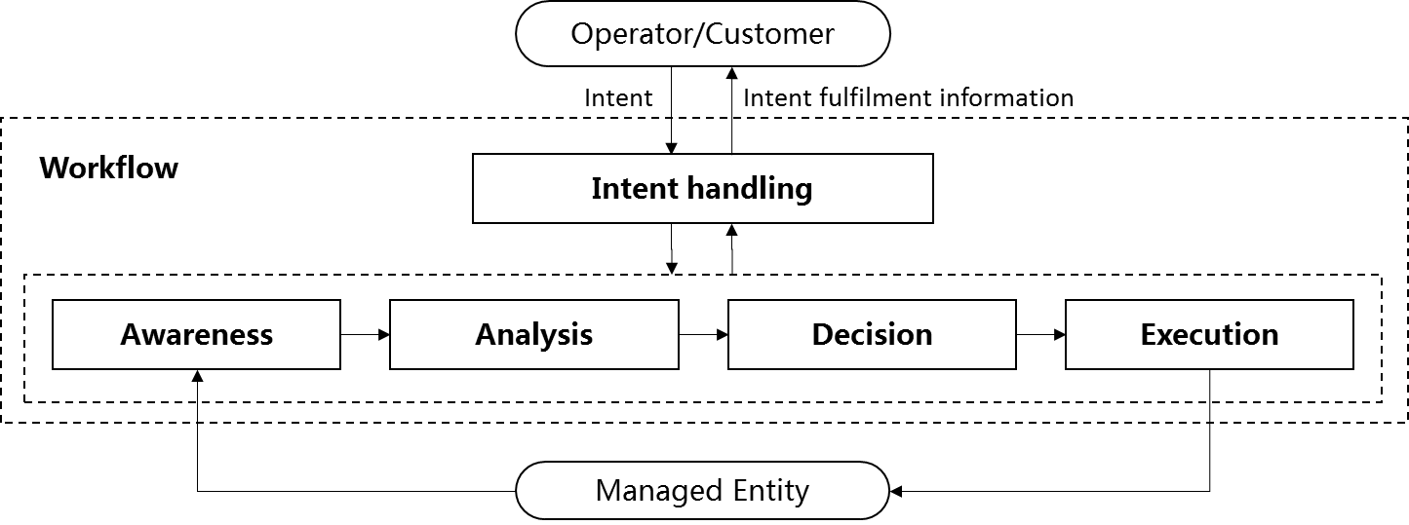
Figure 4.3.4-1: Categorization of the tasks in the workflow for evaluating autonomous network levels
End of changes

