3GPP TSG SA WG5 Meeting 137-e S5-213190

electronic meeting, online, 10 - 19 May 2021

Source: China Mobile, Huawei, China Telecom, China Unicom, AsiaInfo

Title: pCR TS 28.100 Add description for Table 5-1 and update corresponding figures

Document for: Approval
Agenda Item: 6.4.9

1 Decision/action requested
The group is asked to discuss and approval.

2 References
[1] 3GPP draft TS 28.100: “Management and orchestration; Levels of autonomous network v0.4.0”.

3 Rationale
The description of “Human”, “Human&System” and “System” is missing in clause 5 Framework approach for evaluating autonomous network levels. So this contribution proposes to add such description and update the corresponding illustration in the figures in clause 6 and 7.

4 Detailed proposal
It proposes to make the following changes to TS 28.100 [1].
1st Change

5 Framework approach for evaluating autonomous network levels
Editor's Note: the framework approach for evaluating autonomous network levels need to be revised and coordinated with other SDOs.
A framework approach for evaluating autonomous network levels is as following, which is used for evaluating the autonomy capability of telecom system. In the following framework table,
- “Human” represents corresponding tasks are accomplished by human or human utilizing the tools for network and service management and orchestration.
- “Human&System” represents corresponding tasks are accomplished by collaboration of human and telecom system, the detailed collaboration pattern depends on the scenario, which is not addressed in the framework approach for evaluating autonomous network levels.
- “System” represents corresponding tasks are fully accomplished by telecom system.
Table 5-1: Framework approach for evaluating autonomous network levels
Network autonomy level |  | Task categories
 |  | Execution | Awareness | Analysis | Decision | Intent handling
L0 | Manual operating network | Human | Human | Human | Human | Human
L1 | Assisted operating network | Human & Telecom system | Human & Telecom system | Human | Human | Human
L2 | Preliminary autonomous network | Telecom system | Human & Telecom system | Human & Telecom system | Human | Human
L3 | Intermediate autonomous network | Telecom system | Telecom system | Human & Telecom system | Human & Telecom system | Human
L4 | Advanced autonomous network | Telecom system | Telecom system | Telecom system | Telecom system | Human & Telecom system
L5 | Full autonomous network | Telecom system | Telecom system | Telecom system | Telecom system | Telecom system
Note 1: Human reviewed decision have the highest authority in each level if there is any confliction between human reviewed decision and telecom system generated decision.
Note 2: The order of above five task categories does not reflect the workflow sequence.

Level 0 manual operating network: No categorization of the tasks is accomplished by telecom system itself.
Level 1 assisted operating network: A part of the execution and awareness tasks are accomplished automatically by telecom system itself based on human defined rules. At this level, telecom system can assist human to improve the execution and awareness efficiency.
Level 2 preliminary autonomous network: All the execution tasks are accomplished automatically by telecom system itself. A part of the awareness and analysis tasks are accomplished automatically by telecom system itself based on human defined policies. At this level, telecom system can assist human to achieve the closed loop based on human defined policies.
Level 3 intermediate autonomous network: All the execution and awareness tasks are accomplished automatically by telecom system itself. A part of the analysis and decision tasks are accomplished automatically by telecom system itself based on human defined policies. At this level, the telecom system can achieve the closed loop automation based on the human defined closed loop automation policies.
Level 4 advanced autonomous network: All the execution, awareness, analysis and decision tasks are accomplished automatically by telecom system itself. And intent handling tasks can be partly accomplished automatically by telecom system itself based on human defined intent handling policies. At this level, telecom system can achieve the intent driven closed loop automation based on human defined intent handling policies, which means the telecom system can translate the intent to the detailed closed loop automation policies and translate the detailed network and service information to intent fulfilment information (e.g. the intent is satisfied or not) based on human defined intent handling policies.
Level 5 fully autonomous network: The entire network autonomy workflow is accomplished automatically by telecom system without human intervention. At this level, telecom system can achieve the whole network autonomy.
Note: Above framework approach for evaluating autonomous network levels is applicable for evaluating the autonomous network level from both management scope and scenario perspective. The overall autonomous network level of the whole telecom system is a comprehensive reflection of autonomous network level of the individual management scope and scenarios, which means in fully autonomous network level, the telecom system can achieve the whole network autonomy for all management scopes and scenarios.

2nd Change

6.2.1.3 Classification of autonomous network level
Editor’s note: following classification of autonomous network level needs to be revised based on the discussion of the framework approach for evaluating autonomous network level in clause 5.
Level 0:
- All the tasks in the RAN NE deployment workflow (Task A, Task B, Task C, Task D, Task E, Task F, Task G, Task H) are accomplished by human.
Level 1:
- Telecom system executes tasks of downloading and activating the available RAN NE network configuration data and software prepared by human (Task H).
- All the other tasks in the RAN NE deployment workflow (Task A, Task B, Task C, Task D, Task E, Task F, Task G) are accomplished by human.
Level 2:
- Compared to Level 1, telecom system additionally executes the tasks of RAN NE information collection (Task C). Telecom system also can execute the tasks of analysing the network configuration data for the RAN NE based on the network configuration data generation rules (e.g. configuration template) specified by human(Task D).
- All the other tasks in the RAN NE deployment workflow (Task A, Task B, Task E, Task F, Task G) are accomplished by human.
Level 3:
- Compared to Level 2, the telecom system additionally executes tasks of analysing and determining the network configuration data for the RAN NE based on the network configuration data generation policies specified by human (Task D, Task G). Telecom system also can executes tasks of performing the RAN NE commissioning test based on commissioning policies specified by human (Task E), and tasks of performing the RAN NE dialling test based on dialling test policies specified by human(Task F).
- All the other tasks in the RAN NE deployment workflow (Task A, Task B) are accomplished by human.
Level 4:
- Compared to Level 3, the telecom system can additionally execute the tasks of RAN NE deployment policy generation (Task A) and RAN NE deployment intent evaluation (Task B) based on intent handling policies specified by human.
- The intent handling policies maybe pre-defined and specified by human.
Level 5:
- Telecom system can autonomously execute the entire workflow of RAN NE deployment for all scenarios,
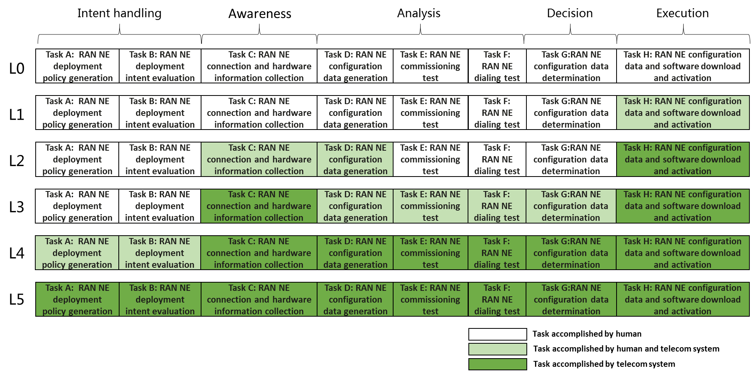
Figure 6.2.1.3-1 Classification of autonomous network level for RAN NE deployment

3rd Change

6.3.1.3 Classification of autonomous network level
Level 0:
- All the tasks in the fault management workflow (Task A, Task B, Task C, Task D, Task E, Task F, Task G, Task H, Task I, Task J) are accomplished by human.
Level 1:
- Telecom system executes the tasks of fault related information collection (Task C) automatically based on predefined rules, and the tasks of fault management action execution (Task J) based on specified action execution rules. Telecom system can also execute the tasks of alarm filtering (Task D) based on specified alarm filtering rules.
- All the other tasks in the fault management workflow (Task A, Task B, Task E, Task F, Task G, Task H, Task I) are accomplished by human.
Level 2:
- Compared to Level 1, telecom system can additionally executes the tasks of fault recognition (Task E) based on specified rules. The tasks of fault management action execution (Task J), fault related information collection (Task C) and alarm filtering (Task D) are fully accomplished by telecom system based on specified rules.
- All the other tasks (Task A, Task B, Task F, Task G, Task H, Task I) are accomplished by human.
Level 3:
- Compared to Level 2, telecom system can additionally execute the tasks of fault root cause analysis based on specified analysis policies (Task G). For certain network faults, telecom system can also additionally execute the tasks of fault recovery mechanism analysis (Task H) and action generation (Task I) based on specified fault management policies.
- All the other tasks (Task A, Task B, Task F) are accomplished by human.
Level 4:
- Compared to Level 3, the telecom system can additionally execute the task of fault prediction (Task F). For certain scenario, telecom system additionally execute the tasks of fault management policies generation (Task A) and fault management intent fulfilment information evaluation (Task B) based on specified intent handling policies. The tasks of fault recovery mechanism analysis (Task H) and action generation (Task I) are accomplished automatically by telecom system without human intervention.
- Intent handling policies can be pre-defined and specified by human.
Level 5:
- The entire fault management workflows is accomplished by telecom system without human intervention and human predefined rules or policies.
- Human can optionally supervise the fault management action generated by telecom system.
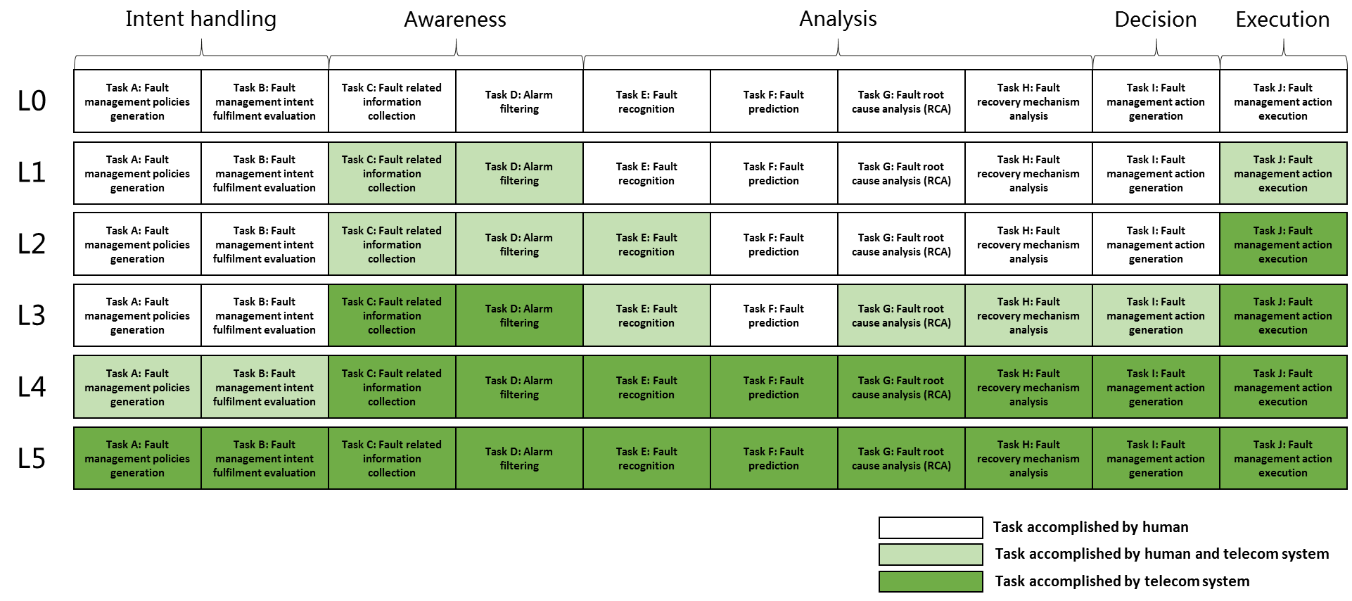
Figure 6.3.1.3-1: Classification of autonomous network level for fault management

4th Change

6.4.1.3 Classification of autonomous network level
Editor’s note: following classification of autonomous network level needs to be revised based on the discussion of the framework approach for evaluating autonomous network level in clause 5.
Level 0:
- All the tasks in the radio network coverage optimization workflow (Task A, Task B, Task C, Task D, Task E, Task F, Task G, Task H, Task I) are accomplished by human.
Level 1:
- Telecom system executes the tasks of coverage adjustment solutions execution based on the specified coverage related parameters (Task I). Telecom system also can execute the tasks of coverage related information collection based on the specified collection rule (Task C). At this level, telecom system can assist human to improve the execution and awareness efficiency for radio network coverage optimization.
- All the other tasks in the radio network coverage optimization workflow (Task A, Task B, Task D, Task E, Task F, Task G, Task H) are accomplished by human.
Level 2:
- Compared to Level 1, telecom system additionally executes the tasks of coverage issues identification, coverage issue analysis based on the specified coverage issue identification and analysis rule (Task D, Task F). At this level, telecom system can assist human to achieve the closed loop for radio network coverage optimization based on human defined rules.
- All the other tasks in the radio network coverage optimization workflow (Task A, Task B, Task E, Task G, Task H) are accomplished by human.
Level 3:
- Compared to Level 2, telecom system additionally executes the tasks of coverage adjustment solutions generation (Task G) and coverage adjustment solutions evaluation and determination (Task H) based on the specified coverage adjustment policies and evaluation policies. At this level, the telecom system can achieve the closed loop automation for coverage optimization based on the human defined optimization policies.
- All the other tasks in the radio network coverage optimization workflow (Task A, Task B, Task E) are accomplished by human.
Level 4:
- Compared to Level 3, the telecom system additionally executes the tasks of coverage deterioration prediction (Task E), coverage optimization policies determination (Task A), and coverage optimization intent evaluation (Task B) based on received coverage optimization intent and intent translation/evaluation policies. At this level, telecom system can achieve the intent driven closed loop automation for radio network coverage optimization based on human defined intent translation and evaluation policies
- The intent translation and evaluation policies maybe pre-defined and specified by human to assist the telecom system.
Level 5:
- Telecom system can autonomously execute the entire workflow of radio network coverage optimization for all scenarios, which means the telecom system can achieve the full autonomy for radio network coverage optimization for full scenarios.

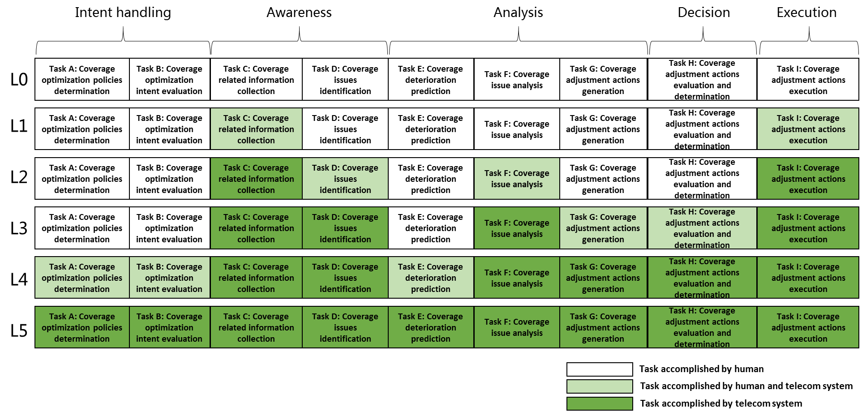
Figure 6.4.1.3-1 Classification of autonomous network level for coverage optimization

5th Change

6.4.2.3 Classification of autonomous network level
Editor’s note: following classification of autonomous network level needs to be revised based on the discussion of the framework approach for evaluating autonomous network level in clause 5.
Level 0:
- All the tasks in the RAN UE throughput optimization workflow (Task A, Task B, Task C, Task D, Task E, Task F, Task G, Task H, Task I) are accomplished by human.
Level 1:
- Telecom system executes the tasks of RAN UE throughput adjustment solutions execution based on the specified RAN UE throughput related parameters (Task I). Telecom system also can execute the tasks of RAN UE throughput related information collection based on the specified collection rule (Task C). At this level, telecom system can assist human to improve the execution and awareness efficiency for RAN UE throughput optimization.
- All the other tasks in the RAN UE throughput optimization workflow (Task A, Task B, Task D, Task E, Task F, Task G, Task H) are accomplished by human.
Level 2:
- Compared to Level 1, telecom system additionally executes the tasks of RAN UE throughput issues identification, RAN UE throughput issue analysis based on the specified RAN UE throughput issue identification and analysis rule (Task D, Task F). At this level, telecom system can assist human to achieve the closed loop for RAN UE throughput optimization based on human defined rules.
- All the other tasks in the RAN UE throughput optimization workflow (Task A, Task B, Task E, Task G, Task H) are accomplished by human.
Level 3:
- Compared to Level 2, telecom system additionally executes the tasks of RAN UE throughput adjustment solutions generation (Task G) and RAN UE throughput adjustment solutions evaluation and determination (Task H) based on the specified RAN UE throughput adjustment policies and evaluation policies. At this level, the telecom system can achieve the closed loop automation for RAN UE throughput optimization based on the human defined optimization policies.
- All the other tasks in the RAN UE throughput optimization workflow (Task A, Task B, Task E) are accomplished by human.
Level 4:
- Compared to Level 3, the telecom system additionally executes the tasks of RAN UE throughput deterioration prediction (Task E), RAN UE throughput optimization policies determination (Task A), and RAN UE throughput optimization intent evaluation (Task B) based on received RAN UE throughput optimization intent and intent translation/evaluation policies. At this level, telecom system can achieve the intent driven closed loop automation for RAN UE throughput optimization based on human defined intent translation and evaluation policies
- The intent translation and evaluation policies maybe pre-defined and specified by human to assist the telecom system.
Level 5:
- Telecom system can autonomously execute the entire workflow of RAN UE throughput optimization for all scenarios, which means the telecom system can achieve the full autonomy for RAN UE throughput optimization for full scenarios.
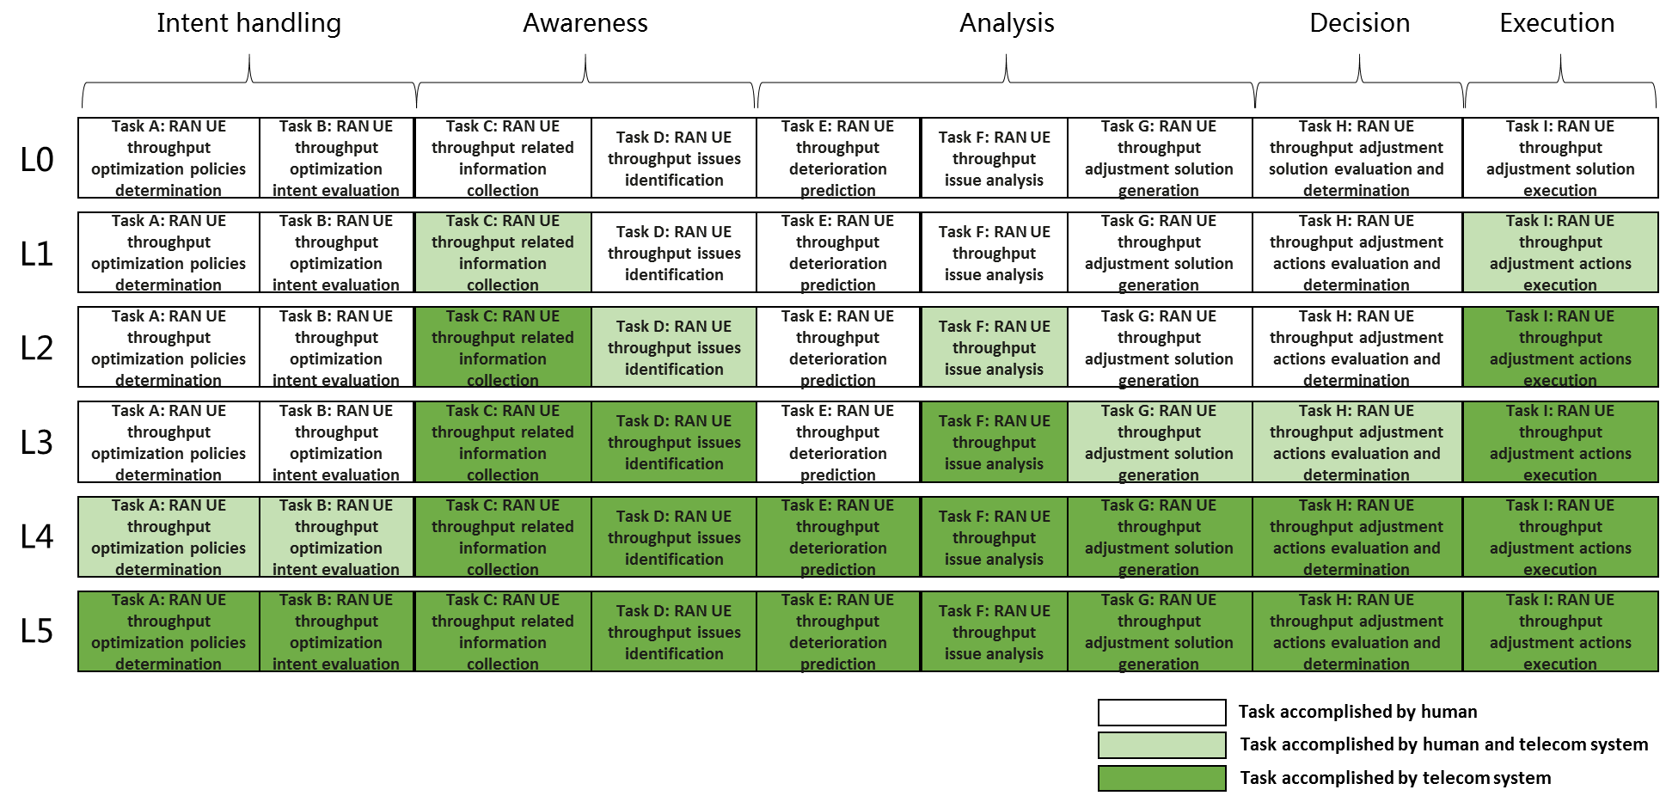
Figure 6.4.2.3-1 Classification of autonomous network level for RAN UE throughput optimization

6th Change

7.1.2 Generic autonomous network level
Level 0:
- All the tasks in the network optimization workflow (Task A, Task B, Task C, Task D, Task E, Task F, Task G, Task H, Task I) are accomplished by human.
Level 1:
- Telecom system executes the tasks of network adjustment solutions execution based on the specified network related parameters (Task I). Telecom system also can execute the tasks of network related information collection based on the specified collection rule (Task C). At this level, telecom system can assist human to improve the execution and awareness efficiency for network optimization.
- All the other tasks in the network optimization workflow (Task A, Task B, Task D, Task E, Task F, Task G, Task H) are accomplished by human.
Level 2:
- Compared to Level 1, telecom system additionally executes the tasks of network issues identification, network issue analysis based on the specified network issue identification and analysis rule (Task D, Task F). At this level, telecom system can assist human to achieve the closed loop for network optimization based on human defined rules.
- All the other tasks in the network optimization workflow (Task A, Task B, Task E, Task G, Task H) are accomplished by human.
Level 3:
- Compared to Level 2, telecom system additionally executes the tasks of network adjustment solutions generation (Task G) and network adjustment solutions evaluation and determination (Task H) based on the specified network adjustment policies and evaluation policies. At this level, the telecom system can achieve the closed loop automation for network optimization based on the human defined optimization policies.
- All the other tasks in the network optimization workflow (Task A, Task B, Task E) are accomplished by human.
Level 4:
- Compared to Level 3, the telecom system additionally executes the tasks of network deterioration prediction (Task E), network optimization policies determination (Task A), and network optimization intent evaluation (Task B) based on received network optimization intent and intent translation/evaluation policies. At this level, telecom system can achieve the intent driven closed loop automation for network optimization based on human defined intent translation and evaluation policies.
- The intent translation and evaluation policies maybe pre-defined and specified by human to assist the telecom system.
Level 5:
- Telecom system can autonomously execute the entire workflow of radio network optimization for all scenarios, which means the telecom system can achieve the full autonomy for network optimization for full scenarios.
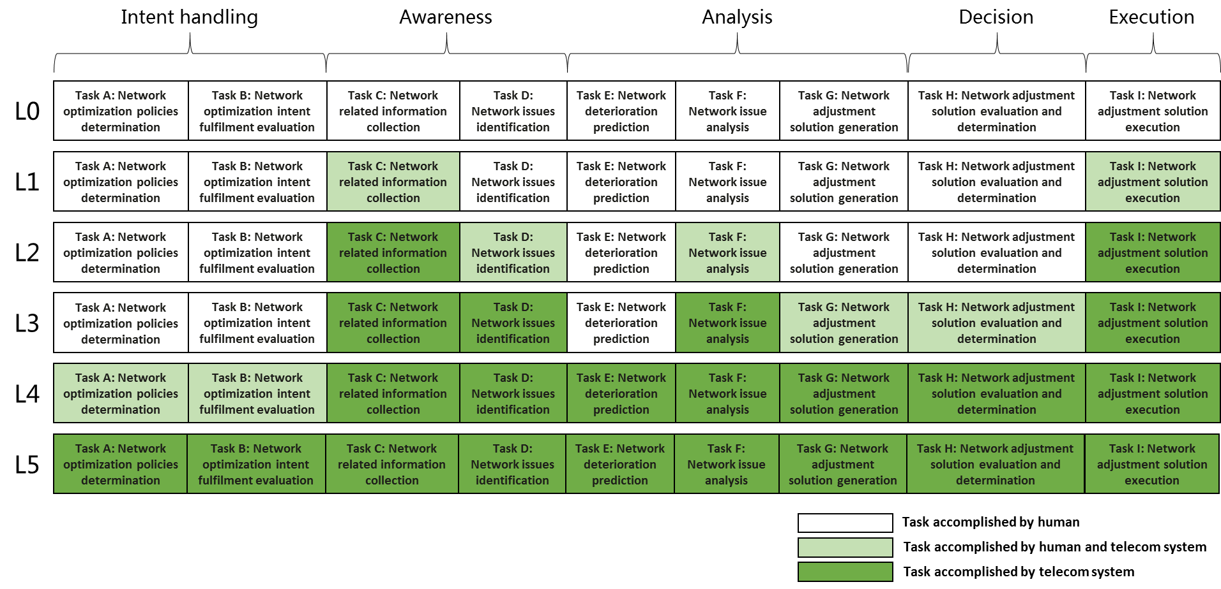
Figure 7.1.2-1 Classification of generic autonomous network level for network optimization

End of changes

