3GPP TSG SA WG5 Meeting 137-e S5-213171

electronic meeting, online, 10 - 19 May 2021

Source: Huawei, Ericsson,China Mobile,China Telecom

Title: Discussion paper for requirements and NRM solution support 5G MOCN network sharing scenarios

Document for: Approval
Agenda Item: 6.4.17

1 Decision/action requested
It proposes to discuss and endorse

2 References
[1] S5-211444 Discussion paper for NR NRM support 5G MOCN network sharing scenario
[2] S5-205304 Discuss on NR NRM update to support MOCN network sharing scenario
[3] S5-212270 RAN Sharing NRM support for MOCN
[4] S5-212197 Rel-17 CR TS 28.541 Enhance the NRM definitions to support NG-RAN network sharing

3 Rationale
Observation#1: It is endorsed in the DP S5-211444 that the NR NRM for MOCN Network sharing should support following two scenarios:
- NG-RAN MOCN Network Sharing with same Cell Identity broadcast.
- NG-RAN MOCN Network Sharing with multiple Cell Identity broadcast.

Observation#2: It is endorsed in the DP S5-205304 that the NR NRM for MOCN Network sharing should follow following principles:
Principle#1: R17 focus on MOCN network sharing scenario (see TS 23.501[2).
Principle#2: R17 NR NRM supporting MOCN network sharing feature should backwards compatible with R16/R15 NR NRM. Also needs to consider flexibility for compatible with other R17 features and to avoid the data (e.g. CM data, PM data) migration issue and redundancy issue.
Principle#3: One NR NRM supporting RAN with and without MOCN network sharing feature, which means the NR NRM fragment specific for MOCN network sharing feature should be modelled as R17 optional NR NRM fragment.

Observation#3: Two Alternative NR NRM solutions (S5-212270, S5-212197) are proposed in the previous meetings to support MOCN with multiple Cell Identity broadcast scenarios. The main issue is that the management requirements for MOCN with same and multiple Cell Identity broadcast scenarios are not clear.

Observation#4: Based on the previous discussion, the following aspects also need to be considered when discuss the NR NRM solutions to support MOCN network sharing scenarios.
- Corresponding solutions defined for EUTRAN MOCN network sharing scenarios
- Operation experiences for the two MOCN network sharing scenarios should be similar as soon as possibility.

Based on above observations and discussion in previous meeting, it proposes analyse the management requirements (including configuration and performance requirements) for above MOCN network sharing scenarios and analyse the potential solutions to support each identified requirements.
Following are the analyses of the requirements and corresponding solutions for NG-RAN MOCN Network Sharing scenario

3.1 Analysis for NG-RAN MOCN Network Sharing with same Cell Identity broadcast scenario
Requirements | Corresponding EUTRAN solutions | Candidate NG-RAN solution | R17 NR NRM update suggestion
Configuration requirements
MOCN-SameCellId-Cfg-Req1. The NgC and NgU shall be configured individually for each supported network operator. | N/A | GNBCUCPFUnction and GNBCUUPFunction are shared for different network operator, but individual EP_NgC and EP_NgU for each network operator. | Add PLMNInfo as attribute of EP_NgC and EP_NgU
MOCN-SameCellId-Cfg-Req2. The PLMNId shall be configured individually for each supported network operator. | EUtranCell is shared for different network operator but EUtranCell should be configured with a list of PLMNId(s) for all supported network operators | Same as EUTRAN Solution.  NRCellCU and NRCellDU are shared for different network operator, but NRCellCU and NRCellDU should be configured with a list of PLMNId(s) for all supported network operators | Already supported, no need to update
Performance measurement requirements
MOCN-SameCellId-Perf-Req1 Certain measurements (e.g. active UEs measurements, packet delay measurements) may be collected and reported by PLMN granularity for different network operator. | The PLMN granularity measurements are collected and reported by sub-counter of EUtranCell | Same as EUTRAN Solution.  The PLMN granularity measurements are collected and reported by sub-counter of NRCellCU, NRCellDU and GNBCUUPFunction | The sub-counter mechanism is already supported, no need to update. The main work is to identify which measurement defined in TS 28.552 should be collected and reported by sub-counter.
Other requirements to be added

3.2 Analysis for NG-RAN MOCN Network Sharing with multiple Cell Identity broadcast scenario
Requirements | Corresponding EUTRAN solutions | Candidate NG-RAN solution | R17 NR NRM update suggestion
Configuration requirements
MOCN-MultiCellId-Cfg-Req1. The NgC and NgU shall be configured individually for each supported network operator. | N/A | (proposed by both S5-212270 and S5-212197):  Individual GNBCUCPFunction/ GNBCUUPFunction and its containing subclass (i.e. NgC and NgU) for each network operator | No update
MOCN-MultiCellId-Cfg-Req2. The PLMN-IdentityInfo (including PLMNId, CellId, TAC) shall be configured individually for each supported network operator. | cellAccessInfoList (a list of [plmnId, tac, cellId, managementServiceExposed]) is configured as attribute of EutranCell, and each cellAccessInfo is configured for each supported network operator. | Option1: (proposed by S5-212270) GNBDUFunction is shared for different network operator, but individual new NRLogicalCellDU and LogicalDU contained by GNBDUFunction for each network operator to hold the PLMN-IdentityInfo.  See Annex A | Propose to endorsement this option:  1.Add NRLogicalCellDU which include attribute “PLMNId” “nRTAC” and “CellLocalId”  2.Add LogicalDU which include attribute “gNBId”
 |  | Option2: (proposed by S5-212197)  Individual GNBDUFunction and NRCellDU for each network operator by removing all shared attributes to NRPhysicalDU and NRphysicalCellDU.  See Annex A | 1.Add NRLogicalCellDU and PhysicalDU  2.Move arttribute 20+ non-shared attributes to new NRLogicalCellDU from NRCellDU  3.Change NRSectorCarrier and its containing subclass(e.g. CommonBeamformingFunction) to be name contained by PhysicalDU
MOCN-MultiCellId-Cfg-Req3. The F1 interface may be configured individually for each network operator | N/A | Option1: (proposed by S5-212270)  Individual F1 interface Case: Individual EP_F1C and EP_F1U contained by LogicalDU  Common F1 interface Case: Common EP_F1C and EP_F1U contained by GNBDUFunction | 1.Add containment relation between EP_F1C/EP_F1U and LogicalDU for each POP to have different F1 interface with MOP
 | N/A | Option2: (proposed by S5-212197)  Individual F1 interface Case: Individual EP_F1C and EP_F1U contained by GNBDUFunction  Common F1 interface Case: Common EP_F1C and EP_F1U contained by NRphysicalDU | 1.Add containment relation between EP_F1C/EP_F1U and NRphysicalDU to support common F1 interface Case
MOCN-MultiCellId-Cfg-Req4. The Cell Relation may be configured individually for each network operator | N/A | (proposed by both S5-212270 and S5-212197):  Individual GNBCUCPFunction and its containing subclass (i.e. NRCellRelation) for each network operator for both common Cell relation and individual Cell relation | No update
Performance measurement requirements
MOCN-MultiCellId-Perf-Req1 Certain measurements (e.g. active UEs measurements, packet delay measurements) may be collected and reported by PLMN granularity for different network operator. | The PLMN granularity measurements are collected and reported by sub-counter of EUtranCell | Option1: (proposed by S5-212270)  Same as solution forMOCN-SameCellId-Perf-Req1:The PLMN granularity measurements can be collected and reported as sub-counter of NRCellDU | No update
 |  | Option2: (proposed by S5-2122197)  The PLMN granularity measurements can be collected and reported with NRCellDU | Needs update the PLMN granualarity measurements can be collected and reported with NRCellDU.
Other requirements to be addeded

Annex A
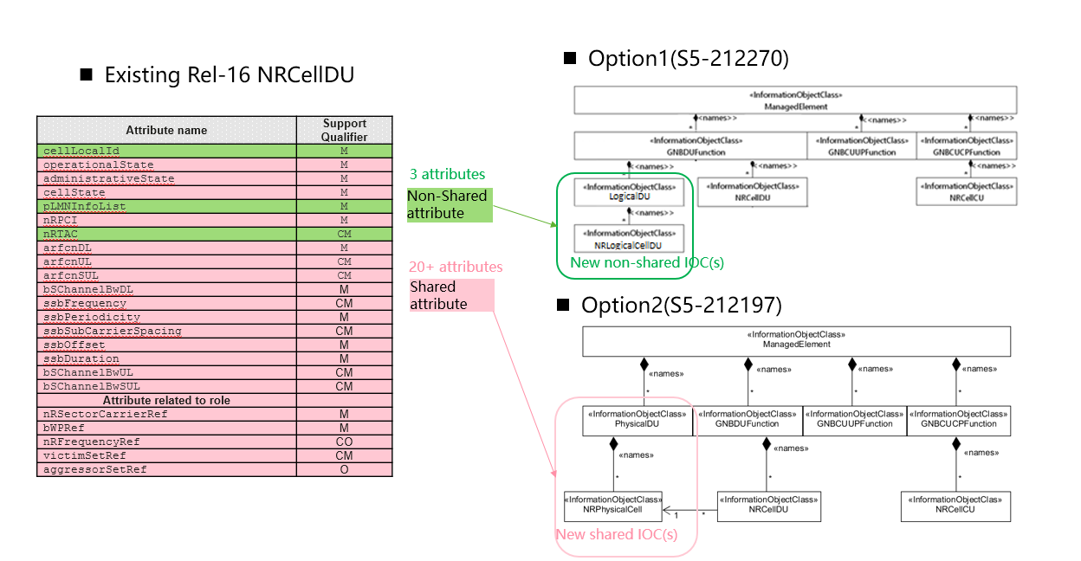
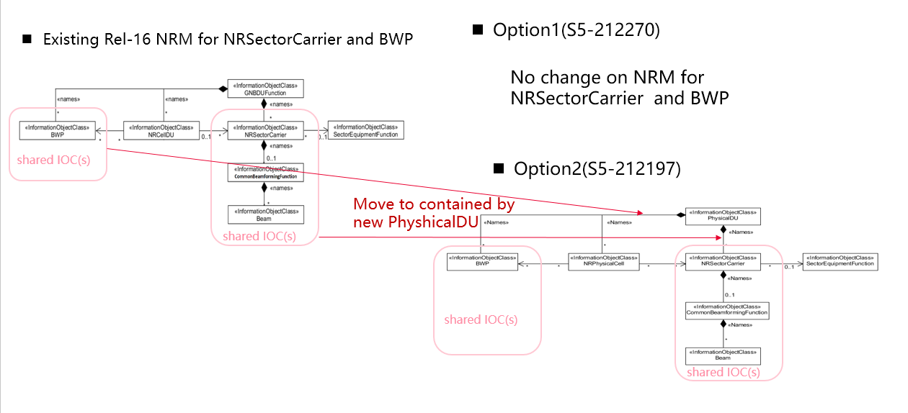

4 Detailed proposal
Proposal#1: It proposes to discuss and endorse following requirements for the following scenarios:
- NG-RAN MOCN Network Sharing with same Cell Identity broadcast scenario
- MOCN-SameCellId-Cfg-Req1. The 3GPP management system shall have the capability to configure NgC and NgU individually for each supported network operator.
- MOCN-SameCellId-Cfg-Req2. The 3GPP management system shall have the capability to configure PLMNId individually for each supported network operator.
- MOCN-SameCellId-Perf-Req1 The 3GPP management system shall have the capability to collect and report certain measurements (e.g. active UEs measurements, packet delay measurements) in PLMN granularity for different network operator.
- NG-RAN MOCN Network Sharing with multiple Cell Identity broadcast scenario
  - MOCN-MultiCellId-Cfg-Req1. The 3GPP management system shall have the capability to configure NgC and NgU individually for each supported network operator
  - MOCN-MultiCellId-Cfg-Req2. The 3GPP management system shall have the capability to configure PLMN-IdentityInfo (including PLMNId, CellId, TAC) individually for each supported network operator.
  - MOCN-MultiCellId-Cfg-Req3. The 3GPP management system shall have the capability to configure the F1 interface individually for each network operator and configure a common F1 interface for different network operators.
  - MOCN-MultiCellId-Cfg-Req4. The 3GPP management system shall have the capability to configure the Cell Relation individually for each network operator.
  - MOCN-MultiCellId-Perf-Req1 The 3GPP management system shall have the capability to collect and report certain measurements (e.g. active UEs measurements, packet delay measurements) in PLMN granularity for different network operator.
Concrete CR see S5-213172and S5-213173.

Proposal#2: It proposes to discuss and endorse above NG-RAN management solution and corresponding NR NRM update proposal to support each endorsed requirement. Concrete CR see S5-213214.

