3GPP TSG SA WG5 Meeting 137-e S5-213164

electronic meeting, online, 10 - 19 May 2021

Source: Huawei, China Telecom, China Mobile,China Unicom, AsiaInfo

Title: Add generic autonomous network level for RAN NE deployment

Document for: Approval
Agenda Item: 6.4.9

1 Decision/action requested
The group is asked to discuss and approval.

2 References
[1] 3GPP draft TS 28.100: “Management and orchestration; Levels of autonomous network v0.4.0”.

3 Rationale
This contribution proposes to add generic autonomous network level for RAN NE deployment including generic workflow, generic autonomous network level and generic requirements.

4 Detailed proposal
It proposes to make the following changes to TS 28.100 [1].
1st Change

6.2.1 Autonomous network level for RAN NE deployment

RAN NE deployment use case refers to the entire workflow of deploying an RAN NE, full autonomy of RAN NE deployment can help the network operator to reduce OPEX by reducing manual involvement in such tasks. However, full autonomy of RAN NE deployment is a long term goal, it will be beneficial for operator to achieve this goal step by step and have clear view on which typical issues can be addressed by utilizing network autonomy mechanisms in corresponding steps. The requirements for each autonomous level for RAN NE deployment are different.

2nd Change

7.X Generic autonomous network level for RAN NE deployment

7.X.1 Generic workflow
Following are the entire workflow for RAN NE deployment:
Intent handling:
- Task A: RAN NE deployment policy generation based on received RAN NE deployment intent. The tasks of generating and determining the RAN NE deployment related policies (e.g. RAN NE configuration data generation policies, RAN NE commissioning polices, RAN NE dialling test policies).
- Task B: RAN NE deployment intent evaluation, the tasks of evaluating RAN NE deployment fulfilment information (e.g. satisfied or not).
Awareness:
- Task C: RAN NE information collection, the tasks of collecting the RAN NE information (e.g., IP address, hardware information).
Analysis:
- Task D: RAN NE configuration data analysis, the tasks of analysing and generating the recommended network configuration data for the RAN NE based on the network planning data for the RAN NE and hardware information collected.
- Task E: RAN NE commissioning test, the tasks of performing the RAN NE commissioning test to put RAN NE into service (e.g. ensure the software and configuration (including radio configuration and transport configuration) is correct, and alarms are cleared).
- Task F: RAN NE dialling test, the tasks of performing the RAN NE dialling test to check whether RAN NE services are normal by testing whether the communication can be established between two subscribers.
Decision:
- Task G: RAN NE configuration data determination, the tasks of evaluating and determining the RAN NE configuration data to be download and activated.
Execution:
- Task H: RAN NE configuration data and software download and activation, the tasks of downloading and activating network configuration data and software in RAN NE.

7.X.2 Generic autonomous network level
Level 0:
- All the tasks in the RAN NE deployment workflow (Task A, Task B, Task C, Task D, Task E, Task F, Task G, Task H) are accomplished by human.
Level 1:
- Telecom system executes tasks of downloading and activating the available RAN NE network configuration data and software prepared by human (Task H) and tasks of collecting part of RAN NE information (inlcuding IP address) based on specified rules(Task C).
- All the other tasks in the RAN NE deployment workflow (Task A, Task B, Task C, Task D, Task E, Task F, Task G) are accomplished by human.
Level 2:
- Compared to Level 1, telecom system additionally executes the tasks of collecting RAN NE information (including hardware information) (Task C). Telecom system also can execute the tasks of analysing the network configuration data for the RAN NE based on the network configuration data generation rules (e.g. configuration template) specified by human(Task D). The tasks of RAN NE configuration data and software download and activation (Task H) are fully accomplished by telecom system.
- All the other tasks in the RAN NE deployment workflow (Task A, Task B, Task E, Task F, Task G) are accomplished by human.
Level 3:
- Compared to Level 2, the telecom system additionally executes tasks of analysing and determining the network configuration data for the RAN NE based on the network configuration data generation policies specified by human (Task D, Task G). Telecom system also can executes tasks of performing the RAN NE commissioning test based on commissioning policies specified by human (Task E), and tasks of performing the RAN NE dialling test based on dialling test policies specified by human(Task F). The tasks of RAN NE information collection (Task C) are fully accomplished by telecom system.
- All the other tasks in the RAN NE deployment workflow (Task A, Task B) are accomplished by human.
Level 4:
- Compared to Level 3, the telecom system can additionally execute the tasks of RAN NE deployment policy generation (Task A) and RAN NE deployment intent evaluation (Task B) based on intent handling policies specified by human. The tasks of RAN NE configuration data analysis (Task D), RAN NE configuration data determination (G), RAN NE commissioning test (Task E) and RAN NE dialling test (Task F) are fully accomplished by telecom system.
- The intent handling policies maybe pre-defined and specified by human.
Level 5:
- Telecom system can autonomously execute the entire workflow of RAN NE deployment for all scenarios,
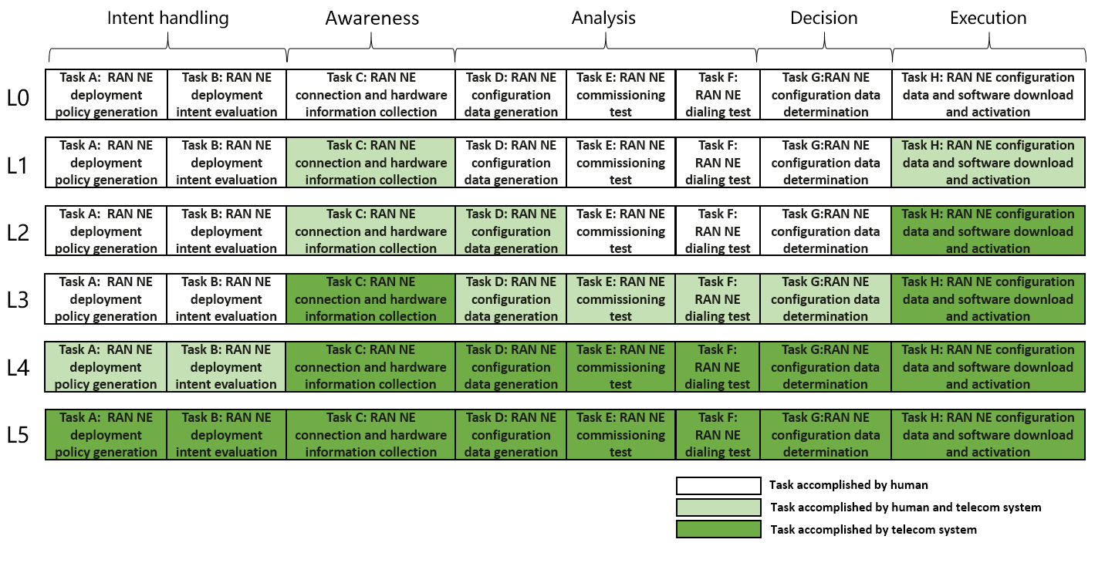
Figure 7.X.2-1 Classification of autonomous network level for RAN NE deployment

7.X.3 Generic requirements
Following are the functional requirements and interface requirements for 3GPP management system to support each autonomous network level (except for level 0) for RAN NE deployment.
Editor’s note: all requirements that do not have any stage 2 and 3 solution shall be deleted before this TS is made public.

7.X.3.1 Requirements to support autonomous network level 1
REQ-ANL-RanNeDeploy-Level_1-FUN-1 The 3GPP management system shall have autonomy capability to download and activate the specified RAN NE network configuration data and software.
REQ-ANL-RanNeDeploy-Level_1- FUN-2 The 3GPP management system shall have autonomy capability to collect RAN NE information based on the specified RAN NE information collection rule.
REQ-ANL-RanNeDeploy-Level_1-MnS-1 The 3GPP management system shall have the capability allowing its authorized consumer to specify the RAN NE network configuration data and software.
REQ-ANL-RanNeDeploy-Level_1-MnS-2 The 3GPP management system shall have the capability allowing its authorized consumer to specify the RAN NE information collection rule.

7.X.3.2 Requirements to support autonomous network level 2

REQ-ANL-RanNeDeploy-Level_2- FUN-1 The 3GPP management system shall have autonomy capability to analyse the network configuration data for the RAN NE based on the specified network configuration data generation rules.

REQ-ANL-RanNeDeploy-Level_2-MnS-2 The 3GPP management system shall have the capability allowing its authorized consumer to specify the network configuration data generation rules.

7.X.3.3 Requirements to support autonomous network level 3
REQ-ANL-RanNeDeploy-Level_3- FUN-1 The 3GPP management system shall have autonomy capability to analyse and determine the network configuration data for the RAN NE based on the specified network configuration data generation policies.
REQ-ANL-RanNeDeploy-Level_3- FUN-2 The 3GPP management system shall have autonomy capability to perform the RAN NE commissioning test based on specified commissioning test policies.
REQ-ANL-RanNeDeploy-Level_3- FUN-3 The 3GPP management system shall have autonomy capability to perform the RAN NE dialling test based on specified dialling test policies.
REQ-ANL-RanNeDeploy-Level_3-MnS-1 The 3GPP management system shall have the capability allowing its authorized consumer to specify the network configuration data generation policies.
REQ-ANL-RanNeDeploy-Level_3-MnS-2 The 3GPP management system shall have the capability allowing its authorized consumer to specify the commissioning test policies.
REQ-ANL-RanNeDeploy-Level_3-MnS-4 The 3GPP management system shall have the capability allowing its authorized consumer to specify the dailing test policies.

7.X.3.4 Requirements to support autonomous network level 4
REQ-ANL-RanNeDeploy-Level_4-FUN-1 The 3GPP management system shall have autonomy capability to determine or update RAN NE deployment policies according to RAN NE deployment intent based on specified intent translation policies.
REQ-ANL-RanNeDeploy-Level_4- FUN-2 The 3GPP management system shall have autonomy capability to evaluate RAN NE deployment intent fulfilment result based on specified intent evaluation policies.
REQ-ANL-RanNeDeploy-Level_4-MnS-1 The 3GPP management system shall have the capability allowing its authorized consumer to specify the RAN NE deployment intent.
REQ-ANL-RanNeDeploy-Level_4-MnS-2 The 3GPP management system shall have the capability allowing its authorized consumer to specify the RAN NE deployment intent translation policies.
REQ-ANL-RanNeDeploy-Level_4-MnS-3 The 3GPP management system shall have the capability allowing its authorized consumer to specify the RAN NE deployment intent evaluation policies.

7.X.3.5 Requirements to support autonomous network level 5
REQ-ANL-RanNeDeploy-Level_5-FUN-1 The 3GPP management system shall have autonomy capability to generate the RAN NE deployment intent translation and evaluation policies.

End of changes

