3GPP TSG SA WG5 Meeting 137-e S5-213163

electronic meeting, online, 10 - 19 May 2021

Source: Huawei,China Mobile,China Telecom, China Unicom, AsiaInfo

Title: Update several existing classification of autonomous network level

Document for: Approval
Agenda Item: 6.4.9

1 Decision/action requested
The group is asked to discuss and approval.

2 References
[1] 3GPP draft TS 28.100: “Management and orchestration; Levels of autonomous network v0.4.0”.

3 Rationale
1. Clause 6.3.1.3 Classification of autonomous network level for fault management described the tasks fully accomplished by telecom system for level2 - level4, however, such description is missing in following clause:
- Clause 6.2.1.3 Classification of autonomous network level for RAN NE deployment
- Clause 6.4.1.3 Classification of autonomous network level for radio network coverage optimization
- Clause 6.4.2.3 Classification of autonomous network level for RAN UE throughput optimization
- Clause 7.1.2 Generic autonomous network level for network optimization
2. Clause 6.4.2.2, “Task D: RAN UE throughput issues identification” is the task of “Analysis”, however, in Figure 6.4.2.3-1 Classification of autonomous network level for RAN UE throughput optimization, “Task D: RAN UE throughput issues identification” is the task of “Awareness”, which is not aliged. Same isse for Figure 7.1.2-1 Classification of generic autonomous network level for network optimization.
3. The participation of Human and System for the Task Network detertioration prediction in clause 6.4.1 Autonomous network level for radio network coverage optimization, Clause 6.4.2 Autonomous network level for RAN UE throughput optimization and Clause 7.1 Generic autonomous network level for network optimization are not aligned. Also the task Network detertioration prediction accomplished by telecom system based on human defined policies/rules is missing which is not align with other tasks.

4 Detailed proposal
It proposes to make the following changes to TS 28.100 [1].
1st Change

6.4.1 Autonomous network level for radio network coverage optimization

Radio networks are geographically distributed, and mobile user activity varies significantly in different places and at different times of day. To achieve the optimal coverage, a set of initial coverage configuration parameters (e.g. coverageShape, digitalTilt and digitalAzimuth) may not always meet the requirements. Therefore, the coverage configuration parameters need to be adjusted in a differentiated manner with the change of the radio network environment. It’s complex for the adjustment due to multiple factors needs to be considered, e.g. interference control, huge data and frequent traffic changes. So introducing the autonomous network level for radio network coverage optimization will benefit for operator to achieve the full autonomy goal step by step and have clear view on which typical issues can be addressed by utilizing autonomy mechanism in corresponding steps. The requirements for each autonomous level for radio network coverage optimization are different.

3rd Change

6.4.2 Autonomous network level for RAN UE throughput optimization

RAN UE throughput is a key performance for radio network, and, numerous radio feature parameters with broad value ranges affect the RAN UE throughput. There are many radio feature parameters of RAN NE level or cell level, for examples, MLB related parameters, resource schedule related parameters, cell reselection related parameters, handover related parameters, different radio feature parameters affect each other and the combination number of various parameter values is large. Therefore, it’s complex to adjust radio feature configuration parameters to achieve the optimized RAN UE throughput. So introducing the autonomous network level for RAN UE throughput optimization will be benefit for operator to achieve the full autonomy goal step by step and have clear view on which typical issues can be addressed by utilizing autonomy mechanism in corresponding steps. The requirements for each autonomous level for RAN UE throughput optimization are different.

4th Change

7.1.2 Generic classification of autonomous network level
Level 0:
- All the tasks in the network optimization workflow (Task A, Task B, Task C, Task D, Task E, Task F, Task G, Task H, Task I) are accomplished by human.
Level 1:
- Telecom system executes the tasks of network adjustment solutions execution based on the specified network related parameters (Task I). Telecom system also can execute the tasks of network related information collection based on the specified collection rule (Task C). At this level, telecom system can assist human to improve the execution and awareness efficiency for network optimization.
- All the other tasks in the network optimization workflow (Task A, Task B, Task D, Task E, Task F, Task G, Task H) are accomplished by human.
Level 2:
- Compared to Level 1, telecom system additionally executes the tasks of network issues identification, network issue analysis based on the specified network issue identification and analysis rule (Task D, Task F). The tasks of network adjustment solutions execution (Task I) and network related information collection (Task C) are fully accomplished by telecom system. At this level, telecom system can assist human to achieve the closed loop for network optimization based on human defined rules.
- All the other tasks in the network optimization workflow (Task A, Task B, Task E, Task G, Task H) are accomplished by human.
Level 3:
- Compared to Level 2, telecom system additionally executes the tasks of network adjustment solutions generation (Task G) and network adjustment solutions evaluation and determination (Task H) based on the specified network adjustment policies and evaluation policies. In this level, telecom system also can execute the tasks of deterioration prediction (Task E). The tasks of network issues identification (Task D) and network issue analysis (Task F) are fully accomplished by telecom system. At this level, the telecom system can achieve the closed loop automation for network optimization based on the human defined optimization policies.
- All the other tasks in the network optimization workflow (Task A, Task B, Task E) are accomplished by human.
Level 4:
- Compared to Level 3, the telecom system additionally executes the tasks of network optimization policies determination (Task A), and network optimization intent evaluation (Task B) based on received network optimization intent and intent translation/evaluation policies. The tasks of network adjustment solutions generation (Task G), network adjustment solutions evaluation and determination (Task H), and network deterioration prediction (Task E) are fully accomplished by telecom system. At this level, telecom system can achieve the intent driven closed loop automation for network optimization based on human defined intent translation and evaluation policies.
- The intent translation and evaluation policies maybe pre-defined and specified by human to assist the telecom system.
Level 5:
- Telecom system can autonomously execute the entire workflow of radio network optimization for all scenarios, which means the telecom system can achieve the full autonomy for network optimization for full scenarios.

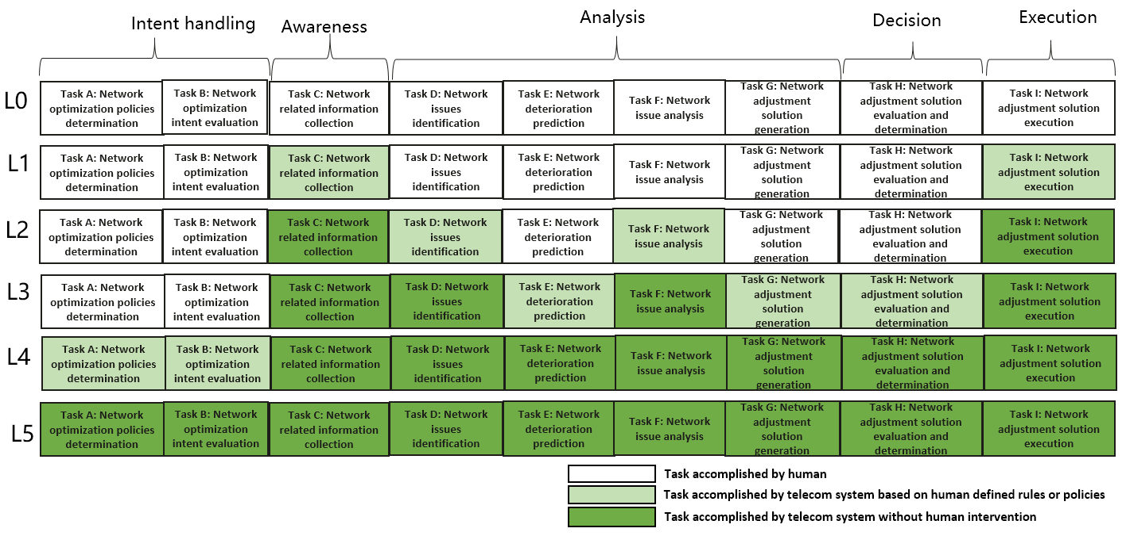
Figure 7.1.2-1 Classification of generic autonomous network level for network optimization

5th Change

Annex A (informative):
Examples of Autonomous network level for network and service optimiation

A.1 Autonomous network level for radio network coverage optimization

A.1.1 Workflow
Following are the entire workflow for the radio network coverage optimization:
Intent handling:
- Task A: Coverage optimization policies generation and determination. The tasks of generating and determining the coverage optimization related policies (e.g., weak coverage issue identification policies, weak coverage analysis policies and coverage parameters adjustment policies) based on received coverage optimization intent (e.g. coverage targets(e.g. weak coverage ratio) for the specified areas).
- Task B: Coverage optimization intent evaluation. The tasks of evaluating coverage optimization intent fulfilment information (e.g. corresponding coverage targets are satisfied or not).
Awareness:
- Task C: Coverage related information collection. The tasks of collecting coverage related data, including coverage performance data (i.e. performance measurement, MDT data), coverage configuration data (e.g. coverageShape, digitalTilt and digitalAzimuth) and environment data (e.g. electronic map)).
Analysis:
- Task D: Coverage issues identification. The tasks of analysing the coverage performance (e.g. geographical grid based coverage performance) and identifying the coverage issues (e.g. weak coverage, coverage hole, overshoot coverage) and corresponding location.
- Task E: Coverage deterioration prediction. The tasks of analysing current coverage performance and historical coverage performance, predicting the coverage performance trend in the future and identifying potential coverage performance deterioration in advance.
- Task F: Coverage issue analysis. The tasks of analysing the root cause (e.g. affected Cells) of the identified or predicted coverage issues.
- Task G: Coverage adjustment solutions generation. The tasks of generating the recommended coverage adjustment solution which can address the identified or predicted coverage issues.
Decision:
- Task H: Coverage adjustment solutions evaluation and determination. The tasks of evaluating the recommended coverage adjustment solutions, and deciding the coverage adjustment solutions to be executed.
Execution:
- Task I: Coverage adjustment solutions execution. The tasks of adjusting and configuring the coverage related parameters (e.g. selection of coverageShape, digitalTilt and digitalAzimuth).

A.1.2 Classification of autonomous network level
Level 0:
- All the tasks in the radio network coverage optimization workflow (Task A, Task B, Task C, Task D, Task E, Task F, Task G, Task H, Task I) are accomplished by human.
Level 1:
- Telecom system executes the tasks of coverage adjustment solutions execution based on the specified coverage related parameters (Task I). Telecom system also can execute the tasks of coverage related information collection based on the specified collection rule (Task C). At this level, telecom system can assist human to improve the execution and awareness efficiency for radio network coverage optimization.
- All the other tasks in the radio network coverage optimization workflow (Task A, Task B, Task D, Task E, Task F, Task G, Task H) are accomplished by human.
Level 2:
- Compared to Level 1, telecom system additionally executes the tasks of coverage issues identification, coverage issue analysis based on the specified coverage issue identification and analysis rule (Task D, Task F). The tasks of coverage adjustment solutions execution (Task I) and coverage related information collection (Task C) are fully accomplished by telecom system. At this level, telecom system can assist human to achieve the closed loop for radio network coverage optimization based on human defined rules.
- All the other tasks in the radio network coverage optimization workflow (Task A, Task B, Task E, Task G, Task H) are accomplished by human.
Level 3:
- Compared to Level 2, telecom system additionally executes the tasks of coverage adjustment solutions generation (Task G) and coverage adjustment solutions evaluation and determination (Task H) based on the specified coverage adjustment policies and evaluation policies. In this level, telecom system also can execute the tasks of coverage deterioration prediction (Task E) based on the specified deterioration predecition policies. The tasks of coverage issues identification (Task D) and coverage issue analysis (Task F) are fully accomplished by telecom system. At this level, the telecom system can achieve the closed loop automation for coverage optimization based on the human defined optimization policies.
- All the other tasks in the radio network coverage optimization workflow (Task A, Task B, Task E) are accomplished by human.
Level 4:
- Compared to Level 3, the telecom system additionally executes the tasks of coverage optimization policies determination (Task A), and coverage optimization intent evaluation (Task B) based on received coverage optimization intent and intent translation/evaluation policies. The tasks of coverage adjustment solutions generation (Task G), coverage adjustment solutions evaluation and determination (Task H) and coverage deterioration prediction (Task E) are fully accomplished by telecom system. At this level, telecom system can achieve the intent driven closed loop automation for radio network coverage optimization based on human defined intent translation and evaluation policies
- The intent translation and evaluation policies maybe pre-defined and specified by human to assist the telecom system.
Level 5:
- Telecom system can autonomously execute the entire workflow of radio network coverage optimization for all scenarios, which means the telecom system can achieve the full autonomy for radio network coverage optimization for full scenarios.

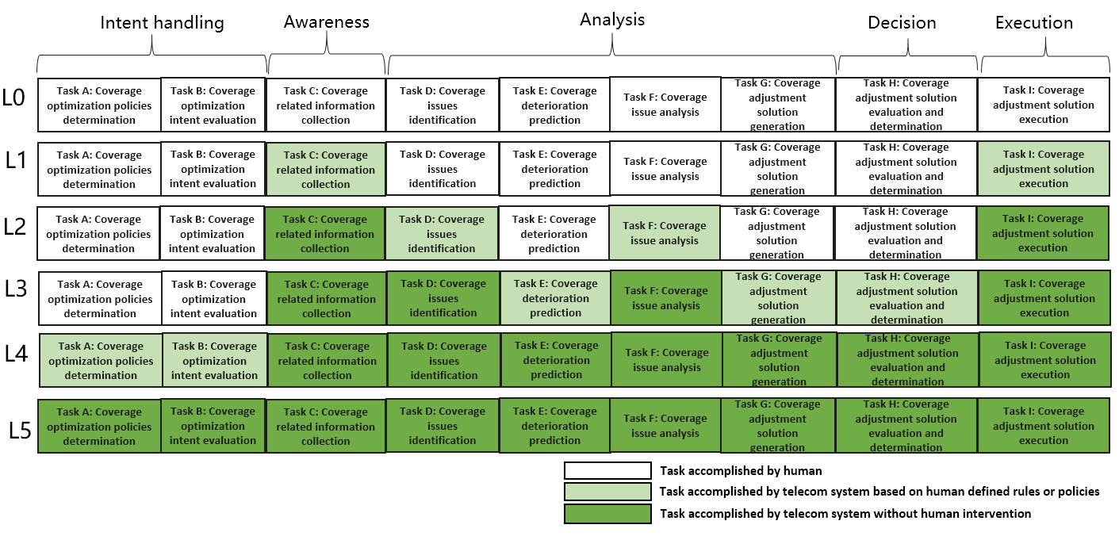
Figure A.1.2-1 Classification of autonomous network level for coverage optimization

A.2 Autonomous network level for RAN UE throughput optimization

A.2.1 Workflow
Following are the entire workflow for the RAN UE throughput optimization:
Intent handling:
- Task A: RAN UE throughput optimization policies generation and determination. The tasks of generating and determining the RAN UE throughput optimization related policies (e.g., RAN UE throughput issue identification policies, RAN UE throughput analysis policies and RAN UE throughput parameters adjustment policies) based on received RAN UE throughput optimization intent (e.g. RAN UE throughput targets(e.g. low RAN UE throughput ratio, target average RAN UE throughput) for the specified areas).
- Task B: RAN UE throughput optimization intent fulfilment evaluation. The tasks of evaluating RAN UE throughput optimization intent fulfilment information (e.g. corresponding RAN UE throughput targets are satisfied or not).
Awareness:
- Task C: RAN UE throughput related information collection. The tasks of collecting RAN UE throughput related data, including RAN UE throughput performance data (e.g., AverageUL/ DL UE throughput in gNB, Distribution of UL/DL UE throughput in gNB ), RAN UE throughput configuration data (e.g., cellIndividualOffset, isHOAllowed and isMLBAllowed of corresponding NRCellRelation(s)) and environment data (e.g. electronic map)).
Analysis:
- Task D: RAN UE throughput issues identification. The tasks of analysing the RAN UE throughput performance (e.g. geographical grid based RAN UE throughput performance) and identifying the RAN UE throughput issues (e.g. low average RAN UE throughput, large number of UEs with low RAN UE throughput) and corresponding location.
- Task E: RAN UE throughput deterioration prediction. The tasks of analysing current RAN UE performance and historical RAN UE throughput performance, predicting the RAN UE throughput performance trend in the future and identifying potential RAN UE throughput performance deterioration in advance.
- Task F: RAN UE throughput issue analysis. The tasks of analysing the root cause (e.g. unbalanced load between different cells, frequently handover among several cells) of the identified or predicted RAN UE throughput issues.
- Task G: RAN UE throughput adjustment solutions generation. The tasks of generating the recommended RAN UE throughput adjustment solution (e.g. reconfigure the NRCellRelation IOC and DMROFunction IOC of corresponding RAN NEs) which can address the identified or predicted RAN UE throughput issues.
Decision:
- Task H: RAN UE throughput adjustment solutions evaluation and determination. The tasks of evaluating the recommended RAN UE throughput adjustment solutions, and deciding the RAN UE throughput adjustment solutions to be executed.
Execution:
- Task I: RAN UE throughput adjustment solutions execution. The tasks of adjusting and configuring the RAN UE throughput related parameters (e.g. cellIndividualOffset, isHOAllowed and isMLBAllowed of corresponding NRCellRelation(s), maximumDeviationHoTrigger of corresponding DMROFunction).

A.2.2 Classification of autonomous network level
Level 0:
- All the tasks in the RAN UE throughput optimization workflow (Task A, Task B, Task C, Task D, Task E, Task F, Task G, Task H, Task I) are accomplished by human.
Level 1:
- Telecom system executes the tasks of RAN UE throughput adjustment solutions execution based on the specified RAN UE throughput related parameters (Task I). Telecom system also can execute the tasks of RAN UE throughput related information collection based on the specified collection rule (Task C). At this level, telecom system can assist human to improve the execution and awareness efficiency for RAN UE throughput optimization.
- All the other tasks in the RAN UE throughput optimization workflow (Task A, Task B, Task D, Task E, Task F, Task G, Task H) are accomplished by human.
Level 2:
- Compared to Level 1, telecom system additionally executes the tasks of RAN UE throughput issues identification, RAN UE throughput issue analysis based on the specified RAN UE throughput issue identification and analysis rule (Task D, Task F). The tasks of RAN UE throughput adjustment solutions execution (Task I) and RAN UE throughput related information collection (Task C) are fully accomplished by telecom system. At this level, telecom system can assist human to achieve the closed loop for RAN UE throughput optimization based on human defined rules.
- All the other tasks in the RAN UE throughput optimization workflow (Task A, Task B, Task E, Task G, Task H) are accomplished by human.
Level 3:
- Compared to Level 2, telecom system additionally executes the tasks of RAN UE throughput adjustment solutions generation (Task G) and RAN UE throughput adjustment solutions evaluation and determination (Task H) based on the specified RAN UE throughput adjustment policies and evaluation policies. In this level, telecom system also can execute the tasks of RAN UE throughput deterioration prediction (Task E) based on the specified deterioration predecition policies. The tasks of RAN UE throughput issues identification (Task D) and RAN UE throughput issue analysis (Task F) are fully accomplished by telecom system. At this level, the telecom system can achieve the closed loop automation for RAN UE throughput optimization based on the human defined optimization policies.
- All the other tasks in the RAN UE throughput optimization workflow (Task A, Task B, Task E) are accomplished by human.
Level 4:
- Compared to Level 3, the telecom system additionally executes the tasks of RAN UE throughput optimization policies determination (Task A), and RAN UE throughput optimization intent evaluation (Task B) based on received RAN UE throughput optimization intent and intent translation/evaluation policies. The tasks of RAN UE throughput adjustment solutions generation (Task G), RAN UE throughput adjustment solutions evaluation and determination (Task H) and RAN UE throughput deterioration prediction (Task E) are fully accomplished by telecom system. At this level, telecom system can achieve the intent driven closed loop automation for RAN UE throughput optimization based on human defined intent translation and evaluation policies
- The intent translation and evaluation policies maybe pre-defined and specified by human to assist the telecom system.
Level 5:
- Telecom system can autonomously execute the entire workflow of RAN UE throughput optimization for all scenarios, which means the telecom system can achieve the full autonomy for RAN UE throughput optimization for full scenarios.

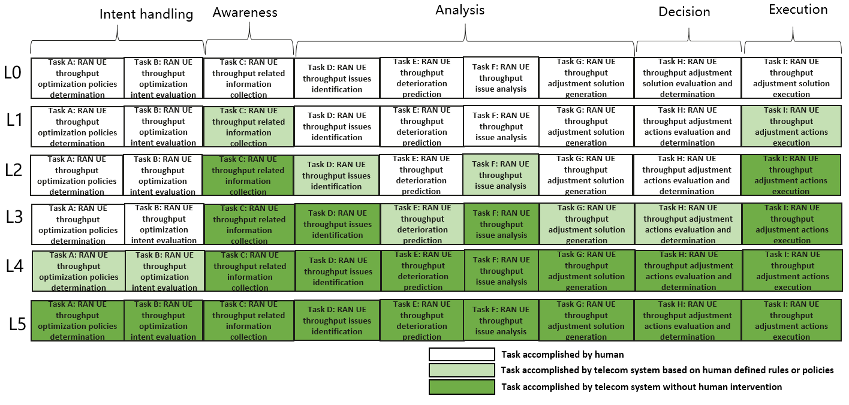
Figure A.2.2-1 Classification of autonomous network level for RAN UE throughput optimization

End of changes

