**3GPP TSG-SA5 Meeting #137-e *S5-213151rev1***

electronic meeting, online, 10 May - 19 May 2021

**Source: CATT**

**Title: pCR Updating on Direct Discovery charging with 5G DDNMF**

**Document for: Approval**

**Agenda Item: 7.5.3**

# 1 Decision/action requested

***The group is asked to discuss and agree on the proposal.***

# 2 References

[1] 3GPP TR 32.846: “Study on charging aspects of Proximity-based Services in 5GS”.

[2] 3GPP TS 23.304: "Proximity based Services (ProSe) in the 5G System (5GS)".

# 3 Rationale

According to the latest TS 23.304 [2], this contribution is to update the solution for Direct Discovery charging with 5G DDNMF.

# 4 Detailed proposal

|  |
| --- |
| **1st Modified Section** |

#### 6.1.4.1 Solution #1.1: ProSe Direct Discovery charging with 5G DDNMF

##### 6.1.4.1.1 Consideration for ProSe Direct Discovery charging with 5G DDNMF

ProSe Direct Discovery is defined as the process that detects and identifies another UE in proximity using NR radio signals. There are two types of ProSe Direct Discovery supported over PC3a reference point: open and restricted, as defined in TS 23.303 [8]. ProSe Direct Discovery can be a standalone service or can be used for subsequent actions e.g. to initiate ProSe Direct Communication.

5G DDNMF is defined to manage the dynamic ProSe Direct Discovery. Functionalities of the 5G DDNMF and the interactions with the UEs are defined in TS 23.304 [11].

The ProSe Direct Discovery with 5G DDNMF procedures could be divided into Discovery Request procedure and Discovery Reporting procedure, both could support Model A, and Model B. The exact signalling procedures are defined in TS 23.303 [8] clause 5.3.3.

The Charging Enablement Function (CEF) is defined in TS 28.201 [10], for ProSe converged charging the CEF could be a consumer of NF service provider for ProSe (e.g.,5G DDNMF Services) and charging (Nchf) service provider.

The charging information on the use of ProSe Direct Discovery is collected by the 5G DDNMF in HPLMN, VPLMN, and local PLMNs.The 5GS should collect the following minimum charging information:

| Information Element | Description |
| --- | --- |
| UE identity | The identity of the ProSe UE |
| Serving PLMN ID | PLMN identity of the serving PLMN which signalled the carrier frequency |
| Announcing PLMN ID | This field holds PLMN identity of PLMN for UE to be monitored in monitor/match report procedure |
| Monitored PLMN ID | This field holds PLMN identity of PLMN for UE requested to be monitored in monitor/match report procedure |
| ProSe Application ID | The identities used for ProSe Direct Discovery, identifying application related information for the ProSe-enabled UE |
| Application ID | A globally unique identifier identifying a specific 3rd party application |
| Direct Discovery Model | Model of the Direct Discovery used by the UE, e.g. Model A, or Model B. |
| ProSe Event Type | This IE holds the event which triggers the charging message delivery, e.g. Announce, Monitor, Match Report |
| ProSe Request Timestamp | The time when ProSe Request is received from UE. |
| PC5 Radio Technology | The PC5 radio technology used by UE for ProSe Direct Discovery |

Table 6.1.4.1.1-1 Structure of the ProSe Discovery Information

Editor's note: Whether other information elements are needed is FFS.

##### 6.1.4.1.2 Architecture Description

A set of trigger conditions are defined for the 5G DDNMF (CTF) or CEF to invoke a Charging Data Request [Event] towards the CHF.

The converged charging architecture is proposed for the event based charging for 5GS ProSe under the alternatives：

- Charging Trigger Function (CTF) based, as depicted in figure 6.1.4.1.2-1.

- Charging Enablement Function (CEF) based, depicted in figure 6.1.4.1.2-2.



Figure 6.1.4.1.2-1: The Converged Charging System (CTF)



Figure 6.1.4.1.2-2: The Converged Charging System (CEF)

##### 6.1.4.1.3 Flow Description

6.1.4.1.3.1-a Message flows for ProSe Direct Discovery Request - CTF

s

Figure 6.1.4.1.3.1-a: Message flow for ProSe Direct Discovery Request - CTF (non-roaming)

The detailed description for the message flow as defined in TS 23.304 [11] clause 6.3.1.4 and TS 23.303 [11] clause 5.3.4.

1-2. These steps are the same as the ProSe Direct Discovery as defined in TS 23. 304 [11]. The Direct Discovery Request could be with command (Announce request, Monitor request, Discoverer request, Discoveree Request).

3. The 5G DDNMF responds with a Discovery Response with:

- (ProSe Application Code, validity timer, PC5_tech) for open discovery.

- (ProSe Application Code, ProSe Restricted Code/ ProSe Restricted Code Prefix[ProSe Restricted Code Suffix pool], validity timer, Discovery Entry ID, PC5_tech) for restricted discovery.

3a. The 5G DDNMF triggers Charging Data Request[Event] to CHF in HPLMN where event represents Discovery Request. The PF-DD-CDR is generated by CHF for Announcing UE.

3b. The CHF creates a CDR for this Announcing UE.

3c. The CHF returns Charging Data Response corresponding to the received Charging Data Request[Event].

NOTE1: Roaming/ inter-PLMN procedures are similar to that procedures as defined in TS 32.277 [4] clause 5.2.2.1.

6.1.4.1.3.1-b Message flows for ProSe Direct Discovery Reporting – CTF

The Direct Discovery Reporting procedure can be used by the "monitoring UE" (in Model A) and Discoverer UE (in Model B) to request the 5G DDNMF to resolve a matched ProSe Discovery Code(s), for both open discovery and restricted discovery.

The message flows for ProSe Direct Discovery Reporting could re-use the procedures as defined in TS 32.277 [4] clause 5.2.2.1, with the following modification:

- the 5G DDNMF takes the role of "ProSe Function" in the procedure;

- the HSS is replaced by PCF/UDM;

- corresponding 5GS identifiers replace the EPS identifiers, e.g. use SUPI instead of IMSI, and use GPSI instead of MSISDN;

- PC5_tech parameter is omitted and the intended PC5 radio technology is NR.

6.1.4.1.3.2-a Message flows for ProSe Direct Discovery Request - CEF

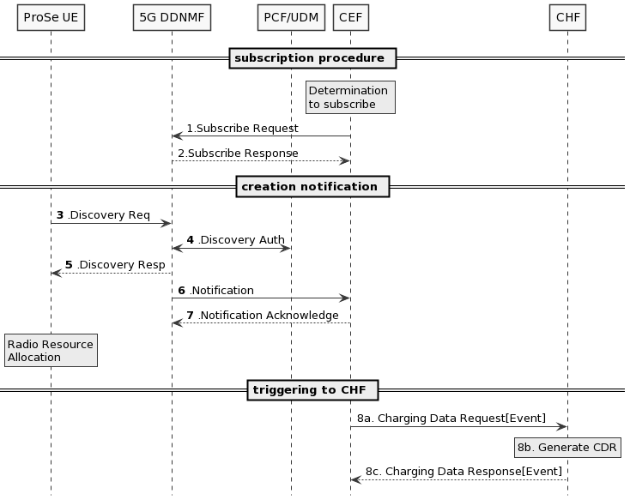

Figure 6.1.4.1.3.2: CEF-Message flow for ProSe Direct Discovery Request (non-roaming)

1. Determination by CEF to subscribe to ProSe Direct Discovery Service.

2. Subscribe Request: the CEF subscribes to 5G DDNMF.

3-5. These steps are the same as the ProSe Direct Discovery will be defined in TS 23.304 [11]. The Direct Discovery Request could be with command (Announce request, Monitor request, Discoverer request, Discoveree Request).

Editor’s Note: This message flow needs to align with future TS 23.304 based on TR 23.752 conclusion.

6. Notification: DDNMF notifies the CEF that ProSe Direct Discovery message has been processed.

7. Notification Acknowledge sent by the CEF.

8-a. The CEF sends Charging Data Request [Event] to CHF associated to the event represents Discovery Request.

8-b. The CHF creates a CDR.

8-c. The CHF acknowledges by sending Charging Data Response to the CEF.

Editor’s Note: It is FFS for the use of services proved from 5G DDNMF for charging information.

6.1.4.1.3.1- b Message flows for ProSe Direct Discovery Reporting – CEF

The message flows could re-use the CEF subscription/notification procedure and Charging Data Request procedure as described in 6.1.4.1.3.1- a.

##### 6.1.4.1.4 Solution evaluation

TBD

|  |
| --- |
| **Next Modified Section** |