3GPP TSG-SA5 Meeting #137e S5-213017

e-meeting 10th 19th May 2021

Source: China Mobile

Title: pCR 28.556 Add policy management procedures

Document for: Approval
Agenda Item: 6.4.11

1 Decision/action requested
To approve policy management procedures.

2 References

3 Rationale
To provide policy management procedures for TS 28.556

4 Detailed proposal
It proposes to make the following changes to TS 28.556
1st Change

4 Policy management procedures

4.a Policy Creation
The Figure 4.2-1 illustrates the procedure for creating a new policy.

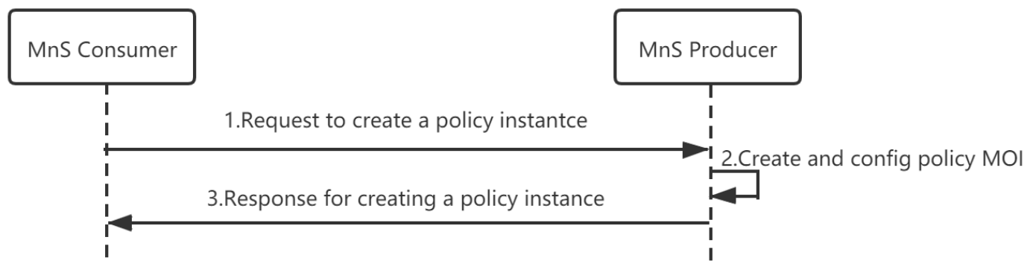
Figure 4.b-1 Procedure for creating a policy

- MnS Consumer sends a request to create a policy instance to MnS Producer for the new policy to be created(see createMOI operation defined in TS 28.532 [x]).
- Based on the request, the MnS Producer creates the concrete policy MOI].
- MnS Producer sends a response to the MnS consumer(see createMOI operation defined in TS 28.532 [x]) .

4.b Policy Deletion
The Figure 4.3-1 illustrates the procedure for deleting a policy.

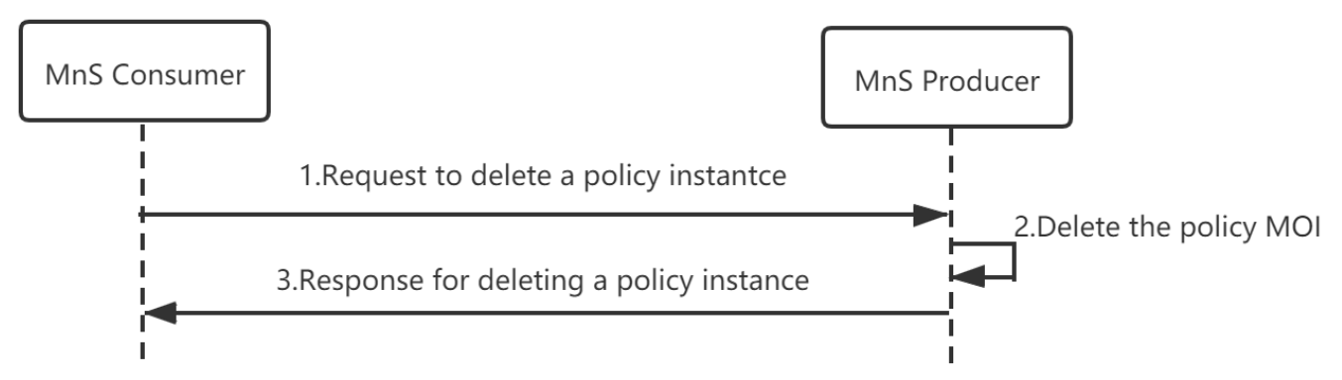
Figure 4.c-1 Procedure for deleting a policy
- MnS Consumer sends a request to delete a policy instance(see deleteMOI operation defined in TS 28.532 [8]) to MnS Producer.
- Based on the request, the MnS Producer deletes the concrete policy MOI (i.e. instance of policy IOC).
- MnS Producer sends a response to the MnS consumer(see deleteMOI operation defined in TS 28.532 [x]).

4.c Policy Update
The Figure 4.4-1 illustrates the procedure for updating a policy.

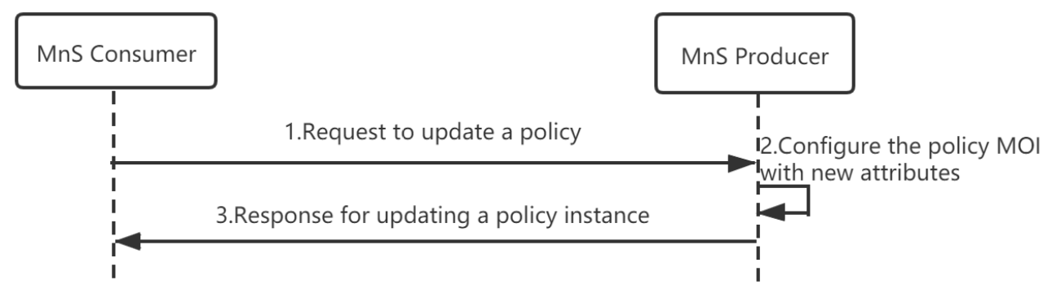
Figure 4.d-1 Procedure for updating a policy
- MnS Consumer sends a request to update a policy instance to MnS Producer(see modifyMOIAttributes operation defined in TS 28.532 [x]).
- Based on the request, the MnS Producer updates the concrete policy MOI (i.e. instance of policy IOC).
- MnS Producer sends a response to the MnS consumer(see modifyMOIAttributes operation defined in TS 28.532 [x]).

4.d Policy Query
The Figure 4.7-1 illustrates the procedure for querying a new policy.
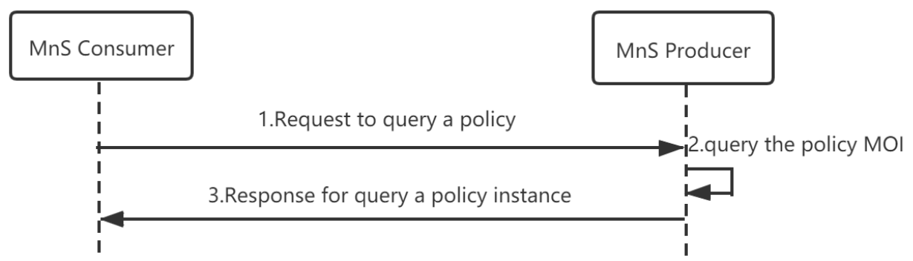
Figure 4.g-1 Procedure for querying a policy
- MnS Consumer sends a request to query a policy instance to MnS Producer(see getMOIAttributes operation defined in TS 28.532 [x]).
- Based on the request, the MnS Producer queries the concrete policy MOI (i.e. instance of policy IOC).
- MnS Producer sends a response to the MnS consumer(see getMOIAttributes operation defined in TS 28.532 [x]).

4.e Policy Conflicts Notification
The Figure 4.8-1 illustrates the procedure for notifying policy conflicts.
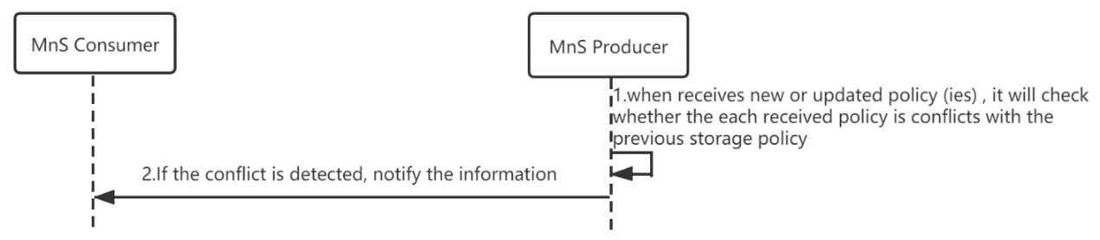
Figure 4.h-1 Procedure for policy conflicts notification
- When MnS Producer receives new or updated policy (ies) from MnS Consumer, it will check whether the each received policy is conflicts with the previous storage policy.
- If the conflict is detected, MnS Producer will notify the information to MnS Consumer(see notifyEvent operation defined in TS 28.532 [x]).

End of changes

