**3GPP TSG-SA5 Meeting #133eS5-205351**

**e-meeting, 12 – 21 October 2020**

|  |  |  |  |  |  |  |  |  |
| --- | --- | --- | --- | --- | --- | --- | --- | --- |
| *CR-Form-v11.4* | | | | | | | | |
| **CHANGE REQUEST** | | | | | | | | |
|  | | | | | | | | |
|  | **28.541** | **CR** | **0405** | **rev** | **-** | **Current version:** | **17.0.0** |  |
|  | | | | | | | | |
| *For* [***HELP***](http://www.3gpp.org/3G_Specs/CRs.htm#_blank)*on using this form: comprehensive instructions can be found at* [*http://www.3gpp.org/Change-Requests*](http://www.3gpp.org/Change-Requests)*.* | | | | | | | | |
|  | | | | | | | | |

|  |  |  |  |  |  |  |  |  |
| --- | --- | --- | --- | --- | --- | --- | --- | --- |
| ***Proposed change affects:*** | UICC apps |  | ME |  | Radio Access Network | **X** | Core Network | **X** |

|  |  |  |  |  |  |  |  |  |  |  |
| --- | --- | --- | --- | --- | --- | --- | --- | --- | --- | --- |
|  | | | | | | | | | | |
| ***Title:*** | Add containment relationship for network slice IOCs | | | | | | | | | |
|  |  | | | | | | | | | |
| ***Source to WG:*** | Nokia, Nokia Shanghai Bell | | | | | | | | | |
| ***Source to TSG:*** | S5 | | | | | | | | | |
|  |  | | | | | | | | | |
| ***Work item code:*** | TEI16 | | | | |  | ***Date:*** | | | 2020-10-16 |
|  |  | | | |  | |  | | |  |
| ***Category:*** | **A** |  | | | | | ***Release:*** | | | Rel-17 |
|  | *Use one of the following categories:* ***F*** *(correction)* ***A*** *(mirror corresponding to a change in an earlier release)* ***B*** *(addition of feature),* ***C*** *(functional modification of feature)* ***D*** *(editorial modification)*  Detailed explanations of the above categories can be found in 3GPP [TR 21.900](http://www.3gpp.org/ftp/Specs/html-info/21900.htm). | | | | | | | | *Use one of the following releases: Rel-8 (Release 8) Rel-9 (Release 9) Rel-10 (Release 10) Rel-11 (Release 11) Rel-12 (Release 12) Rel-13 (Release 13) Rel-14 (Release 14) Rel-15 (Release 15) Rel-16 (Release 16)* | |
|  |  | | | | | | | | | |
| ***Reason for change:*** | | Containment relationship of NetworkSlice and NetworkSliceSubnet IOCs were not defined in network slice NRM fragment. As NetworkSlice and NetworkSliceSubnet IOCs were inherited from SubNetwork IOC, NetworkSlice/NetworkSliceSubnet MOI can be local root instance. In clause 6 of 28.531, it required notifyMOICreation notification to be supported for NetworkSlice and NetworkSliceSubnet MOI, In network slice/network slice subnet creation use case, it also required the MnS provider notifies the network slice instance information of NetworkSlice/NetworkSliceSubnet MOI (e.g., the management identifier of MOI). In addition, network slice management charging specified in TS 28.202 required network slice creation notification.  To support notification consumer to subscribe to notifyMOICreation of NetworkSlice/NetworkSliceSubnet MOI, the NetworkSlice/NetworkSliceSubnet cannot be local root instance, instead it should be explicitly contained by another SubNetwork MOI. Then a NtfSubscriptionControl MOI can be created under that parent SubNetwork MOI, and notifyMOICreation notification could be sent to the consumer subscribed to the notification. | | | | | | | | |
|  | |  | | | | | | | | |
| ***Summary of change:*** | | Add Containment relationship for NetworkSlice and NetworkSliceSubnet IOCs | | | | | | | | |
|  | |  | | | | | | | | |
| ***Consequences if not approved:*** | | 3GPP management system has potential issue to implement network slice/network slice subnet creation/allocation procedures, and some important OAM events cannot be received by charging systems that caused BSS cannot charge correctly for network slice | | | | | | | | |
|  | |  | | | | | | | | |
| ***Clauses affected:*** | | 6.2.1 | | | | | | | | |
|  | |  | | | | | | | | |
|  | | **Y** | **N** |  | | | |  | | |
| ***Other specs*** | |  | **X** | Other core specifications | | | | TS/TR ... CR ... | | |
| ***affected:*** | |  | **X** | Test specifications | | | | TS/TR ... CR ... | | |
| ***(show related CRs)*** | |  | **X** | O&M Specifications | | | | TS/TR ... CR ... | | |
|  | |  | | | | | | | | |
| ***Other comments:*** | | Mirror of Rel16 CR0398 (S5-205253) | | | | | | | | |

|  |
| --- |
| **Start of 1st modification** |

### 6.2.1 Relationships

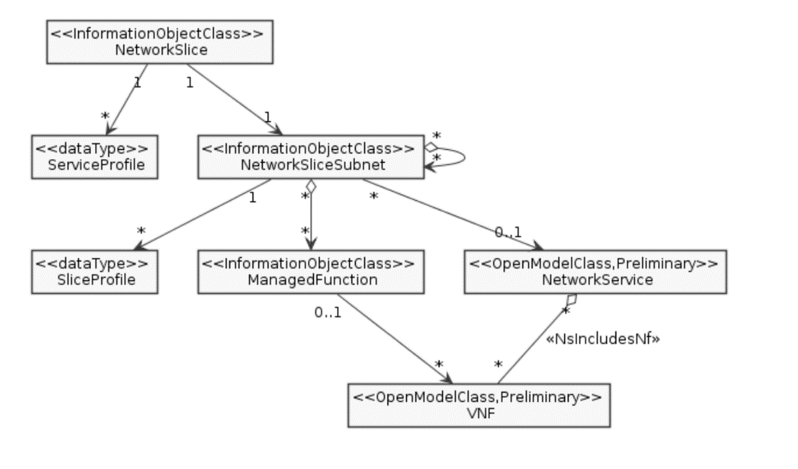

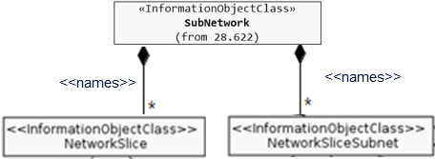

**Figure 6.2.1-1: Network slice NRM fragment relationship**

NOTE 1: The <<OpenModelClass>> NetworkService and <<OpenModelClass>> VNF are defined in [40].

NOTE 2: The target Network Service (NS) instance represents a group of VNFs and PNFs that are supporting the source network slice subnet instance.

NOTE 3: The instance tree of this NRM fragment would not contain the instances of NetworkService and VNF. However, the NetworkSliceSubNet instances would have an attribute holding the identifiers of NetworkService instances and the ManagedFunction instance would have an attribute holding identifiers of VNF instances.

|  |
| --- |
| **End of 1st modification** |